Education Improvement: Curriculum Support Team
Questions of Quality Survey - 2013
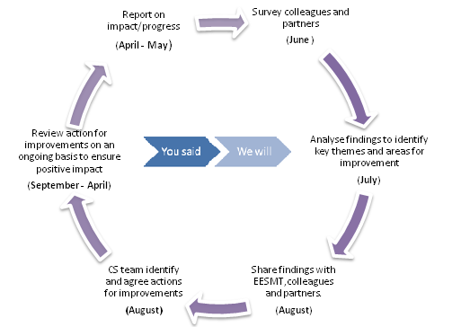

Service improvement is built on effective self evaluation. The Curriculum Support team has a clear set of accountabilities which is used to test team performance on an ongoing basis. The team issues an annual questionnaire to Education Services staff and external partners to gather feedback which informs personal and team development.

Curriculum Support staff are open to and value individual feedback which is used to inform ERD and personal and professional development.

The survey was open for comment during the month of June 2013 and attracted 150 contributors who answered a set of questions and offered qualitative feedback on how well they think the team delivers on its strategic intentions.

Delivering Strategic Intentions- How well do we do?”
Never Sometimes Often Always
Council Staff perspective 2.77% 15.79% 35.52% 45.90%
Partners’ perspective 0.00% 1.55% 24.76% 73.68%

In addition, qualitative feedback delivered specific information relating to the performance of individuals and any bespoke work that has been carried out by the team. Of the 120 comments, 95% were positive affirmations of our work and 5% were constructive suggestions of where improvements could be made.
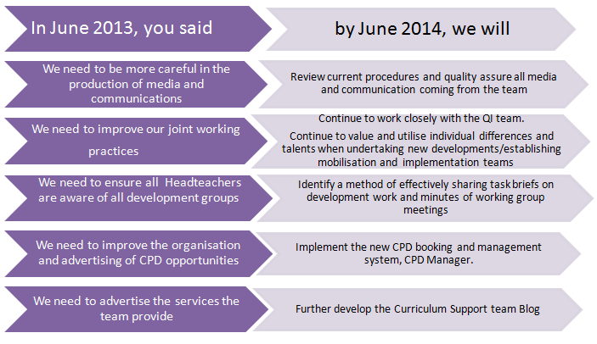

Feedback from Questions of Quality 2013

The table below details how well the team met each of their key targets.

Response from  Partners | Never |  | Sometimes |  | Often |  | Always |  | Total response
 | No. | % | No. | % | No. | % | No. | % | No.
Demonstrate flexibility and/or creative approaches | 0 | 0 | 2 | 4.3% | 13 | 28.3% | 31 | 67.4% | 46
Provide a credible source of expertise | 0 | 0 | 0 | 0 | 9 | 19.1% | 38 | 80.9% | 47
Communicate effectively | 0 | 0 | 1 | 2.1% | 11 | 23.4% | 35 | 74.5% | 47
Build and maintain quality relationships | 0 | 0 | 1 | 2.1% | 10 | 21.3% | 36 | 76.6% | 47
Make an influential contribution to development | 0 | 0 | 0 | 0 | 12 | 26.7% | 33 | 73.3% | 45
Respond effectively to national/local priorities | 0 | 0 | 0 | 0 | 15 | 33.3% | 30 | 66.7% | 45
Add value to the quality of the service you provide | 0 | 0 | 1 | 2.1% | 10 | 21.7% | 35 | 76.1% | 46
Total | 0 | 0 | 5 | 1.55% | 80 | 24.76% | 238 | 73.68% | 323
Response from Council  Services Colleagues | Never |  | Sometimes |  | Often |  | Always |  | Total response
 | No. | % | No. | % | No. | % | No. | % | No.
Provide a strategic lead for innovation and development | 1 | 2.1% | 5 | 10.4% | 19 | 39.6% | 23 | 47.9% | 48
Demonstrate flexibility and/or creative approaches | 2 | 2.4% | 12 | 14.3% | 32 | 38.1% | 38 | 45.3% | 84
Provide a credible source of expertise | 2 | 1.9% | 14 | 13.7% | 37 | 36.3% | 49 | 48.0% | 102
Communicate effectively | 3 | 2.9% | 17 | 16.7% | 36 | 35.3% | 46 | 45.1% | 102
Build and maintain quality relationships | 4 | 3.9% | 17 | 16.7% | 36 | 35.3% | 45 | 44.1% | 102
Influence the practice of establishments | 0 | 0 | 4 | 8.7% | 26 | 56.5% | 16 | 34.8% | 46
Influence classroom practice | 1 | 3% | 8 | 24.2% | 9 | 27.3% | 15 | 45.5% | 33
Respond effectively to identified needs | 0 | 0 | 7 | 15.2% | 16 | 34.8% | 23 | 50.0% | 46
Add value to the quality of the service you provide | 5 | 4.8% | 20 | 19.4% | 28 | 27.2% | 50 | 48.5% | 103
Respond to your needs in a flexible way | 1 | 5.56% | 4 | 22.2% | 4 | 22.2% | 9 | 50.0% | 18
Total | 19 | 2.77% | 108 | 15.79% | 243 | 35.52% | 314 | 45.90% | 684

= Improvement on previous year

= On par with previous year

= Less than previous year

https://blogs.glowscotland.org.uk/fa/CurriculumSupport/

