G I R F E C
(Getting It Right For Every Child)

An approach to supporting your child’s wellbeing at home

The Getting It Right approach looks at eight areas of wellbeing. These are
recognised as areas in which children and young people need to progress in
order to do well now and in the future.

The eight wellbeing indicators are:

Safe, Healthy, Achieving, Nurtured, Active, Respected, Responsible and Included

The approach gives a common language and a way to gather information about a child’s world, making sure the child is developing, and has everything they need from the people who look after them both at home and in the wider community.
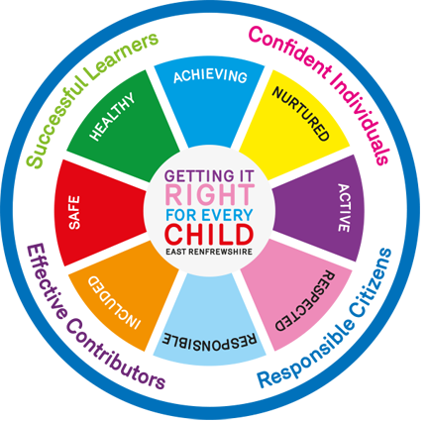
Children will discuss well-being indicators in various ways e.g. whole school virtual assemblies, topics, circle time, etc.

They will be encouraged to think of ways in which they exercise the rights to play, to be healthy and happy, to learn new things and to be looked after and nurtured. Children will record this learning in their Wellbeing Plans which can be kept in their Learning Journeys. Learning Journeys will be sent home on Friday 27 November.

This term we will review the wellbeing indicators with our children. We will ask your child to score their wellbeing on a scale of 1-10 against the wellbeing indicators - safe, healthy, achieving, nurtured, active, respected, responsible and included. The results gathered from the review will determine the focus of health and wellbeing in each class.

In school we focus on one wellbeing indicator each week. During our virtual assembly a child from each class will be identified for their effort in developing that aspect of their wellbeing in class and during play times. Their achievement will be celebrated with the whole school.

As part of our partnership working with you we have devised this approach to learning at home. We have created 3 plans: Early (P1), First (P2-4) and Second (P5-7) levels.

HOW TO COMPLETE YOUR CHILD’S WELLBEING PLAN

We ask that you discuss each task within the eight wellbeing indicators with your child and choose at least one task (maximum 3) from each wellbeing section e.g. Safe, Healthy, etc to focus on for the remainder of this term.

Please place a tick(s) next to the task(s). Your child's teacher will discuss the progress of their targets through the course of the term. You will be asked to comment in the parent's section at the end of each term. New targets will be set each term until the end of the session. It is important that your child chooses targets that are challenging as well as achievable.
In our attempt to save on paper we ask that after you have completed each term's targets that you kindly take a screen shot of your child's wellbeing plan to remind you of their targets. Alternatively your child can write/record their targets before returning their plan to school.

If you are not able to identify suitable targets from the suggested list, please use the blank wellbeing plan and insert your own which might be more suitable to your child's needs and interests.

Please complete term 1 with your child and return their wellbeing plan to school no later than Thursday 17 September. Could all GME children please complete the Gaelic version of the wellbeing plan.

Terms for this session are as follows:

Term 1: August 2020 – Mid November 2020
Term 2: Mid November 2020 – Mid March 2021
Term 3: Mid March 2021 – June 2021

If you have any questions regarding this approach, please contact the school and we will be happy to discuss it with you.

.

(Sample well-being plan)

