Promoting Positive Behaviour

Policy

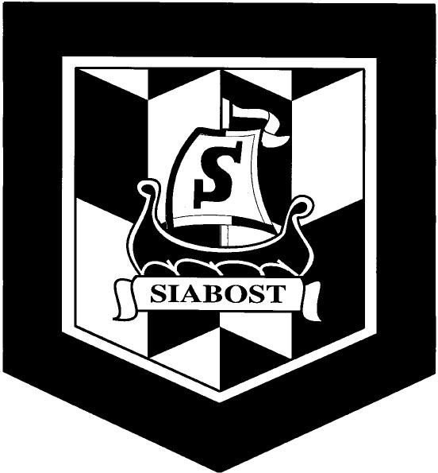

Sgoil Shiaboist

The ethos and values of Sgoil Shiaboist are fundamental to, and permeate, every aspect of school life. To enable all children to be included, engaged and involved in their education, our school supports an inclusive ethos where everyone’s contribution to the school community is valued and everyone has a sense of belonging. Our school ethos and Values influence our policies and procedures, school rules and relationships. These also underpin positive relationships at all levels across the whole learning community.
Our policy recognises that:
- Learning and teaching is most effective in an environment where the ethos is one of mutual respect and where positive relationships are encouraged
- Pupils and staff have a right to learn without their learning being disrupted
- Pupils and staff have a right to feel safe in school
- Pupils, parents and staff all have a share in the responsibility to promote and maintain positive behaviour and positive relationships in school
Where pupils enjoy positive, purposeful learning experiences that meet their individual needs, treats them with respect and promotes their active involvement in decision-making, any behaviour that challenges can be significantly reduced. We actively promote and reward positive behaviour. Recognition of positive behaviour will help pupils learn the behaviour that is expected of them and promote a model of good discipline in the school.
At Sgoil Shiaboist we promote an actively inclusive approach where we aim to meet the needs of all our pupils, regardless of abilities, background or social circumstances. We aim to:
- develop effective systems of support for individual pupils, integrated with well-developed systems for promoting positive relationships
- provide an appropriately differentiated curriculum for all pupils which ensures that they are motivated, achieve success and are appropriately challenged
- organise lessons to ensure that all pupils are challenged and supported
- Recognise and take account of different learning styles that make teaching more accessible and motivating for pupils
- Plan learning with pupils

In addition, Sgoil Shiaboist aims to:
- put the emphasis on praise and reward for positive behaviour. We will avoid, where possible, giving attention to unwanted behaviour.
- involve all staff and pupils in creating school and classroom rules.
- involve parents in supporting the development of a whole school approach to promoting positive behaviour
- encourage all pupils to realise that they each have a part to play in the life of the school.
- develop a positive attitude to learning in pupils by recognising and regularly rewarding work, attitudes and behaviour.
- Recognise and praise achievements and attainment.
- Create a class charter in every room (with the pupils)

Key Features of Promoting Positive Behaviour
Some key features of promoting positive behaviour at Sgoil Shiaboist are:
- Fostering a positive ethos based on a sense of community and shared values.
- Ensuring a motivating and challenging curriculum for all pupils.
- The promotion of mutual respect, self-discipline and social responsibility.
- All pupils having the right to expect that they are included and that their rights are understood and acknowledged
- Schools and partners having a responsibility to support pupils to achieve their full potential.

Importance of a quality Learning Environment
The curriculum we provide will be relevant, challenging and motivating. Our staff will ask pupils what they want to learn and how across the 4 contexts for learning. We will creative a supportive, creative learning environment where pupils:
- Respect staff / partners
- Respect their peers
- Are keen to learn and ready to engage in planned learning activities/experiences

Our rules, expectations and class charters should:
- Be clear and easy to understand
- Be positive in nature and provide opportunities for recognition/ reward
- Reflect the desired ethos and culture of the school
- Be co-created: staff and pupils work together
- Be achievable

Sgoil Shiaboist promotes the following:

Respect for self
Respect for others
Respect for property

Rewards are more important than sanctions in our school. We believe that positive behaviour should be recognised and rewarded. The staff at Sgoil Shiaboist:
- Recognise and highlight positive behaviour
- Ensure that children are praised/rewarded for positive well
- Explain and, importantly, demonstrate positive behaviour to each other and to pupils
- Let parents and carers know about their children’s good behaviour

The school does not accept behaviour such as:
- Bullying (See Anti-Bullying Guidelines)
- Swearing
- Fighting
- Racism/Discrimination
- Name calling
- Vandalism
- Stealing
In the context of the above, the school will:
- Contact parents informing them of the issue
- Ask parents to come and meet with the class teacher/Head teacher

In extreme and very rare circumstances the school may temporarily exclude a child but exclusion will only ever be considered after all other possible avenues have been exhausted. The school will adhere to Local Authority advice/guidance including “Policy on the Management of Exclusions in Schools” (February 2020) and “Included, Engaged and Involved” Part 2 (Scottish Government, 2019).

Partnerships
Although the school has a critical role to play in promoting good behaviour, it is clear that schools cannot, and should not, tackle this responsibility alone. Partnership is key. The school can consolidate its partnership with parents, ensuring that parents will be informed when things are going well and when they are not.
If there are any incidents of behaviours that challenge, for whatever reason, the school will address these through a joint working approach – this will involve working alongside parents/carers and, at times, other partners / agencies.
Strategies that can support positive behaviour:
- Having a well-planned, appropriate and relevant curriculum for all
- The development of whole school behaviour codes with pupils actively involved in the process
- The development of school rewards and sanctions policies which are clearly communicated to all parents and pupils
- The development of strategies for the early identification of pupils who are experiencing barriers to their learning
- Partnership working between parents/carers, schools and other agencies
- Pupil councils / Buddy systems
- Extra-curricular clubs
- Involvement of parents (e.g. Open Days, IDL planning opportunities)
- Classroom charters
- Stickers/stars etc.
- House system – points etc.
- Pride in their learning environment e.g. the mounting of own work.

In addition, Sgoil Shiaboist endorses Comhairle nan Eilean Siar’s (CNES) “Improving Behaviour Policy” (2018):
“CNES carries a range of statutory responsibilities for the welfare of staff and children. We have a statutory duty to support vulnerable children in a manner which balances the welfare and safety of all individuals. This involves the promotion of a positive service culture in which the reasons for challenging behaviour are understood and acceptable responses are defined and consistently applied” (page 3)

Policy Lead: S Gunn
Policy date: February 2024
Policy review : February 2027

