**Information to Support Families during Establishment Closures in Response to Covid – 19**

The Coronavirus outbreak has led to a high degree of worry, uncertainty and concern. The spread of the disease and its implications for everyday life has been very present in the news, and in daily conversation. During these times both children and adults can potentially feel anxious and unsure about their safety. School staff and parents/carers can help provide opportunities where feelings can be discussed within a safe context, while maintaining a sense of normality, routine and calm. Supporting children will enable them to process and manage their feelings and help build resilience.

**Talking to Children and Young People about Covid-19**

* Provide opportunities for **regular check-ins.** Sharing worries can help to reduce vulnerability and isolation, and it can raise optimism and self-esteem.
* **Reassure** children and young people that they are **safe**. Give **positive messages** about the preventative steps being taken as a family, a community and a nation.
* Help children and young people **separate fact from fiction.** The information being shared about Covid-19 is plentiful and changing rapidly. **Answer questions** rather than volunteering too much information to avoid overwhelming.  Be **honest and accurate**. Let children know if you’re unsure of the answer, reassure them that you will keep them informed.
* Ensure that the information you share is **developmentally appropriate**.
  + Young children will need very simple explanations (e.g. *Coronavirus is a bug that can spread between people and make them ill. We don’t know everything about it yet, so we need to take care to stop it spreading. Things might be a bit different for a while*).
  + Older children may have heard partial explanations and ‘filled in the gaps’ themselves with their own ideas, so check what they already think they know about it.
  + Teenagers will need calm, factual information and opportunities to talk through their worries and disappointments.

**Limit access to rolling news** to allow you to filter information relayed to your children in an age appropriate way.

* Provide regular prompts regarding **practical guidance** e.g. hand washing, social distancing.
* **Manage your own worries**. Children learn from the responses of adults around them, talk to them when you are calm to provide reassurance and safety.

(Adapted from advice provided by the British Psychological Society)

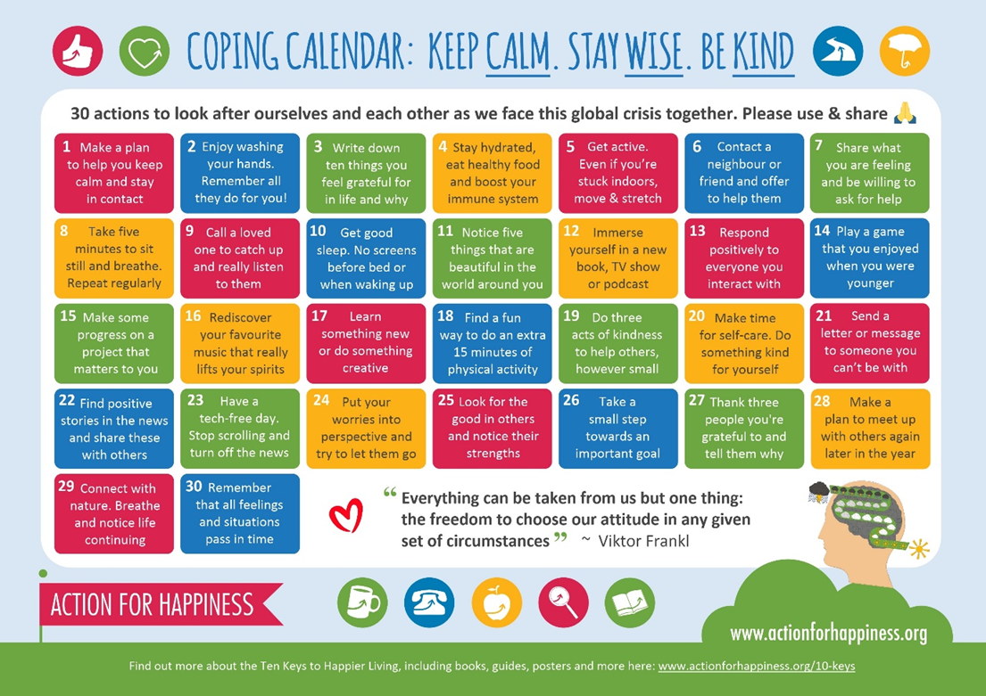

**Further Advice to Support Families during Establishment Closures**

* Try to create a \***flexible* routine and structure** remembering that this is not a normal situation and most of you are not teachers!
  + **Involve** **children** in developing plans for their day to promote engagement
  + If following a routine causes stress and conflict, opt for a **free flow approach** guided by activities the children want to do
  + Focus on **play** and **enjoying shared activities** to **build relationships and reduce stress** rather than trying to replicate a school day**.**
  + Ifpossible, **keep learning activities to one or two designated areas** to create work – life boundaries. Have children pack up school materials to signal the end of the day.
* Build in time for fresh air and exercise whilst adhering to social distancing guidance (<https://www.nhsinform.scot/coronavirus>)
* Think of social distancing as **physical distancing**, help children **stay socially connected** to their friends and family through alternative means such as video calls.

(Adapted from advice provided by the British Psychological Society)