Sgoil an Iochdair

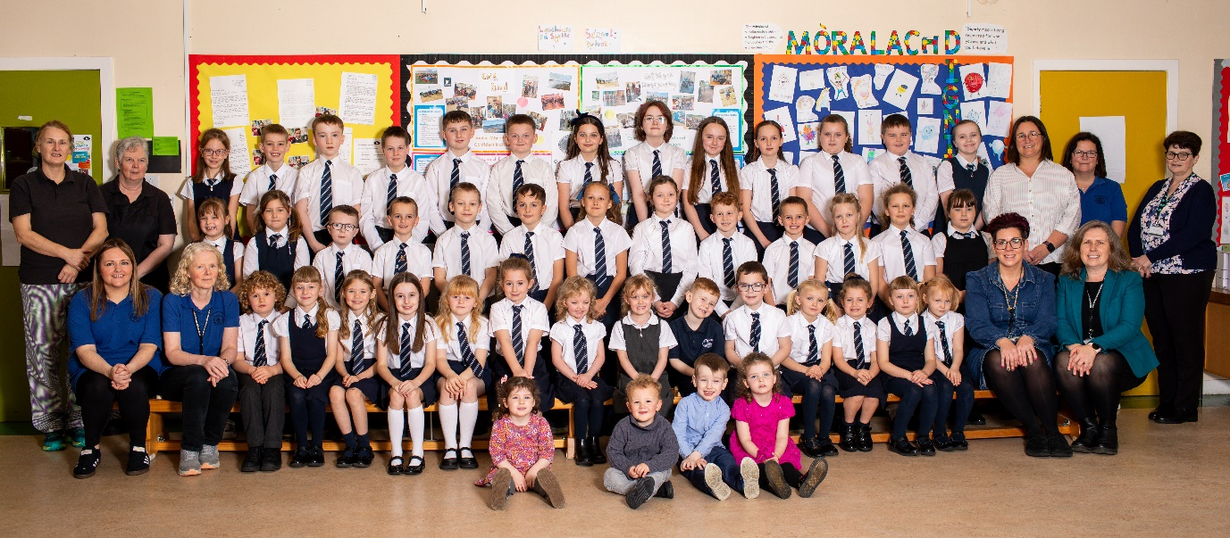
HANDBOOK


December 2025


Cànan - Gaelic, Cultar - Culture, Coimhearsnachd- Community & Cruthachailleachd-Creativity

Welcome from the Head of School, Mrs Joan MacDonald
Fàilte, I would like to welcome you and your child to Sgoil an Iochdair.
This handbook offers an introduction to our school, it’s vision, values and aims as well as practical day to day information to support you. We hope you find it clear and informative. If you have any queries about any of the information in this handbook, or indeed about any aspect of our school, please do not hesitate to contact me.
At Sgoil an Iochdair we take pride in the Gaelic language, culture and heritage of our island community. It is our aim to be a school community celebrated for its high quality learning experiences where everyone is valued, respected and included. We hope that your child enjoys their time at Sgoil an Iochdair.
Please visit our school website or Facebook page for further current information and a flavour of what the pupils have been learning.
Leis gach deagh dhùrachd
Mrs Joan MacDonald Head of School

https://blogs.glowscotland.org.uk/es/sgoilaniochdaireileansiar/
https://www.facebook.com/iochdarschool/?locale=en_GB
2 | Sgoil an Iochdair Handbook December 2025  Còir – Kind, Earbsach – Trustworthy, Urramach – Respectful, Dìcheallach - Diligent

Cànan - Gaelic, Cultar - Culture, Coimhearsnachd- Community & Cruthachailleachd-Creativity
 | SECTION ONE – PRACTICAL INFORMATION ABOUT THE SCHOOL
 | Contact Details |  | 4
 | Staffing |  | 5
 | Organisation of School Day, School Meals, Travel |  | 6
 | Unexpected Closures, Attendance & Absence |  | 7
 | Medical, Health & Safety Information, Uniform |  | 8
 | Clothing Grants, Complaints Procedures, |  | 9
 | SECTION TWO – PARENTAL ENGAGEMENT
 | Parents Evening, Reporting, Online Engagement |  | 10
 | Parent Council |  | 11
 | Pupil Voice including Committees |  | 12
 | Celebrating Success, Pupil Conduct & Dealing with Bullying Behaviour |  | 13
 | SECTION THREE – THE SCHOOL CURRICULUM
 | School Ethos, Vision, Values & Aims |  | 14
 | Curriculum Overview |  | 15
 | Gaelic |  | 16
 | Expressive Arts, Health & Wellbeing |  | 17
 | Language & Literacy, Gaelic Learners, |  | 18
 | German, Numeracy & Mathematics, Religious & Moral Education |  | 19
 | Social Studies, Science & Technologies, Developing the Young Workforce |  | 20
 | Digital Literacy, Global Citizenship, Dùbhlain Dihaoine |  | 21
 | Extra-Curricular Activities, Active Schools |  | 22
 | Assessment & Reporting |  | 23
 | SECTION FOUR – SUPPORT FOR PUPILS including Transitions
 | School Admissions, Transitions |  | 24
 | Placing Requests |  | 25
 | SECTION FIVE – SCHOOL IMPROVEMENT |  | 26
 | SECTION SIX – Additional Information
 | Data |  | 27, 28
 | Photography |  | 29
 | SECTION SEVEN - Appendices
 | Intention to withdraw
 | Administration of medicines
 | Uniform
 | School Holidays
 | Responsible Internet Use
3 |  | Sgoil an Iochdair Handbook December 2025  Còir – Kind, Earbsach – Trustworthy, Urramach – Respectful, Dìcheallach - Diligent

Cànan - Gaelic, Cultar - Culture, Coimhearsnachd- Community & Cruthachailleachd-Creativity
SECTION ONE – PRACTICAL INFORMATION ABOUT THE SCHOOL
CONTACT DETAILS
Name of Head of School: Mrs Joan MacDonald
Name of School: Sgoil an Iochdair
Address: Sgoil an Iochdair, Iochdar, Isle of South Uist, Western Isles, HS8 5RQ
Telephone Number: 01870 604891 Emergency Number: 01870 610337
Email Address: iochdarschool@gnes.net
Parent Council Email Address: iochdairpc@gmail.com
ABOUT THE SCHOOL
We are a multi denominational school.
Stages of Education provided for:
Sgoil-Àraich (Nursery): 2 years to pre-school
Primary School: 4.5 years to approx. 12 years (P1-P7)
Present Roll:
Sgoil Àraich - 6 children Primary School – 40 pupils
Gaelic Medium Education is available from the Sgoil-Àraich to P7. Sgoil an Iochdair is a Gaelic Status School.
Website: https://blogs.glowscotland.org.uk/es/sgoilaniochdaireileansiar/ Social Media: https://twitter.com/iochdarschool
https://www.facebook.com/iochdarschool/
The school operates within the system of educational provision administered by the
Education and Children’s Services Department of Comhairle nan Eilean Siar.
Information about other primary and secondary schools in the Western Isles, or information about the Local Authority’s general policies on such issues as placing requests to schools, school commencement arrangements, transport facilities, or maximum school and class numbers may be obtained from:
The Council’s Website: www.cne-siar.gov.uk Education and Children’s Services Department, Sandwick Road, Stornoway, HS1 2BW Tel:(01851)822696
4 | Sgoil an Iochdair Handbook December 2025  Còir – Kind, Earbsach – Trustworthy, Urramach – Respectful, Dìcheallach - Diligent

Cànan, Cultar, Coimhearsnachd & Cruthachailleachd
The School and Sgoil-Àraich are led and managed by the Head of School, Mrs Joan MacDonald. Ms Sarah Jane MacSween, Acting Executive Head Teacher of the Uist Primaries provides a strategic overview for curriculum and quality assurance across the four Uist Primaries.
STAFF
Executive Head Teacher (Acting): Ms Sarah Jane MacSween
Head of School: Mrs Joan MacDonald
Class Teachers Class Room
Mrs Mereoni Fraser GL 1-7 R8
Mrs Kay Marie MacInnes GM 5-7 R9
Mrs Mairi MacAulay GM 1-4 R10
Mrs Chloe Steele-MacRury Reduced Class Contact Time (RCCT)
Mrs Joan MacDonald Reduced Class Contact Time (RCCT)/ Support for Learning Teacher
Support Staff:
Mrs Ann Evans Secretary/School Assistant
Mrs Catriona MacLennan Support for Learning Assistant
Mr Neil Johnstone/ Ms Louise McBride Janitor/Relief Janitor
Nursery Staff:
Mrs Mary MacKinnon Play Leader
Mrs Margaret MacVicar Nursery Key Worker
Mrs Katy Beaton Nursery Key Worker
Ms Paula Johnson Nursery Key Worker
Catering Staff:
Ms Lorna MacDonald Cook in-Charge
Mrs Mary Wilson Kitchen Assistant
Vacant Post Canteen Supervisor
Instructors (I):
Mrs Esther MacDonald (I) Chanter (Wednesday)
Miss Anna Black (I) Fiddle (Thursday)
Cleaning Staff:
Ms Mary MacEachen Cleaner in-Charge
Ms Louise McBride Cleaner
5 | Sgoil an Iochdair Handbook December 2025  Còir – Kind, Earbsach – Trustworthy, Urramach – Respectful, Dìcheallach - Diligent

Cànan, Cultar, Coimhearsnachd & Cruthachailleachd
ORGANISATION OF THE SCHOOL DAY
Start Time: 09:00 Morning Break: 10:45-11:00
Lunch Time: 12:30- 13:15 Finish Time: 15:00 School Office open 8.00 am – 4:10pm
SCHOOL MEALS/PACKED LUNCHES
School menus offer healthy and varied meal options, reflecting the Scottish Government food and drink legal requirements for school lunches. Pupils can choose a hot meal, soup and sandwiches and a choice of pudding or fresh fruit, or take in their own healthy lunchbox. The children eat their lunches together in the school dining-room from 12.30 to 1pm. For reasons of health and safety we discourage the consumption of sweets, chewing gum, etc. during the school day. Toast or crackers are provided at morning break, the cost is £5 per term a maximum of £10 per term per family. Fresh fruit is available on a Wednesday thanks to a generous donation from Lovats Supermarket, Carnan All pupils are encouraged to drink water throughout the day and are asked to bring a clean filled bottle.
Parents should let the school know in advance if their child has any special dietary requirements and complete a form with details from their doctor.
Children in P1-5 are all entitled to a free school meal at lunch time. The cost is £2.30 per 2 course meal. This can be paid through an online service www.cnes-siar.gov.uk Children of parents in receipt of Income Support are entitled to a free midday meal, and support during school closures and holidays. Application forms are available at www.cne-siar.gov.uk Further information is available from the Catering Officer, Education Dept, Comhairle nan Eilean Siar, Stornoway Tel 01851 600501. A copy of the menu and price list is distributed to parents at regular intervals and is also available on request.
TRAVEL TO AND FROM SCHOOL
Primary School children living two miles or more from school are entitled to free transport. Children who are not eligible for free transport will have to pay a contribution towards the cost of transport if they make use of it.
Children attending this school rather than their local catchment school (as placing requests) are not entitled to free transport. Details of charges and how to apply as well as the school transport policy and transport appeal forms are available at www.cnes-siar.gov.uk
It is the parent’s responsibility to make sure their child arrives at the pick-up point on time and behaves in a safe and acceptable manner while boarding, travelling in and leaving the vehicle. Children who misbehave can lose their right to home to school transport. If there are any changes in usual home-time routine, please contact the office by 2.00pm.
6 | Sgoil an Iochdair Handbook December 2025  Còir – Kind, Earbsach – Trustworthy, Urramach – Respectful, Dìcheallach - Diligent

Cànan, Cultar, Coimhearsnachd & Cruthachailleachd

UNEXPECTED CLOSURE
It may be necessary, occasionally, to close the school at short notice and send the pupils home, for example, in exceptionally bad weather or if there are electricity. heating or water faults. If parents are not regularly at home during school hours, arrangements should be made to have someone available to receive their children in an emergency. The school will ask each parent at the point of enrolment to provide the contact details of a person for these circumstances. Please ensure this information is kept updated. Groupcall is an application that the school uses to send texts to the 1st emergency contact number to inform families of unscheduled school closures as well as emails for general correspondence. Phone calls home are also made to ensure contact with parents. Parents should also feel free to contact the school if they are concerned about the safety of the children because of severe weather conditions.
ATTENDANCE AND ABSENCE
It is the responsibility of parents to ensure that their children attend school. As part of our quality assurance procedures we monitor the attendance of all our pupils. If your child’s attendance falls below 90% you will be contacted to inform you of this. Absences do add up and have a detrimental effect on your child’s education. If your child’s attendance falls below 80% the local authority has to be informed.
Please inform the school of any planned absence. Should parents intend withdrawing their children from school during term time for a family holiday or any other reason, it is necessary to complete the necessary form (see appendix 1 & 2 or request one from the office). We would appreciate notification at least one week in advance. We discourage withdrawals from school as they interrupt the continuity of children’s learning.
Absences fall into two categories:
- Planned Absence
As part of Government Regulations we are required to record all absences as “authorised” or “unauthorised”. Authorised absences are generally due to illness, medical appointments or family bereavement but may also include time off to participate in sporting events or music exams. The Scottish Government has deemed that holidays taken during term time should be recorded as unauthorised absence unless there are special exceptional circumstances.
Please contact the school, preferably the day before, regarding any Medical appointments that require absence from school for part or whole days, reason for the request should be given and a time should be indicated of when they will return to school.
- Unforeseen Absence
When children are absent from school, parents should advise the school of the reason for absence before 9.30am if possible. If we do not receive an explanation, then a staff member will make contact with a parent or carer. In order to avoid causing unnecessary concern, the importance of good communication between home and school cannot be over-emphasised.
7 | Sgoil an Iochdair Handbook December 2025  Còir – Kind, Earbsach – Trustworthy, Urramach – Respectful, Dìcheallach - Diligent

Cànan, Cultar, Coimhearsnachd & Cruthachailleachd
MEDICAL, HEALTH & SAFETY INFORMATION
We are only able to administer certain medicines and preparations if parents request us to do so, using the appropriate written consent form (appendix 2). We store medications in the Medical room and record the dosage and frequency of the medication, etc.
Any pupils who become unwell during the school day will be monitored. If appropriate, parents will be informed and may decide to take their child home. Parents should inform the school of any relevant medical history (e.g. asthma, epilepsy, diabetes, allergies etc.) of which teachers should be aware.
Please note that where a child is known to be suffering from a bout of sickness or diarrhoea or is experiencing other acute symptoms, they should not attend school until the sickness has cleared up satisfactorily until 48 hours from the last episode of sickness or diarrhoea.
The local Public Health Team visit regularly. Parents are kept informed in advance of any medical checks and procedures taking place. The Childsmile Support Worker delivers workshops to the pupils and also carries out the Varnishing Programme on a regular basis. Other Health Professionals may visit our school as part of school or national initiatives.
Notices describing what to do in the event of a fire are displayed in every room/area in the school. Teaching staff remind all pupils of fire procedures at regular intervals and the school holds a fire drill each term. Visitors to the school are requested to sign in and out in the attendance log situated in the main office.
MOBILE PHONES
Pupils should not have mobile phones in school as per School Policy.
SCHOOL UNIFORM
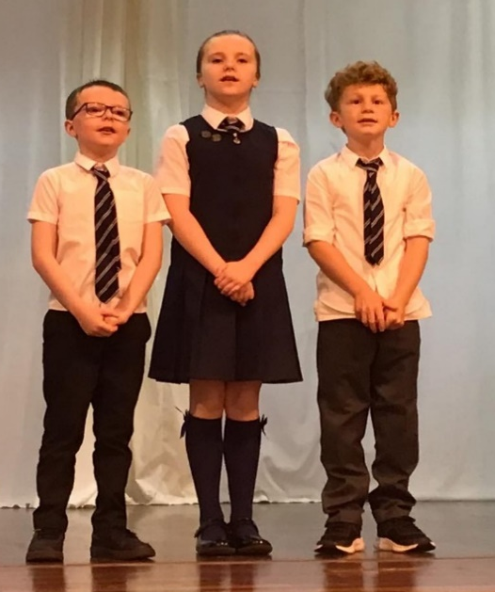
We encourage school uniform and all items of clothing, footwear, etc. should be clearly marked with the child’s name. The school dress code is as follows:
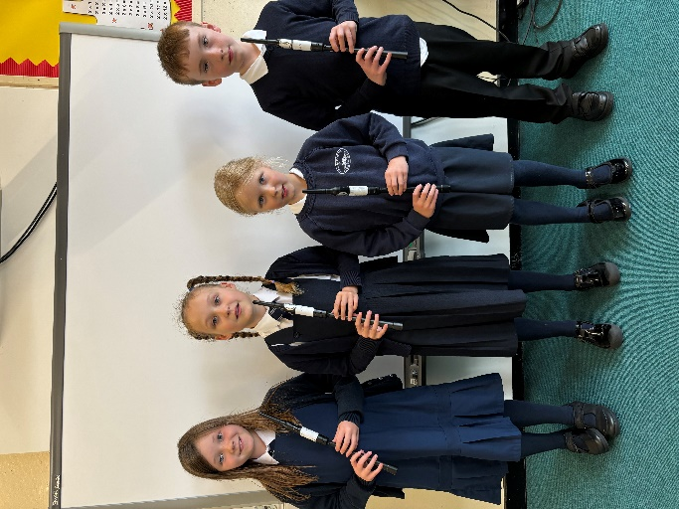
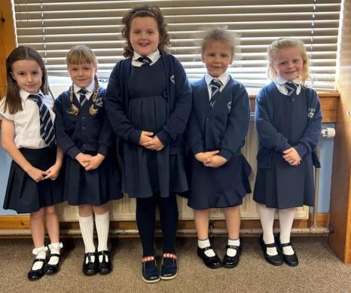
- Navy blue sweatshirt, jumper or cardigan
- White or navy polo shirt with collar, white shirt or white blouse
- Black or navy trousers / skirt / pinafore dress
- Blue & white checked summer dress
- Socks or tights in any of the uniform colours
- Dark coloured footwear
PE KIT
- Plain White or navy T-shirt
- Plain navy blue or black shorts
- A change of footwear, or training shoes
- Swimwear and towels are required for swimming (16 lessons in P4)
Prohibited items
- Blue Denim Jeans/Leggings
- Football logos on any items such as school bag, lunch bag, jackets, hats etc
- Jewellery should not be worn. (Although studs or sleepers are permitted)

8 | Sgoil an Iochdair Handbook December 2025  Còir – Kind, Earbsach – Trustworthy, Urramach – Respectful, Dìcheallach - Diligent

Cànan, Cultar, Coimhearsnachd & Cruthachailleachd

We have a wide range of quality and affordable school uniform, all with embroidered school logo on the front, available to purchase. The current price list is included as an appendix (appendix 3). We also offer a uniform swap shop to encourage sustainability.
The wide range of uniform can be viewed in the school foyer and an order for school uniform will be placed once a term. Order forms can be obtained from the school office.
Protective Clothing
It is advisable for all pupils to have a shirt/overalls (for art activities) to protect their clothing. In the event of wet weather and for gardening, children may wear black boots or wellington boots to school but these should be stored in a bag and school shoes worn whilst inside the building. Pupils are provided with wet weather clothing which they use at break times and during outdoor learning.
FOOTWEAR AND CLOTHING GRANTS
All parents in receipt of Family Credit or Income Support are eligible for a clothing grant to ensure that their children are able to make use of educational provision. Application forms for clothing grants are available from www.cne-siar.gov.uk
COMPLAINTS, COMMENTS AND SUGGESTIONS PROCEDURE
We are keen that you should be completely satisfied about your child’s education and we encourage feedback from parents and pupils. We are, therefore, interested in feedback of all kinds, whether it be compliments, suggestions or complaints. If you have a complaint about the school, please let us know. It is better that these things are shared openly and resolved fairly rather than being allowed to damage the relationship between the family and the school. There will be no negative consequences arising from making a complaint and we will deal with the issue as confidentially as possible. If we have made a mistake, we will apologise quickly and clearly and try to put things right.
There are some things which you should take note of in relation to making a complaint:
- Please in the first instance speak to the Head of School to discuss your complaint. This makes sure we know what is going on and have an opportunity to resolve the issue.
- If you are unhappy with the service or with our response, then you will have the right to take the matter further. You can put your complaint in writing or fill in a complaint form. Completed forms should be sent to the Chief Officer for Education & Children’s Services.
- If you are still unhappy after further investigation and reply you can take the matter up with the Scottish Public Services Ombudsman. The reply will include the contact details.
9 | Sgoil an Iochdair Handbook December 2025  Còir – Kind, Earbsach – Trustworthy, Urramach – Respectful, Dìcheallach - Diligent

Cànan, Cultar, Coimhearsnachd & Cruthachailleachd

SECTION TWO – PARENTAL ENGAGEMENT
We encourage active involvement of parents in the life of the school as it helps promote a learning community in which pupils can engage positively with school staff and their peers. We endeavour to involve parents in all decisions affecting their children’s education and learning.
It is important that we develop relationships of mutual trust and respect where effective communication supports both parents and teachers. Effective home-school partnerships are essential to ensure that children get the most out of their school and the education system. Please do contact the school, by phone or email, we aim to have an open door policy.
Each term we share our planning with parents through Termly Parent Leaflets, which outline their child’s learning for the term as well as extra-curricular activities that take place. Pupils’ plan their learning particularly for IDL / Topic each term and progress on these are shared through Seesaw (online learning platform).
SeeSaw is used as a means of two-way communication about the child’s learning and homework tasks. Homework helps to consolidate learning, encourages active learning and provides an opportunity for parents to become involved in their child’s learning. Homework tasks are varied and are linked to classwork. For example, reading, spelling, maths, preparation for class talks etc.
Seesaw enables staff and parents to share the progress of each individual child’s learning across all areas of the curriculum. Observations and stories of learning are recorded by staff and published for children and parents to enjoy and comment on. Families are also encouraged to record any achievements from home within their child’s Seesaw account.
Parents’ evenings are held twice a year, in November and March. A written report will be issued in June. We also like to encourage discussions between parents and staff throughout the year. If there are any areas causing concern, please do get in touch with us immediately.
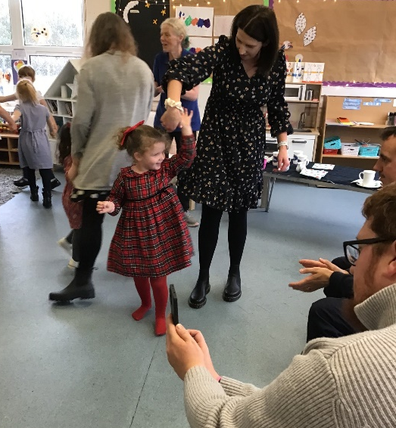
Parents’ Evenings appointment details are informed by letter. If you find your appointment time is unsuitable, please let us know so that a more convenient time/date may be arranged. The Head of School / Support for Learning Teacher is available during the Parents’ Evenings for consultation.
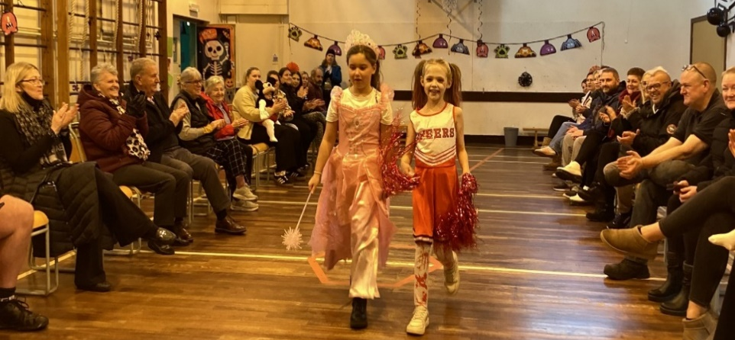
We also hold other curriculum-related events during the year e.g. workshops, information evenings, open afternoons, ceilidhs, class performances, sporting events, religious and other assemblies.
10 | Sgoil an Iochdair Handbook December 2025  Còir – Kind, Earbsach – Trustworthy, Urramach – Respectful, Dìcheallach - Diligent

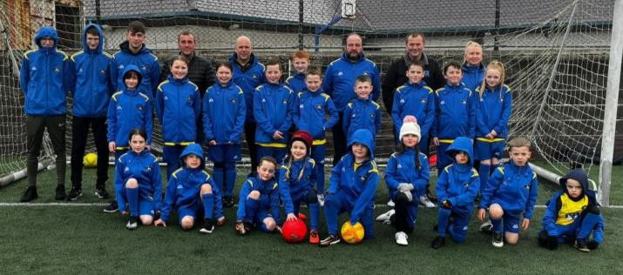
Cànan, Cultar, Coimhearsnachd & Cruthachailleachd
FORMAL PARENT REPRESENTATION
We have an active Parent Council who meet at least once a term, They run the Youth Club and also support the Football Club. Parents/Carers are encouraged to volunteer or put themselves forward to be chosen as representatives of the Parent Council. Our Parent Council meetings are open and all parents are welcome to attend. Invitations are extended to local councillors on those occasions where the school may need support for specific projects.
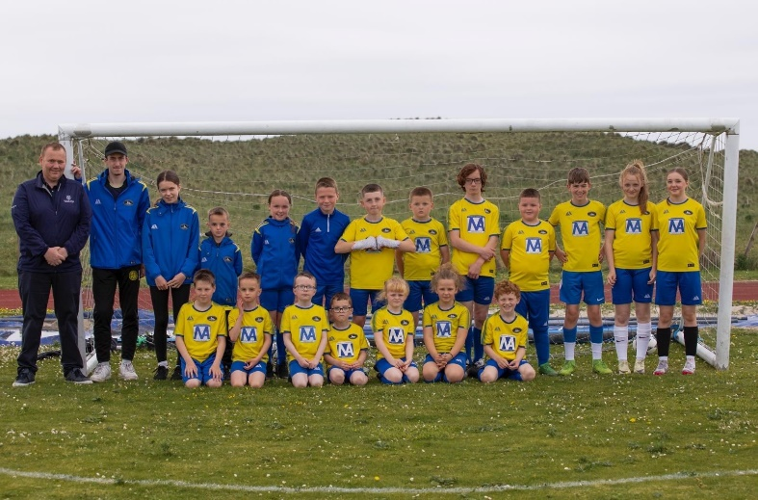
Our present Parent Council office bearers are:
Chairperson –Mel Butler
Vice Chairperson – Andrew Shaw
Treasurer – Mr Martin Butler
Secretary – Phillipa Rewaj
Head of School – Mrs Joan MacDonald
Parent Council Email
Address: iochdairpc@gmail.com
We believe that parental support and partnership is an important factor towards a pupil’s
success at school.
The Parent Council helps to create an environment where all parents know that their views matter, and where they feel confident and comfortable putting them forward. They work on behalf of all parents to discuss educational matters that are of importance to all. They do not get involved in individual matters relating to children or staff in the school.
The role of the Parent Council is to:
- support the school in its work with pupils
- represent the views of all parents
- encourage links between the school, parents, pupils, pre-school groups and the wider community

- report back to all the parents in the school
Parent councils also have a role to play in:
- The appointment of Head and Depute Head Teachers
- School inspections

The following web site gives useful information for parent councils https://education.gov.scot/parentzone/

11 | Sgoil an Iochdair Handbook December 2025  Còir – Kind, Earbsach – Trustworthy, Urramach – Respectful, Dìcheallach - Diligent

Cànan, Cultar, Coimhearsnachd & Cruthachailleachd
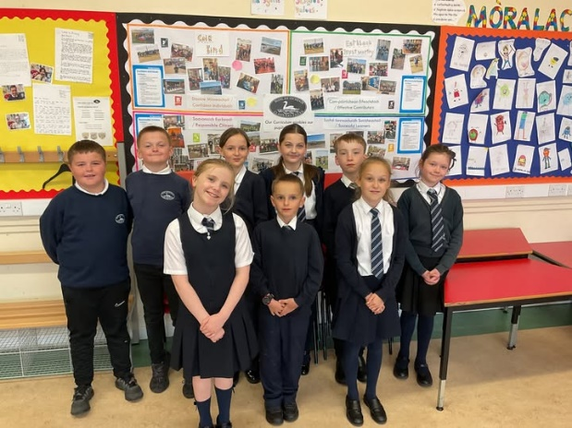
FORMAL PUPIL REPRESENTATION
The Pupil Council has nine members: Jacob, Ellie, Eilidh, Orla, Mirryn, Sebastian, Anthony, Archie and is supported by Mrs MacDonald. Our House Captains this session are:
Caisteal Bheagram – Angus
Casiteal Ormacleit - Carla
Caistal Bhuirgh - Albie
Our House Captains and Vice Captains are very excited and motivated to get started on coordinating events within our school community. Watch this space!


An Comataidh Spèis do Chòiridhean/Rights Respecting School Committee
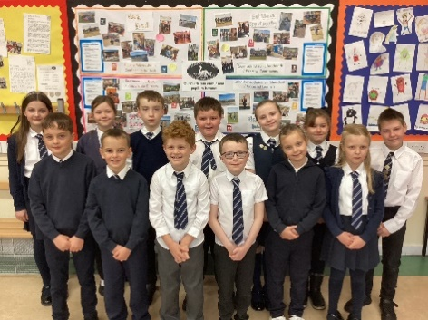
The Rights respecting school committee is supported by Mrs Mereoni Fraser. Last session we were delighted to be awarded Silver status and are working to
- Continue to embed UNCRC in all that we do.
- Continue to share our work through our regular newsletters and social media posts.
- Train our P6/7 pupils in Peer Mediation.
- They were assessed for Gold on December 3rd 2025 and are awaiting results.
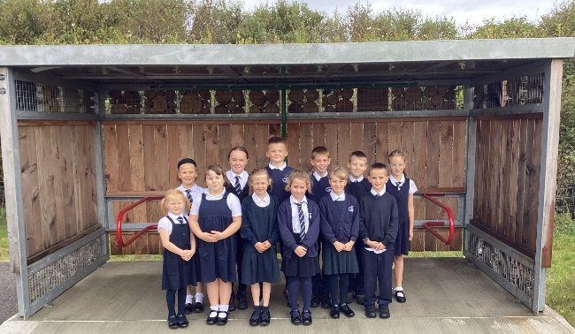
Comataidh Eco/Eco Committee
The Eco Committee is supported by Mrs Kay Marie MacInnes. We received our sixth eco flag in December 2023 and we are working towards our seventh flag in December 2025. The Eco Committee currently have a focus on climate action, transport and global sustainability while continuing to develop our school grounds by ensuring it's kept litter free and our flower boxes are weeded and tidy. The continued success of our own grown produce has allowed our pupils to use the produce for cooking and to give to our school canteen to use for our school lunches.
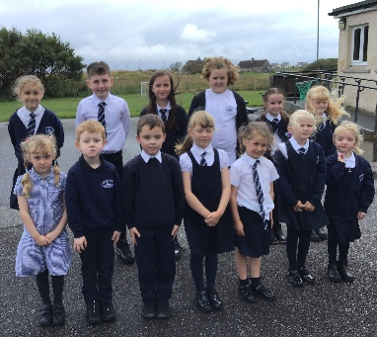
An Comataidh Slàinte agus Sunnd/Health and Wellbeing Committee The Health and Wellbeing Committee is supported by Mrs Mairi MacAulay. They were proud to be awarded their second Gold School Sport Award in December 2023. The panel from Sports Scotland were incredibly impressed by the committees submission of evidence of how sport is supported, encouraged and celebrated at Sgoil an Iochdair. They submitted evidence for their third award in December 2025 and are awaiting results.
12 | Sgoil an Iochdair Handbook December 2025  Còir – Kind, Earbsach – Trustworthy, Urramach – Respectful, Dìcheallach - Diligent

Cànan, Cultar, Coimhearsnachd & Cruthachailleachd
CELEBRATING SUCCESS & ASSEMBLIES
Weekly Assemblies are held with the pupils to celebrate achievements. They provide a forum to acknowledge positive things that have happened both academically, socially and in various extra-curricular activities. Classes award certificates such as ‘Sgoilear na Seachdain’, ‘Rionnag na Gàidhlig’, ‘Sàr Sgrìobhadair’ and Mìorbhaileach air Matamataig. Achievements are also celebrated in our school newsletters, our social media pages and local press.
Sgoil an Iochdair aims to develop the spiritual, moral, social and cultural values of its pupils, having regard to the values of the community, and guided by the recommendations contained in National and regional guidelines. We enjoy good links with our Chaplains.
As a multi-denominational school, we have pupils from different religious denominations and backgrounds and none. Religious and Moral Education takes place weekly, through lessons, regular whole-school Assemblies and opportunities for Religious Observance. Assemblies contribute to the whole school ethos allowing us an opportunity to come together as a community. They also allow pupils to be involved in experiences which stimulate, challenge and extend their capacities for spiritual response to the world in which they live.
PUPIL CONDUCT
A partnership between the school and parents is required in order to ensure the best possible pupil conduct. Pupils are expected to set themselves high standards in appearance and behaviour. We are a Silver: Rights Aware School, and each class creates their own charter to show the shared rights and responsibilities we have as pupils and staff as duty bearers. Our aim is to have an atmosphere of mutual respect and co-operation where everyone feels happy, safe and included. By doing so, the quality of life and opportunities for learning in our school are enhanced.
It is important to allow pupils every opportunity to behave in an acceptable way and to avoid premature escalation of an incident. We would hope to give parents an ‘early warning’ of any problems and we would anticipate active co-operation from parents where necessary so that their child, and others in the school, will benefit from the education provided. Our School’s Relationships & Promoting Positive Behaviour Policy outlines in greater detail the school’s disciplinary procedures. (This is available on request).
DEALING WITH BULLYING
Bullying behaviour will not be tolerated within Comhairle nan Eilean’s educational establishments. Parents should inform staff immediately if they become aware of any incidents of bullying. Children should be encouraged to discuss any worries or problems of this nature with the Class Teacher or Head of School (or both) as soon as possible. During break-times any concerns should be conveyed to the Janitor or Assistant on duty. The Suggestion Box is also a means of communication.
Parents should keep a written record of any incidents including the date, the child(ren) involved, and what happened. This will help the school to deal with the situation and agree the best way to support the child inside and outside the school. The School’s Anti-Bullying and Promoting Positive Behaviour policies are available on request.

13 | Sgoil an Iochdair Handbook December 2025  Còir – Kind, Earbsach – Trustworthy, Urramach – Respectful, Dìcheallach - Diligent

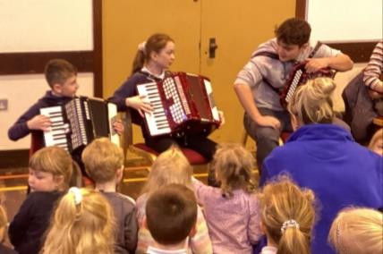
Cànan, Cultar, Coimhearsnachd & Cruthachailleachd
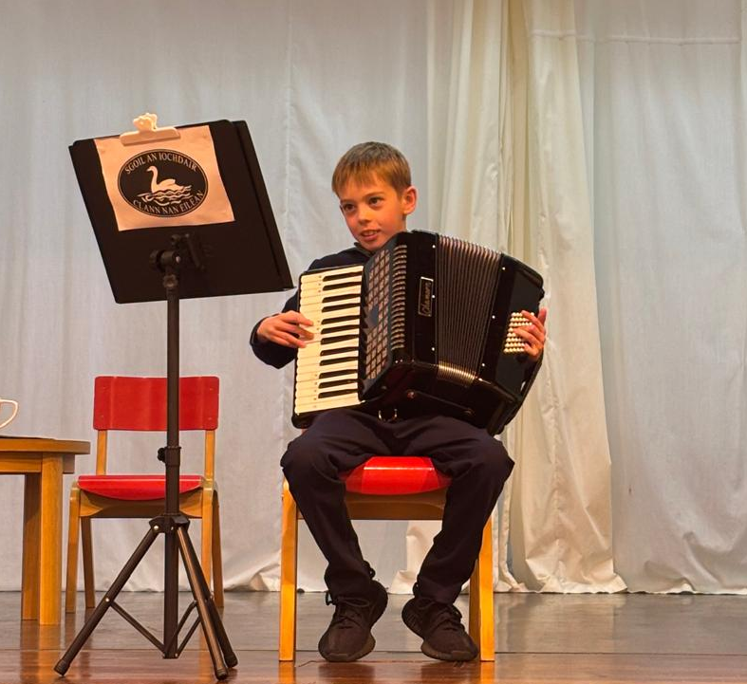
SECTION THREE – THE SCHOOL CURRICULUM
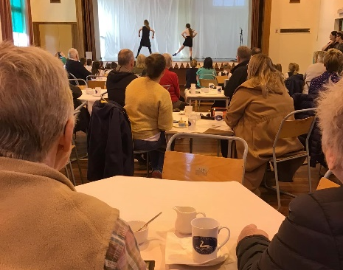
SCHOOL ETHOS
At Sgoil an Iochdair it is our aim to be a school community celebrated for its high quality learning experiences where everyone is valued, respected and included. We aim to raise standards by promoting and supporting the development of the whole child as a reflective learner within a caring, happy and purposeful environment.
We worked together with our pupils, parents and community in March 2023 to select our values:
Còir – Kind Earbsach – Trustworth Urramach – Respectful Dìcheallach – Diligent
Our vision and aims continue to be:
CÀNAN - Gaelic
- To enrich the Gaelic language inspiring all pupils, parents, school staff and partners to be proud of the language, working together to ensure it continues to develop and grow across the school community.
- To celebrate bilingualism, recognising and promoting the benefits that language learning can bring to our pupils, to our school, into sustained positive destinations beyond school, and ultimately impacting on our community as a whole.
CULTAR - Culture
- To celebrate and nurture the Gaelic language and island culture in all aspects of the school community, enriching our knowledge and awareness of our history and heritage.
- To instil a commitment to life-long learning, working in partnership with all stakeholders to provide ambitious learning experiences that equip learners with knowledge and skills for learning, life and work.
COIMHEARSNACHD - Community
- To promote a whole-school rights respecting ethos, expressing a commitment to respect, kindness and equality. This will in turn promote attainment and achievement.
- To enrich links with our parents and partners, including international partners, and value diversity and sustainability with consideration for our community, locally and globally.
CRUTHACHAILEACHD - Creativity
- To instil in each other courage and faith in our ability to learn innovatively, recognising and valuing creativity skills and creating opportunities for the transferring of these skills to new contexts.
- To nurture self-growth and identity by celebrating and acknowledging endeavours at home and in the community with particular focus on the opportunities being created by the expressive arts.
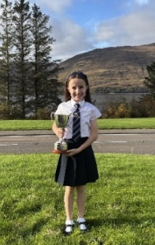


14 | Sgoil an Iochdair Handbook December 2025  Còir – Kind, Earbsach – Trustworthy, Urramach – Respectful, Dìcheallach - Diligent

Cànan, Cultar, Coimhearsnachd & Cruthachailleachd
CURRICUMUM OVERVIEW
At Sgoil an Iochdair, we aim to provide a curriculum that is both inclusive and ambitious for all – a curriculum which is both academically challenging and also provides opportunities to develop skills for learning, life and work. Our Curriculum Rationale is available on request.

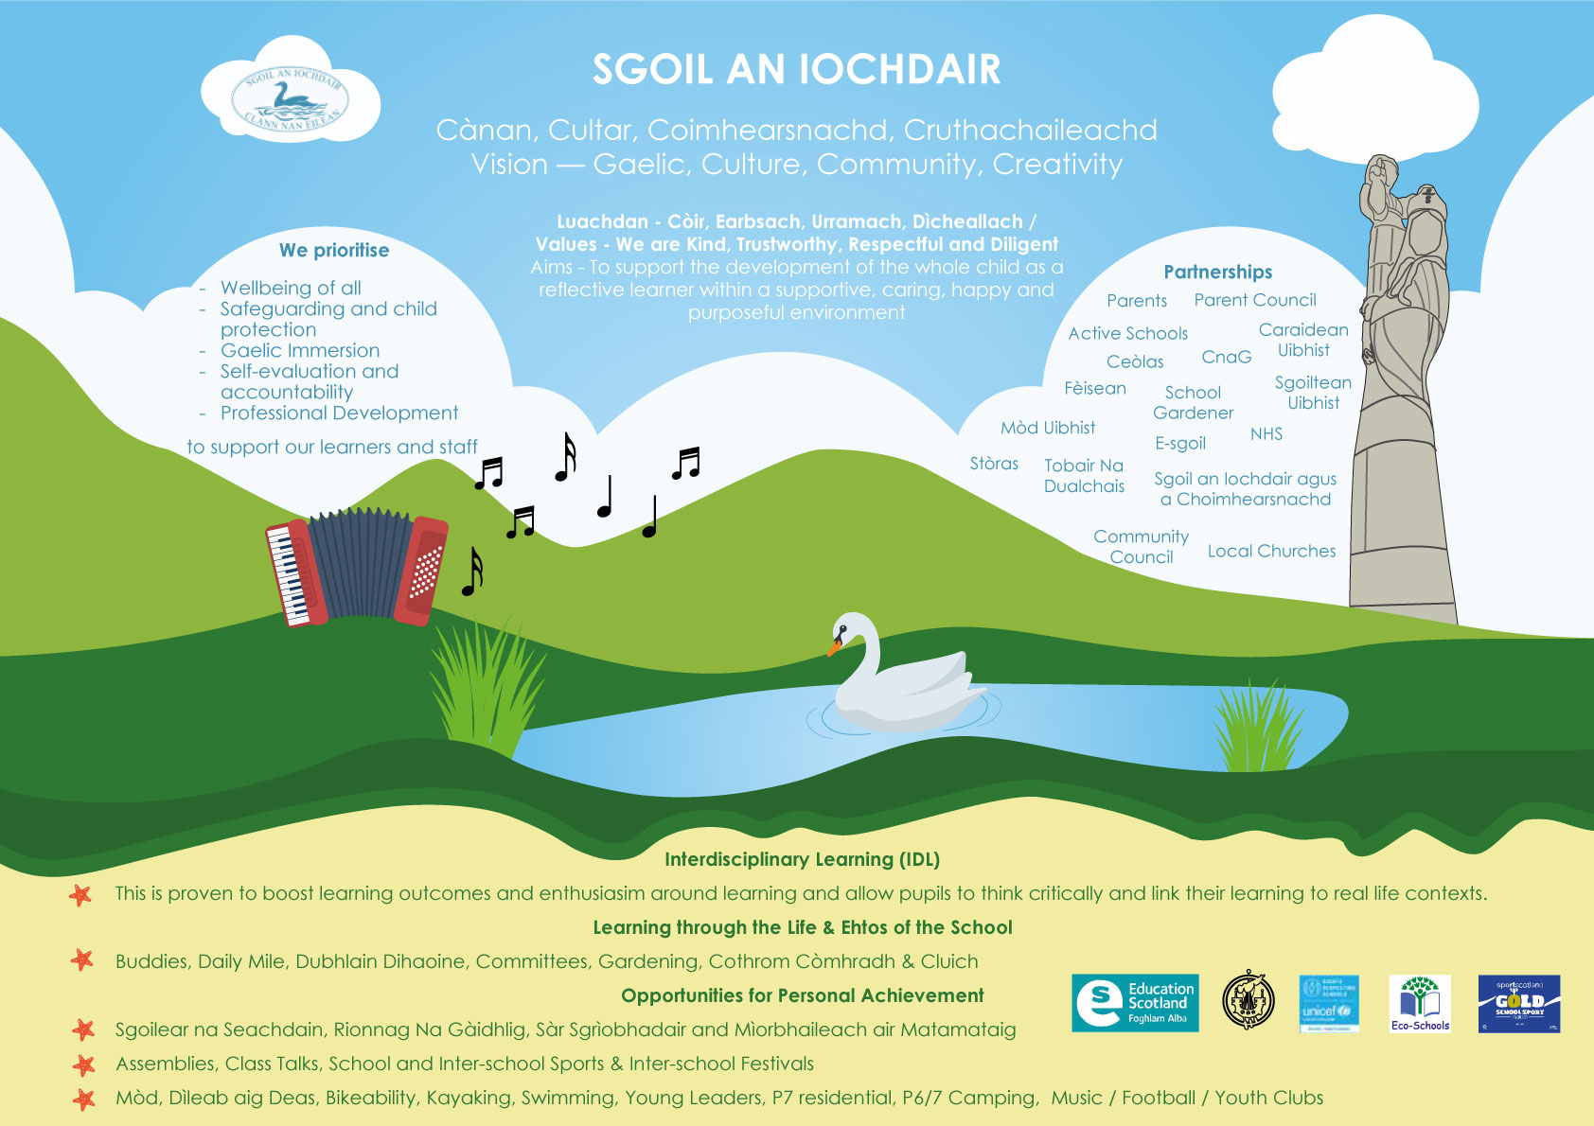#

Our curriculum is based around the four capacities of Curriculum for Excellence – to ensure our pupils are successful learners, confident individuals, effective contributors and responsible citizens. Our curriculum also reflects the principles of curriculum design to ensure breadth, depth, personalisation & choice, challenge & enjoyment, progression, coherence and relevance. We have a curriculum which we adapt continuously over time to meet the needs of our pupils.
Following the principles of Curriculum for Excellence, achievement of children and young people is celebrated in its broadest sense. This means looking beyond formally assessed learning, to recognise activities like volunteering and participation in arts, sports and community-based programmes. This approach complements the nurturing and aspirational outcomes of Getting It Right for Every Child, and our aim to overcome inequality by Raising Attainment for All, promoting Equity and Excellence in schools, and Closing the Gap.
- Literacy and English/Gàidhlig Language • Technologies
- Numeracy and Mathematics • Expressive Arts
- Health & Wellbeing • Religious and Moral Education
- Social Studies • Modern Languages
- Sciences
15 | Sgoil an Iochdair Handbook December 2025  Còir – Kind, Earbsach – Trustworthy, Urramach – Respectful, Dìcheallach - Diligent

Cànan, Cultar, Coimhearsnachd & Cruthachailleachd

FOGHLAM TRO MHEADHAN NA GÀIDHLIG/GAELIC MEDIUM EDUCATION
Gaelic Medium Education is an option within Scottish education that gives children and young people an opportunity to become fluent in Gaelic. As children and young people move from stage to stage, they will continue to develop their fluency. In so doing, they also fulfil all the aims and goals of Curriculum for Excellence and accrue all the benefits of bilingualism.
Education Scotland
GAELIC FIRST POLICY
Comhairle nan Eilean Siar operates a Gaelic First enrolment system where your child will be automatically enrolled in Gaelic Medium Education unless it is specifically requested to do otherwise. Currently, all of our children are enrolled in GME at P1. We want to see this continue in order that we both retain our language and provide all our children with the many benefits bilingual children gain through the acquisition of another language.
BUANNACHDAN DÀ-CHÀNANACHAS/THE ADVANTAGES OF BECOMING BILINGUAL
- Being bilingual helps children become more aware of language itself and how it works.
- Having two languages offers many career opportunities.
- They are better readers, and generally find it easier to learn other languages.
- Children in Gaelic medium education (GME) can be fluent in two languages with advantages learning other ones.
- Having two languages can access different literatures and more ways of thinking and acting.
- Gaelic bilinguals have a strong understanding of the wider Scottish cultural identity.
- Children exposed to different languages at an early age tend to be more focused at
‘multitasking’, than children who speak one language.
- Research shows that children educated through Gaelic are on par with or outperform children educated in one language.
Bòrd na Gàidhlig
Sgoil an Iochdair is a Gaelic Status School. (Gaelic Status achieved in 2015) and we have a Gaelic Immersion and Total Immersion policy available on request.
For further information on the benefits of GME please refer to: http://www.foghlamgaidhlig.com/pdf/Choose_Gaelic.pdf or email gaelic@cne- siar.gov.uk
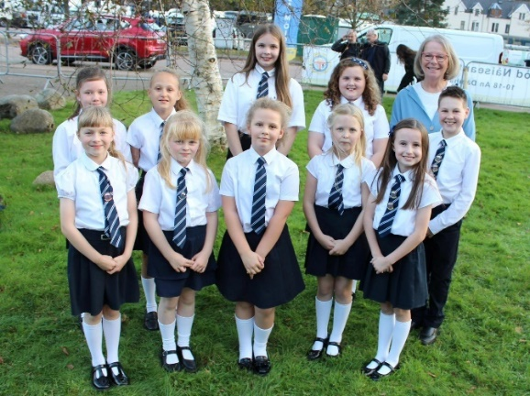
16 | Sgoil an Iochdair Handbook December 2025  Còir – Kind, Earbsach – Trustworthy, Urramach – Respectful, Dìcheallach - Diligent

Cànan, Cultar, Coimhearsnachd & Cruthachailleachd
EXPRESSIVE ARTS
Expressive Arts consists of art & design, drama, music and dance.
Learning in, through and about the expressive arts enables children and young people to:
- be creative and express themselves in different ways
- experience enjoyment and contribute to other people’s enjoyment through creative and expressive performance and presentation
- develop skills, and an appreciation of aesthetic and cultural values, identities and ideas
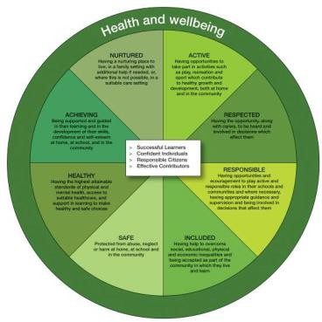
Building the Curriculum 1 [amended]
At Sgoil an Iochdair, teachers look for opportunities within their own teaching approaches for interdisciplinary learning and to foster partnerships with professional arts companies, local artists, creative adults and cultural organisations. Pupils will have the opportunity to participate in dance activities during the time allocated for P.E.
Music plays an important part in school life. Blocks of Gaelic Singing tuition are delivered to all classes through partnership with Fèisean nan Gaidheal and Mòd. Primary 5 – 7 receive instruction in either the Chanter or Fiddle through Youth Music Initiative. Whole school events such as our annual Christmas concert, Assemblies and Mòd are used to showcase the wealth of creative and musical talent we have in our school. Our school Music Club which at present offers accordion, guitar and button box lessons. As an inclusive school, all learners are encouraged to participate to the best of their ability.
HEALTH AND WELLBEING
Health and Wellbeing encompasses mental, emotional, social and physical wellbeing now and in the future. Many of these aspects are taught as discrete subjects but where and when appropriate subjects are delivered through interdisciplinary topics or as part of a general discussion as and when the need arises. Through life pupils will make choices which will affect their wellbeing. We aim to help them make informed choices relating to health and safety and discuss topics such as healthy eating, personal hygiene, personal safety and drug/alcohol awareness. Physical Education is included within this curricular area.
In Sgoil an Iochdair we work with partners to take a holistic approach to promoting the health and wellbeing of all learners, taking account of the United Nations Convention on the Rights of the Child and the Authority’s guidelines on Getting It Right for Every Child (GIRFEC). Relationships, Sexual Health and Parenthood (RSHP)is an important part of our programme and is taught in line with national and local guidelines. Parents are advised in advance of these lessons so that their permission can be sought. Parents wishing to withdraw their children from these lessons should send a letter to the Head of School indicating their wishes. Our RSHP framework and materials are available to view on our School Website.
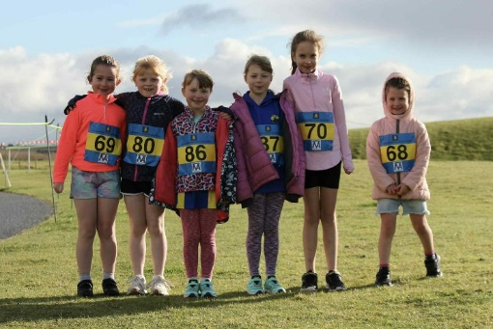
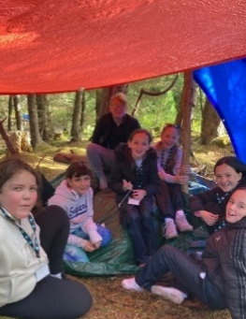
17 | Sgoil an Iochdair Handbook December 2025  Còir – Kind, Earbsach – Trustworthy, Urramach – Respectful, Dìcheallach - Diligent

Cànan, Cultar, Coimhearsnachd & Cruthachailleachd
LANGUAGE & LITERACY
Literacy and English/Gàidhlig
“Literacy is fundamental to all areas of learning, as it unlocks access to the wider curriculum. Being literate increases opportunities for the individual in all aspects of life, lays the foundations for lifelong learning and work, and contributes strongly to the development of all four capacities of Curriculum for Excellence.”
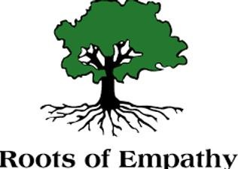
Literacy and English: Principles and Practice, CfE
The three organisers within the framework are:
 Listening and Talking Reading Writing
Learners experience an environment which is rich in language and which sets high expectations for literacy and use of language. Our school library, complimented by visits from the Mobile Library every three weeks, provide a wide variety of literature both fiction and non-fiction to enhance learning, develop language skills and enable learners to find enjoyment. Children are encouraged to read for pleasure both in school and at home. Parents are encouraged to take an interest in their child’s reading development.
GAELIC LEARNERS
At Sgoil an Iochdair we recognise that Gaelic is an integral part of Scotland’s heritage, national identity and current cultural life. We recognise that there is a need to ensure the sustainable development of Gaelic for the future and we are committed to;
- enhancing the status of Gaelic
- promoting the acquisition and learning of Gaelic
- encouraging the increased use of Gaelic

In primary 1-3 Gaelic words and phrases are developed through taking part in play activities and games linked to simple poems, familiar stories and short role plays. The grounding learners get from the embedding the language through routine, day-to-day exposure, coupled with discrete language lessons as learner’s progress through the primary stages ensures that the pace, challenge and ambition for their learning builds steadily from P1 onwards.
In Primary 4-7 pupils’ language learning is developed incrementally to the point where learners are able to take part effectively in conversations which involve sharing information about themselves and others using familiar vocabulary and basic language structures.
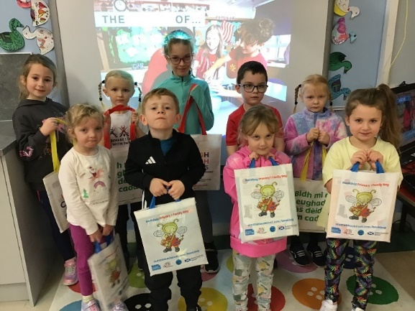
18 | Sgoil an Iochdair Handbook December 2025  Còir – Kind, Earbsach – Trustworthy, Urramach – Respectful, Dìcheallach - Diligent

Cànan, Cultar, Coimhearsnachd & Cruthachailleachd
GERMAN
“Learning other languages enables children and young people to make connections with different people and their cultures.” Education Scotland
In Sgoil an Iochdair we begin to learn German in Primary 5, 6 and 7. The pupils experience German as a discrete language lesson and include playing games, carrying out simple instructions, and role play where they can practice simple conversations.
We hope this gives them an introduction to another language in a fun and enjoyable way to help them to be enthusiastic, confident language learners from the outset.
NUMERACY AND MATHEMATICS
In Sgoil an Iochdair, Mathematics is delivered both as a discrete subject and through interdisciplinary learning.
A multi-sensory approach is used to introduce basic mathematical concepts e.g. rhymes and songs, use of concrete materials, active learning and visual aids. We continually reinforce the recall of number bonds, multiplication facts, place value and mental strategies through a range of imaginative and interactive approaches, including I.C.T, outdoor learning and peer coaching. Number processes and mathematical reasoning are addressed through learning activities which link to everyday experiences e.g. baking, shops and creating models.
Within a specific area of maths, we ensure key facts are given, integrated and applied to ‘real-life’ and imaginative contexts. From this, problems are solved, information is analysed and informed decisions on calculations are made. We recognise the importance of children being able to read and comprehend questions and therefore, use current material to address this. We challenge pupils, at an appropriate level and encourage progression and mathematical reasoning at an aspirational pace.
RELIGIOUS AND MORAL EDUCATION
The planning of learning and teaching in Religious and Moral Education values the diversity within our local community and beyond. Scotland is a diverse nation whose people hold a wide range of beliefs and none. Religious and moral education enables children and young people to explore the world’s major religions and to develop their own beliefs and values.
In Sgoil an Iochdair we divide into denominational groupings for the experiences and outcomes of Christianity from P4. Both Catholic and Multi-denominational Religious Education classes follow a 3-year rolling programme of study. We ensure that opportunities are provided for all pupils to discuss and develop their own beliefs and values by reflecting on different faiths and practices, contrasting these with celebrations and festivals the pupils participate in, and discussing what they have learned.
We draw on the resources of the community and context to inform our planning and teaching. Within practices and traditions, this is made explicit through visits to local places of worship as well as through festivals and celebrations. As well as class lessons, pupils attend regular religious assemblies led by our School Chaplains. Class led assemblies based on charitable or religious themes also occur throughout the year.
Catholic pupils undertake Sacramental preparations in their allocated RE class time; First Confession and Holy Communion in Primary 4 and Confirmation in Primary 7. The work for all three of the sacraments is completed in collaboration with the parish priest, parents and complimented by online classes organized by the diocese.
Please request in writing to the Head of School, if you wish to withdraw your child from RME or Religious Observance.
19 | Sgoil an Iochdair Handbook December 2025  Còir – Kind, Earbsach – Trustworthy, Urramach – Respectful, Dìcheallach - Diligent

Cànan, Cultar, Coimhearsnachd & Cruthachailleachd
WORLD RELIGIONS
World Religions can be taught discretely or, when appropriate, through interdisciplinary topics. Our 3 – year draft plan is currently being refreshed alongside the other Uist Primaries, lessons encourage pupils to explore the world’s major religions and views which are independent of religious belief and to consider the challenges posed by these beliefs and values. Pupils learn about the history, traditions, meanings and beliefs surrounding the major world religions.
Moral Education
Moral Education is covered through Christian and World Religion lessons as well as through the life of the school and committees.
SOCIAL STUDIES, SCIENCE AND TECHNOLOGIES
Social Studies, Science and Technologies are delivered through interdisciplinary (IDL) topics, or as a discrete subject.
Staff plan topics and learning experiences collaboratively. Pupils are involved throughout the planning process with their views taken account of and prior knowledge and understanding used to inform future planning. Learners and staff co-design 4 or 5 ‘Buan na Beachdan/Big Questions’ that will drive the experiences, activities and content of the context for learning.
Through these contexts for learning we encourage pupils to engage in activities which encourage an interest in their local environment, exploring the local community and providing an awareness of the world around them. Topics expand to the world out with our local community at upper stages and at infant level where appropriate.
Active Learning is embedded throughout topics and activities, making use of our strong community links, through regular visits out with our school, as well as regular visitors from the local and international community and work in partnership with organisations such as UHI, Taigh Chearsabhagh, Ceòlas and the Hebridean Whale and Dolphin Trust.
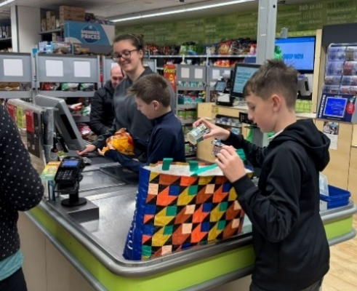
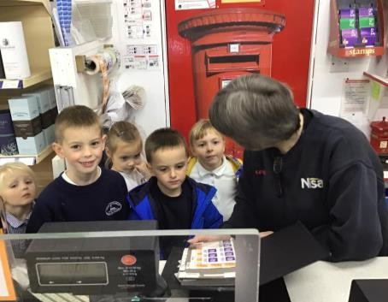
DEVELOPING THE YOUNG WORKFORCE
In Sgoil an Iochdair we plan using a 3-year curriculum draft plan covering a balance of Social Studies, Science and Technologies contexts and ready for the pupils to personalise. these three curricular areas offer a rich context for the development of all of the four capacities and for developing the life skills that are recognised as being important for success in the world of work.
Our Skills for Learning, Life and Work programme has been developed in partnership with local employers and focuses on higher order thinking skills and incorporates skills for learning, life and work. The aim is to support learners to aspire to a positive destination in the future, identifying their own skill set in relation to aspects of work. Pupils from Sgoil Lionacleit come for work experience placements as part of national qualifications.

20 | Sgoil an Iochdair Handbook December 2025  Còir – Kind, Earbsach – Trustworthy, Urramach – Respectful, Dìcheallach - Diligent

Cànan, Cultar, Coimhearsnachd & Cruthachailleachd
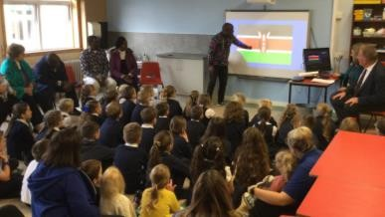
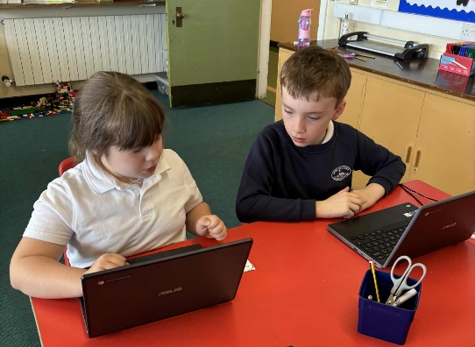
DIGITAL LITERACY AND E-SAFETY
We are committed to the use of Digital Learning and Technologies to develop and enhance the learning and teaching experiences of our pupils. Digital Technology is used to enhance and enrich teaching in all areas of the curriculum and keeping safe online is really important for us at Sgoil an Iochdair. We educate our children on the benefits, risks and responsibilities of using information technology and being responsible digital citizens. In collaboration with parents’, pupils and staff we have created a keep safe booklet on using the internet.
GLOBAL CITIZENSHIP
Teaching Citizenship helps children to understand their own, and others', rights and responsibilities, how society works and how they can play an active role. We aim to empower learners with the knowledge, understanding and skills to play an active part in society as informed and empathetic citizens who are socially and morally responsible.
A global dimension is evident in different lessons, adding a sense of relevance to topics and ensuring all learners are fully engaged. By focusing on global issues such as human rights, climate change and sustainability in a natural way, we improve pupils’ understanding of these key issues.
Pupils’ skills, for example enquiry, communication, participation and responsible action, are increased through learning about and becoming informed interested citizens. We are able to create links between children’s learning in the classroom and what is actually taking place in the school, the community and the wider world.
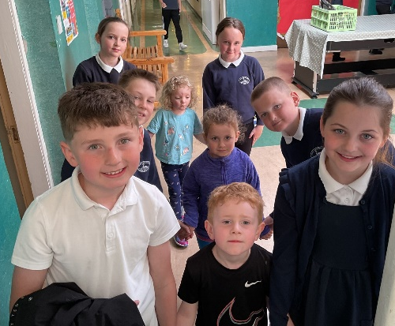
BUDDIES
The buddying system encourages younger children to use their ‘buddy’ as a source of support and information both in school and out in the playground. Our buddying system particularly supports our P1s as they join the school.

DÙBHLAIN DIHAOINE
Every child has the right to relax, play and take part in a wide range of cultural and artistic activities. (The UN Convention on the Rights of the Child, Article 31). In Sgoil an Iochdair, all pupils choose from a range of activities including Gardening, cooking, STEM, Digital Literacy, Sports, Art & Crafts etc. Pupils join together on Friday afternoons in their groups and learn new and interesting knowledge and skills through a range of fun, active sessions.

21 | Sgoil an Iochdair Handbook December 2025  Còir – Kind, Earbsach – Trustworthy, Urramach – Respectful, Dìcheallach - Diligent

SWIMMING ENTITLEMENT
Primary 4 participate in a block of 16 swimming sessions at Sgoil Lionacleit. These are held twice weekly. Transport is provided by the Comhairle.
ACTIVE SCHOOLS
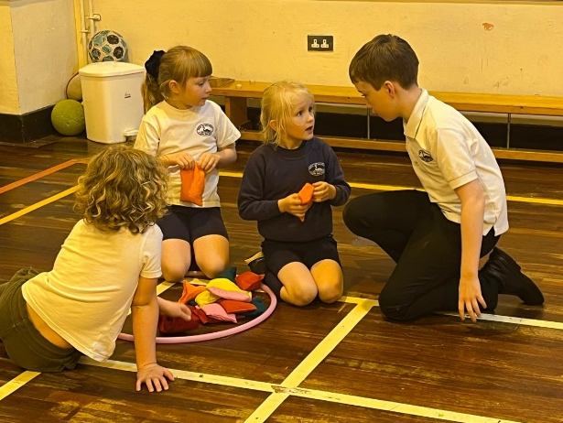
Active Schools work with schools and communities to help make sure children start active and stay active. The fundamental aim is to offer children and young people the opportunities and motivation to adopt active, healthy lifestyles, now and into adulthood. Our Active Schools Co-ordinator is Mrs Christine MacQuarrie, these are the activities that she supports
- Young Leaders Award (P6 & 7s), Bikeability Training (P6s),
- Inter-school festivals and workshops
- Supporting the sportscotland School Sport Award
- After School / Lunch Clubs (e.g. Sport Specific, Active)
- Transition Events (N-P1) (P7-S1) Inter-school events.

EXTRA-CURRICULAR ACTIVITIES
The pupils of Iochdar are involved in various activities. The Youth Club and Football club are organised by the Parent Council and we are delighted to have previous Sgoil an Iochdair pupils as our coaches again this year.
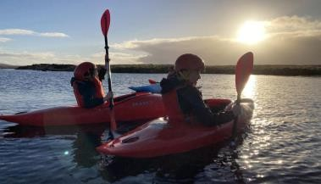
Participation in activities during school holidays is also encouraged e.g. Fèis, Royal National Mòd and Motiv8. The school supports pupils to participate in these events e.g. preparing them for their Mòd performances.
Pupils and their families are informed of different extra-curricular activities that take place in the local community through our website, groupcall and social media. Pupils’ interests and talents are recognised and celebrated in school through SeeSaw, Sgoilear na Seachdain and social media coverage.
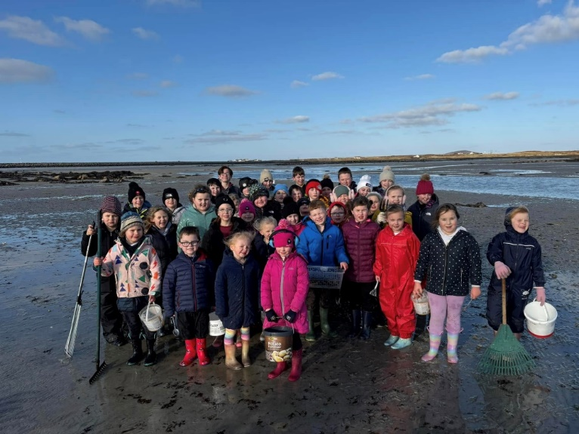

22 | Sgoil an Iochdair Handbook December 2025  Còir – Kind, Earbsach – Trustworthy, Urramach – Respectful, Dìcheallach - Diligent

Cànan, Cultar, Coimhearsnachd & Cruthachailleachd
ASSESSMENT AND REPORTING
Assessment is an integral part of learning and teaching. It helps to provide a picture of a pupil's progress and achievements and to identify next steps in learning. Staff use a wide range of approaches to assess development through Assessment is for Learning (AifL). Learners at all stages are also involved in planning and reflecting on their own learning, through formative approaches, self and peer assessment and personal learning planning/target setting. Our visual planning walls are also effective in engaging our learners and our pupils contribute to planning and reviewing their learning using the visual planning walls and SeeSaw.
Below is this session’s draft assessment calendar:
 | August  CT/SfL initial assessments & observations  Analysis of Data Report/Hub by staff |  | September  P1 Emerging Literacy Phonological Screening PEF Engagement updates | October  HWB Baseline (Whole school) Using GWWP
 | November  Transition reports (P1) P5 CAT Tests |  | December  P1 Emerging Literacy  Phonological Screening (re- assessment) | January  P1 Phonological Screening
 | February  P1, P4 & P7 Reading, Writing and Numeracy SNSA/MCNG (or earlier depending on teacher judgement) |  | March  P4 & P6 Reading (YARC) and Spelling (SWST) Tests | April  Pre-school tracking groups PEF Engagement updates
 | May  P1, 4, 7 Reading, Writing and Numeracy - ACEL Data  Transition reports & Development  Overviews (Nursery Pre-school) HWB Survey (Whole school) |  | June  Analysis and submission of CfE levels by staff
We collate results of these assessments and identify areas of strengths and needs for pupils. We use this information combined with information from termly tracking and monitoring meetings to inform future learning and teaching.
Reports on pupils’ progress are an important form of communication between home and school. Written school reports for each pupil (except for P1 pupils who will also receive their up-dated transition reports in November) will be issued to parents in June and a verbal report will be issued in November and March. The pupil progress report will contain:
- Comments on a child’s strengths and development needs
- Comments on personal and development needs
- An indication of a child’s level of attainment in each core area of the curriculum, as well as in Standardised Assessments, where appropriate.
A tracking system is in place for all pupils in Health and Wellbeing, Language and Mathematics. This is closely monitored through our planned Quality Assurance Procedures. Each child on entering the Sgoil Àraich has a Seesaw profile which follows each individual pupil to Primary Seven.
23 |  | Sgoil an Iochdair Handbook December 2025  Còir – Kind, Earbsach – Trustworthy, Urramach – Respectful, Dìcheallach - Diligent

Cànan, Cultar, Coimhearsnachd & Cruthachailleachd
PRIMARY SCHOOL ADMISSIONS
Children who will be four years of age by 28th February 2026 are eligible for enrolment in August 2026. Enrolment normally takes place at the beginning of February, on a date specified by press advertisement.
All parents and carers have the legal right to defer their child’s entry to primary school if they are not yet 5 years old at the beginning of the school year. All children who defer are automatically entitled to an additional year of funded early learning and childcare (ELC) and a deferral year plan is created to meet their needs,
Relevant information to help prepare the way for your child’s admission to school in August, is issued to parents on receipt of the completed enrolment form and parents are added to our mailing list to help establish links between home and school.
In all school enrolments, the Comhairle operates a Gaelic First Policy. This means that the default language stream for enrolment will be Gaelic Medium unless the choice is made during the enrolment process to opt for English Medium. Enrolment is now done online, with information such as medical, dietary or any other additional needs recorded and an indication of which faith they follow, if any.
Any parents wishing to enrol their child in the Sgoil Àraich or Primary School should contact the school to start the enrolment procedures. Once these have been completed they should accompany their child on their first day.
TRANSITIONS
Transitional arrangements are in place to ensure smooth transitions take place to and from Sgoil an Iochdair.
Transition to Sgoil-Àraich Pre School Education enrolment usually takes place in January on a date notified to parents by local press advertisement. Children aged 2½ can be enrolled at the group if there is sufficient space and that their birthday falls before the 28th of February of the current academic year. If demand for places outweighs supply, priority will be given to children eligible for their pre-school funded place. Children securing a funded place are entitled to 1140 hours for the year. Children who enrol in the Sgoil Àraich will be invited in to experience a little of the atmosphere and to meet the staff as part of a settling in period. Further details are available within the Sgoil Àraich handbook.
Transition from Sgoil-Àraich/ Nursery to Primary Before leaving sgoil àraich, a development overview and transition record for each child will be prepared by staff to hand over to parents and Primary School staff to ensure a smooth transition and continuity of education for the child transferring to Primary. The children will participate in a number of planned transitional activities with the school to ensure a smooth transition is experienced by all and the children’s individual needs are met appropriately. If a child requires an enhanced transition, this is planned early and in partnership with parents and those working with the child to ensure the transition plan supports the child transferring to school.
Transition from Primary to Secondary
When pupils complete Primary 7 they normally transfer to Sgoil Lionacleit, Isle of Benbecula. The contact details for the school are as follows: Head Teacher - Mr Gordon Young. Telephone - 01870 604690.
All progress reports, etc. are transferred by the end of the summer term, prior to admission to Sgoil Lionacleit. We also have meetings with key staff prior to transfer. During Primary 7, pupils take part in a variety of planned transitional activities to get to know their peers and new routines. A P7 Transition Calendar for the academic school year is prepared with collaboration from all cluster schools. If a pupil requires an enhanced transition, this is planned in partnership with parents and those working with the child to ensure the transition from primary to secondary is successful.

24 | Sgoil an Iochdair Handbook December 2025  Còir – Kind, Earbsach – Trustworthy, Urramach – Respectful, Dìcheallach - Diligent

Cànan, Cultar, Coimhearsnachd & Cruthachailleachd
Transferring Schools
Please give us as much notice as you possibly can when transferring to other schools so staff can prepare transfer reports. It is also helpful to leave a forwarding address as personal items sometimes come to light after the pupil has left.
PLACING REQUESTS
As a parent, you have the right to make a Placing Request to be educated in a school other than the local school. Every effort will be made to try to meet parental wishes but you should note that it is not always possible to grant every Placing Request to a particular school.
If you wish to make a Placing Request, you should complete the appropriate form (available from school) and return it to Louise Smith, Principal Officer, Education and Children’s Services, Comhairle nan Eilean Siar, Sandwick Road, Stornoway HS1 2BW. If a Placing Request is successful, parents will be responsible for the safety and transportation costs of their child to and from their chosen school.
25 | Sgoil an Iochdair Handbook December 2025  Còir – Kind, Earbsach – Trustworthy, Urramach – Respectful, Dìcheallach - Diligent

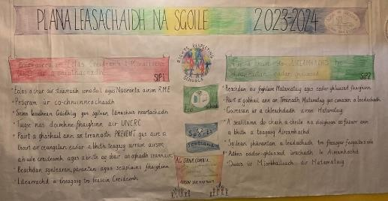
Cànan, Cultar, Coimhearsnachd & Cruthachailleachd
SECTION FIVE – SCHOOL IMPROVEMENT

Standard & Quality Report
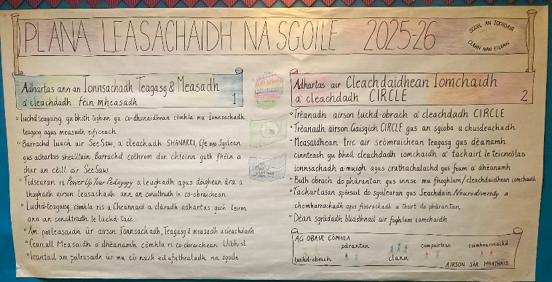
A copy of our Standards and Quality Report which highlights the school’s major achievements in the previous year is available from our school office and on our website.
School Improvement Plan 2025-26
From our self-evaluation, we have identified two projects that will improve the learning experiences of all pupils. A full copy of our School Improvement Plan is also available from our school office or on our website.

SIP 1 Adhartas ann an Ionnsachadh, Teagaisg agus Measaidhean – Using Self Evaluation to improve Learning, Teaching and Assessment

- Luchd-teagaisg gu bhith tighinn gu co-dhunaidhean còmhla mu ionnsachadh, teagasg agus measadh eificeach. Staff to develop a shared understanding of high-quality learning, teaching and assessment.
- Luchd-obrach gu bhith a' cur eòlas air am Frèam-obrach leasachaidh càileachd airson roinnean ionnsachaidh tràth agus cùram-chloinne agus a' cleachdadh sgèile bho mì-riarachail gu sàr-mhath. Staff will become familiar with the new Quality improvement framework for the early learning and childcare sectors and self-assess using the 6-point scale from unsatisfactory to excellent.
- Luchd-teagaisg a’ cleachdadh fèin mheasadh airson na prìomh puingean airson adhartas aithneachadh. Whole staff team to use self-evaluation using the new Quality improvement framework for the early learning and childcare sectors and How Good is Our School HGIOS 4 QI 2.3 Learning, Teaching and Assessment to identify key priorities/ focus for improvement.
- Barrachd luach air SeeSaw a’ cleachdadh SHANARRI neo Sgilean gus adhartas a shealltainn. Barrachd cothrom don chloinn an guth fhèin a chur an cèill air Seesaw.
Increase evaluative learning Journal entries for individual children including next steps. Ensuring learning recorded on SeeSaw links to Education Scotland's curriculum for excellence or SHANARRI or MetaSkills and demonstrates progress. Increasing the children’s participation within their learning log, and target setting UNCRC 29.
- Tidsearan ri Power Up Your Pedagogy a leughadh, agus doighean ùra a thaghadh airson ionnsachadh teagasg agus measadh a leasachadh le conaltradh le co-obraichean ann am Baile a’ Mhanaich.
Teachers to read Power Up Your Pedagogy, choosing and trying new strategies to improve learning, teaching and assessment in collaboration with colleagues at Balivanich.
- Luchd-teagaisg, còmhla ris a Cheannard a claradh adhartas gach teirm ann an conaltradh le luchd taic.
Staff alongside Head of School, to input into new digital tracking document each term, in consultation with support staff.
- Luchd obrach na sgoile air fad a’ cleachdadh am poileasaidh ùr airson ionnsachadh, teagaisg agus measadh.
Whole staff team to engage in full implementation of the CnES Learning, Teaching and Assessment Policy across the school / setting to ensure consistency in standards.
- Luchd obrach a’ tighinn còmhla airson cearcall measaidh a dhèanamh.
All practitioners to use the Moderation Cycle to develop a shared understanding of standards and expectations, alongside cluster and secondary colleagues.
- Cumail sùil gheur air cò tha frithealadh na sgoile agus cò nach eil agus a’ leantail am poileasaidh ùr.
Head of School to track attendance and ensure policy is followed to respond appropriately to concerns over attenance.

SIP 2 Adhartas air cleachdaidhean Iomchaidh – Improve Inclusive Practice

- Treànadh airson Luchd – Obrach a’ cleahdadh CIRCLE.
Deliver CIRCLE Framework CPD training.
- Trèanadh do Gaisgich CIRCLE gus an sgioba luchd-taic a chuideachadh le cleachdaidhean iomchaidh.
Train ‘CIRCLE Champions’ to support colleagues with inclusive practice.
- Measaidhean tric air seòmraichean-teagasg gus dèanamh cinnteach gu bheil cleachdadh iomchaidh a’ tachairt le teicneòlas, ionnsachadh a-muigh agus cruthachalachd, gus feum a dhèanamh dhan neach ionnsachaidh.
Implement structured use of CIRCLE Inclusive Classroom Scale (CICS) regularly to assess classroom environment inclusivity. Considering the use of digital technology, outdoor learning and creativity/innovation to meet need.
- Bùth-obrach do phàrantan gus innse mu fhoghlam / cleachdaidhean iomchaidh.
Deliver inclusive education family engagement workshop and distribute guidance materials.
- Tachartasan spòrsail do sgoilearan gus Seachdain Neurodiversity a chomharrachadh agus fiosrachadh a thoirt do phàrantan.
Celebrate Neurodiversity Week with an assembly, open afternoon and events.
- Dèan sgrùdadh bliadhnail air foghlam iomchaidh a’ cleachdadh innealan CIRCLE agus cruthaich planaichean leasachaidh air na toraidhean.
Conduct an annual whole-school inclusion audit using the CIRCLE tools and create improvement plans based on results.

26 | Sgoil an Iochdair Handbook December 2025  Còir – Kind, Earbsach – Trustworthy, Urramach – Respectful, Dìcheallach - Diligent

Cànan, Cultar, Coimhearsnachd & Cruthachailleachd
SECTION SIX-ADDITIONAL INFORMATION
Education Statistics Privacy Notice
Transferring Educational Data About Pupils
The Scottish Government and its partners collect and use information about pupils in schools (e.g. the number and characteristics of pupils, their attendance, absence and exclusions, their attainment and their destination when leaving school) to help to improve education across Scotland. This note explains why we need this information, how we use it and what we do to protect the information supplied to us.
Why do we need your data?
In order to make the best decisions about how to improve our education service, Scottish Government, education authorities and other partners such as the SQA and Skills Development Scotland need accurate, up-to-date data about our pupils. We are keen to help all our pupils do well in all aspects of school life and achieve better examination results. Accurate and up-to-date data allows us to:
- plan and deliver better policies for the benefit of all pupils
- plan and deliver better policies for the benefit of specific groups of pupils
- better understanding of some of the factors which influence pupil attainment and achievement
- share good practice
- target resources better
- enhance the quality of research to improve the lives of young people in Scotland

Data policy
Information about pupils’ education is collected through our statistical surveys in partnership between the Scottish Government and Local Authorities through the ScotXed Programme which aims to help schools and Local Authorities by supporting efficient collection, processing and dissemination of statistical information. The Scottish Government then provides analysis of the data to support research, planning, management and monitoring of education services as well as to produce National Statistics publications.
Education data within Scottish Government is managed effectively by secure systems and is exploited as a valuable corporate resource, subject to confidentiality restraints. As part of its data policy, Scottish Government will not publish or make publicly available any information that allows individual pupils to be identified, nor will data be used by Scottish Government to take any actions in respect of individuals. Data is held securely and no information on individual pupils can or would be made publicly available by Scottish Government.
The individual data about pupils in schools collected by Scottish Government through statistical surveys is used only for the statistical and research purposes for which it is collected.
27 | Sgoil an Iochdair Handbook December 2025  Còir – Kind, Earbsach – Trustworthy, Urramach – Respectful, Dìcheallach - Diligent

Cànan, Cultar, Coimhearsnachd & Cruthachailleachd
Your data protection rights
The collection, transfer, processing and sharing of ScotXed data is done in accordance with the Data Protection Act (1998). We also comply with the National Statistics Code of Practice requirements and other legislation related to safeguarding the confidentiality of data. The Data Protection Act gives you the right to know how we will use your data. This note can give only a brief description of how we use data. Fuller details of each individual ScotXed survey, including the purpose of each and the published data, can be found on the ScotXed website (http://www.gov.scot/Topics/Statistics/ScotXed). Pupil names and addresses (other than postcode) are never collected in any ScotXed statistical survey.
Scottish Government works with a range of partners including Education Scotland, Skills Development Scotland and the SQA. On occasion, in order to help meet our aim of improving the life of young people in Scotland, we may make individual data available to partners such as the National Registers of Scotland to carry out research relating to the national population census and also to academic institutions and organisations to carry out additional research and statistical analysis which helps inform policy development and contributes to improving outcomes for Scotland’s people. In order to carry out this research to support better decisions, policy making and practice, data may be linked to information from other sources.
Any sharing or linkage of data will be done under the strict control of Scottish Government, and will be consistent with our data policy and the National Data Linkage Guiding Principles. This will ensure that no individual level data will be made public as a result of the data sharing and that these data will not be used to take any actions in respect of an individual. Decisions on the sharing or linkage of data will be taken in consultation with relevant colleagues and individuals within and out with Scottish Government. At all times pupils’ rights under the Data Protection Act and other relevant legislation will be ensured.
Concerns
If you have any concerns about the ScotXed data collections you can email the Head of Schools Analysis, Mick Wilson, at mick.wilson@scotland.gsi.gov.uk or write to Education Analytical Services, Area 2D, Victoria Quay, Leith, EH6 6QQ.
Further details about ScotXed data exchanges are available on the ScotXed website, www.scotxed.net
28 | Sgoil an Iochdair Handbook December 2025  Còir – Kind, Earbsach – Trustworthy, Urramach – Respectful, Dìcheallach - Diligent

Cànan, Cultar, Coimhearsnachd & Cruthachailleachd
PHOTOGRAPHING or FILMING PUPILS on SCHOOL PREMISES
Pupils may be filmed or photographed on school premises for a variety of reasons including recording of curricular activities or events such as school performances. The photographs or films may or may not be accompanied by details about the pupil such as name, age, year group or general home location.
Where filming of pupils under Minimum School Leaving Age is taking place through a media company, that company must already obtain the permission of the pupil’s parent or guardian under Performance Licensing legislation. Having regard to Data Protection, Child Protection principles and the basic principle of parental consent to activities relating to their children, it has now been agreed that any official photographing or filming of children where the images might be for public consumption (i.e. media, website or official school videos) should only take place in school premises or grounds with the prior written consent of parents.
This policy relates to official school photos or filming or official requests made to the school. You will recognise that there are certain situations which might in practice be out-with the school’s control (e.g. another parent inadvertently capturing an image of your child at a school sports day.) If you have specific concerns about this, you should discuss these with your child’s school.
To ensure that your child’ school has the optimum flexibility to allow filming which you would support; we are seeking your views on such activities in advance of their taking place. You have the options of:
- Agreeing to photographs of your child appearing in any publication or form (i.e. on the school internet site) approved by the Head Teacher;
- Not agreeing to photographs or film of your child appearing in any form;
- Agreeing to photographs or film of your child being used only in certain ways (which you can specify)
- Advising the school whether you are happy for school-approved information about your child to accompany any photographs or film – or whether you wish to restrict it.
Once completed, your preferences will be retained in your child’s school file and will remain in force (transferring between schools as appropriate) until you revoke it. If you wish to change your mind at any time, complete a new form, indicating your revised preference.
29 | Sgoil an Iochdair Handbook December 2024  Còir – Kind, Earbsach – Trustworthy, Urramach – Respectful, Dìcheallach - Diligent

 |  | NW1  Rev 08/24
 | Notification of Short-Term Withdrawal of Children from School
Please read the notes overleaf before completing and submitting this form
1. Pupil Information
Name of Child/ren | Class | Date of Birth
2. Dates of Withdrawal (Inclusive) and Duration
From: | DD | MM | YYYY | To: | DD | MM | YYYY |  | Number of school days
3. Reason for Absence (please tick):
Family Holiday or Occasion Sport, Music or Cultural Event Off-Island Medical Other
Additional information to support the withdrawal of your child(ren) during term-time
Parent/Carer Signature: |  | Date:

4. FOR SCHOOL USE ONLY
This absence will be recorded in SEEMiS as: AUTHORISED UNAUTHORISED ABSENCE CODE
For the duration of this absence, will schoolwork be provided? YES NO
School Authorising Signatory: Date:

----------------------------------------------------------------------------------------------------------------------------------------------------------------------------------------------------------
ACKNOWLEDGEMENT OF NOTITICATION OF SHORT-TERM WITHDRAWAL
I acknowledge receipt of your notice to withdraw your child(ren) from school as detailed below:
Pupil Names:
From: | DD |  | MM | YYYY | To: | DD | MM | YYYY |  | Absence  Category: | Authorised |  | CODE
 |  |  |  |  |  |  |  |  |  |  | Unauthorised |  | CODE
For the duration of this absence, will schoolwork be provided? YES NO

Head Teacher’s Signature: Date:
Notification of Short-Term Withdrawal of Children from School
GUIDANCE NOTES
- Comhairle nan Eilean Siar aims to promote good attendance by all pupils throughout the year. Absence from school, whatever the cause, disrupts learning and will have a detrimental effect on attainment. Whilst we strongly discourage the withdrawal of pupils during term-time, we do appreciate that there can be occasions where it is necessary to do so for short periods and pupil attendance at certain events provide opportunities for wider achievement beyond the school.
- Schools monitor the attendance of all pupils regularly and further investigation takes place when a pupil’s attendance falls below 90% or there are notable patters of absence or lateness. It is, therefore, important that all reasons for absence are notified to the school timeously.
- This form is to be used when you are aware in advance of a need to withdraw your child(ren) from school, which it is your right to do for a short notified period. It does not constitute consent from the school for the withdrawal but provides us with a record of the notification to withdraw. The school’s response is an acknowledgement of your notification to us of your intentions.
- It is important that all parts of the form are completed and that it is submitted to the school office prior to the withdrawal taking place.
- Following submission of the form, the school will evaluate the information you’ve provided and make a decision about whether the absence will be categorised as authorised or unauthorised using the ‘Attendance in Scottish Schools’ guidance. This refers to how the absence is documented in the school attendance database and does not relate in any way to the school granting consent or not for the withdrawal.
- All authorised and unauthorised absence categories deduct from a child’s attendance percentage so, whatever the nature of the withdrawal, it will result in an absence being recorded.
- The decision about the categorisation of the absence is the responsibility of the headteacher based on their interpretation of the available guidance at the time of receipt of the request.
Authorised Absences
Reason for Absence | Code
Medical or dental appointments (Whole day or more) | MED
Matters relating to court, Children’s Hearings or Case Reviews | ABS
Acts of Religious Observance | ABS
Family Bereavement | DCA
Weddings or funerals of close family | PHL
Arranged absence relating to traveller families | DCA
Participation in non-school sporting, musical, drama, debating or cultural activities | ABS
Lack of transport due to bad weather | ABS
Exceptional domestic circumstances | DCA
Family holidays agreed by the school in exceptional circumstances | PHL
Unauthorised Absences
Reason for Absence | Code
Family holidays in almost all circumstances | UPH
Parent-condoned absence with-out satisfactory reason | UNA
During disputes resulting from a pupil exclusion | OUA
Domestic circumstances (not exceptional) | DCU
All other absences where a relevant explanation is not provided | OUA

Authorised Absences | Code |  | Unauthorised Absences | Code
Medical or dental appointments (Whole Day) | MED |  | Family holidays in almost all circumstances | UPH
Court, Children’s Hearings or Case Reviews | ABS |  | Parent-condoned absence with-out satisfactory reason | UNA
Acts of Religious Observance | ABS |  | Parent-condoned absence with-out satisfactory reason | UNA
Family Bereavement | DCA |  | Disputes resulting from an exclusion | OUA
Weddings or funerals of close family | PHL |  | Domestic circumstances (not exceptional) | DCU
Arranged absence relating to traveller families | DCA |  | All other absences where a relevant explanation is not provided | OUA
Non-school sporting, musical, drama, debating or cultural | ABS |  |  | OUA
Lack of transport due to bad weather | ABS
Exceptional domestic circumstances | DCA
Family holidays in exceptional circumstances | PHL

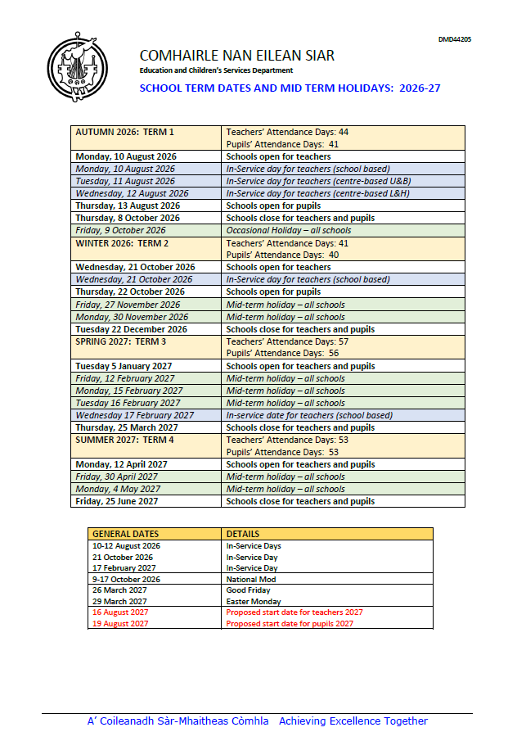
Comhairle nan Eilean
Education and Children’s Services Department
PARENTAL REQUEST FOR ADMINISTRATION OF PRESCRIBED MEDICINES
To: Head Teacher School
I wish my child……………………………………………(name) (date of
birth)
to have the following medicine administered by school staff as indicated until
… (date of completion)
Name of medicine ……………………..............................................................................................
Reason for taking medicine ………………………………………………………………………………
……………………………………………………………........................
This medicine prescribed by self/doctor (delete as appropriate)
Time(s) at which to be given ……………………………………………………………………………
Dosage (and means of administration if applicable)
…………………………………………………………………………………………………………………
…………………………………………………………………………………………………………………
I undertake to deliver the medicine personally to you, to replace it whenever necessary, and to dispose of any unused medicine after completion of the course. I also undertake to advise you immediately of any change of treatment.
Signed …………………………………………………………………………………………….. Name …………………………………………………………………………………………………
(BLOCK CAPITALS)
Date …………………………………………………………………………………………………

Sgoil an Iochdair UNIFORM PRICE LIST
 | Item | Size | Price Each
 | Sweatshirt | 3/4, 5/6, | £11.50
 |  | 7/8, 9/10, 11-13 | £12.00
 |  | S & M | £13.00
 | T-shirt | 3/4, 5/6, | £5.75
 | *white/navy blue | 7/8, 9/10, 11-13, | £6.00
 |  | S, M | £6.50
 | Cardigan | 3/4, 5/6, | £12.50
 |  | 7/8, 9/10, 11-13 | £13.00
 |  | S, M | £13.50
 | Polo shirt – | 3/4, 5/6, | £9.00
 | *white/navy blue | 7/8, 9/10, 11-13 | £9.50
 |  | S, M | £10.50
 | Fleece | 3 /4, 5/6  7/8, 9/10, 11-13  S,M | £15.00  £16.50  £19.00
 | School Tie  School Backpack |  | £4.50  £18.00
All items are navy blue unless otherwise stated. All items are embroidered with the School Logo.
Please contact the school office to purchase

Sgoil an Iochdair Net rules for Responsible Internet Use These rules help us to be fair to others and keep everyone safe.
- I will ask permission before using the Internet.
- I will use only my own network login and password, which is not shared with others.
- I will not delete or look at others people’s files without permission.
- I will only email people I know, or my teacher has approved.
- The messages I send will be polite and sensible.
- I understand that I must never give my home address or phone number, or arrange to meet someone.
- I will ask for permission before opening an email or an email attachment sent by someone I do not know.
- If I see anything I am unhappy with or I receive messages I do not like, I will tell a teacher immediately.

Remember it is not your fault if you get a message like this.

- I understand that the school may check my computer files and the Internet sites I visit.
- I understand that if I deliberately break these rules, I may not be allowed to use the Internet or computers.

Sgoil an Iochdair E-Safety Group

