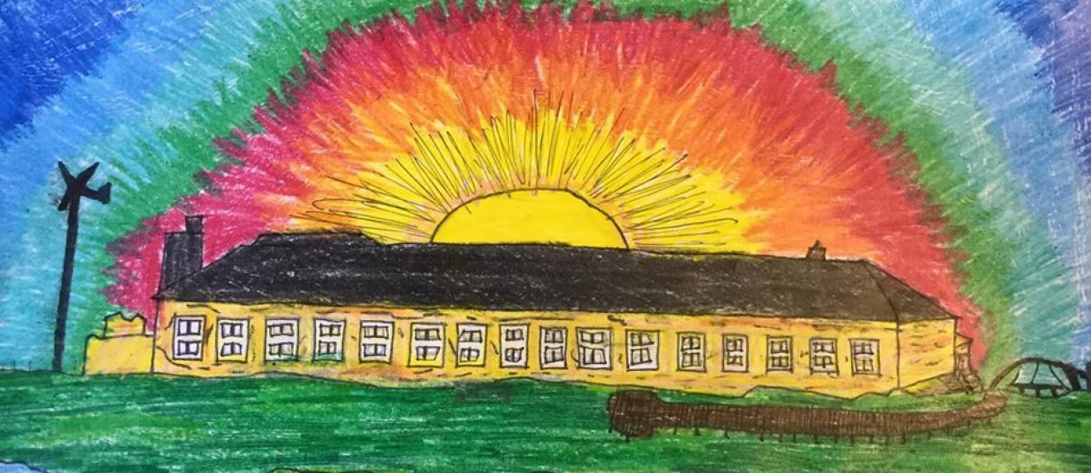

**Sgoil an Iochdair Parent Council**

**19:00hrs Thursday 7th November 2024 @ Sgoil an Iochdair**

**Minutes**

**Present:**

**Mel MacDonald-Butler, Martin Butler, Joan MacDonald, Margaret Campbell, Bellina Currie, Phillipa Rewaj, Iain McKinnon**

|  |  |
| --- | --- |
| * **School Improvement Projects** | * **Action** |
| **Learning for Sustainability**: <https://education.gov.scot/resource-themes/learning-for-sustainability/> Sgoil an Iochdair to feature. Plan for open afternoon to link into WI COP. Want to encourage parents to share skills/occupations, visits to local businesses. Gardening – no gardener at present.  Funding for Sue ended and not renewed. Sue may still be willing if we can find funding. Crown estate previously funded.  Looking into outdoor school/garden shelter/gazebo as part of project.  Outdoor/wet weather gear needing replaced – Ann found jackets and trousers for £12.95 from Amazon. x38 (just for P1-7 as Sgoil Araich recently had new suits donated) £492.10.  Staff considering more sustainable Christmas gifts - card games, jigsaws, stationary | Parents to be encouraged to share skills / occupations  Joan to order 1 suit initially to check for quality |
| **Digital literacy project**: Open afternoon held 9th October focusing on digital literacy. Looking for feedback from parents.  CYPIC Children and Young People Improvement Collaborative (<https://cypic.co.uk/>) – Quality Improvement method using data to improve children’s writing P2-7, involving children in process. Over 12 weeks, focus on particular target areas. | Parents encouraged to share their views of the open afternoon / digital literacy |
| * **Treasurer’s update**   £400 from summer grant and £450 from WI Development Trust to be split between Youth Club and Football club. Possibility for in between Christmas event or post Christmas event for pupils.  £3884.23 in account currently. | Bellina to ask community council for money for selection packs for Christmas. |
| * **Handbook**   Updates to handbook – needs to be on website by 8th December. Minor changes to current version, planned. Current version can be accessed on the school website.  **https://blogs.glowscotland.org.uk/es/sgoilaniochdaireileansiar/parantan-parents/school-handbook/** | Parents welcome to make suggestions by end of November |
| * **Health & Wellbeing Surveys**   SHANARRI used for last few years – found may not be specific to school. Glasgow motivation and wellbeing profile to be used this academic year – score 1-10. More specific questions relating to school – asked twice a year – Oct/Nov and then again towards end of school year. More info:  https://www.youtube.com/watch?v=U3jcWPagdqU&list=PL1QkjbMXB-egY_oxcW5WZKrM1fskGoNKo&index=3 | More info to be shared at Parents Night |
| * **Playpark/Ball Park/Hall**   Visit from Mr Iain G Smith from Education Department in Council – Mel MacDonald-Butler, Anne Bird, Harry Luney present. He wants us to see some action – offering to give £5k from funds council holding for us for any remedial repairs we would like to do. Hoping beginning of year council will put out to tender for works. | Pupil Council to do some kind of campaign to raise awareness and bring issue more attention? |
| Iochdair Saints FC would like to use the cage for training – needs a different surface. Request needs to go in for building permission to local office before it can happen. Children concerned that they might not be able to use for basketball going forward – been reassured this will be ok for needs.  Bike stands need to be installed provided by Iochdair Community Council (pathway improvement). Hoping this might be end of November. Thanks also to Iochdair Community Council for the picnic benches.  Looking to improve music and theatre - Improve sound system, acoustics and lighting in hall. Cultural/arts funding set aside to do this. | Joan to complete a request for building work.  Joan to contact Multi-Media Dept re spec.  Joan to chase maintenance in council about the leak in entrance hall and painting building. |
| * **Child Protection Training (Clubs)**   Training to be held on Wednesday 13th November at 6pm and 6:30pm for parent helpers / volunteers |  |
| * **Fundraising for Trips/Equipment/Christmas/Mod**   Bingo in new year (7th February TBC) for general school funds, P7 selling hampers at Iochdair Christmas market, Bag packing, Car wash and teas **1st March** – all for P7 residential trip to Fairburn. FES have offered funding to pay for mainland bus for P7 trip.  National Mod funding this year from several funds – EDF / Benbecula & Iochdar Community Councils and councilors ward funding, to help contribute towards travel and accommodation costs, incidental items etc. Some funds yet to be paid in. Plans started to return choir to National Mod next year - consider what we want to do for funding next year rather than seeking grants from various organisations – fundraising activity? | 100 club – Martin to look into setting up  AnnMarie Johnson to be approached to support the Bingo. |
| * **AOB**   Noted that a number of parents not currently in closed Facebook Parent Council group – all parents to be encouraged to join.  Outdoor lighting – noted that school doesn’t seem as well lit at night this year – check lighting, ?additional lighting.  Quality Assurance (QA) visit today – Sarah Jane MacSween ExHT, Kirsty Brennan Balivanich HT, Dianne Morrison Acting SUAT HT and Alina Simpson from Sgoil Uibhist a Tuath’s Sgoil Araich. Each Uist cluster school to get a similar visit this session. Visit went well across the school. They were particularly impressed with the pupils independence, and their use of digital literacy, using the new Chrome Books up the school. | Joan to share info on the school Facebook page and via email.  Joan to inquire re lighting. |
| **Date of next meeting**  **23rd January 7pm** | |