

*Roinn an Fhoghlaim is Seirbheisean Chloinne*



**SGOIL SIR E SCOTT**

**SIR E SCOTT SCHOOL**

**Aithisg Ìre de Mhathas 2019-20**

**Plana Leasachaidh na Sgoile 2020-21**

**Standards & Quality Report 2019-20**

**School Improvement Plan 2020-21**

**(SQIP)**

**Combined**

**Standards & Quality Report for 2019-20**

**and School Improvement Plan 2020-21**

**(SQIP)**

Contents

**1. The Context of the School 3**

* 1. The school and its community
  2. Our vision, values, aims and curriculum Rationale
  3. Summary of progress towards improvement

**2. Standards & Quality Report for 2019-20 8**

2.1 Our progress towards achieving NIF Priorities

2.2 How successful were our improvements?

2.3 What progress have we made?

2.4 Outcome of external review or inspection

2.5 What are our key priorities for improvement in 2020-21?

**3. School Improvement Plan for 2020-21 18**

3.1 Creating the plan

3.2 What are our improvement projects?

3.3 Maintenance areas

3.4 Outline Planning for 2022-23

**4. Glossary of Terms 24**

**The Language of Evaluation**

|  |  |
| --- | --- |
| All | 100% |
| Almost All | 90% - 99.9% |
| Most | 75% - 89.9% |
| Majority | 50% - 74.9% |
| Less than half | 15% - 49.9% |
| Few | > 15% |

***A’ Coileanadh Sàr-Mhaitheas Còmhla – Achieving Excellence Together***

**1. The Context of the School**

* 1. **The school and its community**

Sir E Scott School is an all through 2-18 non-denominational local authority school that provides education for children and young people from Sgoil Àraich through to secondary sixth year, through the medium of Gaelic and English. The primary department has Gaelic Status. The school is situated in the village of Tarbert on the Isle of Harris. We have a wide catchment area, covering the whole of Harris for secondary education provision and North Harris, Scalpay and the Bays district in the east for primary and Sgoil Àraich provision. Our associated primary school is Leverhulme Memorial Primary.

The school roll is currently 198, including 14 children in the Sgoil Àraich, supported by 40 teaching and non-teaching staff. The school is managed by the HT, DHT (Secondary), DHT (Primary), 3 Faculty PTs, a fixed term GM PT (secondary) and 1 PT (primary), along with PT Pupil Support.

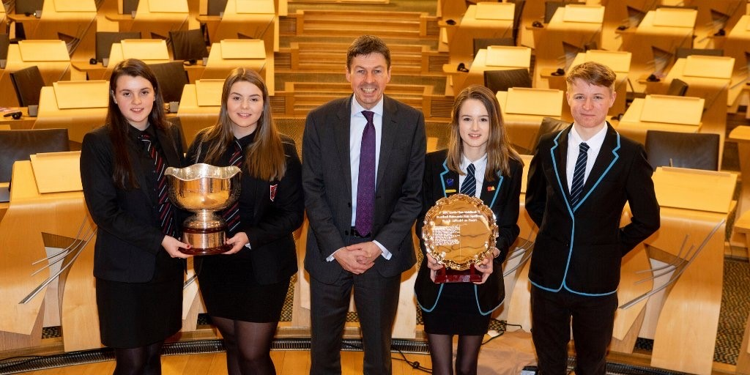In drawing up this report and plan, consultations took place with learners, parents, staff and partners to establish their views about our progress and improvement needs. We have also taken cognizance of the thematic review on Numeracy and Mathematics undertaken by two Senior Education Officers in November 2019, along with the completion of a recent Care Inspectorate self-evaluation exercise. Furthermore, much of our report and plan for sessions 2019-20 and 2020-21 will be based on the school community’ s experience of COVID-19 School closures. A period of unprecedented and challenging days experienced by schools, not only within our country but also worldwide. We will focus on what has worked well and what we have learnt as a school community moving forward out of this pandemic crises.

An Deasbad Final

at the

Scottish Parliament

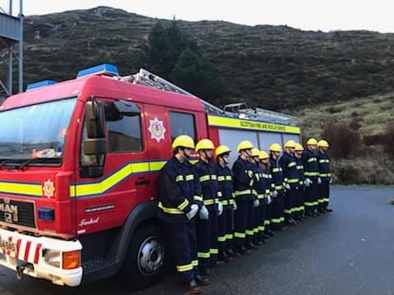

**Fire Skills Youth Engagement**

**Programme**

**1.2 Our vision, values, aims and curriculum rationale**

**Our Vision:**

Developing Our Uniqueness while Getting It Right for Every Child

**Our Values:**

**We will promote the values of the school motto in our day-to-day work:**

Dìlseachd (Loyalty) Dìcheall (Diligence) Dealas (Commitment)

Respectful, responsible, aspirational, confident, resilient

**Our Aims:**

In partnership with parents and the wider community and underpinned by promoting our Gaelic language, our culture and our outdoor environment, our aims are:

**Ethos**

To create a caring and welcoming place where we are all included and supported to develop, learn and fulfil our potential.

**Health & Wellbeing**

To be a caring school community that ensures the health & wellbeing of all, building resilience and celebrating diversity in a safe and secure environment.

**Curriculum**

To provide a curriculum to take account of each learner’s individuality as they progress through a 2-18 pathway, supporting and guiding all children and young people towards their personal, vocational and curricular aspirations**.**

**Learning & teaching**

To provide high quality, active and engaging learning and teaching experiences to allow for skills development and discovery.

**Achievement & Attainment**

To promote excellence and celebrate success to encourage our children and young people to

become confident individuals, responsible citizens, successful learners and effective contributors.

**Leadership**

To support leadership of all across the school to take forward change and be the best that we can be.

**AR LÈIRSINN**

A’ leasachadh Sònrachas agus a’ toirt Ceartas do gach Pàiste.

**AR LUACHAN**

Brosnaichidh sinn luachan suaicheantas na sgoile nar n-obair làitheil.

**DÌLSEACHD DÌCHEALL DEALAS**

Modhail , uallachail, brosnachail, misneachail, subailte

**AR N-AMASAN**

Ann an co-cheangal ri pàrantan agus ris a’ choimhearsnachd san fharsaingeachd, agus le bhith a’ brosnachadh na Gàidhlig, ar cultar agus ar n-àrainneachd, ’s e na h-amasan a th’ againn:

**ÀRAINN IONNSACHAIDH**

Àite a chruthachadh far am faigh sinn fàilte agus cùram agus far a bheil sinn uile a’ faighinn taic airson gun ionnsaich sinn, gun dèan sinn adhartas agus gun coilean sinn ar comasan.

**SLÀINTE AGUS SUNND**

A bhith nar sgoil a nì cinnteach gum bi slàinte agus sunnd aig na h-uile, a’ togail air subailteachd agus eadar-mheasgachadh ann an àrainneachd shàbhailte.

**CURRAICEALAM**

Curraicealam a dhealbh a ghabhas a-steach na pearsaichean air leth fhad ’s a tha iad a’ dèanamh adhartais bho 2 gu 18; a’ toirt taic agus stiùireadh do gach sgoilear anns na dòchasan a th’ aca a thaobh am beatha phearsanta, an curraicealam agus obraichean.

**IONNSACHADH AGUS TEAGASG**

Inbhe àrd a thoirt do ionnsachadh agus teagasg a tharraingeas a-steach na h-uile agus a leigeas leotha sgilean ionnsachadh agus an leasachadh.

**BUADHACHAS AGUS COILEANADH**

Sàr-mhaitheas adhartachadh agus soirbheachas a chomharrachadh airson sgoilearan a bhrosnachadh gu bhith nan daoine misneachail, saoranaich chiallach, luchd-ionnsachaidh shoirbheachail agus com-pàirtichean èifeachdach.

**CEANNARDAS**

Taic a thoirt do cheannardas nan uile air feadh na sgoile airson atharrachaidhean a thoirt air adhart agus a bhith cho math ’s a ghabhas

**Our Curriculum Rationale:**

Our curriculum model at Sir E ScottSchool is based on the underlying philosophy of Curriculum for Excellence, local strategy and national guidance. It takes into consideration the local context and particular needs of all children and young people at Sir E Scott School.

We aspire to provide a Broad General Education up to the fourth level, including well planned and challenging experiences and outcomes across all curricular areas and the four contexts of learning, both in Gaelic and in English, from Sgoil Àraich to S3.

We aspire to provide a Senior Phase which provides opportunities to continue to develop the four capacities and to support learners in moving into positive and sustained destinations beyond school. The senior phase is where pupils are presented for and gain formal qualifications from SQA and other accreditation bodies.

Across the BGE and Senior Phase our curriculum will have a strong focus on developing children and young people’s skills for learning, skills for life and skills for work.

The Curriculum at Sir E Scott School reflects the unique position of the Gaelic language in the local community by promoting our Gaelic language and culture in Gaelic and English classes and by encouraging our understanding of the history and heritage of our local community.

In building our curriculum we seek to utilise the school’s ideal location for outdoor learning provision and to foster strong links with parents, partners and the wider community to provide learning opportunities for our children and young people in meeting the current and future needs of the local economy.

Our 2-18 Curricular framework is based on the pre-birth to 3 national guidance and the four contexts for learning of Curriculum for Excellence. The latter is both a flexible framework and a working document which leaves scope for all teaching staff to introduce well-considered innovations to meet the needs of all learners and for the school to keep the curriculum framework under review on an annual basis to ensure it is fit for purpose. Underpinning this framework is a strong focus on promoting positive Health & Wellbeing for all.

As the school moves forward we recognise the importance of taking quality time to evaluate and review our curriculum, and to learn from evolving best practice. Therefore, we need to actively source good practice and continue to have all staff involved in strategic development at school, area and authority level. This will allow for robust and effective reflection and provide opportunities to refine and further develop a curriculum which will meet the challenges of the 21st Century.

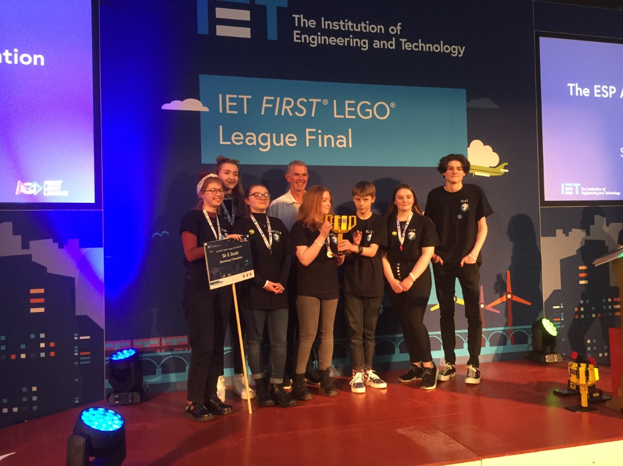

**Celtic Connections, Glasgow 2020**

**First Lego League Final, Perth**

**1.3 Summary of progress towards improvement:**

Due to the COVID-19 school closure situation we are unable to provide robust data in determining our final achievement of a level data for session 2019-20. The Scottish Government will not be collating the annual data on ACEL for June 2020 or possibly for June 2021, to allow schools time to recover from a prolonged period of school closure and a phased return to full time attendance at school for all children and young people.

During the 2019-20 session, up until March 2020 and using our predicted achievement of a level data 75% of our learners were predicted to achieve their curricular milestones. Our average attendance rate up to March 2020 was 95 % for primary and 94% for secondary.

The two planned improvement projects partially achieved the proposed stretch aim in the 2019-20 session. Both projects will require more time to develop and embed the proposed targets in our day to day practice in session 2020-21.

We chose to continue to take responsibility for our own Pupil Equity Funding allocation and looked at Scottish Attainment Challenge resources – for example, the Interventions for Equity grid and the Education Endowment Foundation Toolkit -- in support of our key individual and collective school targets, particularly focusing on the use of metacognition & self-regulation and high quality feedback.

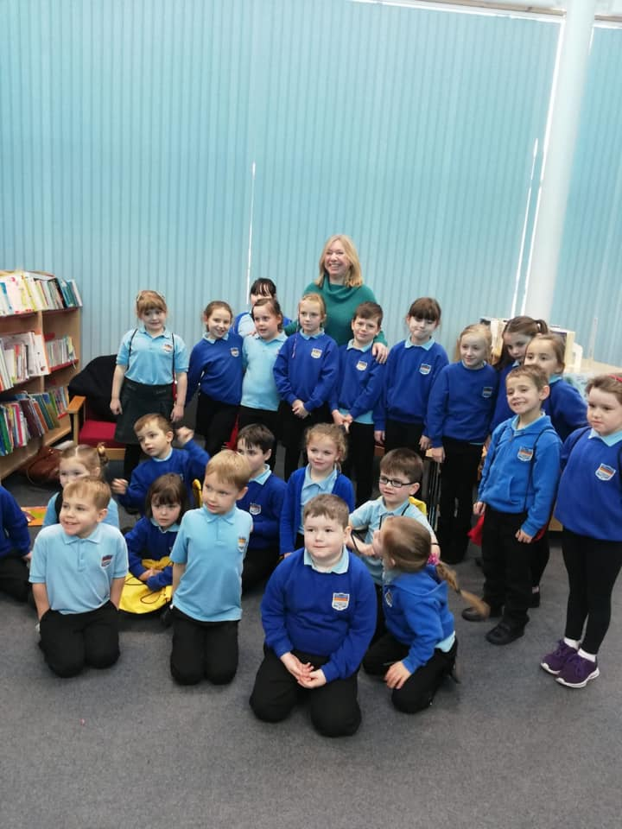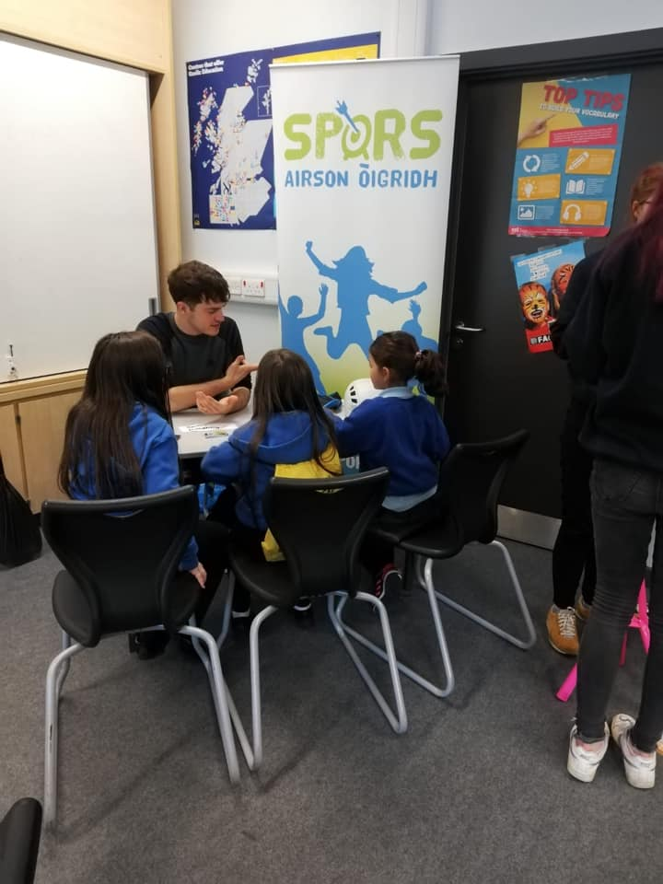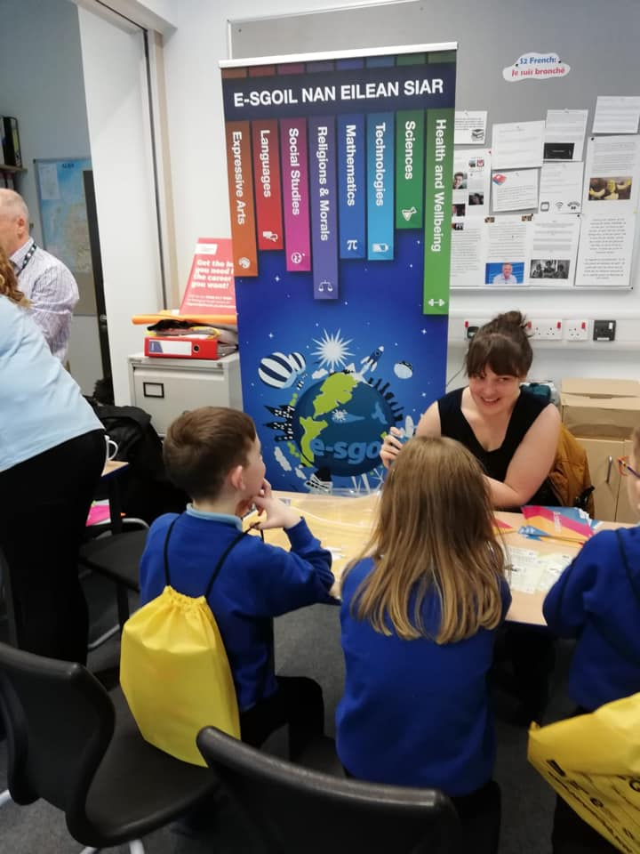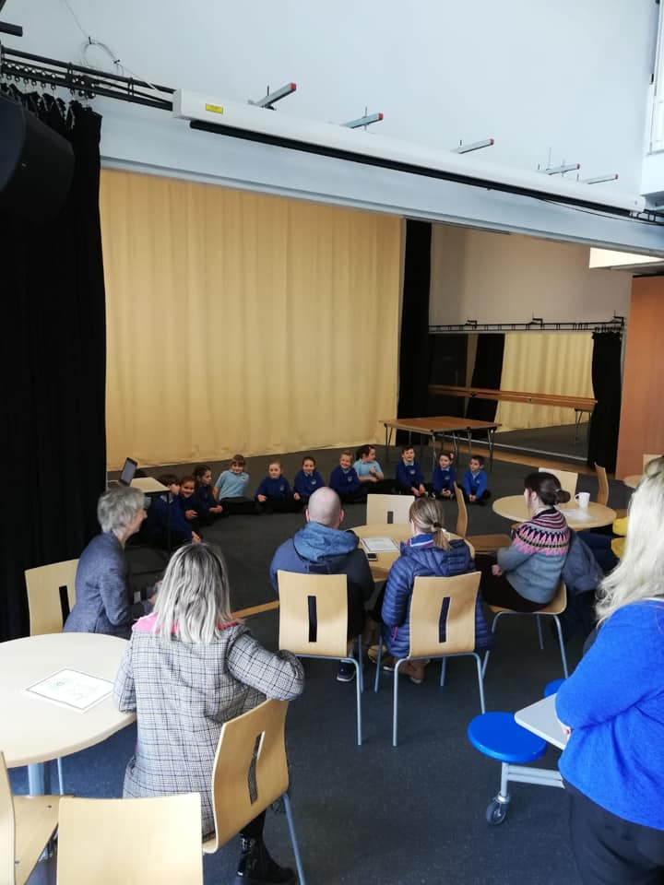Latha Na Gàidhlig

**2. Standards & Quality Report 2019-20**

This section reports on the progress the school has made during the 2019-20 session on improvement priorities, School Improvement Plan projects and with the four key National Improvement Framework priorities.

The National Improvement Framework for Scottish education is a framework to drive improvement in our education system. It brings together a range of key performance information to improve outcomes for every child in Scotland. In addition, it sets out our vision and priorities for Scotland’s children, particularly for the most disadvantaged, and the drivers of improvement which support those priorities. It builds on the best practice within Curriculum for Excellence in using a range of data and evidence to report and plan improvements for children.

**2.1 Our progress towards achieving National Improvement Framework Priorities**

1. **Improvement in Literacy & Numeracy**

Staff across the school continue to focus on improving pupils’ Literacy and Numeracy skills. Improvement in attainment, particularly in literacy (GM & EM) and numeracy where our SNSA results and SQA results show strengths across the school, are in keeping with teacher judgements of BGE CFE levels and NQs. We continue to look at ways and means of improving our Numeracy CFE levels of attainment across the school. However, it is worth noting that our results may vary from year to year when we have particularly small cohorts of pupils. We also need to take into account pupils’ additional support needs. This can make comparisons and identifying attainment over time more challenging to evidence. We will continue to use diagnostic information to take forward our focus for further improving our attainment in literacy & numeracy in SQIP 2020-21 across the 2-18 setting. These strategies include Emerging Literacy programme, learner participation, improving staff pedagogy and developing pupils’ numeracy/literacy skills through the curriculum, and using the whole school tracking of progress through a level.

This priority has been a focus of Improvement in Projects One and Two and reference is made to our review of progress in Section 2.2 below

1. **Closing the attainment gap between the most and least disadvantaged children**

The interventions planned for our use of Pupil Equity Fund are described in Improvement Project One in Section 2.2. In addition to this planned work we also supported disadvantaged families in a range of other ways:

* No costs incurred for families for any school events or non-uniform days, which were purely awareness raising days e.g. Jeans for genes, Eco- day
* PEF budget used effectively for nurture room and resources e.g. to support a whole school approach to supporting mental health
* Uniform swap-shop and recycling of good-quality used uniforms
* Funding of school trips

Curriculum for Excellence data for 2019-20 shows an increase in engagement with learning through improved self-esteem and self-confidence for almost all of our target group.

Closing the attainment gap between the most and least disadvantaged children has been a continued focus this session, using the Pupil Equity Funding. There is evidence of very good progress through PEF and RAFA (Raising Attainment for All) targeted projects closing attainment gaps in literacy, numeracy and health and wellbeing. There has been a notable difference in learners’ social interaction.

1. **Improvement in Children and Young People’s Health & Wellbeing**

As a school we continue to have a whole school approach to ensuring our children’s health and well-being is high priority. We are a very nurturing school, we know all our children and young people well. We continue to provide new and varying opportunities and programmes of work to enhance our provision. Staff have taken on leadership opportunities and undertaken training to further develop a whole school approach to HWB e.g. Decider Skills. The school is improving its gathering of data information on how pupils are feeling e.g. school survey on how pupils were coping with home learning provided an overall positive return, with all pupils identifying the need to be back in the school building. We recognize that we need to continue to develop our good practice to enhance collection and collation of pupil feedback through questionnaires, quantify and act on pupil feedback. There is reference to our review of progress in this area detailed in Section 2.2. (Project 2). A key priority in our SIP for session 2020-21 is to ensure the whole school community will experience a shared understanding of wellbeing, equality and inclusion as part of the recovery period post COVID-19 school closures.

1. **Improvement in Employability Skills and sustained positive school leaver destinations for all young people.**

A continued focus in SIP 2019-20, across Sgoil- Àraich, primary and secondary has resulted in all staff having an improved awareness of what is required to implement DYW successfully into termly planning, including visits to local business etc. Some staff are using the career education standard well for planning. The school regularly approaches and work with all local employers available to us in the local community – e.g. RJ Macleod, Distillery, Essence of Harris, Ardhasaig Glass Company, Hotels, North Harris Trust. We engage with them to enable pupils to see the connection between courses and the world of work e.g. Rural Skills, Business Management, Hospitality, STEM. In the primary, Friday Golden Skills, supported by partnerships from the community provided a range of skill sharing.

There is reference to our review of progress in this area detailed in Section 2.2. (Project 2)

The school is consistently close to 100% for positive leaver destinations. There is an increase, year on year, in pupils leaving school with vocational qualifications.

1. **Initial response to supporting children, families and school communities throughout the Covid-19 crisis**

The school community responded very positively and effectively to supporting all children, young people and families during the school closure period and since our return to the school building in August 2020. There was evidence of strong engagement in home learning by parents and children and young people across the school.100% engagement in the Primary, 98% in the secondary. Engagement was monitored through daily registration and primary weekly evaluations.100% of secondary pupils were provided with digital devices to engage in home learning. ICT provision of devices to all pupils in the secondary allowed pupils to access online learning on a day to day basis enhancing learning experiences. Provision of devices to primary was supplied where requested. There was excellent provision of support to primary/SA parents via Vscene. ASN provision to primary pupils- through remote learning online and provision of differentiated materials. SFLA targeted support continued towards IEP targets successfully, vscene and Hub provision.

Weekly staff meetings focused on sharing good practice, supporting the wellbeing of staff and ensuring clear communication on guidance and developments. Virtual School Assemblies and prize givings proved to be successful. Secondary Challenge week highlighted strong, innovative practise from the young people Teen COVID 19 lifestyle survey issued to all pupils and completed by 25% of pupils.

“How Are You” survey issued to all pupils. 76% pupils responded. 91% of pupils stated that they felt ‘nurtured’ and 71% said they were confident and happy using MS Teams

The school provided Hub provision for vulnerable pupils and the children of keyworkers throughout the school closure period and during the summer holidays. This provision was supported by school staff, CLD and Sgoil- Àraich staff. There was a focus on life skills such as cooking, Health and active learning. Feedback from parents and pupils has been universally positive and played a critical part in the success of the provision of learning and teaching during the period of lockdown. We continue to build on the very good practice developed during this period of school closure as we move forward through this session, which will undoubtedly stand us in good stead for any further potential closures or incidences of children/young people having to self-isolate at home.

**2.2 How successful were our improvements?**

This section provides a detailed summary of the progress made in the delivery of the School Improvement Plan projects for the 2019-20 academic year.

|  |  |
| --- | --- |
| **Improvement Priority One** | **Learning and Teaching** |
| **Project Progress** (What have we done?) | |
| * Clear expectations from SMT that all staff share learning intentions and success criteria with the children and young people, using examples of effective practice to illustrate. * Staff have reviewed their planning to ensure stronger links to the school’s updated vision, values and aims and to RRSA with a weekly focus on the article of the week. * We have improved our displays in communal areas and in the secondary department to ensure RRSA and our Vision, values and aims (English & Gàidhlig versions) are more visual in raising awareness amongst our children, staff, parents and visitors to the school. * Faculty and department meetings have had a strong focus on discussing and evaluating improvement targets linked to the School Improvement Plan. * Working groups (RRSA, DYW, Gaelic, Literacy, IT leaders, learning for Sustainability) continued to take forward aspects of this project * Some staff have undertaken specific training offered through their subject network group. Primary staff signed up for training too. Two members of staff have been trained in using Decider Skills. PEF funding used to train four members of staff by the end of the school year. Decider Skills programme delivered to some secondary pupils, with support from CAHMS provided proactive mental health strategies with young people. * All S5 pupils applied for and were trained as MVP mentors. NHS Senior Health Promotion Officer supported staff and pupils in the training and implementation of the programme. Parent Council members were consulted on the programme and suggested amendments were taken on board for our school setting * We targeted the HWB needs of some of our pupils to ensure they were ready for learning, using our PEF budget and related interventions for equity. We set up pupil nurture group meetings led by our CLD worker, who fully participated in planning and implementing programmes of work for specific pupils, resulting in significant impact from focussed working on wider achievement activities with a number of pupils in Primary and Secondary. * All staff, along with LMS staff engaged in LQAG activities, looking at the responsibility of all in Numeracy & Literacy, from early to fourth level. Staff provided work samples which were compared to the relevant es/os for discussion about ACEL. * Sharing of resources and practice across the school is improving and becoming more effective in raising children’s attainment in literacy and numeracy. * We have improved our practice in data collection and use of data. All staff have a clearer understanding of how to use data to improve attainment and close gaps. * Through a whole school trial of a tracking system, staff feedback was used to develop a more strategic tracking system which feeds into our Monitoring and Tracking cycle, providing a clear whole school overview of pupil progress and progression. * The school engaged in a thematic review (Numeracy & Maths) in November 2019 undertaken by Senior Education Officers, which provided positive feedback for the school and highlighted areas for development. * ICT- provision of devices to all pupils in the secondary has allowed pupils to access online learning on a day to day basis, enhancing learning experiences. Feedback from parents and pupils has been universally positive and played a critical part in the success of the provision of learning and teaching during the period of lockdown. * Microsoft education training of some staff has been successfully rolled out across the school, especially as a result of COVID school closures. * We have worked across our authority to create a senior phase harmonised timetable in the secondary department. | |
| **Evidence & Impact** (How are we doing and how do we know?) | |
| * During classroom observations it was evident that almost all staff were sharing learning intentions and success criteria, either visually or orally. Consequently, almost all children and young people understood the purpose of the lesson and how to achieve success in the lesson. Feedback and next steps were shared in most lessons. * Evidence in Faculty, departmental and working group meeting minutes of progress made in taking forward learner conversations across the 2-18 setting. * Sustained and effective use of resources purchased with PEF funding. Progress tracked through 8 wellbeing indicators, feedback evidence from CLD worker and feedback from class teachers. Nurture rooms in secondary and primary have proven to be effective in providing a “safe space” for pupils who require it. Pupils were supported to interact with their peers and feel supported by staff and other pupils. Evidence of sustained use throughout the school session. Focus of PEF nurture groups addressed HWB needs to enable pupils to be ready for learning, which in turn evidenced a closure of gaps in literacy and numeracy. * Children and young people were given the opportunity to lead on initiatives such as the Think before you Drink campaign, which resulted in eliminating the sale of plastic water bottles in the cafeteria. The Parent Council supported this campaign and the purchase of individual water bottles purchased for all our children and young people. * Children and staff are more aware and knowledgeable about our vision, values and aims and about the Rights. * S5 pupils led and delivered MVP programme successfully to all pupils across the Secondary Department. 50% of the course was covered before school closures due to COVID 19 lockdown. * All staff have a better understanding and appreciation of CFE levels, the standards expected and responsibility for all in Literacy and Numeracy through LQAG activities across the cluster. * Staff attending Craig Barton Maths CLPL sessions have changed aspects of their practice, for example” making the most of worked examples” which in turn they acknowledge has helped pupils to better understand the steps involved * Some staff have started to populate the revised progress through a level tracking system as highlighted in the Quality Assurance calendar, in relation to termly tracking discussions of pupils’ progress and attainment. * An improvement target within the school improvement plan regarding expectations for the implementation of digital technology usage far exceeded expectations. 100% usage of Microsoft Teams across the school. Enhanced engagement amongst all pupils. Staff focus on individual pupil needs and provision through differentiated materials on Teams impacts on raising attainment * Timetabling across the three presenting schools has provided more choice and flexibility within schools, allowing Senior Pupils to access equity of provision. Feedback from parents and pupils on the Options form was positive and currently (20/21) there are a number of pupils engaging in learning provided by other centres. * Introducing a new pathway for qualifications has provided equal status to vocational learning for all. The percentage uptake for these courses has been high in our small school setting. Staff feedback has been positive providing us with the evidence to suggest that our learners are engaging and attaining at the appropriate expected level. | |
| **Next Steps** (What are we going to do now?) | |
| * Ensure a more consistent approach across the school to sharing Learning intentions/Success criteria, using visuals, and linking high quality feedback on the children’s work to the success criteria * Develop good practice to enhance collection and collation of pupil feedback through digital questionnaires * Sustained provision of digital devices to all pupils across the school.Ensure appropriate Microsoft training for new staff and CLPL opportunities for all * Evaluate and use data and experience gathered to take forward   -parental involvement and engagement.  -very good learning and teaching practice  -data gathering  - pupil engagement   * Continue to encourage and support staff to be creative and innovative practitioners, using the skills set available to us in house. * Further development of opportunities from the Harmonised Timetable | |

|  |  |
| --- | --- |
| **Improvement Priority Two** | **Curriculum** |
| **Project Progress** (What have we done?) | |
| * Literacy and Numeracy Frameworks reviewed and in place across SA and Primary, supported by ES Attainment Advisor. * In November 2019 SDS arranged a careers convention for upper primary and secondary pupils at SES, which provided an opportunity for pupils in upper primary and secondary to engage with a variety of career partners. The Gaelic working group planned and arranged the annual Latha Na Gàidhlig with a focus on Gàidhlig related careers * The DYW group in conjunction with PSE class teachers carried out an evaluation of the Careers Education Standards with all secondary pupils. * Our transition programmes across the school were further developed in session 2019-20, building on our 2018-19 transition work, included an increased focus on curricular transition and on pupil led learning for our P7s, including LMS pupils. SA to primary transition had a focus on play. * BGE Curriculum planning documents were introduced and adopted by most subject departments in the Secondary. | |
| **Evidence & Impact** (How are we doing and how do we know?) | |
| * Frameworks provide coherence and clear guidance on expectations for all EM and GM classes and Sgoil- Àraich * We have broadened learner pathways by enabling staff to introducing more courses with a focus on pupils’ individual interests. * The general feedback on the Careers convention from pupils was positive. Older pupils would have preferred more time with certain guests to speak to them in more depth. A wider range of local employers would have been more beneficial to showcase local opportunities. 55% of the secondary pupils attending found information relating to a course/career that they were interested in. 91% stated they felt they knew more about their future options * Results of the evaluation of Careers Education Standard showed that the majority of S1-3 pupils were very confident or confident in their answers to all 10 questions. In S4-6 less pupils were very confident or confident with their answers. * The transition programme that was implemented between January and March was very successful, it was further delivered during lockdown virtually with good feedback from parents and pupils. Evidence of very good communication between staff and parents at SA/primary in preparing for transition. This transition programme and its continuation during school closure period prepared the children well for return to school in August 2020. Children transitioning into the Sgoil- Àraich, primary and secondary settled quickly and seamlessly. * An S1 BGE course overview has been produced and shared across secondary and primary departments. | |
| **Next Steps** (What are we going to do now?) | |
| * Literacy, Numeracy & HWB guidance to be shared and agreed with SA and Secondary to ensure further progression. * LQAG to be further developed and led by identified Literacy and Numeracy leaders to provide more robust moderation and enhance professional judgement (responsibility for all) * Whole school approach to meet termly (in line with Progress through a level input dates) to discuss and analyse data collected- Faculty Meeting agenda item, Sgoil- Àraich/Primary termly tracking meetings. * Increased options available has seen pupil uptake of courses meet the expectations we have of learners in the senior phase. * Family learning programmes to build on experience of home learning during COVID 19 school closures. * Continue to embed the career education standard into lessons across the school. Results show the emphasis in the last 2-3 years has resulted in S1-3 pupils being more confident about the careers standards. * Take forward plans for STEM based learning postponed due to lockdown. * Post COVID 19 develop work placement programme to enable all young people to engage with employers * Develop Secondary PSE & SA/Primary HWB programmes to include RSHP and Decider Skills resources where appropriate, engaging and involving parents and pupils in the process * Whole school to complete actions and achieve RRSA Silver Award. * Transitions to be further developed in session 2020-21 using feedback from children, young people and staff e.g. play pedagogy at SA/P1 using Realising the Ambition. Planning an outdoor learning approach. We will replicate our transition plan for P7/S1, including a focus on John Muir Award (GM & EM) and an enhanced transition nurture group. * Continue to develop BGE planning overviews and carry approach forward into the SP to ensure we have meaningful progression pathways that meet the design principles of CFE, especially relevance, pace and challenge, and meet all children and young people’s individual needs. | |

**2.3 What progress have we made?**

Section 2.3 provides evaluative judgements against key quality indicators from How Good is Our School? 4th Edition (HGIOS4)

|  |  |  |
| --- | --- | --- |
| **Quality Indicator** | **Evaluation** | **Evidence** |
|  | **HGIOS4 Six-Point Scale Evaluation** |  |
| 2.3  Learning, Teaching & Assessment | * The ethos and culture of our school reflects a commitment to children’s rights and positive relationships * Almost all staff create a learning environment that is built on positive, nurturing and appropriately challenging relationships which leads to high quality learning outcomes for learners. * Almost all children and young people understand the purpose of their learning and some have opportunities to lead the learning. * Most Sgoil Àraich, primary and secondary staff have used the community and outdoor spaces to deliver increased quality outdoor learning experiences for all children. * Children and young people’s learning experiences have been enriched and supported by effective use of digital technologies e.g. allocation of individual devices to all secondary pupils, effective use of Microsoft teams/IT leaders sharing and taking forward very good practice. * All staff have engaged in planning, assessment and moderation activities resulting in a better shared understanding of achievement of a CFE level. * Almost all staff are developing/integrating assessment into planning and have improved on the gathering of robust assessment evidence * All staff are starting to use processes more effectively to monitor and evaluate learners’ progress across all areas of the curriculum. There is an improvement in the systems and information we now have in place which provides a clearer overview on progress and attainment across the 2-18 setting. | * Classroom observations * School closure evidence on Microsoft teams * Feedback from staff, parents, children and young people, partners and visitors to the school e.g. Local authority thematic review * LQAG meetings and feedback * Monitoring & tracking systems * Staff meeting minutes |
| **HGIOS4 Six-Point Scale Evaluation** | Good |
| 3.1  Ensuring Wellbeing, Equity and Inclusion | * The whole learning community has a shared understanding of wellbeing and children’s rights. * We know and can demonstrate that all of our children and young people feel safe, nurtured, achieving, responsible and included. Most staff and learners understand and use the wellbeing indicators as an integral feature of school life. * Relationships across the school community are very positive and supportive. There is a strong sense of community, shared values and high expectations in our school setting. * We carefully consider each child and young person as an individual with his/her own needs, and strive to ensure appropriate outcomes for all. We include children and young people in discussions and decisions that may affect their lives. As a school, we are particularly strong at being creative in finding learning pathways for children and young people who encounter challenges and barriers to their education, including those with additional support needs. * We value and work well with all our close partners, who in turn feel valued and supported by the school. * Almost all staff have engaged in regular professional learning to ensure they are up to date with local and national legislation e.g. a focus on the rights, wellbeing and inclusion of all children and young people. * Almost all learners are included, engaged and involved in the life of the school. * Children and young people facing challenges are well supported and are making good progress in their learning. Targeting HWB needs of PEF nurture groups, led by CLD partner, enabled pupils to be ready for learning which in turn closed gaps in literacy and numeracy**.** | • School ethos  • HWB Audit  • HWB Responsibility of All posters/surveys  • Staff meetings and Child’s Plan meetings   * PEF meetings and funding * In-service days – centre and school based * Additional staff training e.g. Decider skills, MVP * Feedback from parents and pupils. TATC meetings   • PST meetings & In house ASN /professionals’ meetings   * SEEMiS records/referrals and school reports   • CPD & PRD records |
| **HGIOS4 Six-Point Scale Evaluation** | Very Good |
| 3.2  Raising Attainment & Achievement | * Most children and young people are attaining at appropriate levels to their ability and a few have exceeded these. * Secondary Challenge week –innovative practise from the young people * During lockdown some S2 pupils accepted the challenge of participating in Your Community Fund, Your Community Fund, was delivered through its Youth and Philanthropy Initiative (YPI) programme, and asked young people to work in virtual teams to develop creative digital submissions, highlighting how their community had been affected by the pandemic and a local charity making a difference at this time. One of the school’s teams were one of the 50 winning teams in Scotland, securing £4000 for the charity of their choice, Western Isles Cancer Care Initiative * Attainment levels in literacy and numeracy in the Senior Phase at SCQF 5 are above our virtual comparator. * 2020 SQA data shows almost all subject departments are consistently achieving above national average results. SQA accepted most of the estimates submitted confirming that staff judgment is in line with SQA predictions * Almost all young people leaving school are consistently moving on to a sustained positive destination. * We recognise and value the personal achievements of all learners by celebrating their successes at school assemblies, in termly newsletters etc. * Most children and young people are attaining appropriate levels in Literacy & Numeracy and a few have exceeded these. Our attainment in Literacy & Numeracy at P1, P4, P7 and S3 continues to be good over time. Small numbers in a year group and learners with additional support needs although we vary in these classes from year to year. A few learners are following individual milestones. SQA results continue to be very good at national and higher levels. A number of our children and young people have experienced success in their wider achievements, developing a range of skills and attributes through a wide range of activities within and out with the school including YPI, Dileab events such as Celtic Connections, Deasbad (National Debate for Secondary School), First Lego League success at local and national level, Sporting achievements (Football and mountain biking at national level) and Music. We continue to have a 100% Learner post-school destinations with close to that figure for sustained positive destinations. Attendance up to March 2020: Primary – 95% Secondary – 94%. * DYW events have increased learners’ understanding of careers and encouraged thinking about and planning of their learning pathways. A strong focus on curricular transitions across the school has had a positive impact in raising staff awareness of children and young people’s readiness for the next stage and in increasing children and young people’s engagement and participation. | * ACEL data * Progress through a level spreadsheet * SNSA/MCNG reports * Children and young peoples’ progress reports. reports * SQA * Skills Development Scotland data * Wider achievement awards – YPI, Saltire * School’s Facebook Page, Twitter, website. Termly newsletters and local newspapers |
| **HGIOS4 Six-Point Scale Evaluation** | Good |

**2.4 Outcome of external review or inspection in the last 12 months**

The school received a visit from our Senior Education Officers and an Early Years Officer in November 2019, with the focus on a thematic review of Numeracy and Mathematics across the 2-18 setting. In summary, the school was identified as having the following strengths:

* Clearly a very positive attitude towards learning in numeracy and Mathematics across the school and Sgoil Araich. Positive relationships among and between learners and staff, effective strategies being used to develop a positive mindset to learning and achieving in Maths.
* Staff and pupils experience very good positive relationships, staff know their pupils very well and SfL support staff are deployed effectively which contributes to positive engagement with the curriculum.
* All the pupils were very positive about learning maths and how important it was to help them be prepared for the world of work, further education.

In addition, the following areas for improvement were identified:

* The school requires to update their curriculum vision and rationale and Curriculum overview in consultation with Staff, pupils and parents to reflect the uniqueness and setting of the school. This needs to incorporate a strategic overview which will ensure a shared understanding of the purpose and design of the curriculum for all.
* Provide further opportunities to link more to the STEM agenda and be mindful of providing balance of Numeracy and Mathematics.
* Continue to focus on planning, tracking and monitoring across the school, which should inform how pupils are progressing through the broad general education and into the Senior Phase.
* Staff need to analyse the data carefully from ongoing assessments, the Scottish National Standardised Assessments and the National Benchmarks to inform their professional judgement.
* Planning requires to reflect more active learning approaches, linked appropriately to IDL subjects to bring the learning alive, purposeful and relevant. Planning also needs to be responsive and provide more opportunities for pace and challenge, meeting the needs of all learners. It also requires to identify the learning and assessment opportunities.
* Learning pathways in both GME and GLE are currently in progress. More opportunities for accreditation in learning requires to be incorporated within the curriculum and to celebrate successes and achievements in Numeracy and Maths.

**2.5 What are our key priorities for improvement in 2021-22?**

Taking into account all of the information set out in section two of the report as well as local and national priorities, the school has identified the following areas for improvement in 2021-22:

* To ensure all our children, young people and staff transition back into school in August 2020 with a strong focus on health and wellbeing through a recovery curriculum.
* To ensure consistent high-quality learning experiences for all children and young people- to improve participation and challenge.
* To make effective use of assessment data, monitoring and tracking by staff and learners over time to ensure that children and young people maximise their successes and achievements.
* To implement the refreshed BGE Curriculum providing flexible learning pathways which lead to raising attainment through meeting the needs and aspirations of all of our learners.

Hamish Scott, S5 was chosen as the winner of this year’s Donald Stewart Memorial Trust Award for Significant Contribution to Gaelic Development.

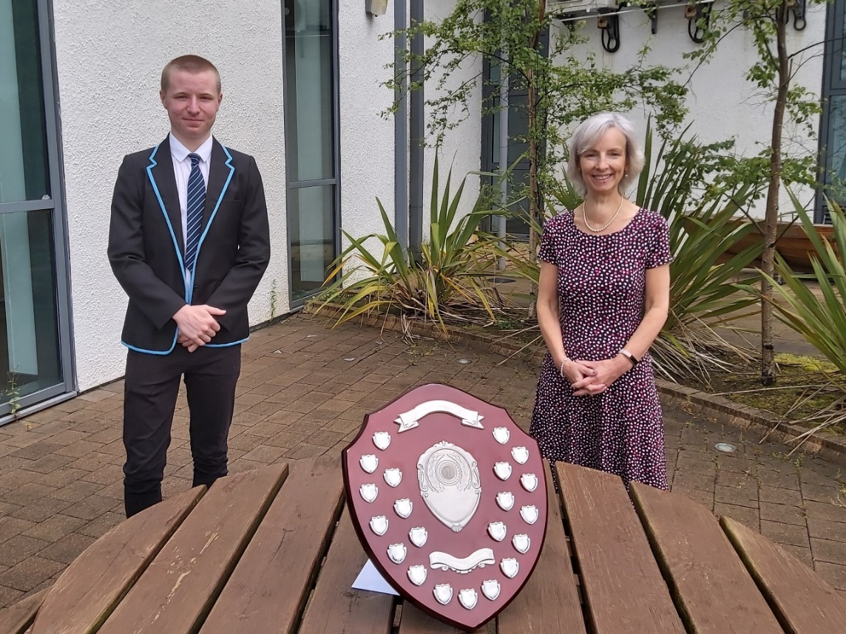

**3. School Improvement Plan 2020-21**

This section uses the evaluative evidence from the Standards and Quality Report to develop improvement plan projects for the coming school session. Having considered all the evaluative information across section two and guidance available about local and national priorities, the school should identify what its key areas are for the 2021-22 SIP

**3.1 Creating the Plan**

The School Improvement Plan set out below was created as a combination of the priorities identified from our evaluative work described in section two, including taking account of our local recovery plans to support the health and wellbeing of our children and young people and the approaches to assessment to assist in identifying gaps in learning. Also, a number of surveys and evaluative activities undertaken with learners, parents and community partners.

As well as the formal planning set out in section 3.2, we will create an A4 summary page of our projects to support communication of them to all our stakeholders. In addition, we will work in partnership with our Pupil Council in October 2020 to create a pupil-friendly version of the plan for all our learners to access.

**3.2 What are our improvement projects?**

|  |  |  |  |  |  |
| --- | --- | --- | --- | --- | --- |
| **Improvement Project One** | Curriculum Re-design | | | | |
| **NIF Priority:** | Improvement in attainment  Closing the attainment gap  Improvement in employability skills and sustained, positive school leaver destinations for all young people. | | | | |
| **HGIOS4 or HGIOELC QIs:** | * 1. Self-Evaluation for self-improvement   2. Leadership of Learning   2.2 Curriculum  2.3 Learning, teaching & assessment – session 2021-22  2.4 Personalised Support –session 2021 -22  2.6 Transitions  2.7 Partnerships  3.2 Raising attainment and achievement/Securing children’s progress – session 2021-22  3.3 Creativity and Employability/ Developing creativity and skills for life and learning | | | | |
| **CnES Priorities:** | To deliver high quality learning and teaching in all educational settings | | | | |
| **Stretch Aim(s)** | | | | | |
| All learners (GM & EM) build on their prior learning to ensure appropriate progression through high quality teaching and learning in all curriculum areas and through outdoor learning, by end of session 2021. | | | | | |
| **Target Group** | | | | | |
| All learners (2 - 18) | | | | | |
| **Planned Outcomes (SMART Primary Drivers)** | | | | | |
| * Ensure curriculum frameworks provide appropriate progression for all learners. * Ensure our revised learning, teaching and assessment guidance is understood and implemented by all staff * Ensure effective analysis of assessment and evidence is integral to planning of learning and teaching improving outcomes for all learners (GM & EM). * All learners, parents and partners are given the opportunity to contribute to the ongoing development of the curriculum. * Increase effectiveness of curricular transitions across the school. * Continue to review and improve effective planning and implementation of Pupil Equity Funding. | | | | | |
| **Baseline Measures** | | | | | |
| * Data analysis – Class/subject assessments, standardised assessments, BGE Benchmarking Tool & Insight Baseline, Progress through a Level monitoring & tracking system * Self-evaluation toolkit Learner Participation – SA, Primary & Secondary visuals per term * SLT monitoring and tracking termly quality assurance calendar. * Review current curriculum frameworks (information to be noted) and to be further developed. * Pupil choice, options, pupil focus groups, parent council and pupil council feedback (soft measures). | | | | | |
| **Change Actions & Methodologies (Secondary Drivers)** | | **Reporting Responsibility** | | **Completion**  **Deadline** | **Measures of Success** |
| Learners exercise choice, understand the purpose of their learning and have opportunities to lead the learning through the four arenas of participation e.g. learning, teaching & assessment, opportunities’ for personal achievement , decision making groups, connections with the wider community | | SMT/PT | | Reviewed  Termly | Through participation, learners will evidence and exercise a key role in actively supporting curriculum, through ongoing dialogue with others – (planning, teaching and learning, assessment and next steps/ Learner conversations/moderation)  Learner participation posters |
| Improve pedagogy and use of benchmarks for planning and assessing of numeracy, literacy and Health and Wellbeing – Sgoil Àraich, primary & secondary (GM & EM) | | SMT/PTs | | May 2021 | Increase in staff knowledge and confidence observed and improved learners’ experiences rich learning environment evident across the school campus, indoors and outdoors.  Raised attainment evidenced in our end of session progress and achievement report. - (development overview, learning through play, outdoor learning, challenge and pace) |
| Review and refresh our curriculum rationale in line with the school’s vision, values and aims, local and national guidance and the national refreshed curriculum | | SMT | | March 2021 | All learners, staff, parents and partners can talk about our curriculum rationale and how we use the uniqueness of our school setting to enhance the curriculum. |
| Implement BGE curriculum frameworks embedding IDL, CES, RRSA and NIF. Extending curriculum overview into the Senior Phase. | | SMT/PTs | | Review progress May 2021 | Curriculum frameworks being used by all staff in all curricular areas to plan and deliver learning and teaching experiences thus ensuring the 7 principals of curriculum design.  Evidence of increased differentiation in the curriculum / classroom – (learning walks, pupil feedback, staff ASN questionnaire, minutes from meetings)  Evidence of continuity and progression of learning across curriculum areas- (use curriculum overview and PTLS spreadsheet to track experiences across transitions) |
| Continue to develop the Senior Phase offer in partnership with the other presenting schools and local authority | | HT/DHT Secondary | | March 2021 | Robust planning documents and evidence of moderation and verification with the other presenting schools and local authority |
| **Resources** | | | | | |
| Learner Participation in Educational Settings (3-18) | | | 4 arenas of participation | | |
| HIGIOS 4/HGIOELC/Realising the Ambition: Being Me/ Health & Social Care Standards/ National Standards, Care Inspectorate resources, Statutory Guidance on Gaelic Education and Advice on Gaelic Education. | | | Self-evaluation & developing/sharing practice | | |
| Primary Curriculum Improvement Toolkit | | |  | | |
| Digital platforms – Microsoft teams | | |  | | |
| Seesaw App Blogs Social Media platforms | | |  | | |
| Rights Respecting School Resources | | |  | | |
| EEF Toolkit | | |  | | |
| Careers Education Standards | | |  | | |
| BGE Benchmarking Tool/Insight | | |  | | |
| Education Scotland website – National Improvement Hub | | |  | | |
| Partners – Education Psychologist, CLD, SDS, Volunteer Centre, Sport & Health agencies, CNAG Youth Worker, Librarian, MWOW | | |  | | |
| Pupil Equity Funding | | | Purchase high quality resources, support targeted pupils | | |
| SQA resources | | | Review of coursework, new awards/courses | | |

|  |  |  |  |  |
| --- | --- | --- | --- | --- |
| **Improvement Project Two** | Health and Wellbeing (COVID-19 Recovery) | | | |
| **NIF Priority:** | Improvement in Health and Wellbeing  Improvement in attainment  Closing the attainment gap | | | |
| **HGIOS4 or HGIOELC QIs:** | * 1. Leadership of Change   2. Leading & management of staff/practitioners (theme 3 staff wellbeing & pastoral support)   2.4 Personalised Support  2.5 Family learning  2.7 Partnerships  3.1 Ensuring wellbeing, equality & inclusion  3.2 Raising Attainment and Achievement/ Securing children’s progress | | | |
| **CnES Priorities:** | To deliver high quality learning and teaching in all educational settings | | | |
| **Stretch Aim(s)** | | | | |
| The whole learning community will experience a shared understanding of wellbeing, equality and inclusion as part of the recovery period post COVID-19 school closures by the end of May 2021. | | | | |
| **Target Group** | | | | |
| All (2-18) | | | | |
| **Planned Outcomes (SMART Primary Drivers)** | | | | |
| * Evaluate existing provision * Plan a whole –school community co-ordinated approach to support pupil wellbeing * Provide opportunities for staff professional learning * Prioritise pupil voice * Involve parents and carers * Link with external support/partners * Support staff and pupil wellbeing | | | | |
| **Baseline Measures** | | | | |
| * Health and Wellbeing pupil surveys. Home learning, return to school and end of session surveys * Health and Wellbeing staff survey * Parent Survey * Minutes of meetings (PST, Departmental/Faculty/Working groups, ASN) | | | | |
| **Change Actions & Methodologies (Secondary Drivers)** | | **Reporting Responsibility** | **Completion**  **Deadline** | **Measures of Success** |
| The H&W working group develop an approach to allow the ongoing evaluation of provision of Health and Wellbeing programmes across the school community including a focus on RRSA. | | SMT/PT PS | 21st Oct (in service day) | Staff across the school can collate and analyse the information  Achievement of Silver Award |
| SMT engage in NHS healthy working lives accreditation – Norma MacLeod, Lynn Hebditch. | | SMT | 21st Oct (in service day) | The feedback from the H&W survey will have been used to implement a wellbeing strategy with clear procedures around staff wellbeing and promoting continuing professional development. |
| High quality training and support available including, Decider Skills, Connected and Compassionate Classrooms, Back to School Toolkit, It’s ok to worry about Corona virus etc. | | SMT /PT PS | May 2021 | 100% of staff, pupils and parents are aware of the Decider Skills language. (in service day Oct 21st) |
| Regular opportunities for pupil voice | | SMT | May 2021 | School Charters in place across the whole school, all children and young people have had a say in creating the charters and acting on them.  Secondary Captains and Pupil Council members take part in RRSA pupil groups (Primary, BGE and Senior phase groups)  House system reinstated in secondary.  The feedback from the H&W survey will have been used to implement a wellbeing strategy with clear procedures around pupil wellbeing and participation.  All pupils and staff know the 7 Golden Rules of Participation and know what participation should feel like. |
| **Resources** | | |  | |
| Learner Participation in Educational Settings (3-18) | | | 4 arenas of participation | |
| Decider Skills, Connected and Compassionate Classrooms, | | |  | |
| RRS resources - Back to School Toolkit | | |  | |
| Pupil profiles, Getting it Right for Me plan, Care plans, ASN plans | | |  | |
| Partners – parents, Education Psychologist, Social Work, ELR, CAHMS, School Nurse, CLD, Sport & Health agencies | | |  | |
| Scottish Government guidance | | |  | |
| National Improvement Hub/Education Scotland | | |  | |
| The Hive of Wellbeing | | |  | |

**3.3 Outline Plans for 2021-2023**

|  |  |  |
| --- | --- | --- |
| **2021-22** | 1 | Improve Parental Engagement and Family Learning in Sgoil Àraich and School |
| 2  3 | Continue to develop learner participation and learner involvement in school self-evaluation empowerment  Further development of the curriculum, embedding Career Education Standard, DYW, IDL and NIF. |
| **2022-23** | 1 | Continue to develop learner participation and learner involvement in school self-evaluation empowerment |
| 2 | Parental Empowerment |

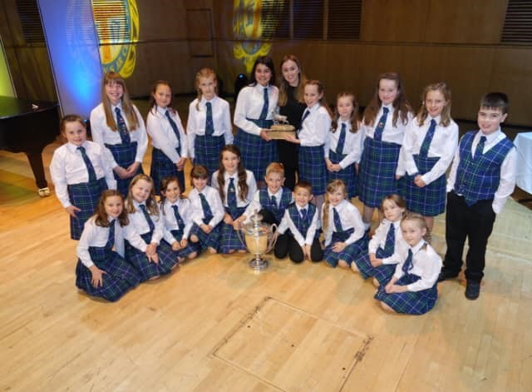

**Junior Choir**

**4. Glossary of Terms**

**Attainment** is the measurable progress within the curriculum which children and young people make as they progress through and beyond school.

**Achievement** refers to the totality of skills, attributes and experiences of children and young people across all aspects of learning in and beyond school.

**Baseline Measures** are a set of measurements taken at the beginning of a project. They are used to make comparisons with measurements taken at the end of the project to evidence the degree of improvement achieved.

**EEA** describes the post of Education Attainment Apprentice. This is a post created to provide a broad range of support to pupils identified as being recipients of Pupil Equity Funding.

**EEF** is an abbreviation of the Education Endowment Foundation and is widely used to describe the toolkit of research-based interventions that schools can use to inform their improvement planning.

**HGIOELC** is an abbreviation of ‘*How Good is Our Early Learning and Childcare?*’ This is a set of quality indicators issued by Education Scotland to measure the performance of early years provision (nursery/sgoil araich) and inform continuous improvement.

**HGIOS4** is an abbreviation of ‘*How Good is Our School? 4th Edition*’ This is a set of quality indicators issued by Education Scotland to measure the performance of schools and other education settings and inform continuous improvement through self-evaluation and quality assurance activities.

**Measures of Success** are measurements that will be taken to confirm the service improvement that a project has delivered. These measures are often compared to baseline measures to evidence degrees of success.

**NIF** is an abbreviation of ‘**National Improvement Framework**’, a Scottish Government publication that sets out the national plan and framework to raise attainment for all, close the poverty-related attainment gap and deliver better outcomes for learners.

**PEF** is the widely-used abbreviation for Pupil Equity Fund. This is a sum of money provided directly to schools from the Scottish Government and is based on the number of pupils entitled to Free School Meals. The funding is to be targeted by schools at closing attainment gaps and promoting equity for the most disadvantaged learners.

**Primary Drivers** are the key areas of improvement within a project and the outcomes that will deliver the project stretch aim.

**Quality Indicator** refers to a quantifiable statement used consistently to measure performance against and agreed standard.

**Rationale (for the Curriculum)** is a statement of reasoning, values and aims that form the foundation of curriculum design for the school. It should always state how the school’s curriculum reflects its unique context and its place within the community.

**Secondary Drivers** are the specific actions and interventions that bring about the improvement need identified in a project. They build towards the achievement of the project stretch aim.

**SMART Targets** are project targets that are **S**pecific, **M**easureable, **A**chievable, **R**elevant and **T**imed**.**

**Stretch Aim** is the overarching and aspirational aim of the project. It should define who the aim refers to; what is to be improved; how much improvement is expected and by what deadline.