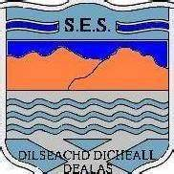

Online Learning

Sir E Scott Primary Department

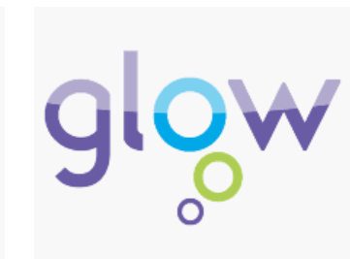

Read Write Inc. Spelling Read Write Inc. Spelling is a 15-minute-a-day programme for P3–P7 EM. Your child may have a class log in for this.

<https://www.oxfordowl.co.uk/for-school/online-learning/read-write-inc-spelling>

Glow - <https://glow.rmunify.com/> children/Young People have a log in to access this.

Office 365 – Word, PowerPoint, Forms, Sway, Excel – your child has access to this using their Glow log in.

This provides access to a range of products such as Word, Excel, PowerPoint, Access and OneNote. Glow users can download the Microsoft Office Suite on to five PCs or Macs, five tablets and five phones.

Office 365 Pro Plus allows all Glow users to download the latest version of the Microsoft Office Suite on to a total of 15 home machines and personal devices, free of charge. To download Microsoft Office 2016 from the Glow Application Library, search for the ‘Office 365’ tile. It can be found on the National (Scotland) Launch Pad.

Glow has an app library. One of the features of Glow is an extensive and growing library of applications which support learning and teaching across the curriculum. Many of the apps are available free of charge. Children/Young People may also be part of Microsoft Teams allowing them to access and share work as well as speak to friends and teachers in a secure zone.

Dear Parents / Guardians,

We would like to advise how parents / guardians can support their children’s learning while the school is closed.

Through the school’s learning platform Glow, we will be maintaining communications between pupils and school as well as keeping the community informed through email and the school website, Facebook or Twitter.

We also need to be able to get work to and from students and we have many online platforms that will allow us to do this quickly, efficiently and without extra burden of costs, while also providing learners with access to learning materials and support.

Online learning ensures that curriculum materials will be available to learners throughout the period. The pupils work will be directed by the class teacher who can monitor progress and assign work accordingly efficiently.

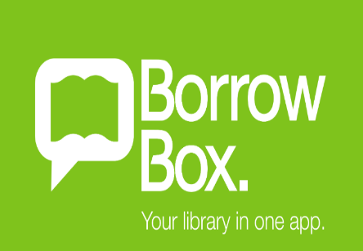

BorrowBox allows you to access to the library at home! You can borrow eBooks and eAudiobooks free from your library using the BorrowBox app.

Download the free app – You will need your library card. Your password is your library card number. Your pin number is the last four digits of your library card number.

Contact Mrs Fiona Morrison our librarian - [fmmorrison1b@gnes.net](mailto:fmmorrison1b@gnes.net) if you have trouble logging in

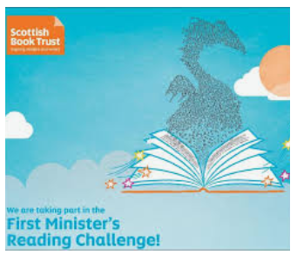

The First Minister’s Reading Challenge aims to help children and young people develop a love of reading. We want to develop reading cultures and give very child in Scotland the opportunity to experience the benefits – and the fun – of reading for pleasure.

Fill in your reading passport so we can share with the class all the brilliant texts you have read once you are back at school.

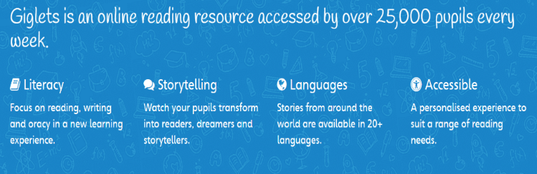

BGE pupils will be issued with a log in. Class teachers may assign books that are suitable to each child/Young Person’s needs, they may be audible and will have resources that can be completed online and monitored by the class teacher.

<https://pupil.gigletsedu.com/landing/>

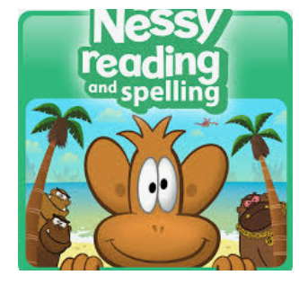

Nessy programs are designed to help students of all abilities learn to read, write, spell and type, especially those who learn differently.

BGE children/Young People may log in using their name and they will work through challenges and get instant feedback. The pupils will need to know the secret word – velvetoaf to log in

<https://learn.nessy.com/account/login#/monkeyLogin>



**Sumdog** is a way for kids to practice math skills while playing fun, math-related games against friends, classmates, or students from around the world. Games are individualized for each kid's ability level, so users can play against opponents who have the same skills.

Your child will have their own log in and their class teacher can set work and monitor and track it.

<https://www.sumdog.com/user/sign_in>

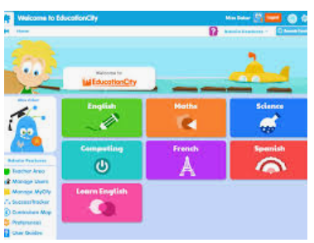

Education City website is a really fun way of learning and it helps pupils become confident learners of many skills. Teachers can set work and progress is tracked. Education City is an educational resource for children aged 3-12. There are lots of learning screen, games and resources. Your child has a log in and it can be accessed at

<https://www.educationcity.com/>

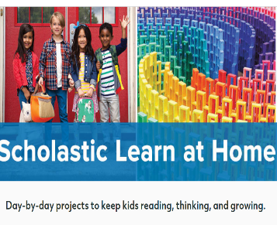

Scholastic’s Learn at Home website. This free resource provides your children with 20 days of exciting articles and stories, videos, and fun learning challenges. Children can complete them anytime, in any order. They can work on their own or together with you and your family.

[www.scholastic.com/learnathome](http://www.scholastic.com/learnathome)