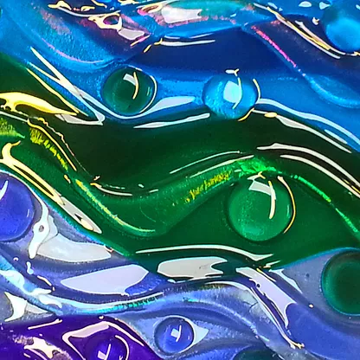 Half Term Glass Workshop

**Family Friendly Event**

**Making Glass Coasters**

**with Stella from Solus Glass**

**Saturday 19 February**

1pm – 4pm

**Museum nan Eilean, Lews Castle**

**Book to confirm a place.**

**https://www.eventbrite.co.uk/e/saturday-glass-workshop-tickets-268851390747**

**You can drop in but you may have to wait for a slot if it is busy**

**Covid precautions in place**

**Half Term Glass Workshop**