Seo na taisbeanaidhean balla againn san Sgoil-àraich.

This is our wall displays in the nursery.

Tha an balla seo a ’sealltainn dhuinn cò tha gar cuideachadh a ’fàs. Seo na prìomh-cloinn againn

This display shows us who our key children are and who is helping them to grow.

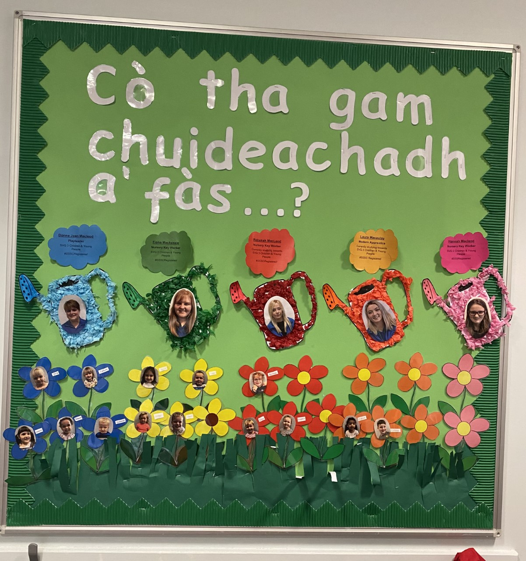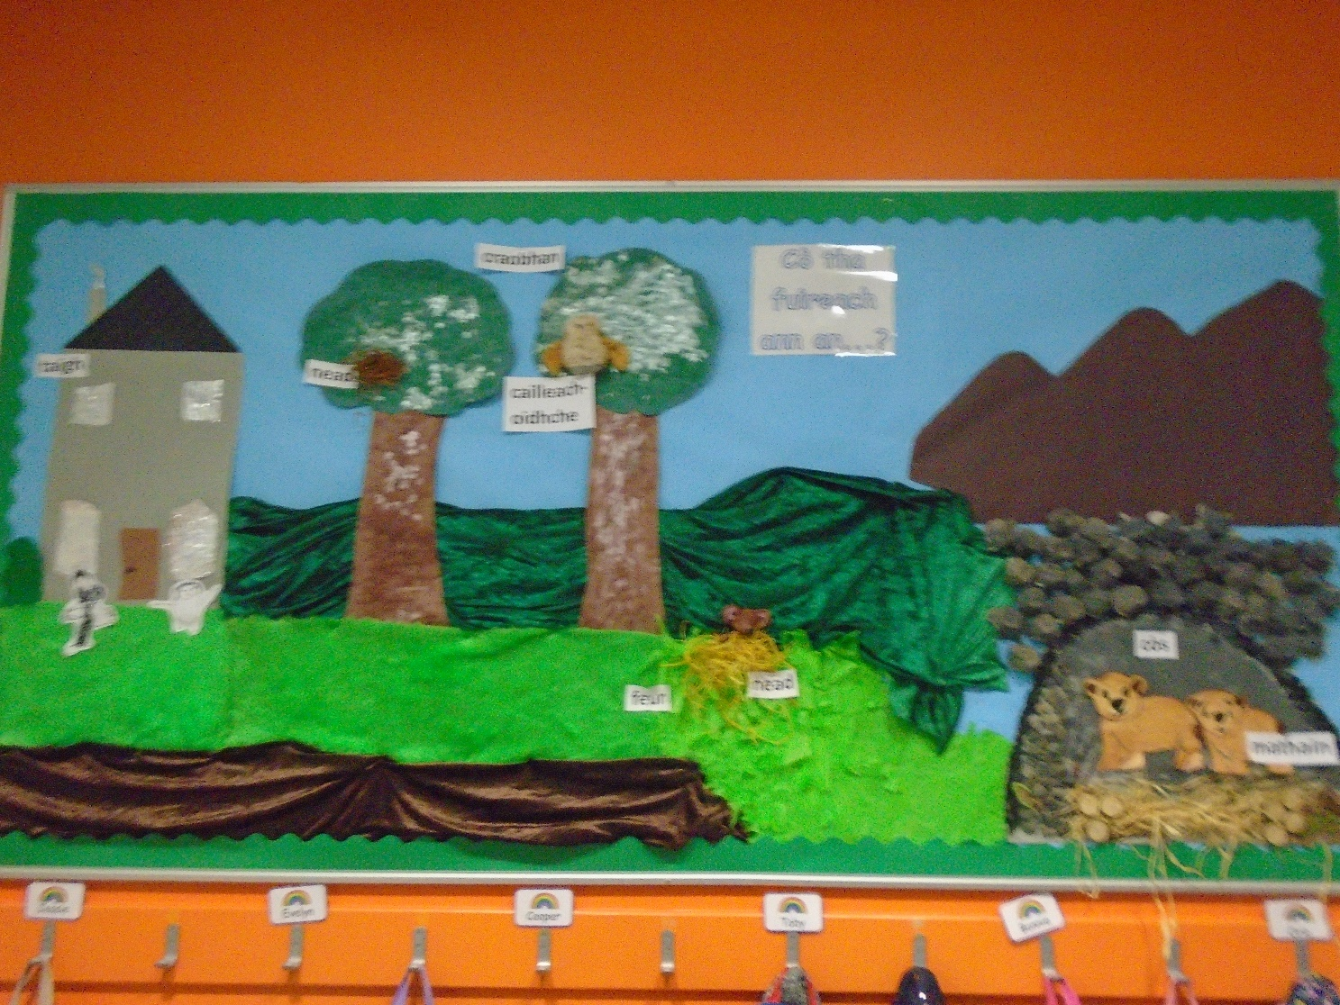

Ann an teirm a h-aon dh ’fhaighnich a’ chlann mòran cheistean mu dheidhinn beathaichean agus càite an robh iad a ’fuireach. Air sgàth sin thagh sinn cuspair a dhèanamh air beathaichean agus na h-àrainnean aca. Chaidh sinn cuairt sa choimhearsnachd dh'fhaicinn far a bheil diofar bheathaichean a 'fuireach

In term one the children asked a lot of questions about animals and where they lived, because of that we decided to make animals and their habitats our topic. From this topic we did activities which included going out walks in our community to see where different wildlife lives.

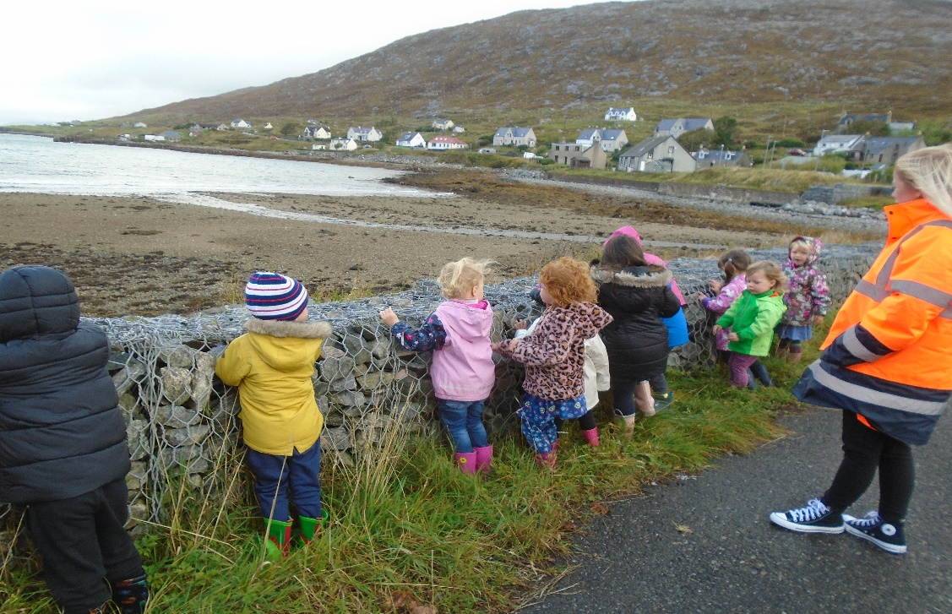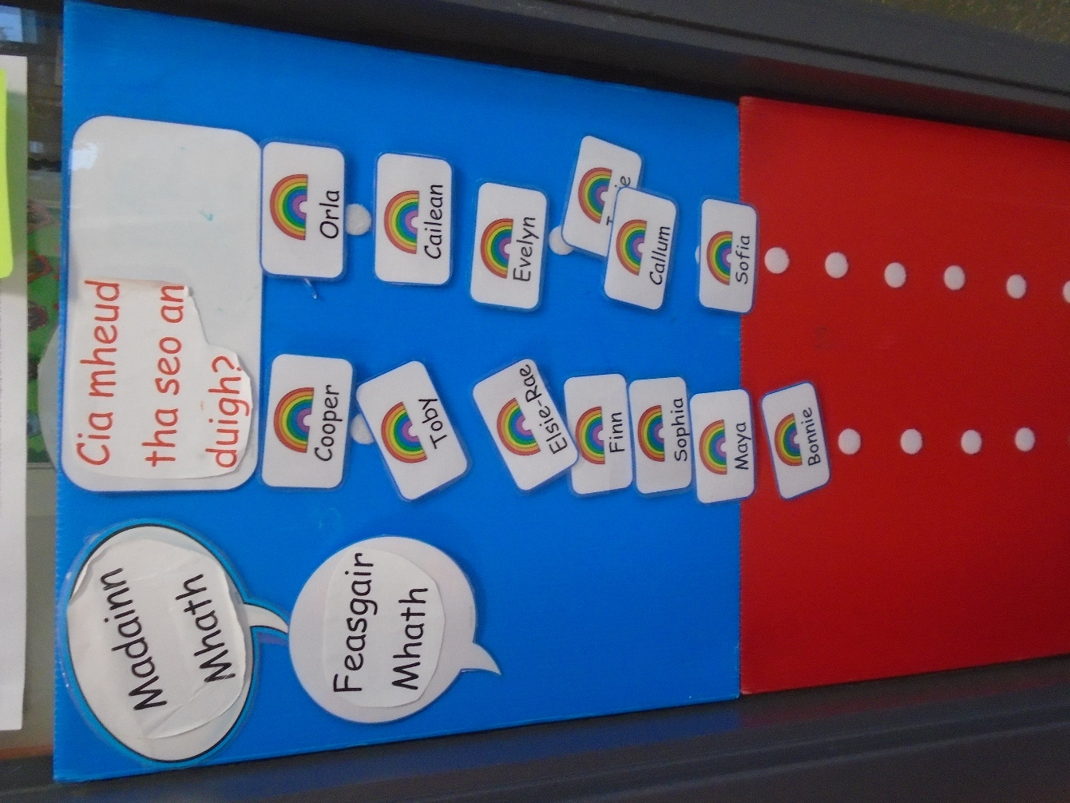

Gach madainn bidh a ’chlann a’ crochadh an t- ainm aca suas air a ’bhalla agus bidh iad gan cuir air ais nuair a theid iad dhachaigh aig deireadh an latha.

Each morning when the children come in they get their name and hang it up on the wall inside the room and then put it back when they go home.

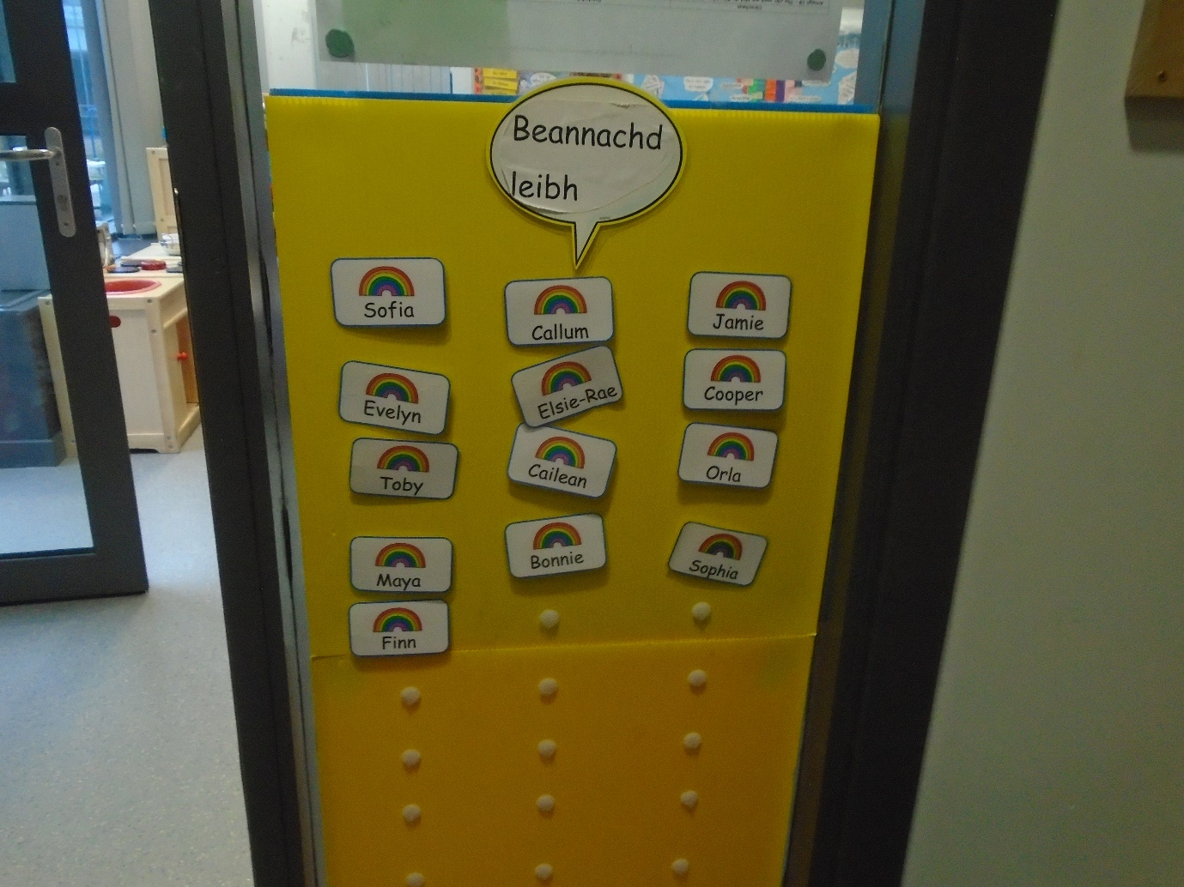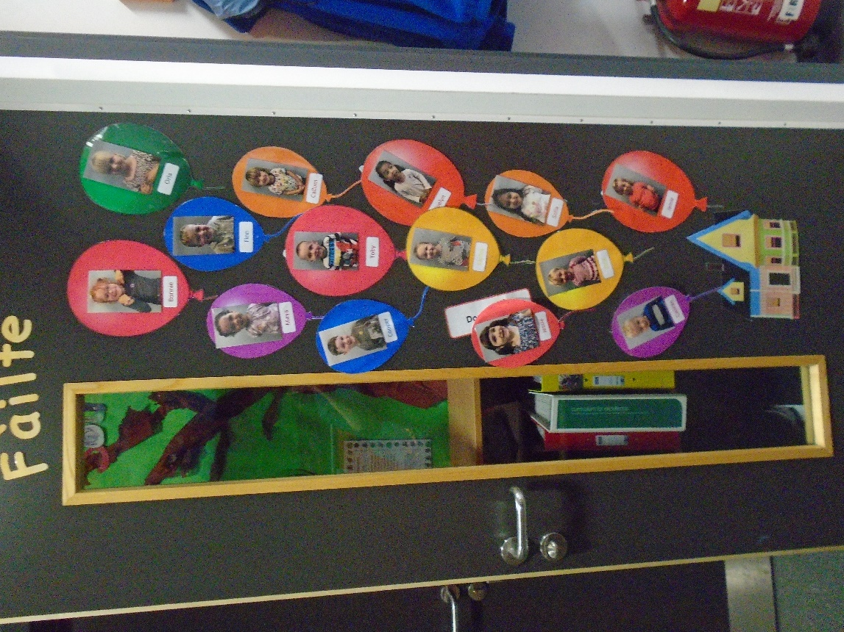

Seo an doras againn le dealbhan is ainmean na cloinne air.

This is our door with all the children’s names and photos on it.

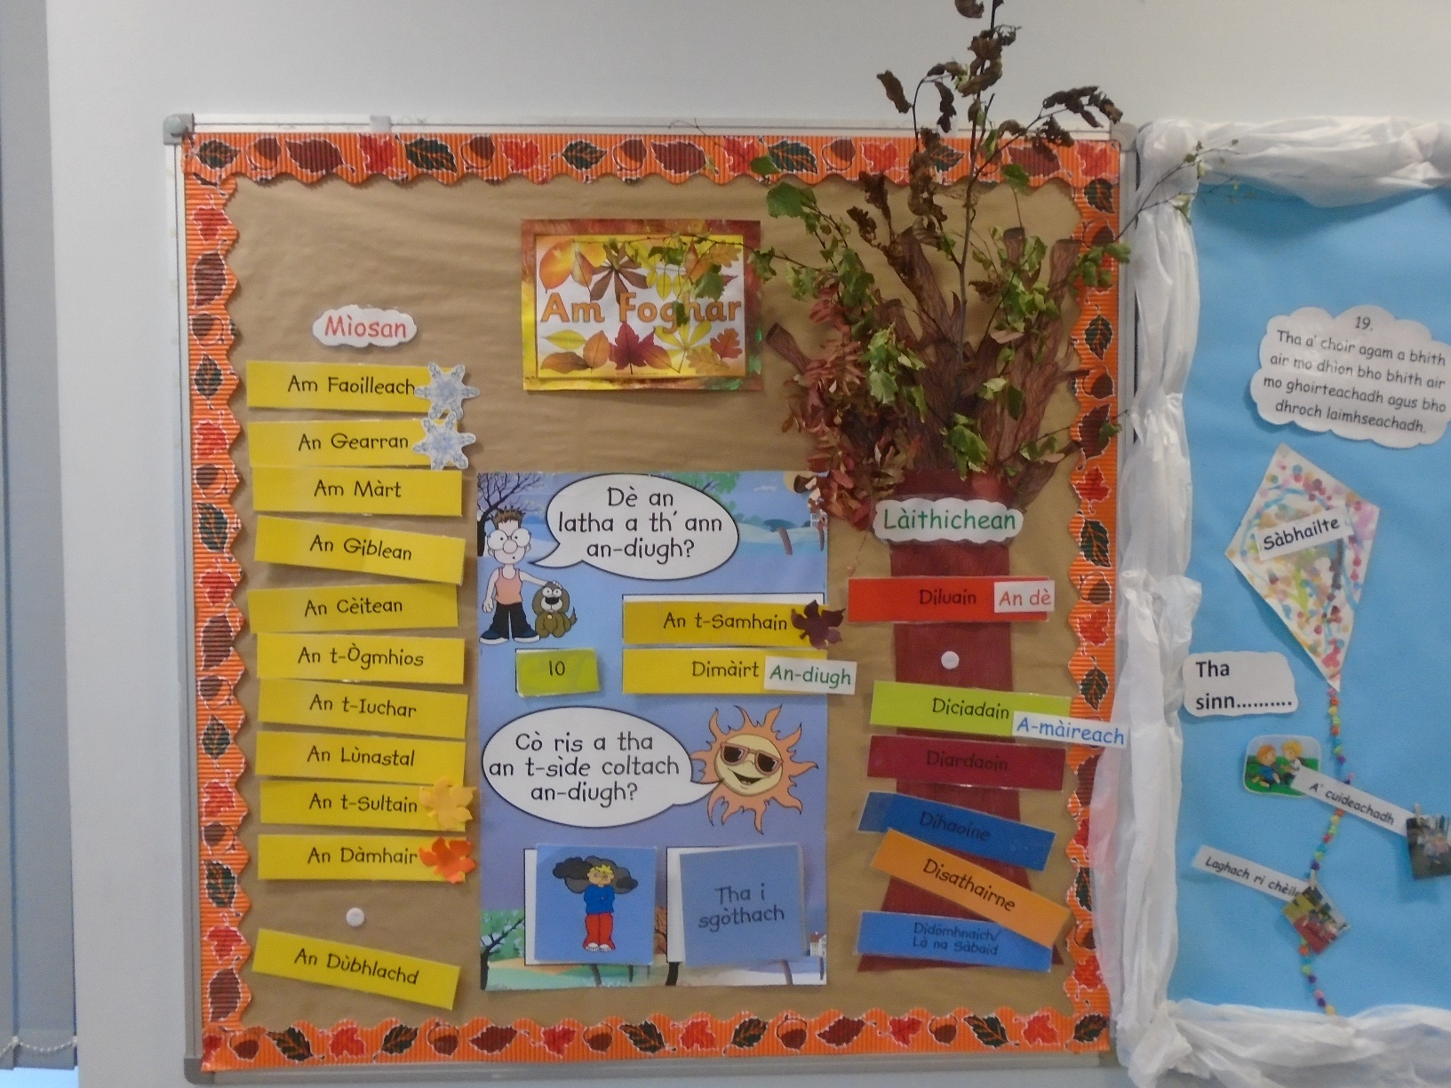

Seo an taisbeanadh againn mun ràithean, tha a ’chlann ag ionnsachadh làithean na seachdain, an dèit, na mìosan agus an aimisir ann an gaidhlig.

This is our wall display about seasons, days, date, month and weather, the children are learning what they are in gaidhlig.

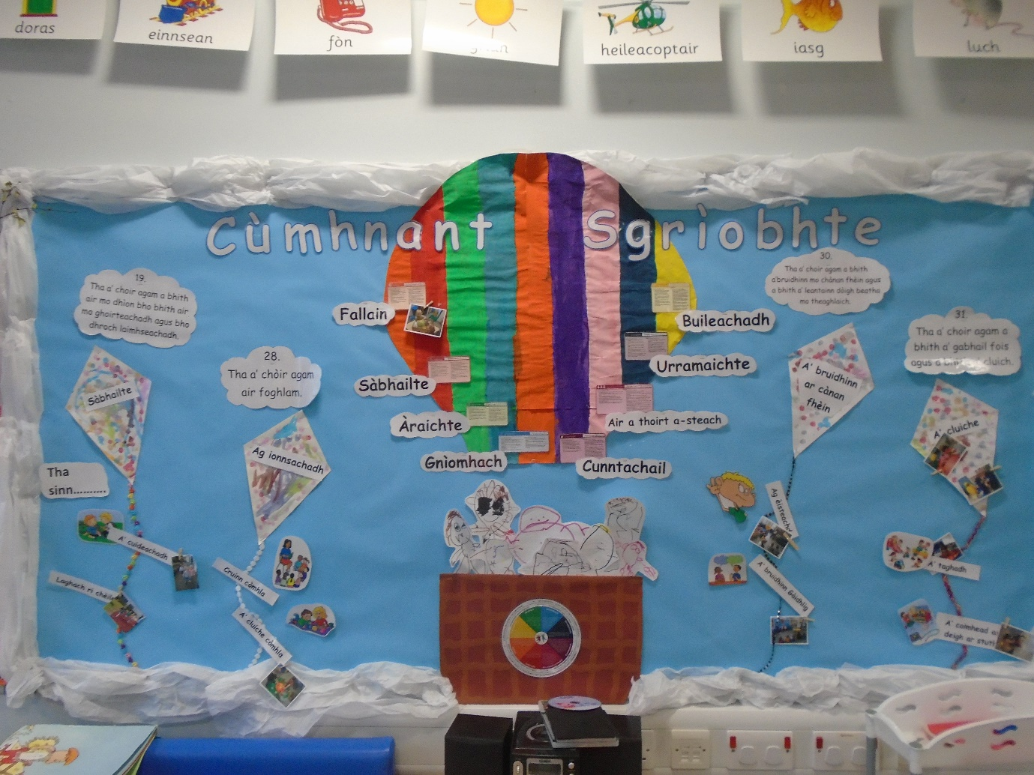

Seo an taisbeanadh againn mu dheidhinn Cùmhnant còraichean na chloinne , tha sinn a ’cuideachadh na cloinne le bhith a’ tuigsinn dè na còraichean a th ’aca.

This is our display on the childrens rights, we are helping them understand what their rights are.

Seo am balla Ealain Chruthachail again, an t-seachdain sa chaidh pheant clann triunsearan pàipeir agus rinn iad peapag leotha. An t-seachdain seo tha iad air dealbhan de chleasan-teine ​​a dhèanamh a ’cleachdadh cailc.

This is our expressive arts wall, last week the children painted paper plates and made them into pumpkins, this week they drew fire works using chalk.

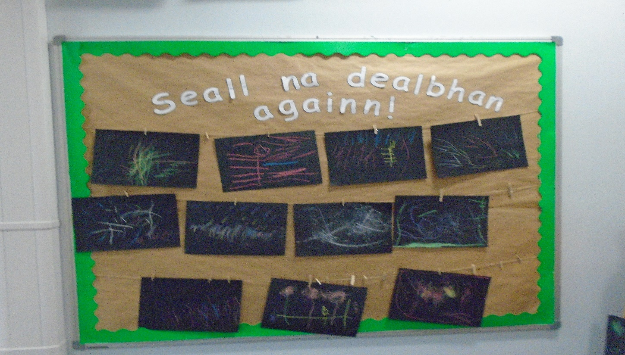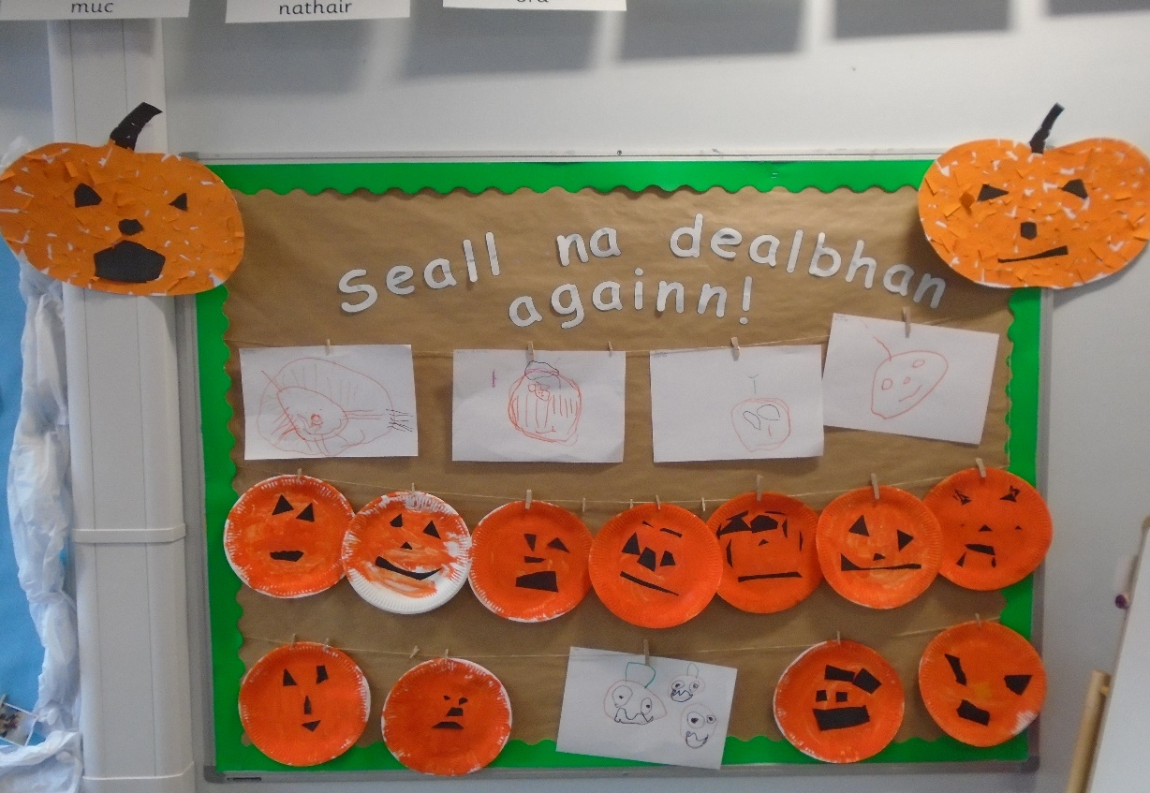

Tha am balla seo mu dheidhinn teaghlaichean na cloinne, dh ’iarr sinn air a’ chlann dealbh a dhèanamh de na teaghlaichean aca agus an uairsin chuir sinn dealbh an teaghlaich ri thaobh.

This wall is about the children’s family’s we asked the children to draw picture of their families then put a photo from home beside it.

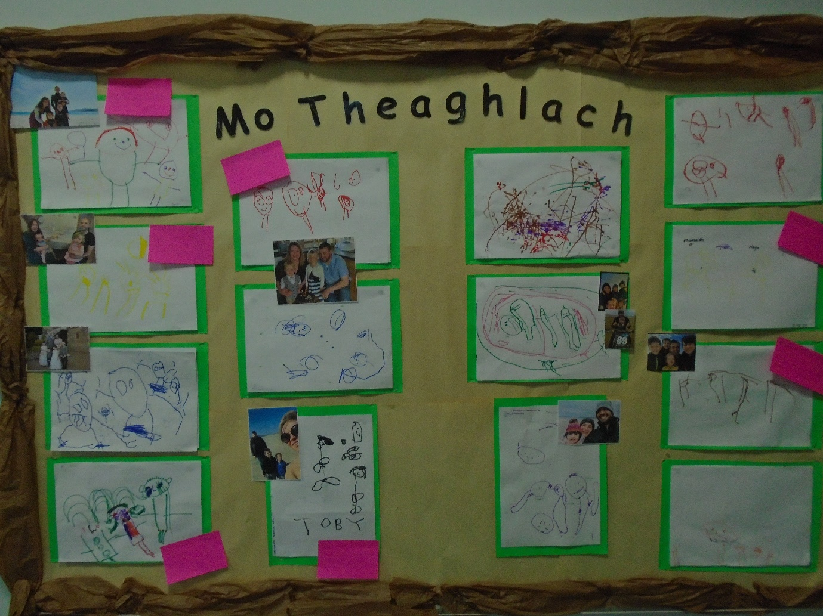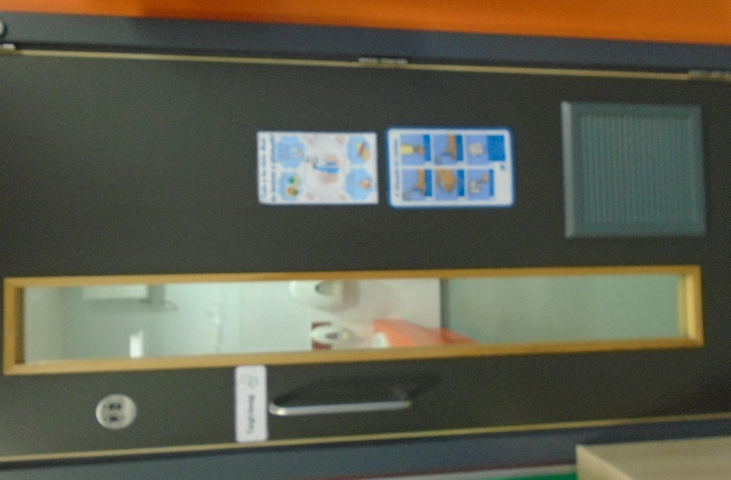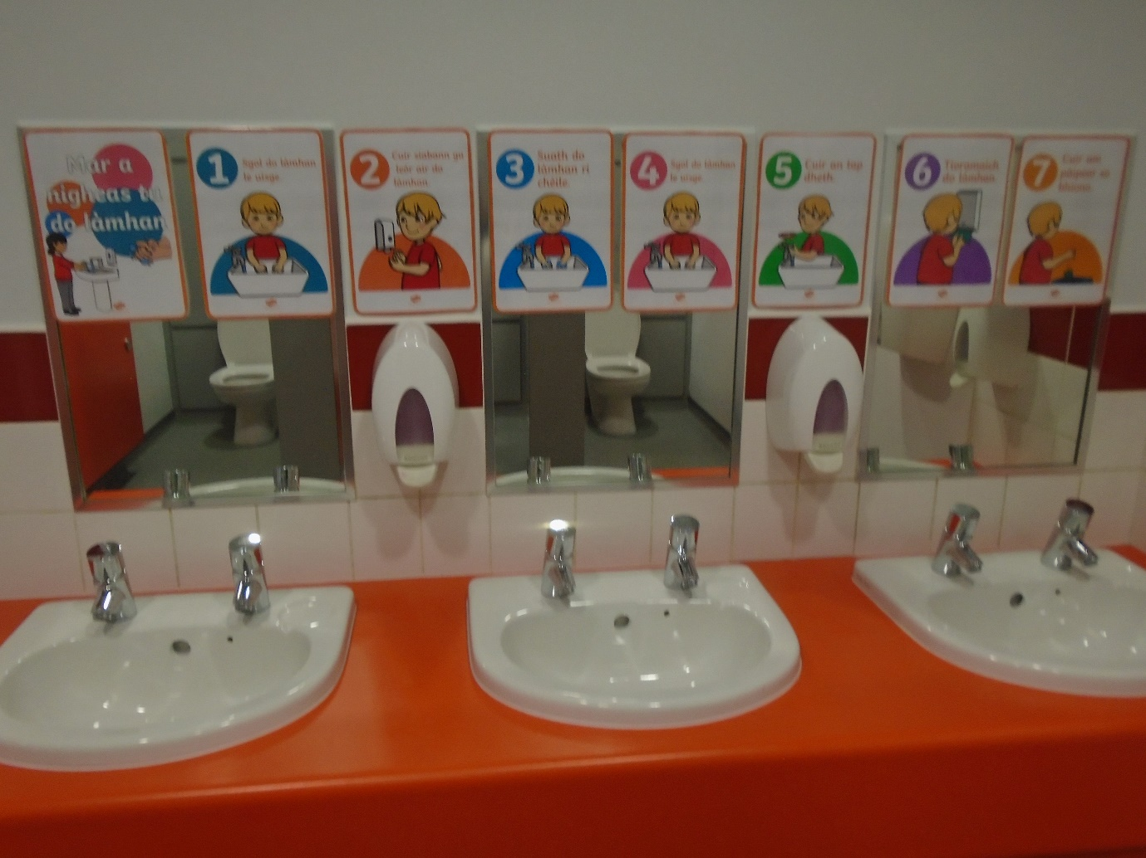

Air sgàth an corona virus feumaidh sinn ar làmhan a nighe nas trice. Airson a ’chlann a tuigsinn mar a bhios sinn gan nighe ceart tha postairean againn an àrd a ‘sealltain dhaibh ciamar a nigheas iad na làmhan aca ceart. Bidh sinn gan cuideachadh cuideachd.

Because of the coronavirus we need to be washing our hands more often, to help the children understand how we do it properly we have posters up to help them understand and we also help them.