|  |  |  |
| --- | --- | --- |
| See the source imageMaidinn | See the source imageFeasgar | See the source imageOidhche |
|  |  |  |

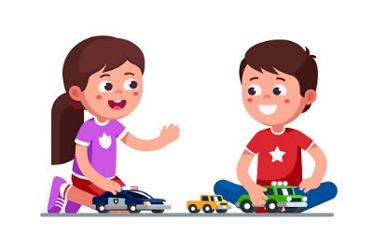[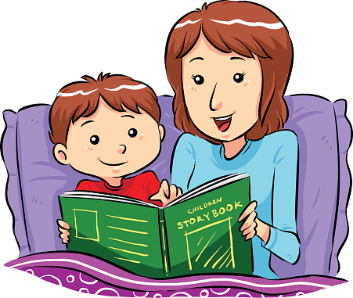](https://www.google.co.uk/url?sa=i&url=https://www.istockphoto.com/vector/mum-reading-bedtime-story-to-little-son-gm465846597-33553366&psig=AOvVaw1YlrwPVRM9GoLxwkk_BtLj&ust=1591868641728000&source=images&cd=vfe&ved=0CAIQjRxqFwoTCOD45_n69ukCFQAAAAAdAAAAABAJ)

