COMHAIRLE NAN EILEAN SIAR

Leverhulme memorial school
handbook

LEABHRAN FIOSRACHAIDH

SGOIL AN T-ÒIB

2023
INTRODUCTION & WELCOME
RO-RÀDH & FàILTE

Fàilte gu Sgoil an t-Òib, bun-sgoil far am bheil foghlam tro mheadhan na Gàidhlig agus clas Beurla le sgoilearan a tha ag ionnsachadh beagan Gàidhlig cuideachd. Chaidh an leabhar seo a dhealbhadh airson fiosrachaidh a thoirt dhuibh air an obair a tha sinn a’ dèanamh anns an sgoil agus tha fiosrachadh ann mu dhiofar nithean co-cheangailte ri foghlam. Tha pàrantan gu mòr nam pàirt dhan sgoil againn agus tha sinn deònach taic a thoirt do pharantan aig àm sam bith a thaobh foghlam na cloinne.

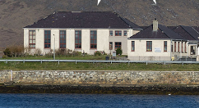

Welcome to Leverhulme Memorial School, a school which provides education through the medium of Gaelic as well as English. This handbook offers an introduction to our school and a general overview of the education your child will be getting at Leverhulme Memorial School. We hope you find the information helpful and self explanatory.
The School and Parent Council always welcomes contact with parents of current or prospective pupils. We would be happy to give you further details or discuss any queries which you may have about the school at any time.

Miss Donna Maclean MR Kenny Macleod
Head Teacher Parent Council chairperson

To make our handbook easy to use, we have divided the information up into five different sections.

CONTENTS / CLÀR-INNSE

Section One – Information about the School and Contact Details

Section Two – School Ethos and Parents as Partners

Section Three – School Curriculum, Assessment and Reporting

Section Four – Support for Pupils and Transitions

Section Five – School Improvement and School Policies Information

Please note that the information in this school handbook is considered to be correct at the time of publication (December 2020), however, it is possible that there may be some inaccuracy by the start of the school term in August 2021.
SECTION ONE

INFORMATION ABOUT THE SCHOOL - FIOSRACHADH MUN SGOIL

Contact Details Fiosrachadh feumail

Name of Head Teacher: Miss Donna Maclean

Name of School: Leverhulme Memorial School / Sgoil an t-Òib

Address: Leverburgh, Isle of Harris, HS5 3TS

Telephone Number: 01859 502980

Email Address: leverhulmeschool@gnes.net

School website: bit.ly/leverhulmeprimary

Parent Council Contact: Mr Kenny Macleod

About the Classes Mu Chlasaichean na Sgoile

Leverhulme Memorial School/Sgoil an t-Òib is a Primary School which has Gaelic Medium and English provision. This session there are currently ten pupils taught through the medium of Gaelic in the multi-composite P1-7 class and 10 pupils in the English class also in a P1-7 composite.

The school has a nursery class, Sgoil Àraich an t-Òib, which provides pre-school education in Gaelic for children aged 2 to 5 years. The provision operates during term time with hours similar to our school day. There is currently one child in the nursery.

Organisation of the School Day Uairean na Sgoile

Start Time: 09.15

Morning Break: 11:00-11:15

Lunch Time: 12:45-1.30

Finish Time: 3.15

Staff Luchd-Obrach

Sgoil Àraich Staff
Miss Jenny MacAulay Nursery Key worker

Teaching Staff
Miss Donna Maclean HT and P1-7 Gaelic teacher (2 days)
Mrs Fiona MacKenzie P1-7 Gaelic class teacher (3 days)
Mrs Kirsty Macleod P1-7 English class teacher
Mrs Mairi Macleod RCCT cover (1½ days)

Visiting Teaching Staff
Mr Iain MacIver Gaelic Singing and YMI Instructor
Ms Ashley MacDonald Piping / Chanter tutor

Non-Teaching Staff
Mrs Donalda MacKinnon School Assistant
Miss Rachael Campbell Support for Learning Assistant (27 hrs)
Mrs Fiona MacLean Cook
Miss Donna M Maclennan School Cleaner

Attendance and Absence Frithealadh

It is the responsibility of parents to ensure that their children attend school. Regular school attendance is important as the law requires it and it ensures that important schoolwork is not missed. With your co-operation we hope to minimise absences.

If pupils cannot attend school because of illness or other circumstances parents should contact the school in the morning to explain their child’s absence. If a parent fails to notify the school, a member of staff will make contact by phone before 9.45am.

It would also be useful if a note could be sent to the school explaining any expected long term absence, in advance of the pupil's return to school.

Parents must put all requests for leave of absence to the head teacher in writing, giving full information on the exact date, time and reason for the absence. A sample form for this purpose is available from the school office.

Please note that family holidays taken during term time, unless for exceptional circumstances, will be classified as unauthorised. If your child is absent and no explanation is given, then the absence will also be marked as unauthorised.

Calendar of Holidays for 2022 – 2023 Làithean-Saora
Term – Spring 2022
5th January  16th February | School opens - staff & pupils  Inset day for staff – School closed for pupils
17th, 18th & 21st February | School closed – staff & pupils (occasional holidays)
1st April | School closes - staff & pupils
Term – Summer 2022
19th April | School opens – staff & pupils
29th April and 2nd May  3rd June | School closed - staff & pupils (occasional holidays)  All schools (Queen’s Platinum Jubilee)
25th June | School closes - staff & pupils
Term – Autumn 2022
15th August  18th August | School opens – staff (three Inset days)  School opens – pupils
14th October  14th October | School closes – staff & pupils  (occasional holiday)
Term – Winter 2022
26th October | School opens – staff (one inset day)
27th October | School opens - pupils
25th & 28th November | School closed - staff & pupils (occasional holidays)
22nd December | School closes - staff & pupils
Term – Spring 2023
5th January  15th February | School opens - staff & pupils  Inset day for staff – School closed for pupils
16th, 17th & 20th February | School closed – staff & pupils (occasional holidays)
31st March | School closes – staff & pupils
Term - Summer 2023
17th April | School opens - staff & pupils
28th April & 1st May | School closed – staff & pupils (occasional holidays)
29th June | School closes – staff & pupils
School Uniform Èideadh Sgoile

Our policy is to encourage the wearing of school uniform and we continue to seek parental co-operation in this.

The school colours are navy and classic red. Parents/pupils can choose which of the two colours of uniform they prefer. Orders for the uniform are taken in May/June in readiness for the new session in August.

Style | Size 3/4 , 5/6 , 7/8 , 9/10 , 11/12 | Xs, sm, med, lge, xl, xxl
Sweatshirt | £7.95 | £9.95
Polo shirt | £5.95 | £7.95
Fleece jacket | £12.95 | £14.95

N.B. Prices may vary from year to year.
Please mark all items with your child’s name as garments are often lost or found.

The fleece jackets are very popular and are excellent value. The fleece jacket is also available in red or navy with the school logo embroidered in the contrasting colour.

For PE lessons, pupils should wear shorts (not track suit trousers) and a t-shirt or polo shirt. Footwear worn should be appropriate for indoor use as well as sport outdoors.
The school from its funds provides pupils with plastic clogs to wear indoors in class.

Footwear and Clothing Grants Taic a thaobh Èideadh

All parents in receipt of Family Credit or Income Support are eligible and encouraged to apply for a clothing grant to ensure that their children are able to make use of educational provision. Application forms for clothing grants are available from the Department of Education, Skills and Children’s Services, Sandwick Road, Stornoway. Telephone 01851 822729/ 822763.

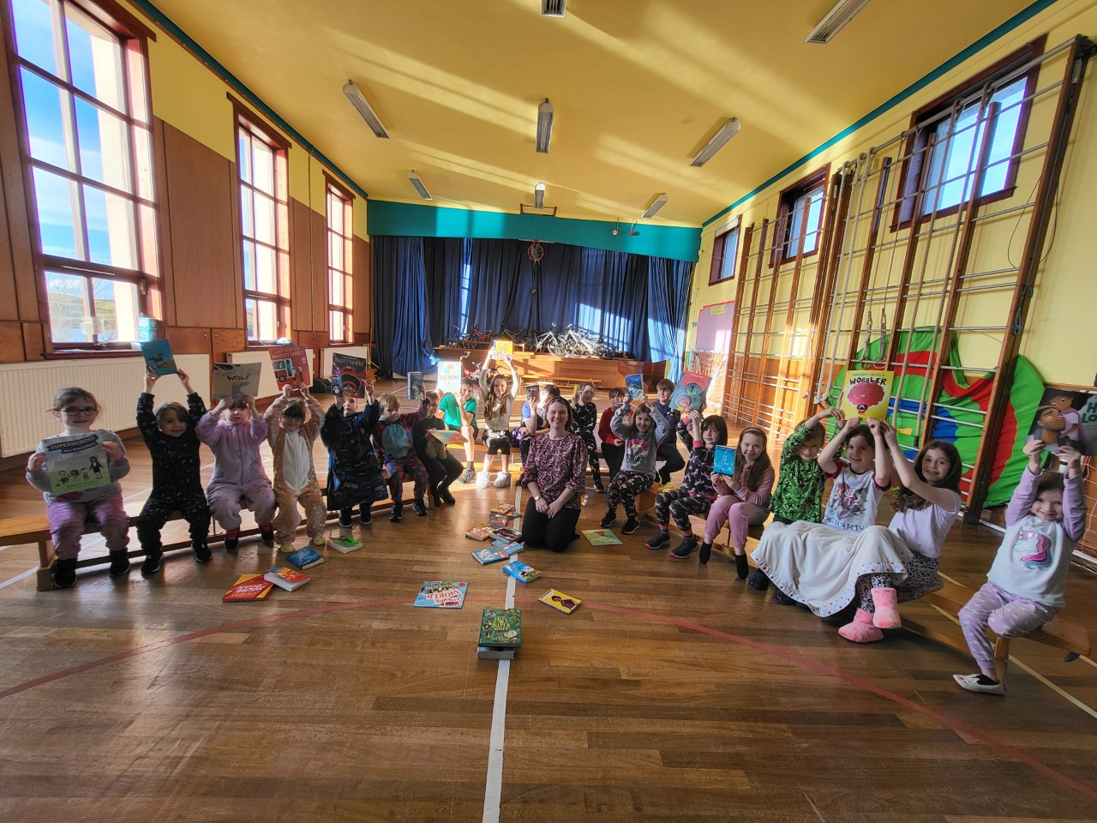

School Meals and Snack Biadh na Sgoile

School Menus offer healthy and tasty meal options which reflect the Scottish Government food and drink legal requirements for school lunches. All pupils in P1-5 classes may opt to take a free meal as part of a Government initiative. Children of parents in receipt of Income Support are also entitled to free meals and application forms are available from the school office for parents who are eligible.

School meals are served daily in the school canteen and are prepared on the premises. Menus are planned on a monthly cycle and parents are issued with a copy.
Lunches cost £2.09 and payment is made via an online payment system.

Parents should let the school know in advance if their child has any special dietary requirements. If this is the case, parents will be invited to a meeting to review menu options and a form will be completed, on receipt of a letter from a doctor or a dietician.

Children having a packed lunch from home also sit and eat in the Dining Room. We strive to be a 'Health Promoting School' and we would ask for parents’ co-operation in ensuring that the contents of packed lunches are healthy.

In the interest of health and safety, glass bottles are discouraged.

Parents should inform the school if children intend to go home at lunch time.

A mid-morning snack of milk and toast or fruit is offered to all pupils in the school on a daily basis. This is currently free to all pupils and is paid for using the generous fundraising proceeds received from the Parent Council and Forum.

Mobile Phones A’ Cleachadh Fònaichean-Làimhe

We generally discourage pupils from bringing mobile phones or other valuable items to the school on the grounds that they may get lost or stolen. If a phone or other valuable item is brought to the school, parents are advised that, where possible, the items should be marked in some way to aid future identification if lost and subsequently found.
If a pupil does bring a mobile phone to school, the phone must not be used on school premises, grounds or during off-site school curricular activities (such as swimming or other sports activities) without the express approval of a member of school staff, or in emergencies. The same rule applies for the use of cameras on phones.
If a pupil is found by a member of staff to be using a mobile phone for any purpose, without authorisation, the phone may be confiscated from the pupil and will generally only be returned to the pupil’s parent.

Travel to and from School Busaichean na Sgoile

Primary School children living two miles or more from school and Secondary School children living three miles or more from school have always been entitled to free transport. Currently children living nearer may also use the buses without paying a fare.

Transport for Leverhulme Memorial School pupils is provided by a main bus operator and a sub contractor:

Lochs Motor Transport  Tel 01851 860 288 | Brings in children from Nisabost, Borve, Scarista and Northton.
South Harris Coaches  Tel 01859 520 259 | One minibus serves Rodel. (Another minibus would serve any children living in or moving to Strond or Borrisdale.)  SHC take children from Northton, Scarista, Borve and Nisabost home at the end of the school day.

Following consultation some years ago regarding the catchment areas for our school, the boundaries were extended on the west side of the island to include Horgabost, while the boundary on the east side of the island was extended as far as Geocrab.

We ask parents to inform the school should there be any changes to the normal home arrangements. It is the parent’s responsibility to make sure their child arrives at the pick up point on time and behaves in a safe and acceptable manner while boarding, travelling in and leaving the school transport vehicle. Children who misbehave can lose their right to home to school transport.

Communication with Home Litrichean Sgoile

From time to time your child will bring home important and routine communications from the school. Parents are encouraged to check their child’s schoolbag for any communications. We would like to encourage more communication by email and would ask parents who have not already done so to provide us with their email addresses. Groupcall, a text / email messaging system, is now regularly used as the quickest means of communicating unplanned changes during the school day.

It is important that parents inform the school office of any changes to mobile phone numbers or email addresses.
Unexpected Closures Dùnadh tràth no Èiginneach

It may be necessary, occasionally, to close the school at short notice and send the pupils home, for example, in exceptionally bad weather or if the electricity or heating fails. If parents are not regularly at home during school hours, they should always make arrangements to have someone available to receive their children should such an emergency occur. The school will ask each parent at the point of enrolment to provide the address and/or telephone number of a person who can be contacted in these circumstances. Please ensure this information is kept updated and notify the school of any changes.

Parents should also feel free to contact the school if they are concerned about the safety of the children because of severe weather conditions and are free to call for them at any time. An additional phone line 01859 520469 is available for this purpose.

In the event of the school having to close before the start of the day, the following procedure will apply and Groupcall text messaging will be used:

- The Headteacher contacts the Radio Scotland Helpline and the local radio station for announcement on the Gaelic programme between 7.30 and 8.30am.
- The Headteacher contacts bus companies to inform them of the need to close the school.
- The Headteacher contacts the staff who are due in school that day to inform them of the decision.
- The School Assistant will use Groupcall, text or contact parents by phone.
- The Headteacher informs Faire and the Education, Skills and Children’s Services Department about the closure.

Complaints, Comments and Suggestions Procedure Conaltradh

We are keen that you should be completely satisfied about your child’s education and we encourage feedback from parents and pupils. We are, therefore, interested in feedback of all kinds, whether it be compliments, suggestions or complaints.

If you have a complaint about the school, please let us know. It is better that these things are shared openly and resolved fairly rather than being allowed to damage the relationship between the family and the school. There will be no negative consequences arising from making a complaint and we will deal with the issue as confidentially as possible. If we have made a mistake we will apologise quickly and clearly and try to put things right.

There are some things which you should take note of in relation to making a complaint:

- Please make any complaints initially to the Head Teacher. This makes sure that the school knows what is going on and has an opportunity to respond and resolve the issue.

- If you are unhappy with the service or with our response then you will have the right to take the matter further. You can put your complaint in writing or fill in a complaint form. Completed forms should be sent to: Director of Education, Skills and Children’s Services, Comhairle nan Eilean Siar, Sandwick Road, Stornoway, Isle of Lewis, HS1 2BW.
- If you are still unhappy after further investigation and reply, you can take the matter up with the Scottish Public Services Ombudsman. The reply letter will include the contact details.

Medical & Health Information Fiosrachadh Slàinte

Parents should inform the school without fail of any relevant medical history affecting their child eg asthma, epilepsy, diabetes etc of which teachers should be aware. Staff will keep this information on file and share only as appropriate. There are some pupils who may require to use medicines or asthma inhalers during the school day. Any such medication must be handed in to the Head Teacher together with a signed letter from either a Doctor or the Parent/Guardian stating:
- Name of pupil.
- The name of the drug and the reason for taking it.
- Whether the medication has been prescribed by the parent or Doctor.
- The correct dosage and the daily time of issue.
- The completion date of the medication.

Any pupil who feels unwell in school or suffers an accident should inform a teacher or a member of the support staff who will make arrangements along with the head teacher to inform a parent of the child concerned and/or seek medical advice if necessary.

In some cases it may be necessary to send your child home but this will only be done after discussion with the parent/carer/emergency contact to make and confirm suitable arrangements, including transport, if required.

The School is visited regularly by Public Health nurses who may carry out P1 medical checks; flu immunisation programmes and occasionally give talks to P6/7 pupils. Parents will be informed and asked for their consent in advance of any medical inspections taking place involving their child.

Dental Services

As part of the Childsmile programme all our pupils and children in the Sgoil Àraich are encouraged to brush their teeth after lunch or snack, every day. It is assumed that all will participate unless they have a signed letter from a parent requesting to opt out of the daily toothbrushing routine.
Dental hygienists visit the school to carry out annual P1 and P7 dental surveys as well as providing a fluoride varnishing programme for pupils who have parental consent.

If any child requires dental treatment, parents should make an appointment for their child at the Dental Clinic where they are registered and we would ask that they inform the school of any appointments throughout school hours.
SECTION TWO
PARENTAL INVOLVEMENT and SCHOOL ETHOS
COM-PÀIRTEACHAS agus AMASAN NA SGOILE

This section contains information about how parents can be involved in their child’s learning and the life and work of the school, and covers - supporting learning at home, improving home/school partnerships and parental representation.

Our school welcomes parental involvement as research has shown that when parents are involved, children do better in school. We promote an ‘open’ school and are always responsive, providing discussions between parents and staff when requested.

We encourage parental communication in a range of ways e.g. through letters, termly newsletters, phone calls and calling in person to the school. Information is sent home from time to time e.g. about useful websites to support learning at home. Seesaw and homework diaries provide tools for continuous engagement about children’s learning and termly parent events are held throughout the year. These may be pupils sharing their learning events, information evenings or parent appointments to discuss children’s progress. Parents are invited to attend review meetings if their child has any additional support needs and to contribute to updating their Child’s Assessment and Individualised Educational Plan or Action Plan targets.

Parents are also regularly involved in the school through fundraising events e.g. helping with teas at the South Harris Agricultural Show, at Bonfire night and Christmas concerts. We also rely on parents to become school volunteers in various capacities including accompanying children on trips. As staff we acknowledge that this input benefits our pupils greatly and are indebted to parents for giving their time.

We encourage parents to share their views and gather parent opinion through questionnaires which are normally issued every second year.

Parent Representation Comunn nam Pàrant

Parents/Carers are encouraged to volunteer or put themselves forward to be chosen as representatives on the Parent Council. The role of the Parent Council is to:
- Support the school in its work with parents
- Represent the views of all parents
- Encourage links between the school, parents, pupils, pre school groups and the wider community
- Report back to the Parent Forum (all parents are members of the Parent Forum).

Every primary year group and the Sgoil Àraich are represented on the Parent Council. Two co-opted members, the Head teacher and a teacher representative and local councillors also attend meetings. The Parent Council meets at least once per school term. All meetings are open and every parent is welcome to attend. Minutes of meetings are emailed to all.

Parentzone is a useful website which provides information and resources for parents and Parent Councils – https://education.gov.scot/parentzone
School Ethos Amasan na Sgoile

Sgoil an t-Òib endorses the Education, Skills and Children’s Services Department Vision and Aims which are displayed throughout the school.

We intend to review our vision, values and aims and to update our Curriculum rationale this year. We also hope to work towards a Rights Respecting Schools Silver Award.

We have used the school abbreviation LMS as our vision statement to represent:

Literacy, Maths and Sport Litearrachd, Matamataig agus Spòrs

We encourage staff to do “all for the children for all the children” and pupils to always do their best, “Dean do dhìcheal.”

Our values:

to be:
friendly, kind, safe, happy, welcoming, fun, peaceful, honest, responsible and caring.

We endorse the wellbeing indicators from Getting it Right for Every Child which all pupils spent some time discussing last session.

Our aims:

At Leverhulme School / Sgoil an t-Òib we will aim to:

- promote the use of Gaelic language and local culture throughout the school

- develop a common rationale and work with children, parents and staff to improve our learning

- develop a culture of ambition and achievement and improve success for children

- involve children in the highest quality learning activities

- support children in reaching their full potential and enable all to be leaders

- work together well with other agencies and the community

- reflect on our work, feel challenged and celebrate success

- provide young people with the skills needed for learning, life and work

Pupil Committees, Partnerships and Achievements Ag obair Còmhla

All pupils are involved in weekly groups such as our Activity, Media and Eco School groups. The views of the pupils are sought regularly through assemblies, learner conversations and through focus groups such as Rights Respecting Schools. Our school received its fourth Green Flag in November 2020 and is currently awaiting a decision regarding receiving a fifth Green Flag.

The School has established partnerships with various organisations, bodies and people who have worked with the school throughout the session. These links include workshops and talks led by a range of organisations such as West Harris Trust, Lucky2Bhere and Feisean nan Gaidheal events.

The school has been involved in a number of fundraising efforts e.g. Blythswood Shoebox and Save the Children Christmas Appeals. Last session local citizenship activities involved children and staff volunteering in annual village clean ups with members of the community as part of Keep Scotland Clean. The children in the Sgoil Àraich visited the local Care Home once a month and P6/7 pupils organised weekly armchair athletics activities for the residents.

Children’s achievements are shared using Seesaw and individual certificates or photos are displayed in school and are normally celebrated at whole school assemblies also.

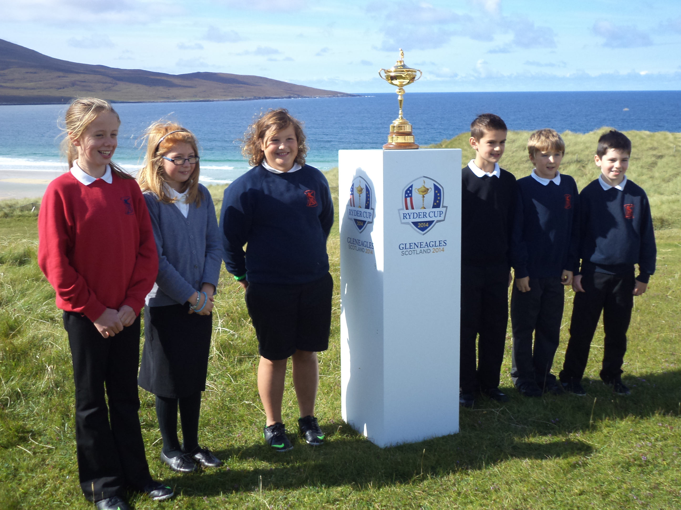

Pupil Conduct Riaghailtean Modh

A partnership between the school and parents is required in order to ensure the best possible standard of pupil conduct. Pupils are expected to set themselves high standards in appearance and behaviour.

Children and staff have worked together on rights and responsibilities and have produced various charters for Rights Respecting School wall displays. This will be further developed as we work towards achieving Silver Rights Respecting School status.

The above will hopefully replace our Code of Behaviour / School Rules which are relatively simple to allow for the smooth running of the school.

The general aim is to produce an atmosphere of friendly co-operation, encouraging respect and consideration for other persons and property.

School Rules / Code of Behaviour Brosnachadh Deagh Mhodh

- Be kind and polite to each other.

- Show respect to everyone.

- Be helpful.

- Be well behaved.

- Keep the school and grounds clean and tidy.

- Look after school equipment, furniture and the school buildings.

- Walk in the classrooms and corridors.

- Welcome new pupils and visitors to the school.

- Remember not to play in the toilets and avoid areas that are out of bounds.

- Remember to come to school prepared.

- Never leave the school without the permission of a member of staff.

Health & Safety Sàbhailteachd

Ball games are permitted in designated areas of the playground.
Snowballing is strictly prohibited, as serious injury could be caused to eyes and face.
Children must not climb fences, walls or any other structure.
Smoking on school premises is strictly prohibited.
Children must not bring anything to school that can cause injury or harm to another pupil or damage to school property.
Children should not bring mobile phones or other valuable items to school on the grounds that they may get lost or stolen.

Pastoral Support Arrangements Taic do Sgoilearan

Our school assistant provides playground supervision as required and our support for learning assistant and/or Head teacher fulfil any First Aid requirements at the school.

Dealing with Bullying Burraidheachd

Parents should inform the School immediately if they become aware of any incidents of bullying. The children should be encouraged to discuss any worries or problems of this nature with the teachers, or a member of the support staff, as soon as possible.

The school promotes positive behaviour through giving pupils responsibilities e.g. buddying.
SECTION THREE

THE SCHOOL CURRICULUM AN CURRAICEALAM

Every child and young person is entitled:
- to experience a curriculum which is coherent from 3 to 18.
- to experience a broad general education.
- to develop skills for learning, life and work, with a continuous focus on literacy and numeracy, and health and wellbeing.
- to personal support and challenge to enable them to gain as much as possible from the opportunities which Curriculum for Excellence can provide.

Gaelic Language Immersion Bogadh sa Ghàidhlig

Comhairle nan Eilean Siar adopts a Gaelic first policy in its schools where P1 pupils are expected to enroll in a Gaelic medium class. Parents may however opt for the Curriculum to be delivered within an English Medium class. Benefits of bilingualism are well documented and staff in the school would be happy to discuss these with you.

In Gaelic Medium Primary Education only Gaelic is used for learning, teaching and assessment from P1 to P3. This is referred to as Gaelic language total immersion. From P4, English is gradually introduced, with Gaelic remaining the main language of the classroom, in order for pupils to maintain and develop Gaelic fluency further.
By the end of P7 pupils should be able to use both languages fluently and confidently.

A sheet with further information about GME in Sgoil an t-Òib is contained in Appendix 1

Curriculum for Excellence Curraicealam airson Sàr Mhathais

Curriculum for Excellence provides a broad and deep general curriculum that develops skills for learning and life, with a real focus on literacy and numeracy while promoting an active and healthy lifestyle. Ultimately, the aim is to improve children’s achievements and to nurture successful learners, confident individuals, effective contributors and responsible citizens. Its principles i.e. challenge and enjoyment; breadth; progression; depth; personalisation and choice; coherence; and relevance will be addressed through discrete subjects and inter disciplinary projects.

Children have had increased opportunities to develop within the four capacities through more detailed planning covering the ethos & life of the school, curriculum areas and subjects, interdisciplinary projects and personal achievement opportunities.

Parents can find out more information on the Scottish education curriculum at: https://education.gov.scot/education-scotland/scottish-education-system/policy-for-scottish-education/policy-drivers/cfe-building-from-the-statement-appendix-incl-btc1-5/experiences-and-outcomes/

and the Comhairle website also contains relevant policies and guidance https://www.cne-siar.gov.uk/schools-and-learning/policies-procedures-and-guidelines/

Our updated School policies will be added to our website which is currently being developed. This may be accessed using the following domain bit.ly/leverhulmeprimary
Subject areas include Literacy and Languages (English, Gaelic and French), Numeracy and Mathematics, Health and Wellbeing which includes PE, Expressive Arts (Art & Design, Music, Dance and Drama), Religious and Moral Education, Social Studies, Technologies and Sciences.

Literacy and Language (English, Gàidhlig, Gaelic & French)
The teaching of Language is covered through the four modes of Listening, Talking, Reading and Writing which are in constant interaction. English and Gàidhlig literacy skills are developed and reinforced across the curriculum. Under plans for Languages 1+2, Gaelic will be taught across all stages in the primary and French introduced in P5.
Numeracy and Mathematics
To achieve a balance of Mathematical experiences pupils will cover a range of activities based on Number, Money and Measurement, Shape, Position and Movement and Information Handling. Numeracy skills are developed and reinforced across the curriculum.
Health & Wellbeing
Work is undertaken within the following framework:
~ Mental, emotional, social and physical wellbeing
~ Planning for choices and changes
~ Food and nutrition
~ Substance misuse
~ Relationships, sexual health and parenthood.
Movement skills, Physical activity and sport and health are also covered under H&WB.

Expressive Arts
Expressive Arts encompasses four subject areas: Art & Design, Dance, Music and Drama. Our pupils currently benefit from tuition by a Gaelic singing instructor who also provides Youth Music Instruction for P5-7 in keyboard playing or guitar tuition.

Social Studies
The Social Studies experiences and outcomes are structured under three main organisers:
~ people, past events and societies
~ people, place and environment
~ people, society, economy and business.
Pupils will be taught through a range of topics covering those areas.

Religious and Moral Education
While Christianity is the basis of our Religious and Moral Education programme, pupils also gain some knowledge of World Religions selected for study.
Technologies
ICT will be used to enhance learning in all subjects. Technological developments in society will be investigated as well as a focus on food and textiles. Craft and design contexts will be used to develop technological skills and knowledge.

Sciences
Through learning in the sciences, children develop their interest in, and understanding of, the living, material and physical world. The key concepts the children will study are:
~ Planet earth
~ Forces, electricity and waves
~ Biological systems
~ Materials
~ Topical Science

Sports & Extra Curricular activities Spòrs & Cur-seachadan

We have a spacious playground and access to the playing field and running track for athletics and outdoor games. Classes may also use the playpark adjacent to the school within school hours if accompanied by school staff. Pupils have two hours of PE per week and PE equipment is available for pupils to use outdoors at break times.

To ensure equity across Western Isles schools, swimming provision should be focused at the Primary 4 age group, with possibly P3 and P5 also benefitting in smaller schools. In recent years all classes have had a block of four swimming lessons, in two groups, with a trainer and lifeguard at the Tarbert Pool, in place of their PE slot in term four.

The pupils take part at the Harris School Sports and in some competitions held throughout the session e.g. Crossroads Football and events organised by Active Schools such as Tchoukball.

Last session football training, arranged by parent helpers and volunteers on Fridays after school in the gym and a weekly athletics club were well attended by the pupils. Parents have involved children in events and organised Football competitions.

All the children are encouraged to participate in Christmas performances and also to take part in competitions at the local Mod in June every year.

Home Learning Obair-dachaigh

Homework packs are issued weekly, on a Monday and to be handed in on Friday. Some homework activities will reinforce work which has already been taught in school. On occasions, some research work may be set as part of class topic work. Pupils may also be expected to read for information or pleasure and to practise tables and spelling skills regularly, if necessary. Computer activities e.g. Education City and other website resources such as Sumdog, will also be set as homework.

Children spending some time at home with their parents, sharing and reflecting on what they have learned at school, would also provide a worthwhile learning experience. As a rough guide 15 minutes (P1 and P2); 30 minutes (P3, P4 and P5) and 45 minutes (P6 and P7) should be sufficient for both reading and home learning activities.
Religious & Moral Education & Religious Observance
Creideamh agus luachan sòisealta

As a school we aim to develop the spiritual, moral, social and cultural values of our pupils, having regard to the values of the community, and guided by the recommendations contained in national and regional guidelines.

As a non-denominational school, we cater for pupils from different religions and backgrounds. Before any Covid restrictions the Head teacher led weekly whole school assemblies, promoting aspects relating to Health and Wellbeing as well as Religious and Moral Education (RME). Class teachers also plan an RME lesson most weeks.

Any parents who may wish to exercise their right to withdraw their child from Religious Education lessons should put their request in writing to the Head Teacher.

Rev Mark MacLeod, our School Chaplain, leads mid-term individual class assemblies. Local Ministers or representatives from all the local churches are in turn invited into the school to participate at our end of term services. The Challenger Educational Bus with representatives from People with a Mission Ministries also visits the school from time to time. Parents will be informed before such visits take place.

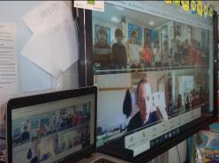

Sensitive Aspects of Learning Poileasaidhean Curam agus Socair

A range of policies exist covering care and welfare issues, for example, anti-bullying, anti-racism and child protection. All members of staff receive annual child protection refresher training.
As part of the Health and Wellbeing programme, primary schools are required to address difficult areas i.e. relationships, sexual health, parenthood and drugs education. Parents will be informed before lessons take place on these topics. Parents may request, if they wish, to view the resources being used for these lessons.

The P6/7 classes have well planned talks about puberty with health nurses and these usually take place every second year. This theme may also be covered in an age appropriate way within Science classes at other stages.

Last session a representative from NSPCC gave younger classes a talk about being safe and involved the older classes in workshops discussing a range of types of abuse.
Active Schools Na h-Eileanan an Iar

Active Schools work with schools and communities to help make sure children are active and stay active. The fundamental aim is to offer children and young people the opportunities and motivation to adopt active, healthy lifestyles, now and into adulthood. Our Active Schools Co-ordinator is Mrs Jenna MacLeod and she works with the school to develop an action plan of work which Active Schools can support through the school year.
Here are some examples of the activities which took place in the past year:

- Young Persons Leadership Awards
- Tchoukball taster sessions

Assessment Measadh

Assessment is the means of obtaining information which allows teachers, pupils and parents to determine what a pupil is actually achieving in relation to expectations of achievement and attainment and drawing conclusions from that comparison.

The experiences and outcomes within Curriculum for Excellence (CfE) will be used to form success criteria for children’s learning and a range of Assessment for Learning strategies, peer and self assessment will be used in class.

The table below highlights the stages at which the levels within Curriculum for Excellence apply:

CfE Levels | Stage/Classes
Early | the pre-school years and P1 or later for some
First | to the end of P4, but earlier or later for some
Second | to the end of P7, but earlier or later for some
Third/Fourth | S1 to S3, but earlier for some. Fourth level broadly equates to SCQF level 4.
Senior phase | S4 – S6 and college or other means of study

Highland Literacy and Numeracy assessments and a range of standardised tests are currently used at different stages throughout the primary which help staff to provide an overall educational profile of pupils e.g. Reasoning tests for all Primary 1 pupils and Cognitive Ability Testing in P5.

Within the English class Standardised National Assessments (SNSAs) are completed by all pupils in P1, P4 and P7 and Gaelic Medium P7 pupils will also be required to sit an English literacy assessment. Measadh Coitcheann Nàiseanta airson Foghlam tron Ghàidhlig (MCNG) assessments are available for Gaelic medium classes which all P1, P4 and P7 pupils will complete at different times throughout the session. As we have so few pupils being assessed at the different stages, our school’s attainment data is not published. However individual data will be shared with parents as appropriate.

Reporting to Parents Conaltradh ri Pàrantan

Reports on pupils’ progress are an important form of communication between home and school. Parents will receive a full written report in May and will also be given opportunities to discuss their child’s progress with the class teacher at Sharing the Learning mornings or during parents' evenings normally held in November and May. Children reflect regularly on their learning. They upload work onto Seesaw or write learning logs weekly and profile folders are maintained throughout the session.
P7 pupils also produce eprofiles as part of their transition to Sir E School activities.

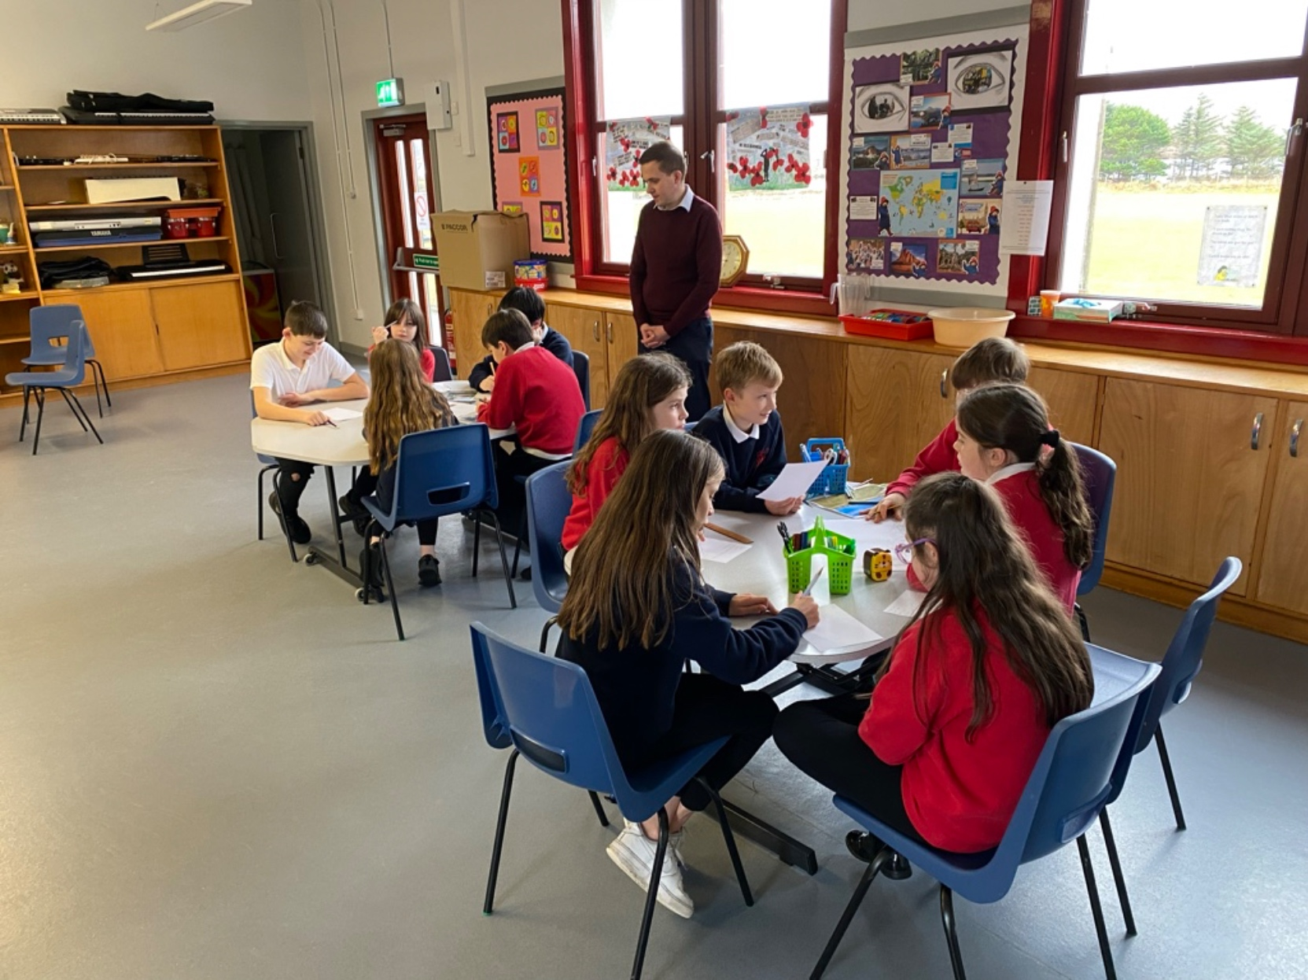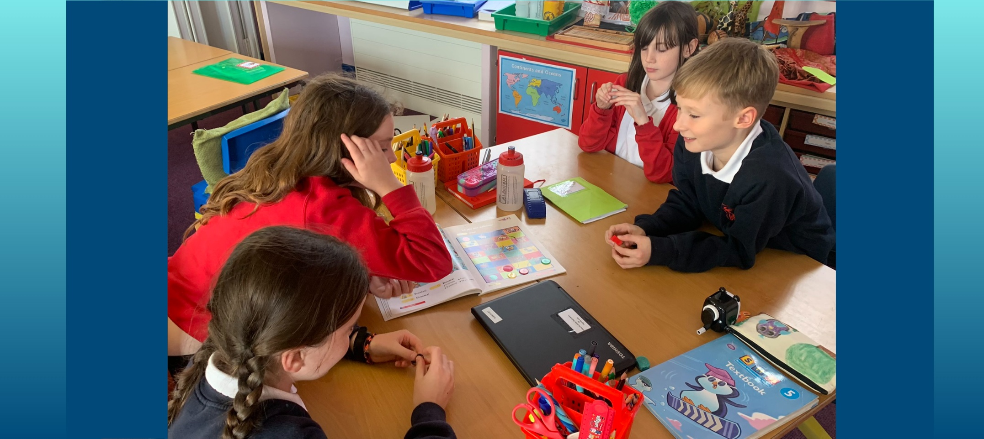

SECTION FOUR
SUPPORT FOR PUPILS
Additional Support Needs Feuman Ionnsachaidh Sònraichte

We aim as far as is possible to educate pupils who have additional support needs alongside their peer group. When necessary, extra help is provided. This help is delivered in a flexible manner and the pupils can be seen individually, in a group or class by the Support for Learning teacher/HT or a Support for Learning assistant.

The Additional Support Needs of the Children are identified through a process of Staged Assessment and Intervention. The process of Staged Assessment and Intervention provides a structured system for identification, assessment, planning, review and record keeping for individual children who receive additional support of any kind. The Getting it Right Approach for Children and Young People (GIRFEC) in the Western Isles puts in place a network to promote wellbeing so that children and young people get the right help at the right time.

A Child’s Assessment and Plan is used to ensure a co-ordinated approach to providing support for children and will summarise assessments carried out for the child, explain the nature of the child’s difficulties and outline the steps to be taken to support the pupil’s needs. An assessment service is also provided by the teacher of children with visual and hearing impairment. Speech Therapists and assistants may also visit schools to help any pupils who require support.

In addition, an Educational Psychologist advises on the varied behavioural and learning difficulties which all pupils can experience. She can work directly with pupils, or with groups of children and families on focussed themes, if required.

All Care Experienced children and young people are considered to have additional support needs unless the school establishes they do not require additional support. The Local Authority must consider whether each care experienced child requires a Co-ordinated Support Plan (CSP).

As with all local authority schools in Scotland, this school operates under the terms of the Additional Support for Learning Act(2009) and its accompanying Code of Practice. These procedures have been strengthened through the Children and Young People Act (2014).

Mediation is provided by Resolve in the Western Isles. It is a non judgemental voluntary process which seems to resolve misunderstandings in the early stages to prevent them escalating. Parents also have the right to have an advocate present at Mediation and this is available through Advocacy Western Isles.
Parents should also be aware of the following organisations which provide advice and further information.
- Children in Scotland: Working for Children and their Families, trading as Enquire – a charitable body registered in Scotland under registration number SC003527.
- Scottish Independent Advocacy Alliance, a charitable body registered in Scotland under registration number SCO33576
- Scottish Child Law Centre, a charitable body registered in Scotland under registration number SCO12741
Further information can be obtained locally from the School or Area Principal Teacher of Learning Support, Mrs Alex MacKay, who is based at the Council Offices in Tarbert.
Primary School Admissions Clàradh

Children who will be four years of age by 28th February 2022 are eligible for infant enrolment in August 2022. Enrolment takes place at the beginning of February, on a date specified by press advertisement.

In our school, pupils are taught through the medium of Gaelic unless parents indicate their preference for English medium at enrolment time. During enrolment, parents should being their child’s Birth Certificate and should inform the school of any medical problems or special needs which their child may have.
Other children, whose families have just moved into our catchment area, should be accompanied by a parent or guardian on their first day of reporting to school if they have not already been in contact with the school.

Placing Requests

If you wish to make a Placing Request to another school, you should complete the appropriate form (available from the school office) and return it to:
Mrs Louise Smith,
Principal Officer,
Education, Skills and Children’s Services,
Comhairle nan Eilean Siar,
Sandwick Road,
Stornoway
HS1 2BW.

If a Placing Request is successful, parents will be responsible for the safety and any transport costs for their child to travel to and from their chosen school.

Transitions Gluasadan

Sgoil Àraich/Nursery

Early learning and childcare enrolment usually takes place in February on a date notified to parents by local press advertisement. Children aged 2½ can be enrolled at the nursery if there is sufficient space and their birthday falls before the last day of February of the current academic year. Children receive funded places at the beginning of different school terms depending on when their 3rd birthday falls. If demand for places outweighs supply, priority will be given to children eligible for their pre school funded place before any non funded children. In situations where a 2 year old’s child’s parent(s)/carer(s) are receiving out of work benefits, a child is eligible for a place following their 2nd birthday. Children securing a funded early learning and childcare place are currently entitled to 1140 hours over 38 weeks i.e. 30 hours each week. Children who enrol in our Sgoil Àraich will be invited into the playroom for transition mornings to experience a little of the nursery atmosphere and to meet the nursery staff before starting on a full time basis.
More information can be obtained from Mrs Kayreen MacMilllan, Sgoil Àraich playleader.
Copies of our revised Nursery handbook will be made available in January 2021.

An electronic copy of the handbook is available on the Comhairle nan Eilean Siar website under Early Years Services: https://www.cne-siar.gov.uk/schools-and-learning/early-years-services/early-education-and-childcare/early-learning-and-childcare/nursery-information/

Transfer from Nursery to Primary

Before leaving nursery, a profile and transition record for each child will be prepared by nursery staff to hand over to Primary School staff to ensure a smooth transition and continuity of education for the child transferring to Primary 1. There will also be a number of visits to the Primary Classes in the lead up to the child (ren) commencing in P1 as well as the class teachers visiting the Sgoil Àraich.

Throughout the session the Sgoil Àraich children are encouraged to join the primary classes for activities such as assemblies and end of term services which assists with transitions.

Primary to Secondary Transfer

Pupils completing Primary 7 will transfer to: Sir E Scott Secondary School
Tarbert,
Isle of Harris
Telephone Number: 01859 50 2900

Pupils may be offered enhanced transition activities where our P7 class may spend some Friday mornings with P7 pupils in Sir E Scott School. As well as getting to know fellow P7 pupils, activities include completing a transition booklet, meeting secondary teachers and finding out about the layout of the school. Two or three full transition days to SES Secondary will also take place during May. During this time parents will be invited by the Head teacher of the receiving school to attend an open afternoon where any questions in relation to Secondary education will be answered.
An overnight residential stay and activities is planned at Scaladale Centre every June.
Pupil progress is shared with SES senior management team towards the end of the school year. Pupil Support staff may visit the school to see P7 children within their classes and to speak with the class teachers. Additional arrangements will be put in place to support pupils with additional needs to make successful transitions.
Education Statistics Privacy Notice

Transferring Educational Data about Pupils
The Scottish Government and its partners collect and use information about pupils in schools (e.g. the number and characteristics of pupils, their attendance, absence and exclusions, their attainment and their destination when leaving school) to help to improve education across Scotland. This note explains why we need this information, how we use it and what we do to protect the information supplied to us.

Why do we need your data?
In order to make the best decisions about how to improve our education service, Scottish Government, education authorities and other partners such as the SQA and Skills Development Scotland need accurate, up-to-date data about our pupils. We are keen to help all our pupils do well in all aspects of school life and achieve better examination results. Accurate and up-to-date data allows us to:

- plan and deliver better policies for the benefit of all pupils
- plan and deliver better policies for the benefit of specific groups of pupils
- better understand some of the factors which influence pupil attainment and achievement
- share good practice
- target resources better
- enhance the quality of research to improve the lives of young people in Scotland

Data policy
Information about pupils’ education is collected through our statistical surveys in partnership between the Scottish Government and Local Authorities through the ScotXed Programme which aims to help schools and Local Authorities by supporting efficient collection, processing and dissemination of statistical information. The Scottish Government then provides analysis of the data to support research, planning, management and monitoring of education services as well as to produce National Statistics publications.

Education data within Scottish Government is managed effectively by secure systems and is exploited as a valuable corporate resource, subject to confidentiality restraints. As part of its data policy, Scottish Government will not publish or make publicly available any information that allows individual pupils to be identified, nor will data be used by Scottish Government to take any actions in respect of individuals. Data is held securely and no information on individual pupils can or would be made publicly available by Scottish Government.

The individual data about pupils in schools collected by Scottish Government through statistical surveys is used only for the statistical and research purposes for which it is collected.

Your data protection rights
The collection, transfer, processing and sharing of ScotXed data is done in accordance with the Data Protection Act (1998). We also comply with the National Statistics Code of Practice requirements and other legislation related to safeguarding the confidentiality of data. The Data Protection Act gives you the right to know how we will use your data. This note can give only a brief description of how we use data. Fuller details of each individual ScotXed survey, including the purpose of each and the published data, can be found on the ScotXed website (http://www.gov.scot/Topics/Statistics/ScotXed). Pupil names and addresses (other than postcode) are never collected in any ScotXed statistical survey.

Scottish Government works with a range of partners including Education Scotland, Skills Development Scotland and the SQA. On occasion, in order to help meet our aim of improving the life of young people in Scotland, we may make individual data available to partners such as the National Registers of Scotland to carry out research relating to the national population census and also to academic institutions and organisations to carry out additional research and statistical analysis which helps inform policy development and contributes to improving outcomes for Scotland’s people. In order to carry out this research to support better decisions, policy making and practice, data may be linked to information from other sources.

Any sharing or linkage of data will be done under the strict control of Scottish Government, and will be consistent with our data policy and the National Data Linkage Guiding Principles. This will ensure that no individual level data will be made public as a result of the data sharing and that these data will not be used to take any actions in respect of an individual. Decisions on the sharing or linkage of data will be taken in consultation with relevant colleagues and individuals within and outwith Scottish Government. At all times pupils’ rights under the Data Protection Act and other relevant legislation will be ensured.

Concerns
If you have any concerns about the ScotXed data collections you can email the Head of Schools Analysis, Mick Wilson, at mick.wilson@scotland.gsi.gov.uk or write to Education Analytical Services, Area 2D, Victoria Quay, Leith, EH6 6QQ.

SECTION FIVE

SCHOOL IMPROVEMENT LEASACHADH NA SGOILE

Policies follow Curriculum for Excellence principle and practice papers and experiences and outcomes for each subject. Benchmarks for curriculum subjects are used for assessment and moderation.

Standards & Quality Report for 2020-21 and School Improvement Plan for 2021-22

In October the school produced a Standards and Quality Report for 2020-21 which outlined the progress made on improvement projects last session. It also highlighted our progress within the core quality indicators as well as identifying key priorities, identified through self-evaluation, requiring improvement in this current session.

Section 3 of this document included the School’s Improvement projects for 2021-22. Areas of focus are closely linked to the National Improvement framework and our aim is to ensure that every child has an opportunity to succeed through closing any poverty related attainment gaps.

A copy of our Standards and Quality report for 2020-21 and School Improvement Plan for 2022-23 will be issued to parents via email. A copy will also be available on our School website which can be accessed using the following link:
bit.ly/leverhulmeprimary

Our improvement projects for this session are summarised below:

Our improvement projects for this session are summarised below:

- Improving transition opportunities at key stages, Gaelic language development and play pedagogy at all levels across the curriculum

Main aims include:
To review play experiences in the nursery and to promote learning throughplay opportunities at all stages
To plan Gàidhlig language development work at the early stages across nursery and P1/2.
To plan and undertake joint transition projects with cluster secondary school.
To raise the profile of Gaelic across the school especially for Gaelic learners.

- Support and promote an effective whole-school approach to Learning for Sustainability through global citizenship, sustainable development education, outdoor learning and children’s rights.

Main aims include:
To extend pupil’s learning in Social subjects especially in relation to global education.
To establish links with other school settings locally, nationally and explore global citizenship ideas.
To enhance outdoor learning and play experiences for Nursery and primary classes.
To engage in a range of activities relating to sustainability such as Eco Schools Live lessons.
To look at the UNCRC Rights and continue our Rights Respecting Schools improvement agenda

Termly newsletters also highlight school successes and help to keep parents informed.
APPENDIX 1


Sgoil an t-Òib
Leverhulme Memorial School

Gaelic Medium Education (GME) Information Sheet for Parents

‘GME is now an established sector in Scottish education. The aim is for young people to be able to operate confidently and fluently in two languages as they progress from early years, through primary education and into secondary school.’ (Statutory Guidance on Gaelic Education – prepared under Section 9 of the Gaelic Language (Scotland) Act 2005.)
‘Gaelic Medium Education, based on the principles of immersion with its resultant fluency, is recognised as the best way of achieving a sustainable future for the Gaelic language. (Education Scotland Advice on Gaelic Education, 2015)

What happens in Sgoil Àraich an t-Òib?

Gaelic early learning and childcare is a very important stage of Gaelic medium education. All children entering Sgoil Àraich an t-Òib will experience the usual activities that children do in early learning and childcare through the principles of immersion. Children learn Gàidhlig by being immersed in the language within the playroom and while outdoors.
Our play leader and nursery keyworker aim to use all available opportunities to develop the children’s understanding and acquisition of Gaelic through our local context, songs, games, stories and through play. Helpful detailed guidance on total immersion is contained within the Education Scotland Advice on Gaelic Education and this information can be made available on request.

What does Gaelic Medium Education look like in Sgoil an t-Òib?

Gaelic medium education is open to everyone, those who speak Gaelic and those who do not. Normally children transition from our Sgoil Àraich into P1. Children moving into the local community who are new to Gaelic may join the class at the P1 stage. Pupils who have been educated within GME elsewhere may enrol into their appropriate class stage at any time during primary education.
Gaelic is the sole language of learning, teaching and assessment in the first three years of Primary School. From P4, English will be introduced but immersion education continues for all areas of the curriculum and Gaelic remains the predominant language of the classroom. The time allocated to English reading and writing activities within the Gaelic class will increase between P4 and P7 to approach parity with Gaelic by P7. As a rough guide the proportion of time devoted to English will range from 20% in P4 to 50% in P7. Homework activities will be used to support both languages. www.Gaelic4Parents.com provides online support and a national network for parents in GME. Please also refer to the accompanying information sheet containing relevant Gaelic ICT resources.

What happens when pupils leave Sgoil an t-Òib?

Children who have been educated through the medium of Gaelic in our school will study Gaelic for fluent speakers in Sir E Scott School which also offers a few subjects such as Eachdraidh (History) through the medium of Gaelic. Transition opportunities are provided prior to entering Secondary.
Research shows that children educated through Gaelic are on par with, or out-perform, children educated in one language. In the past few years local statistics show that pupils within GME in our authority in general perform better in P7 and S2 standardised assessments in English and Maths.
The Head teacher, GME class teacher and staff in the Sgoil Àraich would be pleased to discuss any further questions that you may have about Gaelic medium education in our school and Sgoil Àraich.

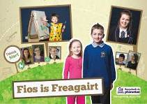

For further details please refer to the Fios is Freagairt packs issued which contain a helpful information booklet for parents, responses to frequently asked questions and CDs highlighting the benefits of bilingualism. (fiosrachadh do phàrantan, Comann nam Pàrant and Bòrd na Gàidhlig)

What are the advantages of Gaelic Medium Education?

The benefits of Gaelic Medium Education are increasingly being recognised.
The following is a summary of some of the potential advantages of bilingualism and bilingual education as outlined in ‘A Parents’ and Teachers’ Guide to Bilingualism’, by Professor Colin Baker, International Expert on Bilingual Education. This information appears on a leaflet within the Fios is Freagairt pack.

Communication Advantages
- Wider communication (extended family, community, international links, employment)
- Literacy in two languages

Cultural Advantages
- Broader enculturation, a deeper multiculturalism, and two ‘language worlds’ of experience
- Greater tolerance and less racism
Cognitive Advantages
- Thinking benefits (creativity, sensitivity to communication)

Character Advantages
- Raised self-esteem
- Security in identity

Curriculum Advantages
- Increased curriculum achievement
- Easier to learn a third language

Cash Advantages
- Economic and employment benefits

