
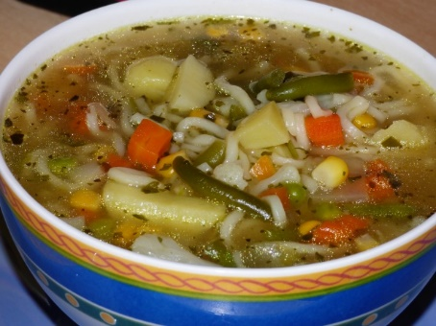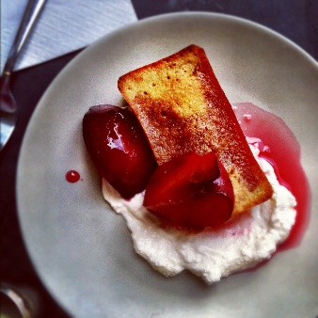

Soup & Pudding Lunch
Friday 25th September 2026
12noon – 2pm

Mums, dads, grandparents, aunties & uncles and neighbours are all invited to join us.

To help with catering numbers the pupils would like to know numbers in advance, please scan QR Code to fill in form.

School lunch on this day will be the soup & pudding lunch

