Be Bright - Be Seen

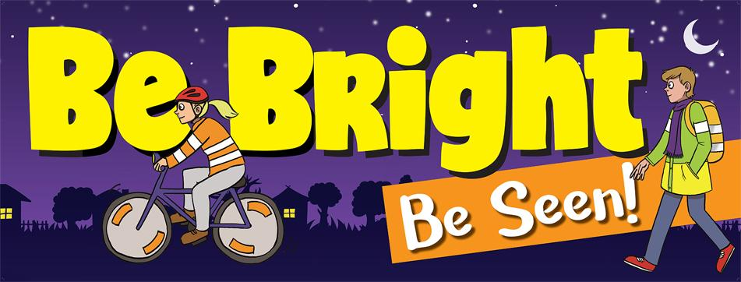

Top tips for Parents & Children
- Make sure you can be easily seen, especially at night, on dark days and in bad weather.

- Bright or fluorescent clothes show up best by day, even in dull or misty weather.

- In the dark, reflective material is best and shows up in car headlights - remember fluorescent clothing doesn’t work after dark. You can put reflective tape on your coat or school bag to help you to be seen by drivers.

- It is against the law to cycle at night without a white front light, a red back light and a red reflector at the back, so make sure that your bike is properly equipped and working. And remember always wear a helmet.

- Cross the road at the safest place possible. Remember to use the Green Cross Code – Stop, Look, Listen and Think.

- If you’re out at night, choose routes that are well-lit by street lights and cross the road at well-lit places.

- If there is no pavement and you have to walk on the road, always face the oncoming traffic – this is particularly important in poor light or in the dark.

A few preventative measures could make all the difference, so be prepared: Be Bright – Be Seen and stay safe!

