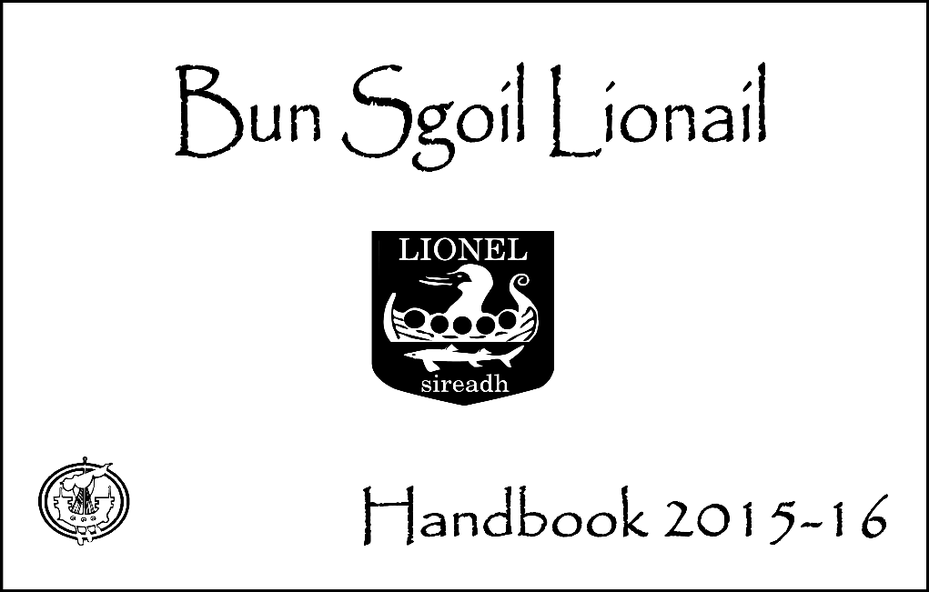



Dear Parents,

The staff and I would like to welcome all parents and their children, particularly those new to the school. This handbook offers an introduction to our school and a general overview of the education your child will receive.

We value the contribution parents make to their children’s education and we hope to work in partnership with you during your child’s time here.

You are always welcome to come in to school, or to telephone, to discuss any issues concerning your child.

If you are thinking about enrolling your child at Lionel School please contact the school office to make an appointment to meet with the Head Teacher or to request enrolment forms.

Yours sincerely,

**M. Alice Macleod**

Head Teacher

# Contents Clàr-innse

## 

## 

## PAGE

Welcome.………………………………...... 2

Contents…………………………………… 3

School Ethos……………………………… 5

Vision, Values and Aims............................ 5

The School……..………………………….. 6

School Information

Address / Telephone number / email 6

Current Roll...................................... 7

Staff.............................................................. 8

Enrolment…………………………………. 9

School Uniform……………………………. 9

School Day................................................... 10

School Transport.......................................... 10

Attendance.................................................... 10

School Meals................................................ 11

Communication with Home………………. 11

Emergency Closures..................................... 11

**PAGE**

Healthcare..................................................... 12

Discipline...................................................... 13

Bullying........................................................ 13

Religious and Moral Education..................... 14

Policies…………………………………….. 15

PE Kit…....................................................... 15

Homework.................................................... 15

Clubs and Activities…………………………. 15

Safety and Security....................................... 15

Additional Support Needs............................ 16

Transitions…………………........................ 17

Monthly Newsletter……………………….. 18

School Fund Expenditure.............................. 18

Mobile Phone Policy………………………. 18

Parent Council ……………………………. 19

Complaints, Comments and Suggestions…. 20

Curriculum for Excellence.......................... 21

The Four Capacities……………………… 22

Assessment.................................................. 23

Tracking Pupil Progress………………….. 24

Reporting Progress...................................... 24

School Improvement……………………… 24

Enterprise in Education …………………… 25

Pupil Involvement…………………………. 26

Community Involvement………………….. 26

School Holidays……………………………. 27

Sample Menus for School Meals………….. 28

Appendix 1 Allergens……………………… 30

Appendix 2 School Policies……………….. 29

The information in this handbook is accurate at the time of publication but may be subject to amendment during the school year. The school handbook will be revised in December each year.

# School Culture & Ethos Cultur agus Modhannan

We reflect the Christian values of our community in our relationships with others. We are kind and caring and show respect for one another.

We forge close links with community organisations such as Comunn Eachdraidh Nis and

Urras Oighreachd Ghabhsainn to develop in pupils a sense of belonging and an appreciation for the people, language, history and traditions of the district.

Our rich Gàidhlig heritage is celebrated through poetry, prose and song and we promote an interest in preserving and continuing the traditional way of life on land and at sea. We seek to develop responsible citizens who will make reasoned choices relating to the environment and to sustainable development.

Across the school, learning in technologies allows pupils to gain the skills and confidence to use technologies for learning, life and work in the 21st century.

We recognise and celebrate the attainment and achievements of everyone involved in our school and promote confidence, independent thinking and positive attitudes in the classroom, playground and wider school community.

# School Information Fiosrachadh Sgoile

1. **Address:**

Bun Sgoil Lionail

Lionel

Port of Ness

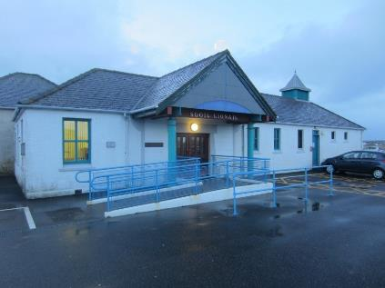

Isle of Lewis

HS2 0XB

Telephone: 01851 810 208

Fax: 01851 810 742

***E-mail:*** lionelschool@gnes.net

|  |  |  |  |  |  |  |  |  |  |  |  |  |  |  |  |  |  |  |  |  |  |  |  |  |  |  |  |
| --- | --- | --- | --- | --- | --- | --- | --- | --- | --- | --- | --- | --- | --- | --- | --- | --- | --- | --- | --- | --- | --- | --- | --- | --- | --- | --- | --- |
| 1. **Current Roll**    Sgoil Araich 18 English Gàidhlig    **P1** 6 6  **P2** 3 5  **P3** 9 5   |  |  |  |  | | --- | --- | --- | --- | | **P4** |  | 1 | 4 | | **P5** |  | 11 | 4 | | **P6** |  | 11 | 0 | | **P7** |  | 8 | 0 | | **Total** |  | 18 **nursery** |  | |  |  | **73** **primary** |  | |  |  |  |

# The Staff An Luchd-obrach

**Head Teacher** M. Alice MacLeod

## Manager, Sgoil Araich Lionail M. Alice MacLeod

**Teaching Staff**

|  |  |  |
| --- | --- | --- |
| **P1-3GM** |  | Mrs M MacLean  Principal Teacher |
| **P1-3EM** |  | Mrs M MacAskill |
| **P4-5EM** |  | Mrs F MacKenzie |
| **P4-5GM** |  | Miss H MacLeod |
| **P6-7EM** |  | Mrs A MacLennan |
|  |  |  |
| **Support for Learning** |  | Mrs S MacAulay |
| **Art** |  | Mrs M Smith |
| **Music** |  | Mrs E Rank |
| **P.E** |  | Mr D J Smith |
| **Gaelic Music Instructor** |  | Mr F Smith |
| **Chanter Instructor** |  | Mr N Gordon |

**Non-Teaching Staff**

|  |  |  |
| --- | --- | --- |
| **School Assistants** |  | Mrs K Libby  Mrs C Amos |
|  |  | Mrs M MacLeod |
| **School Auxiliaries** |  | Mrs J MacInnes  Mrs MA MacDonald |
|  |  | Miss H Macrae  Mrs A MacLeod |
|  |  | Miss D MacKenzie |
| **Nursery Play Leader** | | Mrs M Corbett |
| **Nursery Play Assistant** | | Mrs C MacDonald |

|  |  |  |  |
| --- | --- | --- | --- |
| **Catering Staff** |  |  | Mrs MA MacLean |
|  |  |  | Mrs A Ferguson |
|  |  |  | Ms J Evans |
|  |  |  | Mrs A Morrison |
| **Cleaning Staff** |  |  | Mrs S Rainbow |
|  |  |  | Ms J Evans |
|  |  |  | Mrs A Morrison |
| **Janitors** |  |  | Mrs M MacLeod |
|  |  |  | Mr T Waddington |

# Enrolment Clarachadh

Parents wishing to enrol their children are welcome to visit the school. They should telephone the school to arrange a time for their visit. Parents of children who are 5 years old before the end of the following February may enrol them for entry into primary one in August. Enrolment week is usually advertised in the Stornoway Gazette and we also display notices with specific dates in the nursery, local shops and the local newsletter.

Parents should come to school to complete an enrolment form and we also need to see the child’s birth certificate. Enrolment forms are available from the school office or Education and Children’s Services Department.

Parents wishing to apply for a place at a school other than the local primary school should apply in writing to:

**Louise Smith**

**Principal Officer - Administration & Staffing**

**Department of Education and Children’s Services**

**Sandwick Road**

**Stornoway**

**HS1 2BW**

# School Uniform Eideadh Sgoile

Comhairle nan Eilean Siar’s policy is that pupils attending schools within the Western Isles shall wear school uniform. We support that policy and encourage Sgoil Lionail pupils to wear their school sweatshirts regularly with a white polo top or shirt and a dark skirt or trousers. Parents can reinforce this by encouraging children to wear school uniform. Due to parental income, some families are eligible for a clothing grant from the Education Authority. Application forms, which must be submitted annually, are available from the school office or Department of Education and Children’s Services.

It is important that parents **label their children’s** **clothing**, particularly their sweatshirts and gym shoes so that any found articles can be returned immediately. The weather in Ness can be wet and windy and all children should bring a jacket to school. Sweatshirts, polo shirts, t-shirts and ties can be purchased through the school.

|  |
| --- |
|  |

|  |  |  |
| --- | --- | --- |
| **School Day** | | **Latha Sgoile** |
| **School**  **Starts Interval** | **School**  **Lunch Closes** | |
| 9.30am 10.45am –  11.00 am | 12.30 pm – 1.15pm (Infants) 3.30pm  12.45pm - 1.30pm (P4-7) | |
| **School Transport** | | **Busaichean na Sgoile** |

Primary school children living two miles or more from school are entitled to free school transport. Children who are not eligible for free transport will have to pay a contribution towards the cost of transport if they make use of it. It will be possible for parents to buy weekly books of tickets or purchase a termly pass or purchase a session pass.

Payment for the above can be made by direct debit if parents wish. The overall price is the same regardless of which method of payment parents choose. There is also a system of stepped discounts for families with more than one child travelling to school.

Buses usually pick up pupils between 8.40am and 9.10am.

As part of our Health and Well-being programmes, children are taught road safety which includes awareness of their own and others’ safety in cars and buses. We are also extremely fortunate in having caring drivers who take an interest in our children’s welfare.

Please make your own arrangements if sending pupils to another home after school as a seat on minibuses cannot be guaranteed.

Primary-aged pupils travelling onwards to Stornoway should ensure they pay the correct fare for the journey. A bus pass does not cover the cost of travel to Stornoway.

# Attendance Lathaireachd

Class teachers note pupils’ attendance electronically each morning and afternoon. If a child is to be off school, parents should contact the school office by 9.30am to inform the school of the absence and to indicate the reason for absence. A written note is also acceptable.

If the school has not been notified of an absence and a reason for absence has not been given, the School Assistant will telephone parents or emergency contact to ask if the child will attend later. Where there is no explanation, the absence will be recorded as *unknown*. An absence certificate will be issued on the pupil’s return for completion by parents. It should be returned to the school office.

The Head Teacher will report pupil attendance of below 90% to the Principal teacher of Learning Support for further investigation.

# School Meals Biadh Sgoile

School meals are available to all pupils and are cooked on the premises.

School meals offer healthy and tasty meal options which reflect Scottish Government food and drink legal requirements for school lunches. A monthly menu of cooked meals is available. Sample menus are included at the back of the handbook. Menus are sent home in pupil wallets so parents are able to discuss the options with children and then order the lunch of their choice. Payment for lunches is made at the till. We encourage pupils to bring healthy home-packed lunches to school and food and beverages must be transported in non-breakable containers. A Canteen Supervisor oversees pupils in the cafeteria during lunchtime.

P1-3 pupils are entitled to daily free school meals.

Children of parents in receipt of Income Support are entitled to free school meals. Application forms are available from the school office or Department of Education and Children’s Services. Please note that application forms must be submitted annually.

Fruit is available to P1-3 through the Free Fruit for Schools initiative.

Please contact the school if your child has any special dietary needs.

A list of common allergens is included at the back of the handbook.

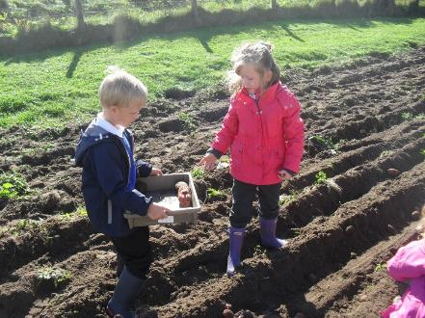

# Communication With Home Conaltradh

A system is operated across the school whereby each child is allocated a plastic wallet at the beginning of the school year. The wallet is to be used by parents and the school to ensure two-way communication. From time to time your child will bring home important and routine communications from school and each week the minutes from the Weekly Meeting will be issued. These will be placed in the child’s wallet. Pupils take wallets to and from school each day. They are collected and checked by the School Assistant each morning. Parents are encouraged to check their child’s wallet for such communication.

# Emergency Closures Dùnadh Tràth no Eiginneach

Parents are always contacted before children are sent home early. In cases where parents may not be home, the emergency contact will be informed. Parents should make arrangements to have someone available to receive their children should such an emergency occur. The school will, at the beginning of the school year, ask parents to provide the name, address and telephone number of a person who can be contacted in these circumstances. Please ensure this information is kept updated and notify the school of any changes. Children will be taken home by the bus contractor unless other arrangements have been made and agreed and no child will be sent home unless the Head Teacher is satisfied that an adult will be waiting for him or her. In the event of extreme weather conditions or power cuts, parents will be kept notified by the school's Group Call text messages as well as announcements on Radio nan Gaidheal and Isles FM. In addition, up-to-date information will be posted on Comhairle nan Eilean Siar’s website [www.cne-siar.gov.uk](http://www.cne-siar.gov.uk/) and on their WIEPCG Facebook page [http://wiepcg.org.](http://wiepcg.org) Parents may also contact Faire (701702), the Comhairle’s helpline, to enquire about school closures.

Parents may wish to contact the school if they are concerned about the safety of children because of severe weather conditions and are free to collect them from the school if they wish.

Bus contractors may decide not to collect children if road conditions are too dangerous during winter months. Parents will be informed if this decision is taken. The school will however remain open to children who can make their way to school safely.

|  |
| --- |
| **Healthcare Cùram Slàinte** |

## Health and Dental Checks

The Primary One pupils are given a health check by the School Nurse. Parents are advised by letter when the examination will take place so that they may attend. Children’s eyesight and hearing are periodically checked and the School Dentist visits the school to inspect the dental health of P1 and P7 pupils. Parents of children who require treatment have the option of allowing this treatment to be done by the school or family dentist.

## Medication

Parents are responsible for supplying written information about medicines which their child needs to take at school. Medication **will not** be administered without parents/guardians recording details of medication. Forms are available from the school office and in the absence of the Head Teacher, a member of staff will be nominated to administer or supervise the taking of medication.

## Toothbrushing

With parental consent, pupils take part in a supervised tooth brushing programme which was introduced to improve the oral and general health of the children. Alison Macdonald, Dental Health Support Worker, visits the school regularly to ensure this is done correctly.

## Head Lice

Parents are asked to be vigilant and to regularly check their children’s hair for head lice or eggs. If live, moving head lice are found, parents should use lotions as per instructions and ‘wet combing’ to remove head lice. Information leaflets issued by Western Isles NHS Board are available from the school office. Further advice may be sought from the School Nurse, GP practice or chemist in Stornoway.

## Illness during school hours

If a child becomes ill during the school day, parents will be asked to make arrangements to take their child home. In cases where parents may not be home, the emergency contact will be informed.

## Illnesses

Any child who is unwell should not attend school. Children with diarrhoea and/or vomiting **must** be kept at home until they have had no symptoms for **48 hours after** an episode of diarrhoea and/or vomiting.

## First Aid

An adequate number of staff hold a recognised first aid qualification to deal with minor injuries. A qualified first aider will accompany children on school trips.

## Allergies

It is a parent’s responsibility to inform the school of allergies when enrolling a child.

A list of common food allergens in included at the back of the handbook.

## Sensitive Aspect of Learning

Sgoil Lionail has developed programmes of work for P1-3 and P4-7 in Health and Well-being. Included in these programmes are sensitive aspects of learning such as relationships, sexual health, parenthood, bereavement and drug awareness.

Such topics are introduced in a very simple way in Nursery and are covered in more depth as children progress towards P7. Parents wishing further information about the school’s Health and Well-being programme and associated resources should contact the school office to make an appointment to speak with the Head Teacher.

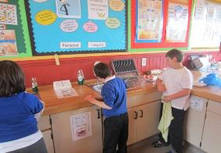

At Sgoil Lionail we value partnerships with health practitioners and community organisations in the delivery of sensitive aspects of learning advance the values and standards of the community. Each child is known and valued as an individual and we seek to enhance the confidence and self-esteem of each pupil through appropriate activities and positive guidance and praise. Children are given tasks of responsibility and are encouraged to care for each other, their school building and grounds and the larger community. The importance of co-operation with parents is considered vital. All members of staff, including visiting teachers and ancilliary staff, are aware of the ethos of positive behaviour in the school. The school rules are minimal and are linked to the safety of the children and the well-being of the community. Golden Rules are decided by pupils at the beginning of each school session. Where any misbehaviour occurs, each incident is dealt with by the class teacher and is usually reported to the Head Teacher. Where necessary, contact will be made with parents and advice may be sought from partners such as the

Educational Psychologist.

|  |
| --- |
| **Discipline Smachachd Bullying Burraidheachd**    We feel that Sgoil Lionail is an extension of the community and we try to |

**We encouraging positive behaviour through:**

House System

Golden Time

Buddy Systems

Star Writer

Golden Book

Sgoilear na Seachdain

Use of rewards and sanctions including *Suns and Clouds, Goodie Jars*

Use of praise including celebrating success in school and local community

2-way diary – pupils aware that school and parents communicate

**Pupils are given responsibilities:**

Classroom helpers

Working in enterprising ways

Young Leaders

Pupil Council

Our school community aims to create an environment in which each child feels happy, safe, respected and included. Children are encouraged to discuss any concerns or problems they might have either personally with their teacher, with the Head Teacher or during Circle Time.

Programmes of work support and nurture the health and well-being of our pupils. Each member of staff is aware of his/her role in promoting a positive ethos, relationships and participation in activities which promote a healthy lifestyle.

We have school policies on Bullying and Discipline. All our pupils are aware of our school code of conduct. Parents should contact the school office if they wish to view the school’s anti-bullying policy.

Our school community prides itself on the high standard of behaviour of all of our pupils and we would want any incidents of bullying to be raised immediately with the Head Teacher or any staff member.

Pupils are made aware of the dangers of internet misuse and cyberbullying through our Health and Well-being programmes. Class teachers are assisted in the delivery of these topics by local authority staff and local police.

# Religious and Moral Education Foghlam Cùram ’s Moraltach

Sgoil Lionail is a non-denominational school and its curriculum for Religious and Moral Education is based on Christianity with time for children to explore the world’s major religions and to develop and reflect upon their own values and beliefs. A whole school assembly is led by the Head Teacher or Principal Teacher. Classes or individual children may be asked to contribute. We have regular visits from speakers who come to talk with the children about their work or charities. Our School Chaplains, Rev G MacDonald and Rev E Matheson visit the school regularly to conduct Assembly. All other Religious Education lessons are taught in each class as part of our Religious and Moral Education programme or through integration into other subject areas.

Parents have the right to withdraw their child from Religious Education with class teachers or Assembly with School Chaplains. Parents who wish to do this should put their request in writing to the Head Teacher. There is an opportunity for parents to indicate their preference at the time of enrolment. Arrangements are made for pupils who are withdrawn from Religious Observation to participate in worthwhile alternative activities.

Comhairle Nan Eilean Siar’s Religious Observation policy may be viewed at:

<http://www.cne-siar.gov.uk/education/policiesprocedures/documents/policy/Religious%20Observation%20Policy.pdf>

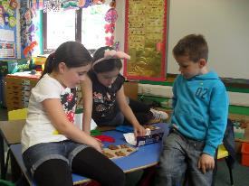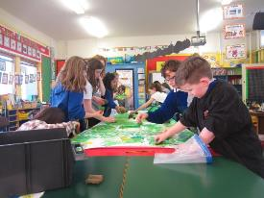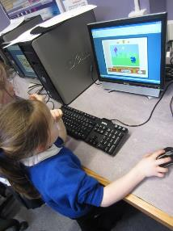

# Policies Poileasaidhean

School policies are listed in Appendix 1. Please contact the school office if you wish to view school policies.

Local authority policies may be viewed at:

<http://www.cne-siar.gov.uk/education/policiesprocedures/index.asp>

# Safety and Security Sàbhailteachd Sgoile

## School Security

All visitors, including parents, are asked to report to the School Office on arrival. Access can be gained by ringing the door bell at the main entrance to the school. The main door is one of our fire escape doors and so it can be quickly and easily opened in the event of an emergency.

Contractors must also report to the School Office before commencing work.

Exterior lighting is provided for personal safety and building protection

# Homework Obair Dachaigh

Homework is an important part of a pupil’s education and help from parents is greatly appreciated. Homework is set and noted in a Homework Diary. Parents are encouraged to supervise and help with homework, encouraging good study habits and self discipline and we ask that you sign the diary when work is complete. Homework may not always be in written form; it may be preparation for a talk, finding information for a topic or doing some work on the computer.

# P.E. Kit

Class teachers will remind pupils of PE times. Pupils should have PE kit: shorts, t-shirt and gym shoes in school on these days.

**Fire Safety**

## A fire drill is undertaken once a term.

## Volunteers

Parents are always welcome to help in our school. However, for the protection of pupils, the Education and Children’s Services Department now requires any persons coming into regular close contact with children to be checked on an enhanced disclosure basis. The Department will be responsible for processing volunteers’ Protecting Vulnerable Groups (PVG) checks. Please contact the school if you would like to be considered as a helper.

## Photographs/Video

When a child enrols at the school, parents are asked to sign an agreement to say whether or not their child may be photographed or filmed.

# Clubs and Activities Clubaichean

Sgoil Lionail and SpòrsNis offer a number of after school clubs to pupils and young people living in Ness. Please contact the School Office or SpòrsNis to find out which clubs are currently available.

Parents may wish to contact Ionad Spòrs Leòdhais for information on after school and weekend clubs. Flyers received by the school

advertising clubs are distributed in pupil wallets or by email and are displayed in school.

## Cycling

Children in Primary 6 and Primary 7 receive cycle training. Children may ride bicycles to school. Younger children should be accompanied by a responsible adult. Bicycle racks are provided at the side of the school.

# 

# Additional Support Needs Feumalachdan Sònraichte

## Getting It Right For Every Child (GIRFEC)

GIRFEC is a national initiative, the principles of which centre around the child. At Sgoil Lionail we apply the *Getting it Right* values and principles to support children and families and strive to ensure that each child is safe, healthy, active, nurtured, achieving, respected, responsible and included. Where pressures, risks and needs are identified, school staff work with partners using the local authority system of staged intervention to support the learning and general progress of children. It provides pupils, parents, school staff and other agencies with a structured system for identification, assessment, planning, review and record keeping for individual children who require additional support of any kind.

Applying a getting it right approach contributes directly to helping children and young people become successful learners, confident individuals, effective contributors and responsible citizens. We recognise that children develop in different ways and at different rates and our teaching methods take account of these differences. Some children may experience specific learning difficulties which demand additional help and we try to ensure that able children are given work which challenges them. Additional support may be long or short term depending on the nature of the difficulty identified. It may involve the input of other professionals such as the Support for Learning teacher or Speech and Language Therapist.

For pupils with additional support needs, an action plan, individual programme of appropriate targets, tasks and activities or co-ordinated support plan is devised to build on their strengths and by meeting their very specific needs, help them to attain and to develop self-esteem.

The Head Teacher and class teachers meet with the Principal Teacher of Learning Support to discuss the progress, achievements and attainment of pupils who require additional support. Professionals who work alongside the school and families may also attend such meetings.

Further advice and information on additional support for learning and mediation services may be sought from:

**Enquire** Children in Scotland: Working for Children and their Families (registered charity - number SC003527)



**Scottish Independent Advocacy Alliance** (registered Charity - number SCO33576)  **Scottish Child Law Centre** (registered charity - number SCO12741)

## Role of the School Assistants and School Auxiliary

School Assistants and School Auxiliaries assist with the supervision of tasks under class teacher direction. They work with individual children and small groups of pupils. They also supervise children in the dining hall, in the school playground and during wet weather indoor play. They deal with minor incidents and report those of a more serious nature to class teachers or the Head Teacher as necessary.

**Child Protection -** The Head Teacher is the school’s Child Protection Co-ordinator and is trained to Level 2 in Child Protection. All school staff undertake annual Child Protection refresher training.

The local authority policy on GIRFEC and additional support needs can be viewed at: <http://www.cne-siar.gov.uk/education/policiesprocedures/index.asp>

# Transitions A’ gluasad

Transition simply means moving from one school or class to another. In our school, the main points of transition are when children move from pre-school to P1 and from P7 to S1. We are also aware that joining the nursery class or moving between teachers are times of transition. It is our aim to prepare children for the next step in their education and to work with our nursery, primary and secondary colleagues to ensure transition is smooth.

An enhanced transition is planned by school staff, Principal Teacher of Learning Support and parents of pupils with additional support needs to ensure they make a successful

transition whether from nursery to P1 or P7-S1.

**Home – Nursery**

Staff take cognisance of Pre-birth to 3 documents

Settling in reports

Allow parent to stay in nursery until child settles

Informal chats

**Nursery- P1**

Wall displays to highlight transition activities

Information packs distributed to parents

Regular meetings with Head Teacher

Profiles

Planning – Learning wall

Attainment and achievement

Opportunities to use school library, hall

Planned visits to primary classroom

Planned visits to P1-3 class

Buddy system

Open day

**Moving between schools**

**P7-S1**

Planned induction days

Liaison between P7 teacher, PTLS and secondary staff

‘Moving Up’ pack

S1 Subject teachers visit P7 pupils

On-line events such as ‘Choices for Life’.

Childline workshop

Exchange of PPRs and attainment and achievement data on SEEMiS

P7 ePortfolios

|  |
| --- |
|  |

When a pupil leaves Sgoil Lionail and enrols at a new school, a member of staff will contact our school office to confirm enrolment and to request the pupil’s records. When a new pupil joins a class at Sgoil Lionail, the Head Teacher will contact the pupil’s last school to confirm enrolment and request the pupil’s records. If a pupil leaves Sgoil Lionail and the school has not been informed of enrolment elsewhere, the child may be identified as missing from education. In such circumstances, the Head Teacher would follow Comhairle nan Eilean Siar guidelines to track and trace missing children.

# School Fund Expenditure Cosgais Airgead Sgoile

The School Fund is used to purchase and renew educational resources to support learning and teaching and it also covers extra-curricular activities – fees and transport costs, exhibition visits, visiting theatre groups, field trips, shows and other school-centred projects.

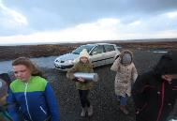

Fundraising takes place throughout the year and parents and the community are very supportive of these events. The Parent Council has raised money for Christmas gifts, parties and equipment for the school.

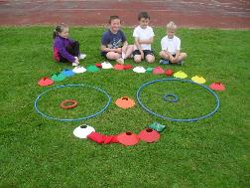

# Mobile Phone Policy Fònaichean-làimhe

We generally discourage parents and pupils from bringing mobile phones and other valuables to school on the grounds that they may get lost or stolen.

If it is necessary for a pupil or parent to bring a phone to school, it should be marked in some way to aid identification if lost and subsequently found.

If it is necessary for a pupil to bring a mobile phone to school, the phone must remain switched off during the school day and may not be used on school premises, grounds or during off-site curricular activities.

Where a pupil is found by a member of staff to be using a mobile phone, for any purpose, the phone will be confiscated from the pupil. It will generally only be returned to the parent.



# Parent Council Dàimhean le Pàrantan

**Office bearers**: Chair Helen MacKenzie helen@helen.ackenzie.com

Clerk Johanna Furey

Treasurer Mary Margaret Murray

Our school welcomes parental involvement. We recognise that children do better in school when parents are actively involved in their education.

As a member of the Parent Council you can expect to:

* get information about what your child is learning get information about events and activities at the school get advice and help on how you can support your children’s learning
* be told of opportunities to be involved in the work of the school have a say in selecting a Parent Council to work on behalf of all parents at your school.
* attend termly meetings with the pupil council and teaching staff.

The role of a Parent Council is to:

support the school in its work with pupils represent the views of all parents encourage links between the school, parents, pupils, pre-school groups and the wider community report back to the Parent Forum

School staff make every effort to keep parents informed of their children’s progress and involve them in the work of the school. This includes:

Fundraising Involvement in topic work Parents’ questionnaires

Sports Festival Parents’ noticeboard Glow

Assisting on outings/trips Displays Target setting

Reports and parents’ evening Achievements board Supervising homework

Showcase events Homework diary Christmas activities

Regular newsletters Sports Day

Comhairle nan Eilean Siar’s Parental Involvement Strategy can be viewed at: <http://www.cne-siar.gov.uk/education/policiesprocedures/index.asp>

# Complaints, Comments and Suggestions Gearain agus Molaidhean

We recognise that there may be times when you will want to express concern, make complaints, offer suggestions or compliment the school and its pupils.

If you want to make a complaint about the school, please let us know. It is better that issues are discussed openly and resolved fairly rather than be allowed to damage the relationship between parents and the school.

There will be no negative consequences arising from making a complaint and we will deal with the issue as confidentially as possible. If we have made a mistake we will acknowledge this, apologise quickly and clearly and we will try to put things right.

## Making a complaint

Please make any complaint initially to the Head Teacher. This makes sure that the school knows what is going on and has an opportunity to respond and resolve the issue.

If you are unhappy with the service or with our response, then you have the right to take the matter further. You can put your complaint in writing or fill in a complaint form. Complaints forms are available from the school office. Completed forms or letters of complaint should be sent to:

## Director of Education and Children’s Services Comhairle nan Eilean Siar Sandwick Road Stornoway Isle of Lewis HS1 2BW

If you are still unhappy after further investigation and reply, you can take the matter up with the Scottish Public Services Ombudsman. The reply will include relevant contact details.

## Suggestions

Pupils may pop their suggestions in a box located outside the staffroom. Pupils’ ideas and opinions are valued and are sought during Learner Conversations. Welfare questionnaires, whole school Assemblies and during Circle Time.

Parents may also wish to make suggestions in this way.

# Curriculum for Excellence An Curraicealam airson Sàr-mhathais

The Curriculum for Excellence is based on the values of **wisdom, justice, compassion** and **integrity** and is focused on enabling all young people to become

## Successful learners Confident individuals Responsible citizens Effective contributors

By providing structure, support and direction to young people’s learning, the curriculum should enable them to develop these four capacities. The curriculum is broadly defined as covering:

**The ethos and life of the school Curriculum areas and subjects Interdisciplinary projects and studies Opportunities for personal achievement**

and is divided into these main areas:

**Literacy Numeracy**

**Health and Well-being** (including Physical Education)

**Social Studies**

**Technologies** (including ICT)

**Sciences**

**Expressive Arts** (Art, Music, Drama and Dance)

## Religious and Moral Education

**Gaelic** – including Gaelic singing for all classes from P1-7

**Modern Languages** (French at P6-7)

At different times, the children may be taught as a class, as a small group or individually. Although the subjects above are sometimes taught separately, many are integrated. Teachers use a variety of methods to motivate the children and they try to create an atmosphere which promotes active and purposeful learning. Pupils are encouraged to take a pride in their work, complete all tasks and to take care of books and equipment. Above all it is hoped that the pupils will enjoy challenging learning experiences and develop skills and knowledge about the world in which they live.

School staff are creating programmes of work to ensure children receive a coherent, broad general education during their time at Sgoil Lionail. Programmes are based on Curriculum for Excellence experiences and outcomes and include opportunities for community involvement, interdisciplinary learning and the development of skills for learning, life and work.

A range of approaches are used to deliver the curriculum including active and outdoor learning. Collaboration and co-operation is encouraged amongst pupils.

Pupils at all stages are involved in the planning of topics to ensure personalisation and choice.

Curriculum for Excellence aims at progression. Pupils work through a series of targets which are set out in graded levels which become increasingly challenging:

|  |  |
| --- | --- |
| **EARLY** | The pre-school years and P1, or later for some. |
| **FIRST** | To the end of P4, but earlier or later for some. |
| **SECOND** | To the end of P7, but earlier or later for some. |
| **THIRD** | In S1-S3 but earlier for some |
| **FOURTH** | Broadly equates to Standard Grade Int 1 |
| **SENIOR** | In S4-S6 but earlier for some |

# The Four Capacities

Please make an appointment with the Head Teacher if you wish to discuss the school curriculum.

Further information about Curriculum for Excellence can be found at: <http://www.educationscotland.gov.uk/thecurriculum/whatiscurriculumforexcellence/index.asp>

# Assessment Measadh

Each child’s progress is assessed by his/her class teacher throughout the year. Pupils are given opportunities to discuss their progress and to assess their performance. Next steps in learning are decided in consultation with pupils and where appropriate, parents.

Opportunities for peer assessment are also built into activities.

Teachers choose a variety of methods to capture what pupils **say, write, make** and **do** but assessment by the teacher is done mainly through day-today observation.

The National Assessment Resource (NAR) is an on-line resource designed to support assessment approaches for Curriculum for Excellence. It can be used by teachers to make decisions about a child’s progress, attainment and achievement.

## Assessment is for Learning (AifL)

Assessment is for Learning recognises that children learn best when:

They understand what they are trying to learn and what is expected of them



They are given feedback about the quality of their work and what they can do to make it better



They are given advice about how to go about making improvements They are fully involved in deciding what needs to be done next and who can give them help if they need it.



Staff in the nursery and primary classes use AifL strategies to ask pupils better questions and provide helpful feedback leading to improved achievement and to provide clearer information for parents.

## Programme of Standardised Assessments

Schools throughout the Western Isles administer a programme of assessments throughout the school year to check baseline knowledge, indicate potential and to identify learning styles. All assessment scores take into account the different ages of pupils within a given group. This allows direct comparisons to be made between the performance of pupils in each of the assessments against national scores.

School staff use assessment results to compare a pupil’s potential with attainment in Curriculum for Excellence Literacy and Numeracy.

**Annual Assessment Programme:**

**Primary 1**  Reasoning EM and GM classes September Baseline literacy EM class only May

**Primary 3** Progress in Maths (PiM) EM class only May

Progress in English (PiE) EM class only May

**Primary 5** Cognitive Abilities Tests (CATs) September

EM and GM classes

**Primary 7** Progress in Maths (PiM) EM and GM classes May

Progress in English (PiE) EM and GM classes May

## Cognitive Abilities Tests (CATs)

Cognitive Abilities Tests assess a pupil’s ability to reason with and manipulate different types of symbols. These symbols are words, numbers, shapes and designs and precise shapes.

It is the policy of CnES to offer CATs to pupils in P5 and S1.

The four tests give an overall educational profile of the pupil. All parents receive a copy of their child’s CAT scores.

# Tracking Pupil Progress Adhartas

## Tracking Pupil Progress

Schools across the Western Isles use an electronic system called SEEMiS to track pupil progress. School staff update pupil records by assigning a level and progress code for Numeracy and Literacy.

The Head Teacher accesses SEEMiS to monitor pupil progress within different areas of the curriculum and to enable comparison with cognitive potential and attainment in literacy and numeracy**.**

# School Improvement Leasachadh

## Standards and Quality Report

The main purpose of a Standards and Quality Report is to report on the main achievements over the last school year and to bring about further improvement to the learning experiences and achievements of children and young people.

Sgoil Lionail publishes an annual Standards and Quality Report which identifies strengths and areas for improvement. A copy of the report can be requested by contacting the school office. The report forms the basis of the School Improvement Plan.

# Reporting Progress Aithisgean

Parents receive information about their children’s strengths, progress and achievements in November and June each year. Parents are invited to discuss pupil progress at a face-to-face meeting with class teachers in November. Progress and achievements are highlighted, next steps in learning, any specific support needs and ways that they can help support learning at home are discussed.

In January, full written reports are issued with meetings arranged with parents.

Class teachers may ask to meet with parents at other times during the school year if they wish to discuss a child’s progress.

At P7, pupils sum up their achievements using an ePortfolio. ePortfolios are shared with secondary staff when a pupil transfers to S1.

If you have concerns about your child’s progress please do not hesitate to contact the school office to make an appointment to meet with his/her class teacher in the first instance.

## School Improvement Plan

The school also publishes a plan which is used to improve the achievements and learning experiences of pupils. Improvement planning involves identifying what is good about a school, deciding how good a school can be and identifying the best way forward.

Improvement projects are identified through self-evaluation which is directly linked to quality indicators. This means that we can measure our success at improving the quality of education which we provide.

We value the contribution that parents and the wider community make to the life of the school and include them in the writing of the improvement plan. A copy of the School Improvement Plan can be requested by contacting the school office.

# Enterprise in Education Iomairt ann am Foghlam

The process of education involves more than just the acquisition of knowledge. It aims to develop the core personal and interpersonal skills and aptitudes considered essential for participation in personal, social and economic life in the community today and in the future.

Every child who attends Sgoil Lionail will experience working in enterprising ways through topic work, whether to organise an event, serve on a committee, carry out a make and do project or to fundraise. To make enterprise activities more realistic, attempts are made to include a mix of business, community and environmental activities and, where possible, these are supported by members of the community. Enterprise activities are planned in a way that meets the needs, abilities and aspirations of the pupils through real and relevant projects which give pupils roles and responsibilities and an opportunity to reflect on their contributions, skills and effort. This is done mainly through self and peer assessment. Enterprise projects promote progression and continuity in learning, they have Literacy, Numeracy and Health and Well-bring at their core and develop skills for learning, life and work.

At Sgoil Lionail, enterprise education gives children the opportunity to:

develop enterprising skills and attitudes through learning and teaching across the whole curriculum.



experience and develop understanding of the world in all its diversity participate fully in enterprise activities

We promote an enterprising approach to learning by:

giving pupils responsibility making learning real taking roles providing relevance encouraging reflection



Further information about Enterprise Education can be found at

[http://www.educationscotland.gov.uk/learningteachingandassessment/learningacrossthecurriculum/themesacrosslearning/enterprise/about/ enterprisingteaching.asp](http://www.educationscotland.gov.uk/learningteachingandassessment/learningacrossthecurriculum/themesacrosslearning/enterprise/about/enterprisingteaching.asp)

# Pupil Involvement Compàirteachadh Clann-Sgoile

Pupils are encouraged to look after the school environment, equipment and to be kind to one another. They are given responsibilities and are encouraged to be actively involved in school life. Such participation encourages positive behaviour and helps pupils to feel valued. Planned Eco-school activities encourage whole-school action for the environment and a Pupil Council will be elected annually to allow pupils to have a say in what happens in their school.

Pupils at the upper stages develop organisational skills to achieve Young Persons Leadership Awards with Active Schools Co-ordinator, Jenna Stewart. They use their skills and knowledge to organise buddy systems, playground games and wet weather activities.

Community Involvement Compàirteachadh Coimhearsnachd

Sgoil Lionail enjoys close links with a number of individuals, local organisations and businesses. Such links enhance learning and teaching and provide excellent opportunities to develop skills for learning, life and work.

At Sgoil Lionail we attempt to develop tolerance and empathy by involving pupils in charitable events such as fundraising for Children in Need, filling shoeboxes for Blythswood and donating monies to charities such as Autism Scotland.

We very much appreciate the support and assistance we receive from:

Cross Stores GAIN

An Lanntair Spòrsnis

Church of Scotland Ionad Spòrs Leòdhais

Active Schools Hebridean Coach Service

Fios Galson Motors

Free Church of Scotland (Continuing) Free Church of Scotland

Issy Oakley (Outdoor Learning)

We also invite guest speakers such as representatives from OMF and Blythswood to share their work and experiences with pupils.

We use ICT to broaden children’s knowledge and appreciation of the people and world about them.

## Active Schools

Our Active Schools Co-ordinator, Jenna Stewart helps children understand ways in which they can be active and stay active throughout the school year. Jenna works closely with pupils to promote participation and increase motivation by:

* supervising Young Persons Leadership activities
* creating an overview of physical activities for the school year
* introducing and demonstrating new sports and games
* encouraging participation in the local Sports Festival
* supporting schools with award and funding applications
* organising whole school and inter-school events
* arranging cycle training

**School Holidays 2015-2016**

|  |  |  |
| --- | --- | --- |
| **School Status** | **Affects** | **Date** |
| Open | Teachers | Monday 10 August 2015 |
| Open | Pupils | Thursday 13 August 2015 |
| Close | Teachers/Pupils | Thursday 8 October 2015 |

|  |  |  |
| --- | --- | --- |
| **School Status** | **Affects** | **Date** |
| Open | Teachers | Tuesday 20 October 2015 |
| Open | Pupils | Thursday 22 October 2015 |
| Close | Teachers/Pupils | Thursday 26 November 2015 |
| Open | Teachers/Pupils | Tuesday 01 December 2015 |
| Close | Teachers/Pupils | Tuesday 22 December 2015 |

**Term 1 – 2015 Term 2 – 2015**

|  |  |  |
| --- | --- | --- |
| **School Status** | **Affects** | **Date** |
| Open | Teachers/Pupils | Thursday 7 January 2016 |
| Close | Teachers/Pupils | Wednesday 10 February 2016 |
| Open | Teachers/Pupils | Tuesday 16 February 2016 |
| Close | Teachers/Pupils | Friday 1 April 2016 |

**Term 3 – 2016**

|  |  |  |
| --- | --- | --- |
| **School Status** | **Affects** | **Date** |
| Open | Teachers/Pupils | Monday 18 April 2016 |
| Close | Teachers/Pupils | Thursday 28 April 2016 |
| Open | Teachers/Pupils | Tuesday 3 May 2016 |
| Close | Teachers/Pupils | Friday 24 June 2016 |

**Term 4 – 2016**

**Menu**

**Clàr**

**-**

**bidh**

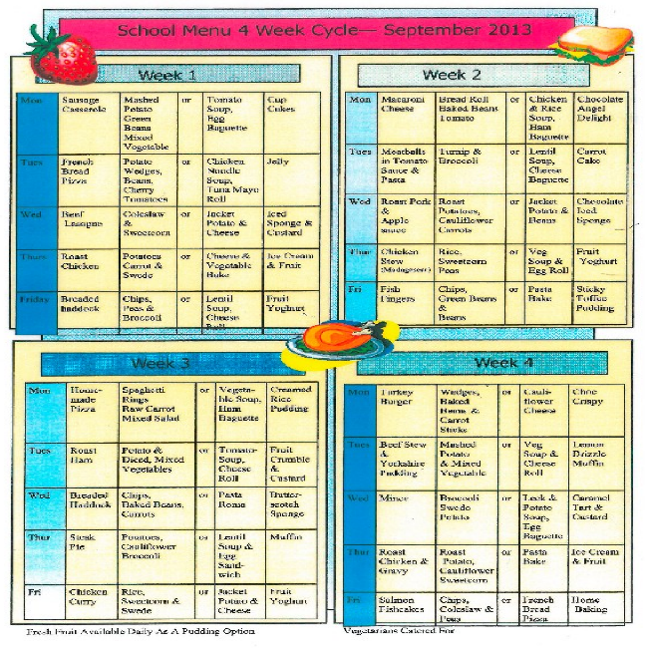

## Appendix 1 Allergens

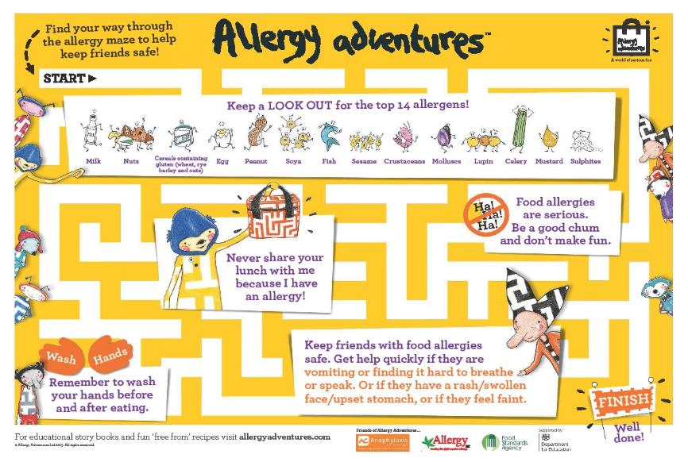

## Appendix 2 School Policies Poileasaidhean

Additional Support needs –

Additional Support Needs

Most Able Children

Care and Welfare

Anti-Bullying

Bereavement

Care and Welfare

Child Protection

Cross Curricular Aspects

Discipline

Health and Safety

Inclusion

Induction

Partnership with Parents

Promoting Positive Behaviour

Dress Code

Racial Equality

Pupil Participation in Decision Making

Citizenship

Environmental Studies

Expressive Arts

Health Education

Drugs Education

Sex Education

Personal and Social Education

Homework

ICT

Internet Access

Language

Listening and Talking

Reading

Handwriting

Spelling

Learning and Teaching

Assessment Monitoring

Mathematics

Languages in the Primary School

French Language

Gaelic Language

Quality Assurance

Religious and Moral Education

Professional Review and Development