**Comhairle nan Eilean Siar**



**Sgoil Eirisgeidh**

**Handbook**

**December 2012**

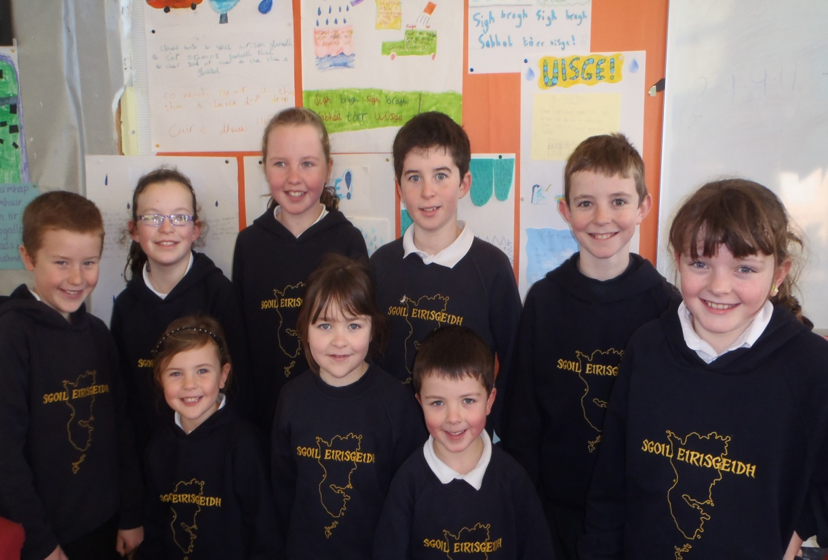



**Contents**

**Section One -**

* Welcome from the Headteacher
* Contact details
* School Day
* Holidays
* Enrolment/transition
* Attendance and Absence
* Travel
* School meals
* Unexpected Closures
* Complaints, comments & suggestions procedures
* School Uniform
* Medical & health Information

**Section Two –**

* Parental Involvement in the School
* Parent Council
* Pupil Council
* School ethos
* Pupil Conduct
* Dealing with Bullying

**Section Three –**

* School Curriculum
* Assessment
* Reporting to Parents
* Homework
* Active Schools

**Section Four –**

* Support for Pupils

**Section Five –**

* Standard & Quality Report
* School Improvement Plan

**Section One**

**Welcome from the Head Teacher**

This handbook offers an introduction to our school and a general overview of the education your child will receive at school.

Eriskay Primary School is situated in the village of Rubha Ban. The School caters for boys and girls from Primary 1 through to Primary 7 and has a Gaelic Medium Unit. Currently the school is a one teacher school with a shared headship.

The school benefits from a full time secretary/ classroom assistant and visiting specialists who support the teacher with the curriculum. Master classes from other specialists are encouraged also to enrich the learning experiences of pupils and help them use their skills out of context.

The school is proud of its Green Flag Eco school status, is a Fairtrade school and has gained a four star rating for Enterprise. The school is non-denominational. When children complete their Primary Education they transfer to Sgoil Lionacleit.

If you have any questions, or would like any further information on any aspect of this handbook or the education of your child, please do not hesitate to contact me.

**Contact Details**

**Name of Head Teacher**: Margaret Campbell

**Name & Address of School**:

Eriskay Primary

Rhuba Ban,

Eriskay

South Uist.

HS8 5JJ

**Telephone Number**: 01870604890

**Email Address**: eriskayschool@gnes.net

**Parent Council Email Address**: mmackinnon38@googlemail.com

**About the School**

**Organisation of the School Day**

**Start Time**: 09.00

**Morning Break**: 10.45-11.05

**Lunch Time**: 12.20-13.00

**Finish Time**: 15.00

**PE Days for Pupils are**: Wednesday 09.00-10.00 Friday 13.00-14.00

**Assembly Day for Pupils:** Thursday Morning

**HOLIDAYS**

The school term dates and mid-term holidays for 2013-2014 are as follows:

**Spring 2013 Term 3**

Monday, 7th January – Thursday, 28th March. (Teachers and pupils)

Mid-term local holidays: Thursday, 21st February – Monday, 25th February (inclusive)

**Summer 2013 Term 4**

Monday, 15th April – Friday, 28th June. (Teachers and pupils)

Mid-term local holiday: Monday, 6th May.

**Summer 2013 Term 1**

Monday, 12th August (Teachers) Thursday, 15th August (Pupils) – Thursday, 10th October

Local holiday: Friday, 11th October.

**Autumn 2013 Term 2**

Tuesday, 22nd October (Teachers) Thursday, 24th October (Pupils) – Friday, 20th December.

Mid-term local holidays: Friday, 29th November – Monday, 2nd December (inclusive)

**Spring 2014 Term 3**

Tuesday, 7th January – Friday, 28th March (Teachers and pupils)

Mid-term holidays: Friday, 14th February- Monday, 17th February (inclusive)

**Summer 2014 Term 4**

Monday, 14th April – Friday, 27th June (Teachers and pupils)

Mid-term local holidays: Friday 18th April (Good Friday) – Monday, 21st April (Easter Monday)

Monday, 5th May.

All holiday dates and information is available on the council website.

[**www**.**cne**-**siar**.**gov**.**uk**](http://www.cne-siar.gov.uk)

**Enrolment**

Infants join the school in August of each year, but enrolment usually takes place in the February on a date notified, by press advertisement, to the parents of prospective pupils.

Children who will be five years old by the last day of the following February are eligible for infant enrolment. At the time of enrolment, you should inform the school of any medical problems or special needs your child may have. The children are taught through the Medium of Gaelic. New entrants are normally invited into the school for transition days prior to entry. You are, of course, welcome to visit the school. You should telephone the school to arrange a time for your visit. On such a visit, you will meet the class teacher and will be able to look round the school.

Other children, whose families have just moved into our catchment area, should be accompanied by a parent or guardian on their first day of reporting to school if they have not already been in contact with the school.

**Transition**

When pupils complete Primary 7, they transfer to Sgoil Lionacleit (Headteacher: Mr Miller MacDonald, Tel 01870 603690) Primary 7 pupils now have a primary/secondary pupil profile which is used to inform the school of the next stages for the child’s education. There will be various transition dates before the final induction week in June.

**Attendance and Absence**

If your child cannot attend school because of illness or other circumstances, the school should be notified by note or by telephone by 9.30a/m. It is also useful if a note can be sent to the school explaining any long term absence in advance of the pupils return to the school.

The category of **Authorised Absence** includes absences deriving from reasons such as:-

* Sickness
* Medical & Dental treatment
* Bereavement
* Short term exceptional domestic circumstances
* Agreed debates, sports, musical or theatrical productions not arranged by or in conjunction with the school.

The category of **Unauthorised Absence** includes absences deriving from reasons such as:-

* Unexplained absences
* Most family holidays taken during term time
* Truancy

If you are intending to withdraw your child from school during term time, please contact the school office for the relevant form which must be filled in.

**Travel to and from School**

Primary School Children living two miles or more from school are entitled to free transport. Pupils requiring transport on medical grounds must produce a medical certificate before the beginning of the school session so that suitable arrangements can be made in advance.

**School Meals**

Primary School Menus offer healthy and tasty meal options which reflect the Scottish Government food and drink legal requirements for school lunches. Children of parents in receipt of Income Support are entitled to free meals. Forms can be obtained from the school or the Department of Education & Children’s Services, Stornoway. 01851 822737. . Did you know that if you qualify for free meals you could also be entitled to £120 off your electricity bill if you are a registered Scottish Hydro Electric customer?

Those children not taking a school meal can either go home or take a healthy packed lunch with them, which they may eat in the school canteen

As a health promoting school, parents pay termly for healthy snacks at break-time. These include toast, crackers, fruit and milk. Sweets in school are strongly discouraged.

**Please note for banking purposes school meals should be paid for at the beginning of the week.**

**Communication with Home**

From time to time your child will bring home important and routine communications from the school. Parents are encouraged to check their child’s schoolbag for communications regularly.

**Unexpected Closures**

It may be necessary, occasionally, to close the school at short notice and send the pupils home, for example, in exceptionally bad weather or if the electricity or heating faults. If parents are not usually at home during school hours, they should always make arrangements to have someone available for their children should such an emergency occur. The school will ask each parent at the point of enrolment to provide the address and/or telephone number of a person who can be contacted in these circumstances. Please ensure this information is up to date and notify the school of any changes.

In the event of the school closing unexpectedly you will be informed either by radio broadcast and/or by telephone.

Parents should also feel free to contact the school if they are concerned about the safety of the children because of severe weather conditions and may call for them at any time.

**Complaints, Comments and Suggestions Procedure**

We are keen that you should be completely satisfied about your child’s education and we encourage feedback from parents and pupils. We are, therefore, interested in feedback of all kinds, whether it be compliments, suggestions or complaints. If you have a complaint about the school, please let us know. It is better that these things are shared openly and resolved fairly rather than being allowed to damage the relationship between the family and the school. There will be no negative consequences arising from making a complaint and we will deal with the issue as confidentially as possible. If we have made a mistake we will apologise quickly and clearly and try to put things right.

There are some things which you should take note of in relation to making a complaint:

* Please make any complaints initially to the Head Teacher. This makes sure that the school knows what is going on and has an opportunity to respond and resolve the issue.
* If you are unhappy with the service or with our response then you will have the right to take the matter further. You can put your complaint in writing or fill in a complaint form. Completed forms should be sent to: Director of Education and Children’s Services, Comhairle nan Eilean Siar, Sandwick Road, Stornoway, Isle of Lewis, HS1 2BW.
* If you are still unhappy after further investigation and reply you can take the matter up with the Scottish Public Services Ombudsman. The reply will include the contact details.

**School Uniform**

The wearing of school uniform is strongly encouraged. School uniform is ordered once a year. There is a small amount of stock held in school if you require anything out-with the ordering time. School uniform consists of:-

* Navy blue Sgoil Eirisgeidh Sweatshirt available with or without a hood.
* Smart trousers or skirt.
* Sensible shoes.
* Navy jacket with school logo.

Some forms of dress are unacceptable on the grounds of health and safety:-

* Dangling earrings and clothing made of flammable material.
* Items of dress which raise moral concerns e.g. questionable logos and slogans, advertisements for alcohol or tobacco.
* Items of dress which encourage factional identification such as football colours (This includes PE kit.)
* Please note the wearing of jeans is also discouraged.

Parents are encouraged to write names on children’s clothing to identify items if lost and found, something that happens frequently.

All parents in receipt of Family Credit or Income Support are eligible for a clothing grant. Application forms for clothing grants are available from the Department of Education and Children’s Services, Sandwick Road, Stornoway, Tel 01851 822737.

**Mobile Phones**

Eriskay School generally discourages pupils from bringing mobile phones or other valuable items to school. These include MP3 players, and other electronic equipment. If for any reason such equipment is taken into school, it should be left in the school office until the end of the school day. The school does not accept any responsibility for such equipment particularly if these rules have not been adhered to.

**Medical & Health Information**

Parents with Pupils requiring medication (short/long term) should inform the school if medication is required during school hours. Medication will then be stored in the school office. Pupils should not carry or administer medicines themselves (with the exception of inhalers). It is essential that every parent keeps the school informed of any developments or changes to any long term health care needs. In the event of continued health problems an appropriate health care plan will be drawn up with the school involving parents, pupil, staff and healthcare professionals.

In the event of a medical emergency the parent/guardian will be contacted by phone to advise of the situation and the course of action deemed necessary. It is important to keep the school up to date with emergency contact numbers and mobile phone numbers. The nominated First Aider for the school is Margaret Campbell, School Assistant.

**Section Two**

**Parental Involvement in School**

Our school welcomes parental involvement. Research has shown that when parents are involved children do better in school.

The children produce a Newsletter twice a year for both parents and the community. There is also a school blog which pupils can access through their Glow account. This enables parents to see online, work that their child is involved in. The blog is updated regularly.

Detailed School Progress Reports are issued once a year. There are also two formal reporting to parents’ nights and pupil led parents evenings happen throughout the school year.

Personal Learning Plans are complied with input from pupils, parents and school. This partnership is continued through homework. Homework Diaries are means of a two-way communication between school and parents and parents are encouraged to check their child’s homework diary and comment where appropriate.

The school actively encourages parents and the wider community to be part of the life of the school. The children regularly run a Fairtrade Shop to which both parents and the Community are invited to buy goods bearing the Fairtrade logo. The Eco garden is an on-going project which involves hands on approach from everyone. Parents and helpers have helped pupils and staff plant potatoes, shrubs and bushes as well as daffodil bulbs to create a ‘Field of Hope’, which was very successful last year and hopefully will be repeated this year. During the harvesting of the potato crop there were also plenty of volunteers to help. The Ragbag Project is a recycling bin for clothes. It is situated in the grounds of the local Community Hall and is well supported helping the school raise money for projects while raising awareness of the importance of re-cycling.

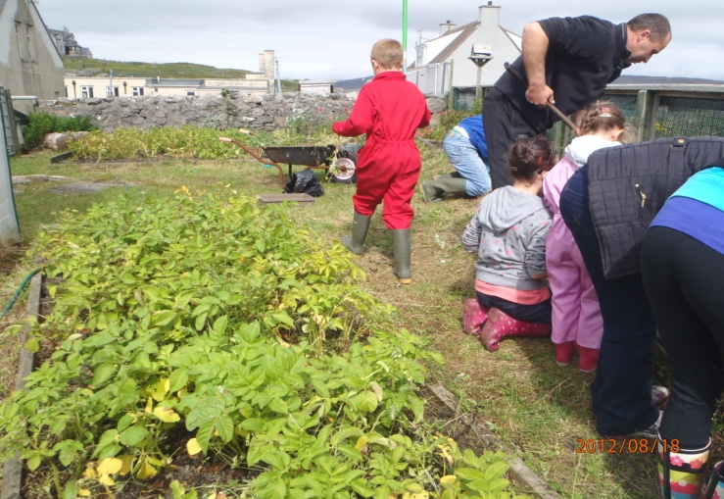 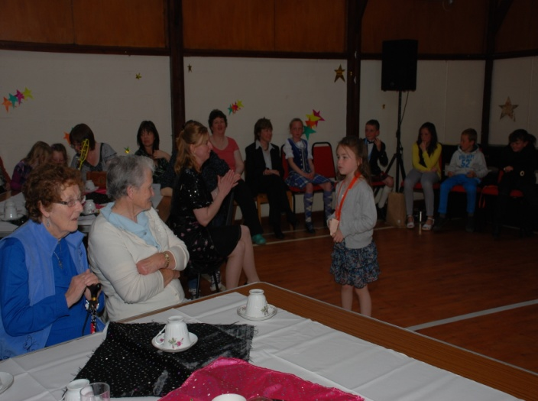

**Parent Council**

The role of the Parent Council is to:

* Support the school in its work with parents
* Represent the views of all parents
* Encourage links between the school, parents, pupils, pre-school groups and the wider community
* Report back to the Parent Forum (all parents are members of the Parent Forum).

Eriskay School has a Parent Council ‘Caraidean Eirisgeidh’. The Chairperson is Mary Flora MacKinnon, she can be contacted on 01878720771. It is important that all parents become involved and take an interest in the life of the school.

**Pupil Council**

All pupils are members of the Eco Committee. Eco meetings are held regularly where children are encouraged to air their ideas and views as well as discussing our Eco Action Plan. Children are confident that they can approach members of staff anytime they feel a need to discuss any ideas or concerns.

**School Ethos**

**Visions, Values and Aims**

Eriskay School aims to ensure that every pupil will experience-

“Challenge and enjoyment,

breadth, progression,

depth, personalisation and choice,

coherence and relevance”

throughout the Curriculum with a focus on skills development in accordance with the Curriculum for Excellence Experiences and Outcomes.

* Ensure that wellbeing and relationship building are seen as crucial elements in the learning & teaching process.
* Provide opportunities to achieve and attain to the highest levels through appropriate personal support and challenge.
* Ensure continuous and on-going improvement through Personal Learning Planning.

Eriskay School aims to develop the spiritual, moral, social and cultural values of its pupils, having a high regard to the values of the community, and guided by the recommendations contained in national and regional guidelines.

As a non-denominational school, we can have pupils from different religions and backgrounds. All pupils receive both Religious and Moral Education and Catholic RE weekly with prayers said daily

The school is a vital link in the Community. All events organised are well supported and attended.

The school’s involvement with the local community extends to selling enterprise projects through the local shop ‘Co-chomunn Eirisgeigh’. The School recently received a four star Enterprising School’s Award from CnES for Enterprise projects. Fairtrade status was achieved this year and a Fairtrade shop is held at school and at community events e.g. ceilidhs, Christmas Fair. Global links through ‘Mary’s Meals Backpack Project’ and Water Aid ensure a good understanding of wider world issues. The school will be applying for a third green flag award through Eco Schools in February.

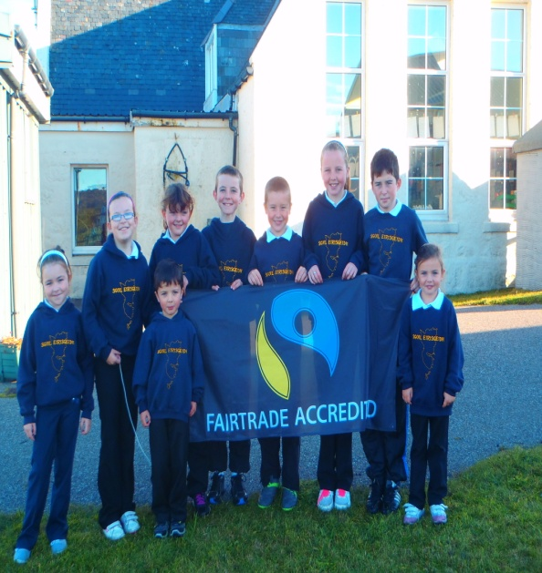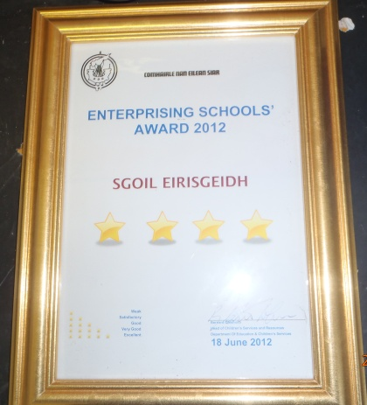

**Pupil Conduct**

A partnership between the school and parents is required in order to ensure the best possible standard of pupil conduct. The agreement between the school and parents on the wearing of school uniform ensures that pupil feel an important part of the school and are proud to represent it. Pupils are expected to set themselves high standards in appearance and behaviour. School rules are relatively simple and few in number to allow for the smooth running of the school. The School’s aim is to produce an atmosphere of friendly co-operation, encouraging respect and consideration for other people and property. In general, respect for people, school buildings, furniture and equipment is expected at all times. Strict observation of the rules concerning Health and Safety is essential. It is expected that pupils observe rules and discipline procedures of the school and co-operate with their peers and the staff to enhance the quality of life within the school.

The school promotes good behaviour through many activities.

* Eco meetings, where the children are given the chance to air their views and discuss concerns.
* The children receive ‘stars’ for good behaviour & work, when they have collected twenty stars they get a certificate to show at home and it is then filed in their Suil air M’Obair folder.
* Assembly is held weekly and there is an achievements board displaying certificates etc. of wider achievements
* Every week we have Writer of the Week where a piece of work is displayed which the class teacher feels a special effort has been put into to produce a high quality piece of work.

Great emphasis is laid on praising and rewarding, for appropriate good behaviour, effort and achievement.

Where there are concerns about behaviour parents are invited to come along to the school to discuss issues further.

**Dealing with Bullying**

You should inform the school immediately if you become aware of any incidents of bullying. This can be done either by telephone or by coming into the school in person. However, any complaint/concern must also be put in writing. Quite naturally, some parents may worry about overreacting to a situation particularly because bullying can be difficult to define, since it covers a wide range of behaviour. The following kinds of behaviour could be defined as bullying:

* **Physical Bullying-Pushing, kicking and hitting and other forms of violence.**
* **Verbal Bullying-name calling, sarcasm, spreading rumours, persistent teasing, threats.**
* **Emotional bullying-excluding (not speaking to) tormenting (e.g. hiding books, unpleasant gestures) ridicule, humiliation.**
* **Racist, Cultural Bullying-being attacked because of your religion, colour or where you come from.**
* **Sexual Bullying- unwanted physical contact, suggestive or verbal comments.**

You should keep a written record of any such incidents including the date, those involved and what happened. This will help the school deal with the situation and agree the best way to support the child inside and, where possible, outside the school. Your initial complaint will be responded to within 24 hours but it is important to realize that it may take some time to address a bullying problem and parents are requested to work co-operatively with the school and with other parents involved in what might be a fairly lengthy process.

A Worry Box is in place for children to drop confidential notes. The box is checked regularly by staff. Pupils who bully or threaten to bully other pupils within the school or while going to or leaving school should expect to experience the disciplinary measures detailed in the school’s anti-bulling policy.

Teachers will always listen to the pupils who confide in them about bullying and will make careful notes of the information given. If a teacher wishes to deal with the problem in the first instance, they should exercise their professional judgment on the action taken. In all circumstances, the Headteacher will be informed.

**Section 3**

**The School Curriculum**

Curriculum for Excellence is built around a commitment to giving every child the best possible chance to realize their full potential and become **successful learners,** **confident individuals,** **responsible citizens, effective contributors.**

There are eight curricular areas. Sciences, Languages (including English, Gaelic, classical and modern languages), Mathematics, Expressive Arts, Social Studies, Technologies, Health and Wellbeing, Religious and Moral Education.

There are six curricular levels:

* Early, The pre-school years and P1, or later for some
* First To the end of P4, but earlier or later for some
* Second To the end of P7, but earlier or later for some
* Third and Fourth S1 to S3, but earlier for some.
* Senior Phase S4 to S6 in school/college/other types of study, until the age of 18.

Active learning is learning which engages and challenges children and young people’s thinking using real-life and imaginary situations. It takes full advantage of the opportunities for learning presented by:

* spontaneous play
* planned, purposeful play
* investigating and exploring
* events and life experiences
* focused learning and teaching.

**Audit Process**

A regular audit of the Curriculum is carried out. The timetable is organized and designed to ensure effective learning and teaching of core subjects. Termly Interdisciplinary Projects encompass a broad spectrum of subjects which often include outside agencies and the wider community.

Audits are undertaken in order to monitor and evaluate learning and teaching with the intention of refining and improving practice. The audits are carried out in line with the quality indicators listed in “How Good is Our School?”

Audits can be:

* Classroom observations by teaching staff
* Formal observations by the Head Teacher
* Sampling of pupils’ work
* Analysis of pupils’ attainment
* Reviews of school policies and plans
* Staff and support staff meetings
* Working groups with other schools
* Professional review and development
* Questionnaires
* Discussions
* Meetings with QIO and Education Department.

**Assessment**

In line with Curriculum for Excellence the school uses summative and formative assessment.

For each curricular area, within each curricular level, there are Experiences and Outcomes which describe children’s learning and achievements. Personal Learning Plans for each individual pupil, show pupils self -assessment and achievements. Pupils, staff and parents are actively involved in target-setting through their Personal learning Plans.

Assessment is the means of obtaining information which allows teachers, pupils and parents to determine what a pupil is actually achieving in relation to expectations of achievement and drawing conclusions from that comparison. Teachers report on pupils’ progress and attainment across the whole curriculum, using their professional judgment and the evidence available to them from continuous assessment throughout the year. Moderation between schools locally and nationally ensures that standards are agreed for applying the terms, developing, consolidating and secure to Curriculum for Excellence levels. Cognitive Ability Tests are used to set personal Learning Targets. A balance of approaches to assessment is maintained, always bearing in mind that it is not necessary or desirable to assess all the time. Pupils themselves are involved in their own assessment and their views are valued. Feedback to pupils about their own progress and attainment is ongoing.

The School will be in a position to make up to date reports on all aspects of a pupil's progress:

* To parents and others at short notice when a request is made
* Formal reporting of all 8 curricular areas.
* Verbally at Parents Meetings at least twice a year.
* To other professionals. (Psychologists, Social Workers etc.)

Written reports will be in a form that will be readily understandable by the people for whom they are intended. School reports to parents will emphasize pupil achievement, include comment on social development, identify next steps in learning and indicate any necessary remedial action to be taken.

**Reporting to Parents**

Reporting will involve the learner and will engage parents actively in their child’s learning. It will also describe strengths and areas for development, show progress in the eight curricular areas, show achievement within one of the six levels, demonstrate achievement in different context, share learning goals and next steps and identify specific support for individual pupils. There is a written Formal Report produced once a year and reporting to parents is done throughout the year through Parents evenings, Personal learning Plans, Targets etc.

**Homework**

Homework is an important part of school work as it enhances work being done in class. It provides opportunities for individual work and develops good habits and self-discipline. It provides information to both parents and teachers. Regular homework should generate a variety of learning experiences additional to school lessons and in that sense quality is always more important than quantity.

There are various types of work which a pupil can do out-with the formal classroom, e.g.:-

* Consolidation e.g. Tables, spelling, reading.
* Written exercises.
* Topic work
* Research in any curricular area.

It is the school’s policy to give homework to all children beginning in P1. Year by year, the amount of homework that we set may increase gradually, as will its difficulty, but with certain differences of individual needs being catered for.

By P7, we hope that the children are mature enough to cope, on occasion, with several varied tasks being given to them for homework.

**WHAT CAN PARENTS DO TO HELP?**

The most important thing to do is simply to take an interest in the child’s work. For example, in the early primary years, it is useful simply to discuss what a child has done that day. Parents should help children quickly establish a routine (e.g. a set time to do homework each evening). Homework should be done in an appropriate place (warm, well lit place free of distractions e.g. television). All children should have access to basic things such as pencils, pens, rubbers and rulers. Teachers will set homework which is useful and relevant. Teachers will also mark any written work as quickly as possible. Parents will be informed if a child regularly fails to do the set tasks.

**Sensitive aspects of Learning**

For sensitive aspects of Health and Wellbeing such as relationships, sexual health, drug and alcohol issues the school will advise parents of the content and involvement of health specialists in these areas.

**Religious & Moral Education & Religious Observance**

Eriskay School aims to develop the spiritual, moral, social and cultural values of its pupils, having regard to the values of the community, and guided by the recommendations contained in national and regional guidelines.

In general, the School attempts to re-enforce what the children learn from the Home and the Parish. The Parish Priest, Donald Cannon MacKay, visits the school on a regular basis and Mass is celebrated for both pupils and the rest of the islanders in the school from time to time. The children serve on the Altar on a weekly rota.

Parents who wish to exercise their right to withdraw their child from Religious Education or Religious Observance should put their request in writing to the Headteacher.

**Active Schools**

Active Schools work with schools and communities to help make sure children start active and stay active. The fundamental aim is to offer children and young people the opportunities and motivation to adopt active, healthy lifestyles, now and into adulthood. Our Active Schools Co-ordinator is Christine MacQuarrie. Her role is helping the school to develop an action plan of work that can be supported through the school year. Here are some examples of the activities which took place in the last year:

* Cycling Training
* Rural Schools Sports
* Young Leaders Award
* Skipping Challenge.

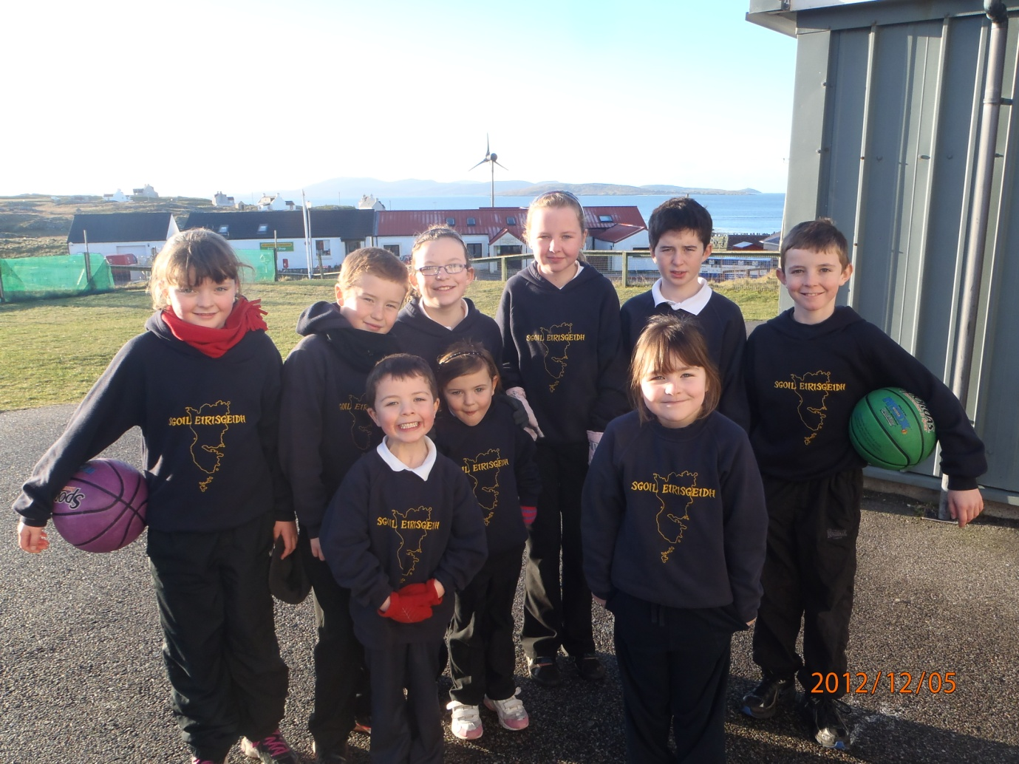

**Section 4**

**Support for Pupils**

We aim as far as is possible to educate pupils who have additional support needs alongside their peer group. When necessary, extra help is provided. This help is delivered in a flexible manner and the pupils can be seen individually, in a group or class.

The Additional Support Needs of the Children are identified through a process of Staged Assessment and Intervention. The process of Staged Assessment and Intervention provides a structured system for identification, assessment, planning, review and record keeping for individual children who receive additional support of any kind. The Getting it Right Approach for Children and Young People(GIRFEC) in the Western Isles puts in place a network to promote wellbeing so that children and young people get the right help at the right time.

All Looked After Children and Young People are considered to have additional support needs. This is the case unless the school establishes they do not have additional support needs. The Local Authority must consider whether each looked after child requires a Co-ordinated Support Plan (CSP). The CSP is used to ensure a co-ordinated approach to providing support for children. The CSP will summarise assessments carried out for the child, explain the nature of the child’s difficulties and outline the difficulties the Authority will take to support the pupil’s needs. An assessment service is also provided by the teacher of children with visual and hearing impairment. The Speech Therapist also visits the schools to help any pupils who require support.

In addition, an Educational Psychologist advises on the varied behavioural and learning difficulties which all pupils can experience. He can work directly with pupils and families if required.

Under the Equality Act 2010, the Education Authority is not allowed to discriminate against disabled pupils.

Mediation is provided by Resolve in the Western Isles. It is a non-judgemental voluntary process which seems to resolve misunderstandings in the early stages to prevent them escalating. Parents also have the right to have an advocate present at Mediation and this is available through Advocacy Western Isles.

Parents should also be aware of the following organisations which provide advice and further information.

* Children in Scotland: Working for Children and their Families, trading as Enquire – a charitable body registered in Scotland under registration number SC003527.
* Scottish Independent Advocacy Alliance, a charitable body registered in Scotland under registration number SCO33576
* Scottish Child Law Centre, a charitable body registered in Scotland under registration number SCO12741

Enquire is funded by the Scottish Government to provide information on the framework for supporting children who require additional support for learning and to encourage positive partnerships between families, schools and local authorities to ensure children get the right support.  
  
Enquire – the Scottish advice service for additional support for learning  
  
 Enquire offers independent, confidential advice and information on additional support for learning through:  
  
          Telephone Helpline: 0845 123 2303  
  
           Email Enquiry service: info@enquire.org.uk  
  
           Advice and information is also available at [http://www.enquire.org.uk](https://webmail.glowscotland.org.uk/cp/ps/Mail/ExternalURLProxy?d=glowscotland.org.uk&u=gw09eriskayoffice&url=http://www.enquire.org.uk&urlHash=2.4193998723715498E-55#_blank)

Further information locally can be obtained from the School or Area Principal Teacher of Learning Support.

Everyone within each learning community, whatever their contact with children and young people may be, shares the responsibility for creating a positive ethos and climate of respect and trust – one in which everyone can make a positive contribution to the wellbeing of each individual within the school and the wider community

Getting it right for every Child (GIRFEC) is a Scottish Government imitative to provide a consistent way for people to work with all children and young people. The responsibilities of all include each practitioner’s role in establishing open, positive, supportive relationships across the school community, where children and young people will feel that they are listened to, and where they feel secure in their ability to discuss sensitive aspects of their lives; in promoting a climate in which children and young people feel safe and secure; in modelling behaviour which promotes health and wellbeing and encouraging it in others; through using learning and teaching methodologies which promote effective learning; and by being sensitive and responsive to the wellbeing of each child and young person. Practical responsibilities include understanding of anti-discriminatory, anti-bullying and child protection policies by all staff and knowledge of the steps to be taken in any given situation, including appropriate referral.



**Section Five**

**School Improvement**

**Standard & Quality Report**

Each year the school publishes a Standards and Quality Report which highlights the school’s major achievements in the previous year. These include:-

* 4 * Enterprise Award, June 2012
* Fairtrade status
* All through Gaelic Medium school
* Gaelic promotion project term 1 with partner agencies CNAG & ALBA
* First Eco-conference Uist where pupils prepared and delivered multi-media presentations
* First Uist mod- presented playlet and choir
* Catering for community events – OFFTI plant sale and senior citizens’ lunch
* Enhanced transitional arrangement for new entrants and P7 pupils
* After- school clubs- homework, drama, gardening
* Support staff involved in Gaelic Ulpan programme throughout the year
* Croft diversification business model to organize eco/enterprise programme throughout the year
* Marie Curie “Field of Hope”
* Meeting community demands for specific projects - Football logo, keyrings for tourist, summer display in community hall
* Delivery of curriculum enhanced through structure/embedded practice to feed learning
* First pupil – led parents’ evening sharing CfE practice
* Eco school second Green flag award
* Annual Eco- week and Fairtrade weeks involving staff, pupils, volunteers, the community and a variety of external agencies to support learning across the curriculum
* All pupils are members of Eco school committee and P 5-7 are office bearers
* Two hours of quality PE delivered across the curriculum
* Church services regularly attended by pupils with community
* Pupils regularly contribute to services and celebrations in the community and church
* P 6/7 Young Leaders award for Active Schools
* P6/7 attend Science festival in Sgoil Lionacleit
* Whole school Active School handball competition
* Links with associate school to embrace opportunities for learning eg Generation Science, Transition basketball, Kilphedar run, athletics club

Baseline assessments are carried out in numeracy, maths, spelling and reading regularly to inform planning and measure attainment.

A copy of the Standards & Quality report was issued to each family. It is also available on the School page in Glow

**School Improvement Plan**

This year, 2012-2013, Sgoil Eirisgeidh is focusing on three main areas for improvement:

1. e1 and Learning Wall tracking to inform planning and assessment
2. Moderating standards across the Learning Community for Expressive Arts
3. To develop further a programme to improve Numeracy, Maths and Financial Education.

A copy of the School Improvement Plan 2012-13 was issued to each family. It is also available on the School page in Glow

**Transferring Education Facts about Pupils**

Education authorities and the Scottish Government have collected data about pupils on paper forms for many years. We now work together with schools to transfer data electronically through the ScotXed programme. Thus Scottish Government has two functions: acting as a ‘hub’ for supporting data exchange within the education system in Scotland and the analysis of data for purposes within the Scottish Government itself.

**Why do we need your data?**

In order to make the best decisions about how to improve our education service, SEED and education authorities need accurate, up-to-date data about our pupils. We are keen to help all our pupils do well in all aspects of school life and achieve better exam results. Accurate and up-to-date data allows SEED, education authorities and schools to:

* Plan and deliver better policies for the benefit of all pupils,
* Plan and deliver better policies for the benefit of specific groups of pupils,
* Better understand some of the factors that influence pupil attainment and achievement,
* Target resources better.

**Data Policy**

The ScotXed programme aims to support schools and Local Authorities by supporting the collection, processing and dissemination of statistical information required for planning, management and monitoring of Scottish education services.

A subset of this information is passed to the Scottish Government and National Statistics publications. Education data within Scottish Government is managed effectively by secure systems and is exploited as a valuable corporate resource, subject to confidentiality restraints. As part of its data policy, Scottish Government will not publish or make publicly available any information that allows individual pupils to be identified, nor will data be used by Scottish Government to take any actions in respect of individuals. Data is held securely and no information on individual pupils can or would be published by Scottish Government.

The individual data collected by Scottish Government is used for statistical and research purposes only. We hope that the explanations contained on the ScotXed website will help you understand the importance of providing the information.

**Your data protection rights**

The collection, transfer, processing and sharing of ScotXed data is done in accordance with the Data Protection Act (1998). We also comply with the National Statistics Code of Practice requirements and other legislation related to safeguarding the confidentiality of data. The Data Protection Act gives you the right to know how we will use your data. This message can give only a brief description of how we use data. Fuller details of the uses of pupil data can be found on the ScotXed website.

Scottish Government works with a range of partners including HM Inspectorate of Education and SQA. On occasion, we will make individual data available to partners and also academic institutions and organisations to carry out research and statistical analysis. In addition, we will provide our partners with information they need in order to fulfil their official responsibilities. Any sharing of data will be done under the strict control of Scottish Government, which will ensure that no individual level data will be made public as a result of the data sharing and that this data will not be used to take any actions in respect of an individual. Decisions on the sharing of data will be taken in consultation with relevant colleagues and individuals within and outwith Scottish Government.

**Activities, Groups, Clubs**

The children have opportunities to attend activities which include:-

* Youth Club
* South Uist & Eriskay Athletics Club
* Highland Dancing
* Rural Sports Meetings
* Feis/Mod
* Football Training
* Active School Initiatives
* Local drama Group
* Ceilidhs
* Christmas play

