COMHAIRLE NAN EILEAN SIAR

Leverhulme memorial school
handbook



LEABHRAN FIOSRACHAIDH
SGOIL AN OIB

DECEMBER 2014 -oOo- AN DÙBHLACHD 2014
HEAD TEACHER'S INTRODUCTION & WELCOME
RO-RÀDH & FAILTE BHON CHEANNARD

This handbook offers an introduction to our school and a general overview of the education your child will be getting at Leverhulme Memorial School / Sgoil an Oib.

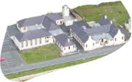

The School always welcomes contact with parents of current or prospective pupils. I would be happy to give you further details or discuss any queries which you may have about the school at any time.

To make our handbook easy to use, we have divided the information up into five different sections.

CONTENTS
CLÀR-INNSE

Section One – Information about the School and Contact Details

Section Two – School Ethos and Parents as Partners

Section Three – School Curriculum, Assessment and Reporting

Section Four – Support for Pupils and Transitions

Section Five – School Improvement and School Policies Information

We hope you find the information helpful and self explanatory. If you have any queries about any of the information contained in this handbook, or about your child’s education, please do not hesitate to contact me.

Rhoda MacDonald
Head Teacher

Please note that the information in this school handbook is considered to be correct at the time of publication (December 2014), however, it is possible that there may be some inaccuracy by the start of the school term in August 2015.
SECTION ONE

INFORMATION ABOUT THE SCHOOL - FIOSRACHADH MUN SGOIL

Contact Details

Name of Head Teacher: Miss Rhoda MacDonald

Name of School: Leverhulme Memorial School

Address: Leverburgh, Isle of Harris, HS5 3TS

Telephone Number: 01859 502980

Email Address: leverhulmeschool@gnes.net

Parent Council Contact & Number: Mrs Caroline Chaffer 01859 520777

About the School

Leverhulme Memorial School/Sgoil an Oib is a Primary School which has Gaelic Medium and English provision. There are currently thirteen pupils in the multi-composite P1-7 Gaelic class and ten in the P1-7 English class.

The school has a nursery class, Sgoil Àraich an Oib, which provides pre-school funded sessions in Gaelic for children aged 2½ to 5 years. The present daily roll is eleven children on average and five of the children are in their pre-school year.

Organisation of the School Day

Start Time: 09.15

Morning Break: 11:00-11:15

Lunch Time: 12:45-1.30

Finish Time: 3.15

PE Days for Pupils this session are: Gaelic class – Tuesdays and Thursdays
English class – Thursdays and Fridays

Assembly Days for pupils are normally held monthly and at the end of every term

Staff Luchd-Obrach

Sgoil Àraich Staff
Mrs Nellie Morrison Play leader
Miss Louise MacAulay Play Assistant
Mrs Kathryn Campbell Auxiliary Support (part-time)

Teaching Staff
Mrs Morag MacPherson P1-7 English class
Miss Rhoda MacDonald P1-7 Gaelic class / Head teacher
Ms Hannah MacQueen Reduction in Class Contact time / Groups from both P1-7 classes

Non Resident Teaching Staff
Mrs Suzanna Visser Art and Design
Mrs Christine Hurley Music
Mr Iain MacIver Gaelic Singing and YMI Instructor
Mr Donald John Smith Physical Education

Non-Teaching Staff
Mrs Maighread Morrison Secretary/School Assistant
Mrs Ishbail MacKay Auxiliary Support (part-time)
Mrs Anne Marie MacVicar Cleaner
Mrs Fiona MacLean Cook
Mrs Elaine Morrison Relief Cook
Mr Iain MacIver Handyman (visits monthly)

Attendance and Absence Frithealadh

It is the responsibility of parents to ensure that their children attend school. Regular school attendance is important as the law requires it and it ensures that important schoolwork is not missed. With your co-operation we hope to minimise absences.

If pupils cannot attend school because of illness or other circumstances parents should contact the school and on the child's first day back at school provide a written explanation of the absence to the class or head teacher.

It would also be useful if a note could be sent to the school explaining any expected long term absence, in advance of the pupil's return to school.

Parents must put all requests for leave of absence to the teacher in writing, giving full information on the exact date, time and reason for the absence. A sample form for this purpose is available from the school office.

Please note that family holidays taken during term time, unless for exceptional circumstances, cannot now be authorised. If your child is absent and no explanation is given, then the absence will be marked as unauthorised.

Calendar of Holidays for 2015 – 2016 Làithean- Saora

Term – Spring 2015
6th January | School opens - staff & pupils
13th, 16th, 17th February | School closed – staff & pupils (occasional holidays)
27th March | School closes - staff & pupils
Term – Summer 2015
13th April | School opens – staff & pupils
1st and 4th May | School closed - staff & pupils (occasional holidays)
26th June | School closes - staff & pupils
Term – Autumn 2015
10th August | School opens – staff
13th August | School opens - pupils
8th October  9th October | School closes – staff & pupils  (occasional holiday)
Term – Winter 2015
20th October | School opens - staff
22nd October | School opens - pupils
27th and 30th Nov | School closed - staff & pupils (occasional holidays)
22nd December | School closes - staff & pupils
Term – Spring 2016
7th January | School opens - staff & pupils
12th, 15th, 16th February | School closed – staff & pupils (occasional holidays)
1st April | School closes – staff & pupils
Term - Summer 2016
18th April | School opens - staff & pupils
28th April and 2nd May | School closed – staff & pupils (occasional holidays)
24th June | School closes – staff & pupils

School Uniform Eideadh Sgoile

Our policy is to encourage the wearing of school uniform and to seek parental
co-operation in this.

The school colours are navy and classic red. Parents can choose which of the two colours of uniform they prefer. Orders for the uniform are taken in May/June in readiness for the new session in August.

Style | Size 3/4 , 5/6 , 7/8 , 9/10 , 11/12 | Xs, sm, med, lge, xl, xxl
Crew neck | £6.50 | £7.50
Polo shirt | £4.95 | £7.00
Fleece jacket | £10.95 | £14.00

N.B. Prices may vary from year to year.
Please mark all items of clothing with your child’s name.

The fleece jackets are very popular and are excellent value. The fleece jacket is also available in red or navy with the school logo embroidered in the contrasting colour.

For PE lessons, pupils should wear shorts (not track suit trousers) and a t-shirt or polo shirt. Footwear worn should be appropriate for indoor use.

Footwear and Clothing Grants

All parents in receipt of Family Credit or Income Support are eligible for a clothing grant to ensure that their children are able to make use of educational provision. Application forms for clothing grants are available from the Department of Education and Children’s Services, Sandwick Road, Stornoway. Telephone 01851 822729/ 822763.

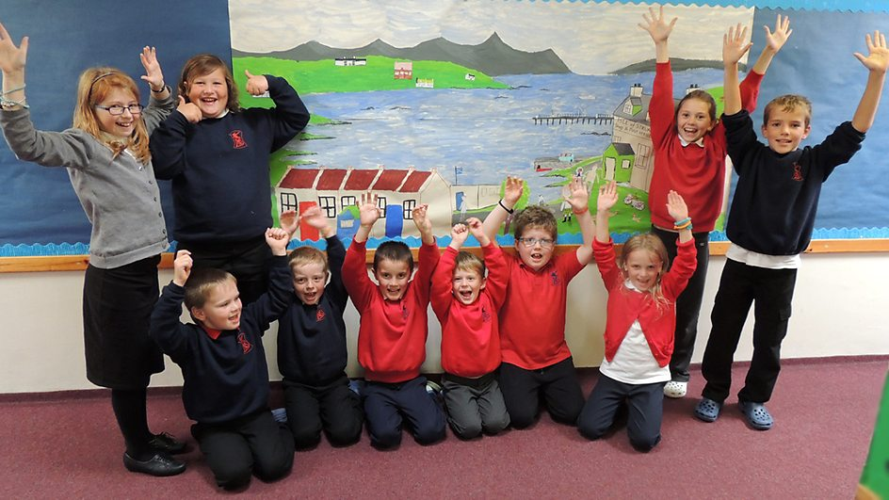

School Meals and Snack Biadh na Sgoile

School Menus offer healthy and tasty meal options which reflect the Scottish Government food and drink legal requirements for school lunches. From January 2015 all pupils in P1-3 classes will be offered a free meal as part of a Government initiative. Children of parents in receipt of Income Support are also entitled to free meals and application forms are available from the school office.

School meals are served daily in the school canteen and are prepared on the premises. Menus are planned on a monthly cycle and parents are issued with a copy.
Lunches cost £1.90 and payment is preferred every Friday (for the current week).

Parents should let the school know in advance if their child has any special dietary requirements. If this is the case, parents will be asked to complete a form which ought also to be signed by either a doctor or a dietician.

Children having a packed lunch from home also sit and eat in the Dining Room. The school has achieved 'Health Promoting Schools' Gold Award and we would ask for parents’ co-operation in ensuring that the contents of packed lunches are healthy.

In the interest of health and safety, glass bottles are discouraged.

Parents should inform the school if children intend to go home at lunch time.

A mid-morning snack of a glass of milk, toast or fruit is offered to all pupils in the school on a daily basis. The Western Isles Health Board and Education & Children’s Services contribute funding towards providing fruit for P1-3 pupils. Milk and bread will be paid for this session using generous fundraising proceeds received from the Parent Council.

Mobile Phones A’ Cleachadh Fònaichean-Làimhe

We generally discourage parents and pupils from bringing mobile phones or other valuable items to the school on the grounds that they may get lost or stolen. If a phone or other valuable item is brought to the school, parents are advised that, where possible, the items should be marked in some way to aid future identification if lost and subsequently found.
If a pupil does bring a mobile phone to school, the phone must remain switched off during the school day and may not be used on school premises, grounds or during off-site school curricular activities (such as swimming or other sports activities). The only exceptions to this will be on school trips, where the school will have discretion to allow pupils to carry and use phones if they wish, in emergencies or with the express approval of a member of school staff.
If a pupil is found by a member of staff to be using a mobile phone for any purpose, without authorisation, the phone may be confiscated from the pupil and will generally only be returned to the pupil’s parent.

Travel to and from School Busaichean na Sgoile

Primary School children living two miles or more from school and Secondary School children living three miles or more from school are entitled to free transport.

Transport for Leverhulme Memorial School pupils is currently provided by two bus operators:

Hebridean Transport  Tel 01851 70 5050 | Brings in children from Scarista and Northton.
South Harris Coaches  Tel 01859 520 259 | Brings in/takes home children from Strond, Borrisdale and Rodel.  Also takes home children to Northton and Scarista.

Following a recent consultation process regarding the catchment areas for our school, the boundaries were extended on the west side of the island as far as Horgabost. A current consultation exercise proposes that our boundary on the east side of the island will be south of the village of Geocrab, as from August 2015.

We ask parents to inform the school should there be any changes to the normal home arrangements. It is the parent’s responsibility to make sure their child arrives at the pick up point on time and behaves in a safe and acceptable manner while boarding, travelling in and leaving the school transport vehicle. Children who misbehave can lose their right to home to school transport.

Children who are not eligible for free transport will have to pay a contribution towards the cost of transport if they make use of it. It will be possible for parents to:
- buy weekly books of tickets, or
- purchase a termly pass, or
- purchase a session pass.

Payment for the above can be made by direct debit if parents wish. The overall price is the same regardless of which method parents choose – in other words, there is no cost penalty for choosing to pay weekly or monthly. There is a system of stepped discounts for families with more that one child travelling to school.

Communication with Home Litrichean Sgoile

From time to time your child will bring home important and routine communications from the school. Parents are encouraged to check their child’s schoolbag for any communications. We would like to encourage more communication by email and would ask parents who have not already done so to provide us with their email addresses. Groupcall, a text messaging system, is also being trialled as a means of communication.
Unexpected Closures Dùnadh tràth no Èiginneach

It may be necessary, occasionally, to close the school at short notice and send the pupils home, for example, in exceptionally bad weather or if the electricity or heating fails. If parents are not regularly at home during school hours, they should always make arrangements to have someone available to receive their children should such an emergency occur. The school will ask each parent at the point of enrolment to provide the address and/or telephone number of a person who can be contacted in these circumstances. Please ensure this information is kept updated and notify the school of any changes.

Parents should also feel free to contact the school if they are concerned about the safety of the children because of severe weather conditions and are free to call for them at any time.

In the event of the school having to close before the start of the day, the following procedure will apply and Groupcall text messaging will be used:

- The Headteacher contacts the Radio Scotland Helpline and the local radio station for announcement on the Gaelic programme between 7.30 and 8.30am.
- The Headteacher contacts bus companies to inform them of the need to close the school.
- The Headteacher contacts the staff who are due in school that day to inform them of the decision.
- The School Assistants will use Groupcall, text or contact parents by phone.
- The Headteacher informs Faire and the Education and Children’s Services Department about the closure.

Complaints, Comments and Suggestions Procedure

We are keen that you should be completely satisfied about your child’s education and we encourage feedback from parents and pupils. We are, therefore, interested in feedback of all kinds, whether it be compliments, suggestions or complaints.

If you have a complaint about the school, please let us know. It is better that these things are shared openly and resolved fairly rather than being allowed to damage the relationship between the family and the school. There will be no negative consequences arising from making a complaint and we will deal with the issue as confidentially as possible. If we have made a mistake we will apologise quickly and clearly and try to put things right.

There are some things which you should take note of in relation to making a complaint:

- Please make any complaints initially to the Head Teacher. This makes sure that the school knows what is going on and has an opportunity to respond and resolve the issue.

- If you are unhappy with the service or with our response then you will have the right to take the matter further. You can put your complaint in writing or fill in a complaint form. Completed forms should be sent to: Director of Education and Children’s Services, Comhairle nan Eilean Siar, Sandwick Road, Stornoway, Isle of Lewis, HS1 2BW.
- If you are still unhappy after further investigation and reply, you can take the matter up with the Scottish Public Services Ombudsman. The reply letter will include the contact details.

Medical & Health Information Fiosrachadh Slàinte

Parents should inform the school without fail of any relevant medical history affecting their child eg asthma, epilepsy, diabetes etc of which teachers should be aware. Staff will keep this information confidential. There are some pupils who may require to use drugs or medicines e.g. asthma inhalers during the school day. Any such medication must be handed in to the Head Teacher together with a signed letter from either a Doctor or the Parent/Guardian stating:
- Name of pupil.
- The name of the drug and the reason for taking it.
- Whether the medication has been prescribed by the parent or Doctor.
- The correct dosage and the daily time of issue.
- The completion date of the medication.

Any pupil who feels unwell in school or suffers an accident should inform a teacher or a member of the support staff who will make arrangements to inform you and/or seek medical advice if necessary.

In some cases it may be necessary to send your child home but this will only be done after discussion with the parent/carer/emergency contact to make and confirm suitable arrangements, including transport if required.

The School is visited regularly by Health Visitors who may carry out P1 medical checks; flu immunisation programmes and occasionally gives talks to P6/7 pupils. Parents will be informed and asked for their consent in advance of any medical inspections taking place involving their child.

Dental Services

As part of the Childsmile programme all our pupils are encouraged to brush their teeth after lunch, every day at school. A dental worker visits regularly to review this programme.

Dental officers and hygienists also visit the school and annual dental surveys are carried out, usually involving P1 and P7 pupils.

If any child requires dental treatment, parents should make an appointment for their child at the Dental Clinic.

SECTION TWO
PARENTAL INVOLVEMENT and SCHOOL ETHOS
COM- PÀIRTEACHAS agus AMASAN NA SGOILE

This section contains information about how parents can be involved in their child’s learning and the life and work of the school, and covers - supporting learning at home, improving home/school partnerships and parental representation.

Our school welcomes parental involvement as research has shown that when parents are involved, children do better in school. We promote an ‘open’ school and are always responsive - providing discussions between parents with staff when requested.

We encourage parental communication in a range of ways e.g. through letters, termly newsletters, phone calls and calling in person to the school. Information is sent home from time to time e.g. about useful websites to support learning at home. Homework diaries provide a tool for continuous engagement about children’s learning and termly parent events are held throughout the year e.g. information evenings, parent appointments to discuss children’s progress and pupil led open afternoons. Parents are invited to attend Individualised Educational Plan meetings and to contribute to setting targets for their child if he or she receives additional support in their learning.

Parents are also regularly involved in the school through fundraising events e.g. Agricultural Show teas and Bonfire night. We also rely on parents to become school volunteers in various capacities including helping to run after school clubs. As staff we acknowledge that this input benefits our pupils greatly and are indebted to parents for giving their time.

We encourage parents to share their views and gather parent opinion through questionnaires which are normally issued every second year.

Parent Representation Comunn nam Pàrant

Parents/Carers are encouraged to volunteer or put themselves forward to be chosen as representatives of the Parent Council. The role of the Parent Council is to:
- Support the school in its work with parents
- Represent the views of all parents
- Encourage links between the school, parents, pupils, pre school groups and the wider community
- Report back to the Parent Forum (all parents are members of the Parent Forum).

Every primary year group and the Sgoil Àraich are represented on the Parent Council. A co-opted member, the Head teacher and a teacher representative also attend meetings. The Parent Council meets at least once per school term. All meetings are open and every parent is welcome to attend.
If you wish to discuss any matter relating to the Parent Council, you can contact the chairperson, Mrs Caroline Chaffer, on 01859 520 777.

Parentzone is a useful website which provides information and resources for parents and Parent Councils – http://www.educationscotland.gov.uk/parentzone/index.asp.
School Ethos Amasan na Sgoile

We recently reviewed our vision, values and aims with our stakeholders and updated a rationale of our Curriculum.

As our vision statement we will use the appropriate Gaelic proverb:
“Is e an t-ionnsachadh òg an t-ionnsachadh bòidheach.”
this translated would read “Learning in youth is lovely learning.”

The children thought of catch phrases to encourage learning and achievement and agreed on “Don’t give up – Do your best” - “Feuch e co-dhiù – Dean do dhicheall”

Our school values and aims were adapted from the ten dimensions of Journey to Excellence, and an additional aim relating to our Gaelic ethos is included.

At Leverhulme School we will aim to:

- involve children in the highest quality learning activities

- focus on outcomes and improve success for all the pupils

- develop a common vision across children, parents and staff

- enable all to be leaders

- work together well with other agencies and the community

- work with our parents to improve our learning

- reflect on our work and feel challenged

- listen and act on the views of staff and children

- promote well-being and show respect to others

- develop a culture of ambition and achievement – Don’t give up - Do your best

- promote the use of the Gaelic language and local culture throughout the school

Last year in an article about Gaelic Medium education, Mr and Mrs Raymond Campbell were very positive about the experiences that their children have had at this school. They stated that their children “ have enjoyed many good opportunities in the GMU such as visits to authors and drama sessions in the school…There are lots of Gaelic resources available online to help parents and also for children to help them learn Gaelic.”

Pupil Committees, Partnerships and Achievements Ag obair Còmhla

All pupils are involved in either the Eco School or Pupil Council committees. Minutes of meetings are on display on information boards and within folders in the school. The school was awarded Green Flag Status last session and fundraised to help to sponsor two toilets in Afghanistan and Bangladesh as part of their Global citizenship activities.

The School has established partnerships with various organisations, bodies and people who have worked with the school throughout the session. These links include workshops and talks led by a range of organisations and author visits. The school has been involved in a number of fundraising efforts e.g. Blythswood Shoebox and Save the Children Christmas Appeals. Local Citizenship activities involved all the children volunteering to collect bags of rubbish as part of Keep Scotland Clean 2014 last June.

Children’s achievements are celebrated at end of term assemblies and certificates are displayed in the school.
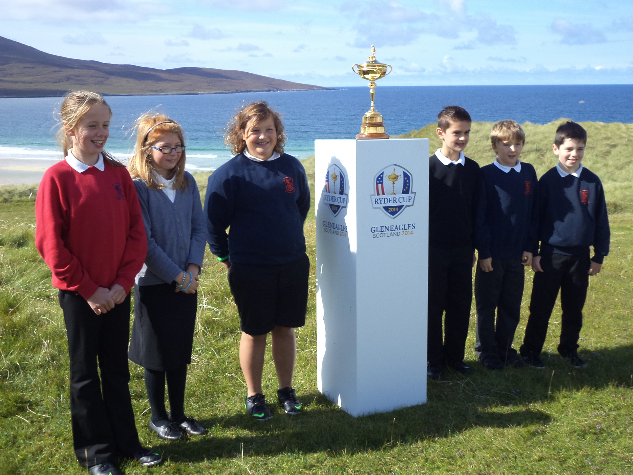
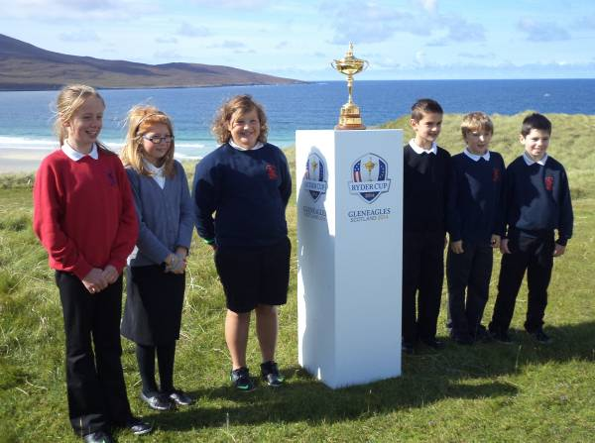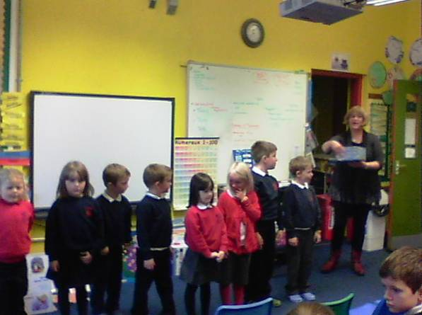

Pupil Conduct Riaghailtean Modh

A partnership between the school and parents is required in order to ensure the best possible standard of pupil conduct. Pupils are expected to set themselves high standards in appearance and behaviour. Our Code of Behaviour / School Rules are relatively simple and few in number to allow for the smooth running of the school. The general aim is to produce an atmosphere of friendly co-operation, encouraging respect and consideration for other persons and other property.

School Rules / Code of Behaviour

- Be kind and polite to each other.

- Show respect to everyone.

- Be helpful.

- Be well behaved.

- Keep the school and grounds clean and tidy.

- Look after school equipment, furniture and the school buildings.

- Walk in the classrooms and corridors.

- Welcome new pupils and visitors to the school.

- Remember not to play in the toilets and avoid areas that are out of bounds.

- Remember to come to school prepared.

- Never leave the school without the permission of a member of staff.

Health & Safety Sàbhailteachd

Ball games are not permitted in the playground except in designated areas.
Snowballing is strictly prohibited, as serious injury can be caused to eyes and face.
Children must not climb fences, walls or any other structure.
Smoking on school premises is strictly prohibited.
Children must not bring anything to school that can cause injury or harm to another pupil or damage to school property.
Children must not bring mobile phones or other valuable items to school on the grounds that they may get lost or stolen.

Pastoral Support Arrangements

Our school assistant provides playground supervision and also fulfils any First Aid requirements at the school.

Dealing with Bullying

Parents should inform the School immediately if they become aware of any incidents of bullying. The children should be encouraged to discuss any worries or problems of this nature with the teachers, or a member of the support staff, as soon as possible.

The school promotes positive behaviour through giving pupils responsibilities e.g. buddying and children are rewarded with free play activities during golden time.

SECTION THREE

THE SCHOOL CURRICULUM AN CURRAICEALAM

Every child and young person is entitled:
- to experience a curriculum which is coherent from 3 to 18.
- to experience a broad general education.
- to develop skills for learning, life and work, with a continuous focus on literacy and numeracy, and health and wellbeing.
- to personal support and challenge to enable them to gain as much as possible from the opportunities which CfE can provide.

Curriculum for Excellence provides a broad and deep general curriculum that develops skills for learning and life, with a real focus on literacy and numeracy while promoting an active and healthy lifestyle. Ultimately, the aim is to improve children’s achievements and to nurture successful learners, confident individuals, effective contributors and responsible citizens. Its principles i.e. challenge and enjoyment; breadth; progression; depth; personalisation and choice; coherence; and relevance will be addressed through discrete subjects and inter disciplinary projects.

Children have had increased opportunities to develop within the four capacities through more detailed planning covering the ethos & life of the school, curriculum areas and subjects, interdisciplinary projects and personal achievement opportunities.

Health & Wellbeing

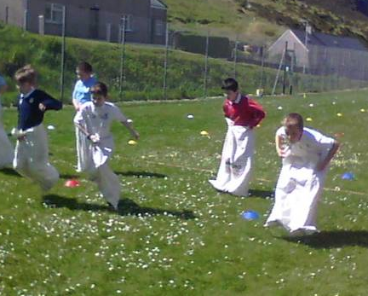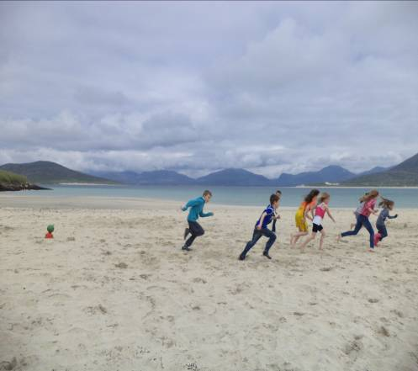

Subject areas include Literacy and Languages (English, Gaelic and French), Numeracy and Mathematics, Health and Wellbeing which includes PE, Expressive Arts (Art & Design, Music, Dance and Drama), Religious and Moral Education, Social Studies, Technologies and Sciences.

Literacy and Language (English, Gaelic & French)
The teaching of Language is covered through the four modes of Listening, Talking, Reading and Writing which are in constant interaction. Literacy skills are developed and reinforced across the curriculum.
Numeracy and Mathematics
To achieve a balance of Mathematical experiences pupils will cover a range of activities based on Number, Money and Measurement, Shape, Position and Movement and Information Handling. Numeracy skills are developed and reinforced across the curriculum.
Health & Wellbeing
Work is undertaken within the following framework:
~ Mental, emotional, social and physical wellbeing
~ Planning for choices and changes
~ Food and nutrition
~ Substance misuse
~ Relationships, sexual health and parenthood.
Movement skills, Physical activity and sport and health are also covered under H&WB.

Expressive Arts
Expressive Arts encompasses four subject areas: Art & Design, Dance, Music and Drama. P4-7 pupils currently benefit from one hour a week with specialist teachers of Music, PE and Art as well as tuition from a Gaelic singing and music instructor.

Social Studies
The Social Studies experiences and outcomes are structured under three main organisers:
~ people, past events and societies
~ people, place and environment
~ people, society, economy and business.
Pupils will be taught through a range of topics covering those areas.

Religious and Moral Education
While Christianity is the basis of our Religious and Moral Education programme, pupils also gain some knowledge of World Religions selected for study.
Technologies
ICT will be used to enhance learning in all subjects. Technological developments in society will be investigated and food and textiles contexts and also craft and design contexts will be used to develop technological skills and knowledge.

Sciences
Through learning in the sciences, children develop their interest in, and understanding of, the living, material and physical world. The key concepts the children will study are:
~ Planet earth
~ Forces, electricity and waves
~ Biological systems
~ Materials
~ Topical Science
Sports & Extra Curricular activities Spòrs & Cur-seachadan

We have a spacious playground and access to the playing field and running track for athletics and outdoor games. Classes may also use the playpark adjacent to the school with permission from school staff. Pupils have two hours of PE per week and PE equipment is available for pupils to use outdoors at break times.

The pupils take part at the Harris School Sports and in some competitions held throughout the session e.g. Crossroads Football, Sports Festival Unihoc competition and events organised by Active Schools.

In previous years the children have had a block of 5 swimming lessons within two groups in place of their PE slot during term three but the PE specialist teacher will no longer be available weekly for this so swimming provision will need to be reviewed.

We hope to resume after-school club on Tuesdays from the beginning of January to the end of March. The children will have an opportunity to participate in a range of games and activities which will be led by parents and volunteers. Sradagan, the new Gaelic after school club, is well attended and will resume on Wednesdays next term.

All the children are encouraged to participate in Christmas performances every year and also to take part in competitions at the local Mod. The older pupils were involved in a successful play about World War 1 in partnership with Proiseact nan Ealain this year.

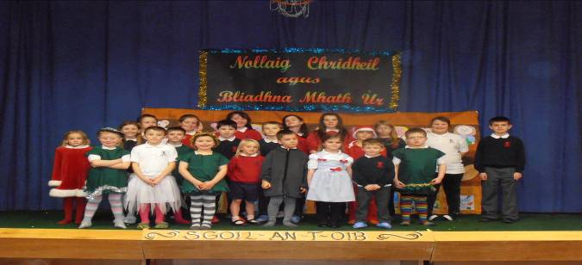

Parents can find out more information on the curriculum via the following link:
http:www.educationscotland.gov.uk/thecurriculum/howisthecurriculumorganised

Home Work Obair-dachaigh

Homework packs are issued weekly on a Monday and handed in on Friday. Some homework activities will reinforce work which has already been taught in school. On occasions, some research work may be set as part of class topic work. Pupils may also be expected to read for information or pleasure and to practise tables and spelling skills regularly, if necessary. Computer activities e.g. Education City and other website resources will also be set as homework.

Children spending some time at home with their parents, sharing and reflecting on what they have learned at school, would also provide a worthwhile learning experience. As a rough guide 15 minutes (P1 and P2); 30 minutes (P3, P4 and P5) and 45 minutes (P6 and P7) should suffice.
Religious & Moral Education & Religious Observance
Creideamh agus luachan sòisealta

As a school we aim to develop the spiritual, moral, social and cultural values of our pupils, having regard to the values of the community, and guided by the recommendations contained in national and regional guidelines.

As a non-denominational school, we cater for pupils from different religions and backgrounds. All pupils have a Religious and Moral Education lesson most weeks.

Any parents who may wish to exercise their right to withdraw their child from Religious Education lessons should put their request in writing to the Head Teacher.

Assemblies are also held fortnightly and they promote aspects relating to Health and Wellbeing as well as Religious and Moral Education. Although our School Chaplain position is currently vacant, Ministers or representatives from all the local churches are invited into the school to participate in our end of term services. The Challenger Educational Bus with representatives from People with a Mission Ministries also visits the school annually.

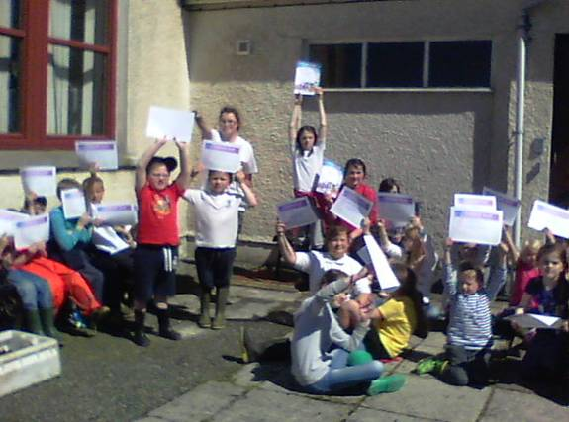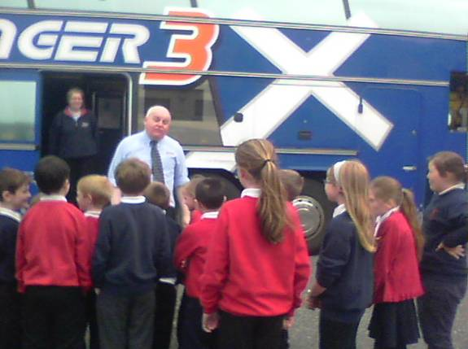

Sensitive Aspects of Learning Poileasaidhean Curam agus Socair

A range of policies exist covering care and welfare issues, for example, anti-bullying, anti-racism and child protection. All members of staff receive annual child protection refresher training.
As part of the Health and Wellbeing programme, primary schools are required to address difficult areas i.e. relationships, sexual health, parenthood and drugs education. Parents will be informed before lessons take place on these topics. Parents may request, if they wish, to view the resources being used for these lessons.

The P6/7 classes recently had a talk about puberty with health visitors and the pupils in P6 received a visit from a ChildLine worker where they discussed forms of abuse and the importance of talking to a trusted adult about any worries they may have.
Active Schools Na h-Eileanan an Iar

Active Schools work with schools and communities to help make sure children are active and stay active. The fundamental aim is to offer children and young people the opportunities and motivation to adopt active, healthy lifestyles, now and into adulthood. Our Active Schools Co-ordinator is Miss Jenna Stewart and she works with the school to develop an action plan of work they can support through the school year. Here are some examples of the activities which took place in the last year:

- Young Persons Leadership Awards
- Bikeability Training
- Tchoukball taster sessions

Assessment Measadh

Assessment is the means of obtaining information which allows teachers, pupils and parents to determine what a pupil is actually achieving in relation to expectations of achievement and attainment and drawing conclusions from that comparison.

The experiences and outcomes within Curriculum for Excellence (CfE) will be used to form success criteria for children’s learning and a range of Assessment for Learning strategies, peer and self assessment will be used in class.

The table below highlights the stages at which the levels within Curriculum for Excellence apply:

CfE Levels | Stage/Classes
Early | the pre-school years and P1 or later for some
First | to the end of P4, but earlier or later for some
Second | to the end of P7, but earlier or later for some
Third/Fourth | S1 to S3, but earlier for some. Fourth level broadly equates to SCQF level 4
Senior phase | S4 – S6 and college or other means of study

A range of standardised assessments is currently used at different stages throughout the primary which helps staff to provide an overall educational profile of pupils e.g. P1 Reasoning and Literacy Booklets (English class) , P3 and P7 Performance in English (PiE) and Performance in Maths (PiM) assessments and Cognitive Ability Testing in P5. Gaelic Phonological tests are also available where required at P2/3 level. Significant scores will be shared with parents.

In addition, some pupils in P4 and P7 may also be asked to participate in the annual Scottish Surveys of Literacy and Numeracy which provide a national picture of progress in attainment.

Reporting to Parents Conaltradh ri Pàrantan

Reports on pupil's progress are an important form of communication between home and school. Parents will receive a full written report in April and will also be given opportunities to discuss their child’s progress with the class teacher at parents' evenings held in November and June.
The children maintain profile folders throughout the session and P7 pupils are required to produce eportfolios which are used for transition to Secondary School.

Latha na Gàidhlig
Gaelic Open Day
2.12.14

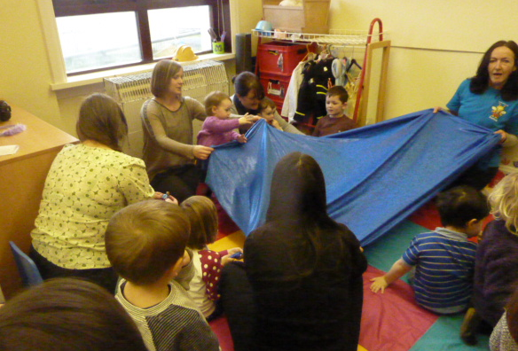

SECTION FOUR
SUPPORT FOR PUPILS
Additional Support Needs Feuman Ionnsachaidh Sònraichte

We aim as far as is possible to educate pupils who have additional support needs alongside their peer group. When necessary, extra help is provided. This help is delivered in a flexible manner and the pupils can be seen individually, in a group or class.

The Additional Support Needs of the Children are identified through a process of Staged Assessment and Intervention. The process of Staged Assessment and Intervention provides a structured system for identification, assessment, planning, review and record keeping for individual children who receive additional support of any kind. The Getting it Right Approach for Children and Young People (GIRFEC) in the Western Isles puts in place a network to promote wellbeing so that children and young people get the right help at the right time.

All Looked After Children and Young People are considered to have additional support needs. This is the case unless the school establishes they do not have additional support needs. The Local Authority must consider whether each looked after child requires a Co-ordinated Support Plan (CSP). The CSP is used to ensure a co-ordinated approach to providing support for children. The CSP will summarise assessments carried out for the child, explain the nature of the child’s difficulties and outline the steps the Authority will take to support the pupil’s needs. An assessment service is also provided by the teacher of children with visual and hearing impairment. Speech Therapists may also visit schools to help any pupils who require support.

In addition, an Educational Psychologist advises on the varied behavioural and learning difficulties which all pupils can experience. He/She can work directly with pupils and families if required.

Under the Equality Act 2010, the Education Authority will strive to avoid any discrimination against disabled pupils.

Mediation is provided by Resolve in the Western Isles. It is a non judgemental voluntary process which seems to resolve misunderstandings in the early stages to prevent them escalating. Parents also have the right to have an advocate present at Mediation and this is available through Advocacy Western Isles.

Parents should also be aware of the following organisations which provide advice and further information.
- Children in Scotland: Working for Children and their Families, trading as Enquire – a charitable body registered in Scotland under registration number SC003527.
- Scottish Independent Advocacy Alliance, a charitable body registered in Scotland under registration number SCO33576
- Scottish Child Law Centre, a charitable body registered in Scotland under registration number SCO12741

Further information can be obtained locally from the School or Area Principal Teacher of Learning Support.
Primary School Admissions Clàradh

Children who will be four years of age by 28th February 2015 are eligible for infant enrolment in August 2015. Enrolment takes place at the beginning of February, on a date specified by press advertisement.

In our school, pupils can be taught through the Medium of Gaelic or English and parents should indicate their preference on the enrolment form. At the time of enrolment, parents should being their child’s Birth Certificate and should inform the school of any medical problems or special needs which their child may have.
Other children, whose families have just moved into our catchment area, should be accompanied by a parent or guardian on their first day of reporting to school if they have not already been in contact with the school.

Placing Requests

If you wish to make a Placing Request, you should complete the appropriate form (available from school) and return it to:
Louise Smith,
Principal Officer,
Education and Children’s Services,
Comhairle nan Eilean Siar,
Sandwick Road,
Stornoway
HS1 2BW.

If a Placing Request is successful, parents will be responsible for the safety and transportation costs of their child to and from their chosen school.

Transitions Gluasadan

Sgoil Àraich/Nursery

Early learning and childcare enrolment usually takes place in February on a date notified to parents by local press advertisement. Children aged 2½ can be enrolled at the group if there is sufficient space and their birthday falls before the 28th of February of the current academic year. Children receive funded places at the beginning of different school terms depending on when their 3rd birthday falls. If demand for places outweighs supply, priority will be given to children eligible for their pre school funded place before any non funded children. In situations where a 2 year old’s child’s parent(s)/carer(s) are receiving out of work benefits, a child is eligible for a place following their 2nd birthday. Children securing a funded early learning and childcare place are entitled to 600 hours over 38 weeks i.e. 15 hours and 50 minutes each week.

Children who enrol in the nursery will be invited into the playroom for transition days to experience a little of the nursery atmosphere and to meet the nursery staff before starting full time.
More information can be obtained from Mrs Nellie Morrison, Sgoil Àraich playleader. Copies of our revised Nursery handbook will be made available in January 2015.

An electronic copy of the current handbook is available on Comhairle nan Eilean Siar’s website.

Transfer from Nursery to Primary

Before leaving nursery, a profile and transition record for each child will be prepared by nursery staff to hand over to Primary School staff to ensure a smooth transition and continuity of education for the child transferring to Primary. There will also be a number of visits to the Primary Classes in the lead up to the child(ren) commencing in P1 as well as the class teachers visiting the Sgoil Àraich.

Throughout the session the Sgoil Àraich children join the primary classes for activities for example fundraising for Save the Children’s Festive jumper day.

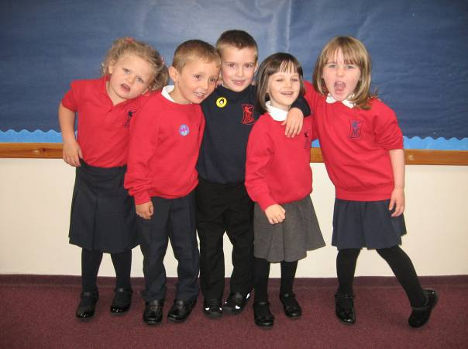

Primary to Secondary Transfer

Pupils completing Primary 7 will transfer to: Sir E. Scott Secondary School
Tarbert,
Isle of Harris
Telephone Number: 01859 50 2900

Two or three transition days to Sir E Scott Secondary School will take place during the summer term and children will have the opportunity to meet and get to know other P7 pupils, their secondary teachers and the layout of the school. Pupil Support staff also visit the school to see P7 children within their classes and to speak with the class teacher. Children may also be asked to complete transition work across stages/schools.

Last session all the P7 children in Harris took part in activities and a residential visit at the Scaladale Centre and had high tea together in Tarbert as part of their transition.

Additional arrangements will be put in place to support pupils with additional needs to make successful transitions.
Transferring Education Facts about Pupils

Educational authorities and the Scottish Government require accurate, up-to-date information about pupils inorder to make best decisions about how to improve the education service.
Education authorities and Scottish Government have collected data about pupils on paper forms for many years. We now work together with schools to transfer data electronically through the ScotXed programme. Thus Scottish Government has two functions: acting as a ‘hub’ for supporting data exchange within the education system in Scotland and the analysis of data for statistical purposes within Scottish Government itself.

Why do we need your data? In order to make the best decisions about how to improve our education service, Scottish Government, education authorities and other partners such as the SQA and Careers Scotland need accurate, up-to-date data about our pupils. We are keen to help all our pupils do well in all aspects of school life and achieve better examination results. Accurate and up-to-date data allows us to:
- plan and deliver better policies for the benefit of all pupils,
- plan and deliver better policies for the benefit of specific groups of pupils,
- better understand some of the factors which influence pupil attainment and achievement,
- share good practice,
- target resources better.

Data policy
The ScotXed programme aims to support schools and Local Authorities by supporting the collection, processing and dissemination of statistical information required for planning, management and monitoring of Scottish education services.
A subset of this information is passed to Scottish Government for research and National Statistics publications. Education data within Scottish Government is managed effectively by secure systems and is exploited as a valuable corporate resource, subject to confidentiality restraints. As part of its data policy, Scottish Government will not publish or make publicly available any information that allows individual pupils to be identified, nor will data be used by Scottish Government to take any actions in respect of individuals. Data is held securely and no information on individual pupils can or would be published by Scottish Government.
The individual data collected by Scottish Government is used for statistical and research purposes only. We hope that the explanations contained on the ScotXed website will help you understand the importance of providing the information.

Your data protection rights
The collection, transfer, processing and sharing of ScotXed data is done in accordance with the Data Protection Act (1998). We also comply with the National Statistics Code of Practice requirements and other legislation related to safeguarding the confidentiality of data. The Data Protection Act gives you the right to know how we will use your data. This message can give only a brief description of how we use data. Fuller details of the uses of pupil data can be found on the ScotXed website (www.scotxed.net).
Scottish Government works with a range of partners including Education Scotland and the SQA. On occasion, we will make individual data available to partners and also academic institutions to carry out research and statistical analysis. In addition, we will provide our partners with information they need in order to fulfil their official responsibilities. Any sharing of data will be done under the strict control of Scottish Government, which will ensure that no individual level data will be made public as a result of the data sharing and that these data will not be used to take any actions in respect of an individual. Decisions on the sharing of data will be taken in consultation with colleagues within and outwith Scottish Government.

Concerns
If you have any concerns about the ScotXed data collections you can email the Senior Statistician, Peter Whitehouse, at Peter.Whitehouse@scotland.gsi.gov.uk or write to The ScotXed Support Office, Area 1B, Victoria Quay, Leith, EH6 6QQ. Alternative versions of this page are available, on request from the ScotXed Support Office, in other languages, audio tape, Braille and large print.

Want more information?
Further details about ScotXed are available on the ScotXed website, www.scotxed.net., which contains a section on ‘frequently asked questions’ at https://www.scotxed.net/jahia/Jahia/lang/en/pid/220.
SECTION FIVE

SCHOOL IMPROVEMENT LEASACHADH NA SGOILE

Policies are in place for every subject and these will be updated in line with Curriculum for Excellence as the experiences and outcomes for each subject area are being developed. Our Care and welfare policies are also kept under regular review.

Standards & Quality Report

Each year the school publishes a Standards and Quality Report which highlights the school’s major achievements in the previous year.

A copy of our June 2014 Standards and Quality report was issued to all parents in June. Termly newsletters also highlight achievements and copies are distributed to all parents at the end of every term.

School Improvement Plan

All schools are required to plan improvement priorities annually. Our targets for this session are summarised below:

Identified Targets 2014/15
1 | To deliver high quality learning and teaching with a focus on Numeracy and Maths.
2 | To improve use of data in order to meet the learning needs of all learners.
3 | To bring about improvement and promote leadership through self evaluation.

A summary of our School Improvement Plan was issued to all parents at the start of this session. A copy of the full School Improvement Plan is available to parents on request.

We will continue to engage with parents and the local community in developing the work of the school and nursery as we continue to promote Curriculum for Excellence.



