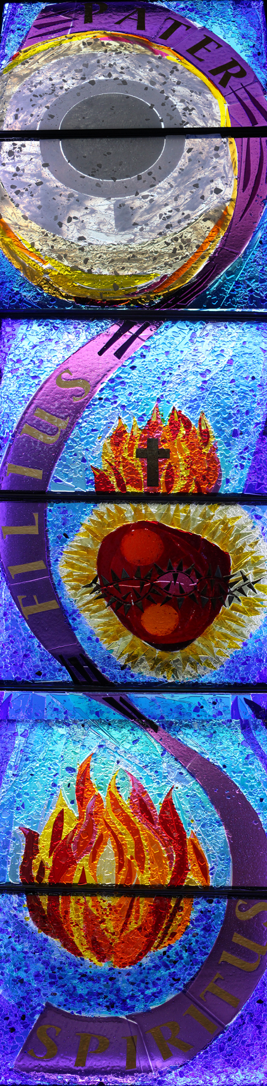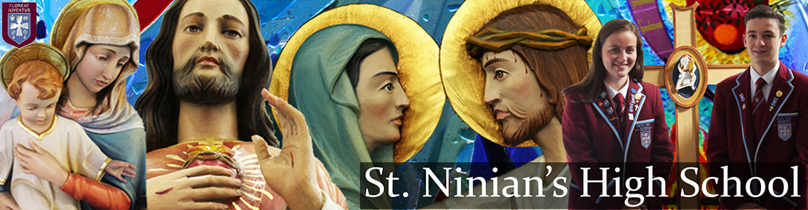

**Invitation to parents and friends to take part in our Retreat**

**'The Lord is With You'**

**Friday 17th May, 2019**

***“Ignorance of Scriptures is ignorance of Christ”***

*This strong exhortation from St Jerome, a Father and Doctor of the Catholic Church, urges us to recognize that serious study of the Gospels is a necessity, not an optional luxury, if we are to have a personal encounter with the Lord. The Retreat will be led by Monsignor Thomas Monaghan, former Parish Priest of St. Cadoc’s, Newton Mearns who is now retired and living in Johnstone. The day will be an opportunity of discovering more about Jesus by looking at questions Jesus asked…or about questions asked of Jesus. Through meditations and quiet prayer, our day will provide us with the opportunity to ponder the importance of daily contact with Jesus, a faithful friend who never deserts us.*

*The timetable for the day:*

*10.15: Introduction and Opening Prayer*

*10.30: Why does Jesus ask questions?*

*11.00: Morning refreshments*

*11.15: First meditation*

*12.15: Lunch*

*1.00: Second mediation followed by Holy Mass*

*2.15: Depart.*

If you would like to take part in the Retreat on Friday 17th May, please telephone the school office (577 2000) giving details of name and contact telephone number.

***We look forward to welcoming you.***

***John Docherty***

***Head Teacher***