St Ninian’s High School

S4 Work Experience



November S4


Work Experience

Benefits of Work Experience

Work Experience is an extremely valuable and worthwhile exercise and has many benefits. These include:

- Organising your own work experience promotes greater responsibility
- During work experience you can see first-hand what happens in a typical day on the job. Getting a realistic idea of the positive and negative parts of a job helps you make a more informed choice.
- Meeting people in the job means you can ask them questions, such as what they like best about their job, how they ended up in their line of work, and what qualifications they have.
- Meeting people in the job also helps you to start building a network of contacts in an industry you like, which can help you find a job later on.
- You can learn about related jobs in the same field, which could give you more ideas about what kind of career you might go into.

Where do I Start?

Firstly the sky really is the limit. As long as the company/organisation you want to work for has insurance and passes a Health and Safety risk assessment then you really can go anywhere! This has meant pupils going to some of the largest and most successful companies in the world such as Google.

Think about what type of job/profession you would like to do. Use resources such as the internet to get ideas about what different jobs involve and which ones are most suited to your skills, abilities and personal interests.

The school Careers Adviser can also help discuss which options might be best for you and give you information on specific jobs and contact information (ask your Pastoral Support Teacher to arrange a meeting with the Careers Adviser).

Finally, speak to your friends, family and subject teachers for ideas and to get

There are two ways of finding and securing a placement:

- www.workit.info
- Self Found Placements

WorkIT


www.workit.info is a bank of many excellent opportunities in a wide variety of jobs and professions. This will be available from mid April. It is important to regularly check the workIT website as new opportunities are continually posted.

Logging In

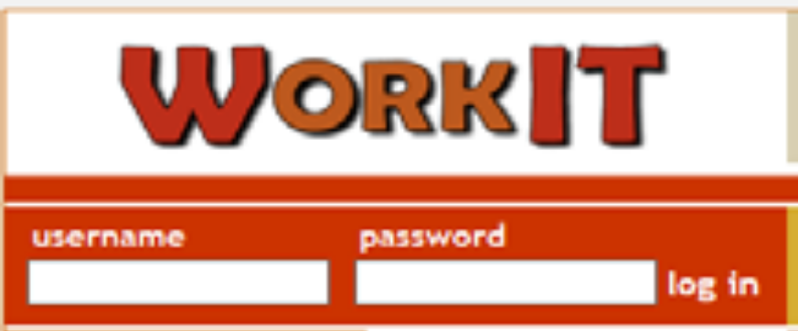

- In the Log In section you will be prompted to enter a Username and Password (individual username and password provided on letter – keep this safe and do not let anyone else know your username and password)

- Type in your Username and Password, then click on the Log In button

Viewing Placements and Applying

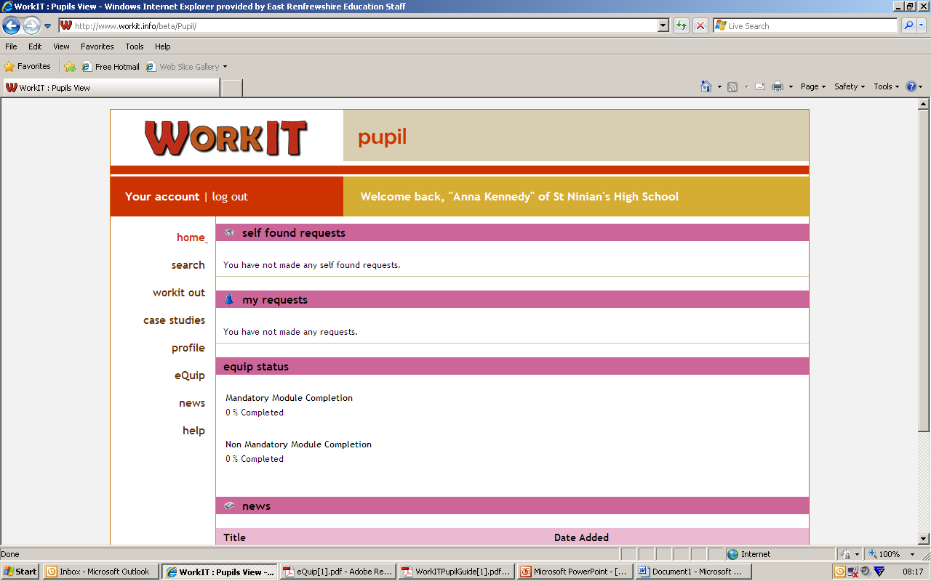

- Logging in will take you to the pupil Home Section of WorkIT where your own name and St Ninian’s High School will be displayed towards the top of the screen.

Searching for Jobs

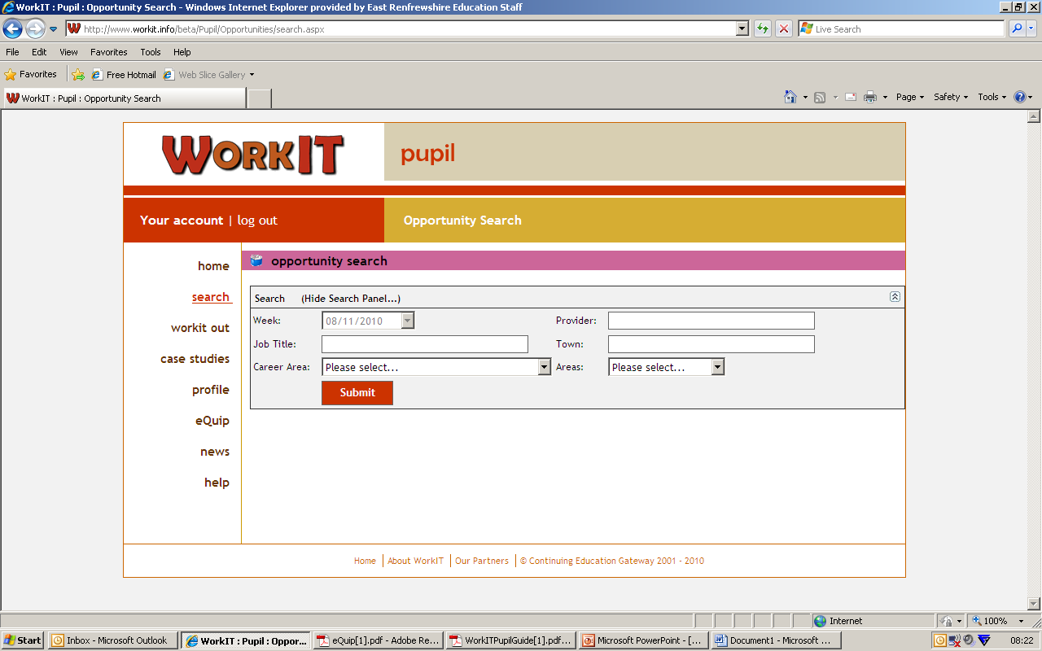

- The Search facility allows you to search for work experience vacancies.

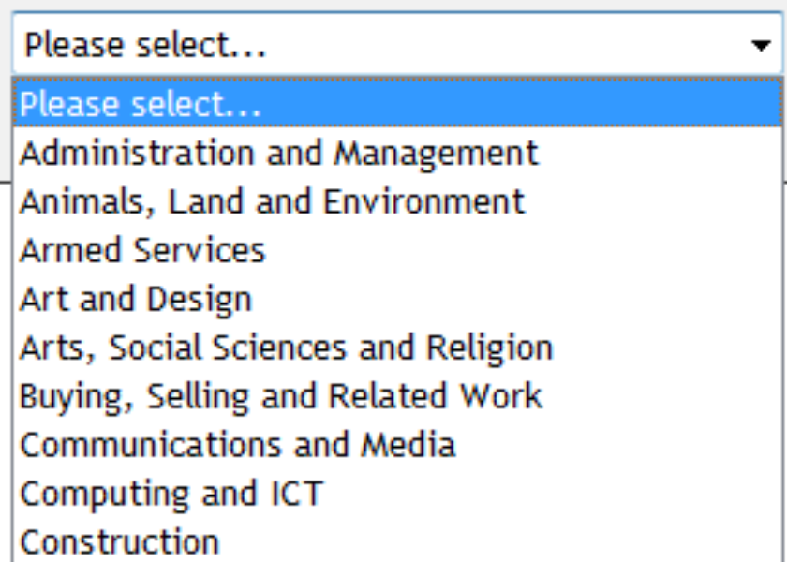

- If you wish to narrow down your search you can use the Career Area option to look for opportunities in a particular area of work.

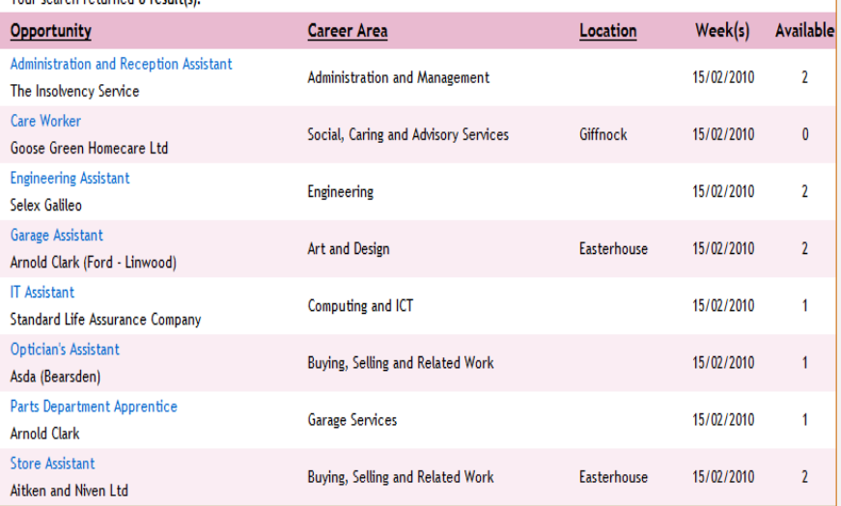

- The screen display will change to show a list of available work experience opportunities for that week.
- You can use the page numbers at the bottom of the screen to move forwards and backwards through the list.

Viewing Placements and Applying

- Click on the job title of one of the placements on your list.
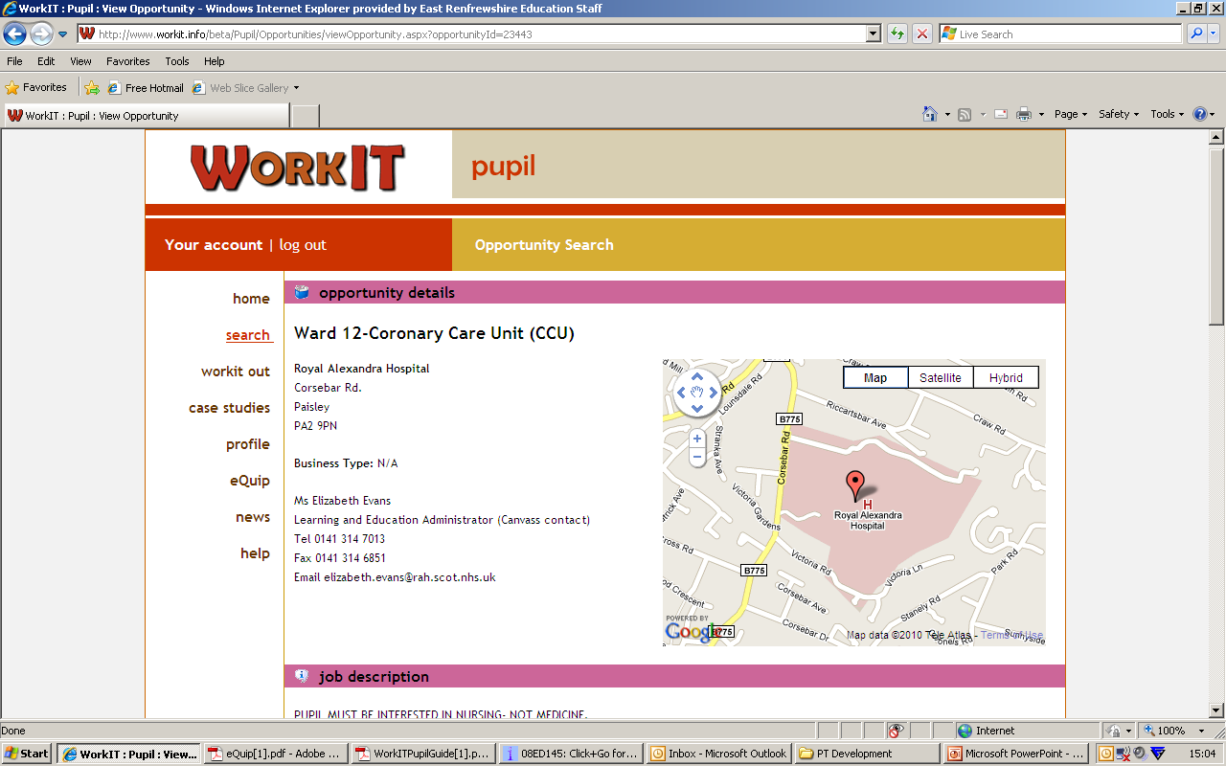

- You will now see a more detailed description of the opportunity.
- This includes information on:-
  - The name, address (with map) and contact details of the placement
  - Job description – what you will be doing on the placement
  - Hours – how long you will be expected to work
  - Lunch – how long you will get for lunch and whether or not it is provided
  - Dress code – how you will be expected to dress for the job.
  - Additional info – any other information about what the provider requires
  - Health and Safety – what you need to know and do to be safe while you are on the placement.
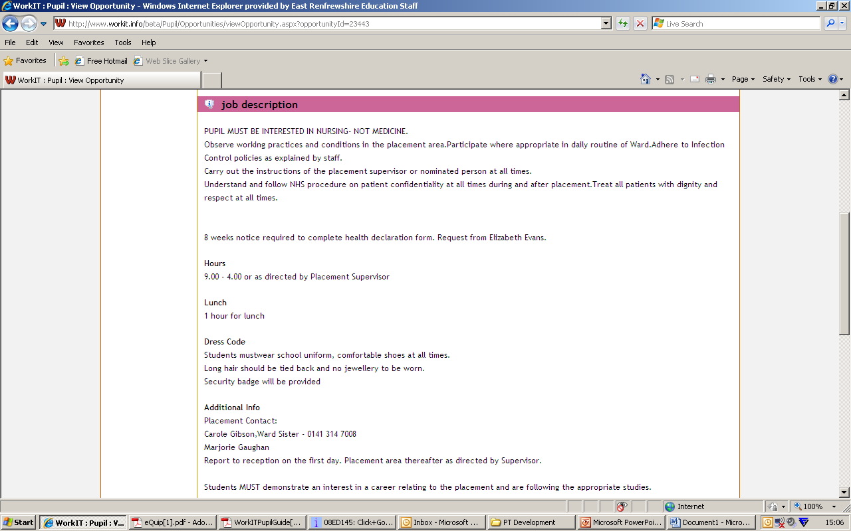
Requesting a Vacancy
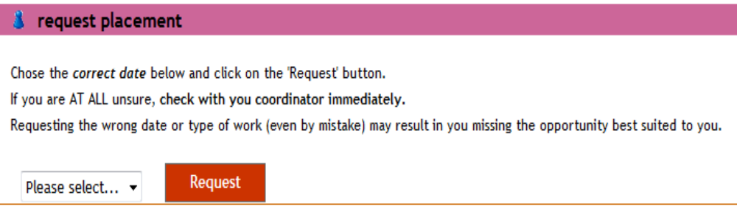

- If you wish to request this vacancy, scroll down the bottom of the screen to the request placement section.
- You can request up to 3 different placements.
- Please only request placements you are sure about and would definitely like to do.

What Happens Next?

- An information letter, placement details form, and parental permission (medical) form will be posted to your home address.
- Return the parental permission (medical) form to the school office.
- Keep information letter and placement details letter at home – you must read this as some placements ask you to confirm certain details e.g. working hours closer to the time of your placement.
- A letter of confirmation also goes to the employer with your details.
- Around a week before the placement begins make contact with the placement to confirm everything.

Self Found Vacancies
- Firstly, double check on that there is nothing suitable on www.workit.info
- Take green ‘Self Found Placement’ form (this is also available on the school website and GLOW)
- This is to be completed by the employer and handed back to the school office
- Time for this is limited as every placement has to be risk assessed.
- Once confirmed, an information letter, placement details form, and parental permission (medical) form will be posted to your home address.
- Return the parental permission (medical) form to the school office.
- Some placements such as Police, Armed Services and Fire Brigade have an application process and the dates for these placements may fall outwith the regular school work experience week. This means that another placement for that week will still be requires.
- NOTE: Self found placements can only be completed in mainland Britain. This is because of the health and safety assessments that have to be carried out for ALL requests.

Changing Your Placement

Once your placement has been confirmed you should not request to change this. Please be sure when you are requesting a job that you are happy with this and you realise you cannot change it for something else.
FAQ’s

- “I don’t have a username and password for the workIT website”
- See Mrs McLuskie in the school office immediately
- “I need a green self found placement form.”
- See Mrs McLuskie in the school office immediately
- “I am just going to work in my family business.”
- You still must complete a green self-found placement form and so see Mrs McLuskie in the school office immediately.
- “I have forms to give you”
- Hand it in to the school office
- “I am waiting to hear back from my mum’s, friend’s, pals, boyfriend.”
- As the deadline gets closer you must know now whether this is going ahead or not. If it is even doubtful, look for another placement so you have a plan B.

Further Information

GLOW

Information will be posted on the Work Experience GLOW Group. This will contain items such as:

- News
- Information about other placements not available through the workIT website such as Fire Service and Police.
- Downloadable copies of ‘Self Found Placement’ Form
- Health and Safety Information
- Links to useful resources and websites

Pupils who need log in details for this should ask at the school office.

Twitter

Information will also be posted on the school Twitter which can be accessed by going to www.twitter.com/stninianshigh. To ensure they don’t miss any vital information.

Deadline

All placements need to be Health and Safety Checked by the government organisation Gateway. In order for this to happen the deadline to have your placement confirmed whether it is organised via the workIT website or a self found placement is May

TIMELINE
Parental Consent Letter | March of S3
Pupil User Name & Password letter | March/April of S3
Database available for placements | March/April of S3
Self Found Placement Forms issued | March of S3
Self Found Placement Deadline | May of S3

ALL PUPILS MUST HAVE A PLACEMENT BY THE END OF MAY OF S3

Any queries regarding Work Experience please contact:

Miss S Higgins (Pastoral) 577 2000
Mrs PMcLuskie (School Office) 577 2000

