Principal Teacher of
Pupil Support
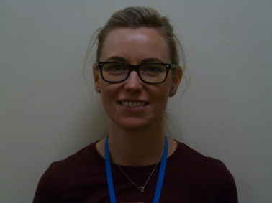

Dear Parent/Guardian
My name is Kirsty Macphee and I am your child’s Pupil Support Teacher.
As a Principal Teacher of Pupil Support I am responsible for a group of pupils in each year, S1-S6 and the well-being of children and young people is at the very heart of GIRFEC
In Williamwood we feel it is very important that we target support to young people as they require it throughout their time at school.
We operate a vertical support system which means that your child, and other brothers and sisters, will have the same pupil support teacher.
As your child’s Pupil Support teacher, I monitor each pupil’s progress and to support the pupil in a range of areas which includes personal and social issues, subject choice in S2/S3 and S4/S5 and the final transition between school and the next stage of their career.
Our first task will be to get to know our pupils as quickly as possible and ensure that they settle in quickly. We hope that if you have any concerns, you will not hesitate to contact me.
My timetable is printed overleaf. It is better to contact me when I am not teaching as I will be able to speak to you personally but I will respond, as quickly as possible, to any message left for me in the school office.
You can also arrange a meeting if you feel that would be more appropriate.
For more information on Pupil Support please refer to the appropriate section of the school website.
www.williamwood.e-renfrew.sch.uk

Yours faithfully

Kirsty Macphee
Principal Teacher of Pupil Support

