Name

Class Teacher

**Advanced Higher Physics**

**Waves**



# Simple Harmonic Motion (SHM)

If an object is subject to a linear restoring force, it performs an oscillatory motion termed ‘simple harmonic’. Before a system can perform oscillations it must have (1) a means of storing potential energy and (2) some mass which allows it to possess kinetic energy. In the oscillating process, energy is continuously transformed between potential and kinetic energy.

**Note:** any motion which is periodic and complex (i.e. not simple!) can be analysed into its simple harmonic components (Fourier Analysis). An example of a complex waveform would be a sound wave from a musical instrument.

**Examples of SHM**

|  |  |  |
| --- | --- | --- |
| Example and Diagram | Ep stored as: | Ek possesed by moving: |
| mass on a coil spring | elastic energy of  spring | mass on spring |
|  | potential energy  (gravitational) of bob | mass of the bob |
|  | elastic energy of the springs | mass of the trolley |
|  | potential energy  (gravitational) of the tube | mass of the tube |

Note that for the mass oscillating on the spring, there is always an **unbalanced** force acting on the mass and this force is always **opposite** to its direction of motion. The unbalanced force is momentarily zero as the mass passes through the rest position.

To see this, consider the following: when the mass is moving upwards past the rest position, the gravitational force (**downwards**) is greater than the spring force. Similarly when moving downwards past the rest position, the spring force (**upwards**) is greater than the gravitational force downwards.

This situation is common to all SHMs. The force which keeps the motion going is therefore called the **restoring** force.

## Definition of Simple Harmonic Motion

When an object is displaced from its equilibrium or at rest position, and the unbalanced force is proportional to the displacement of the object and acts in the opposite direction, the motion is said to be simple harmonic.

### Graph of Force against displacement for SHM

|  |  |
| --- | --- |
| F = - kx  F is the restoring force (N)  k is the force constant (N m-1)  x is the displacement (m)  The negative sign shows the direction  of vector F is always opposite to vector x. |  |

If we apply Newton’s Second Law in this situation the following alternative definition in terms of acceleration as opposed to force is produced.

F = ma = m = - kx

a = - x thus = - x

Remember that k is a force constant which relates to the oscillating system.

The constant, is related to the period of the motion by 2 = ,  =

This analysis could equally well have been done using the y co-ordinate.

Thus an equivalent expression would be .

## Kinematics of SHM

Point P is oscillating with SHM between two fixed points R and S. The amplitude of the oscillation is therefore ½ RS and this is given the symbol a. The displacement y is the vector OP.



The period, T, of the motion is the time taken to complete one oscillation, e.g.

path O->R->O ->S->O.

The frequency, f, is the number of oscillations in one second.

and because  =

**Solutions of Equation for SHM**

The equation = - 2 y could be solved using integration to obtain equations for velocity v and displacement y of the particle at a particular time t. However, the calculus involves integration which is not straightforward. We will therefore start with the solutions and use differentiation.

The possible solutions for the displacement y at time t depend on the **initial conditions** and are given by:

y = a cos t if y = 0 at t = 0 and y = a sin t if y = a at t = 0

|  |  |
| --- | --- |
| ***Acceleration*** |  |
| Differentiating =  = - a sint  Differentiating again = - a2 cost  but y = a cos t = - 2 y | =  = a cost  = - a2 sint  = - 2 y (y = a sin t) |
| ***Velocity*** |  |
| v = = - asin t   v2 = a2sin2t  and y2 = a2cos2t   sin2t   +  cos2t       Thus    = 1     v2 = (a2 - y2)  Thus | v = = acos t   v2 = a2cos2t  and y2 = a2sin2t   cos2t   +  sin2t       Thus    = 1     v2 = (a2 - y2)  Thus |

## Linking SHM with Circular Motion

This allows us to examine the mathematics of the motion and is provided for interest.

If the point Q is moving at constant speed, v, in a circle, its projection point P on the y axis will have **displacement**  y = a cos    

|  |  |
| --- | --- |
|  | positive direction of y is upwards  note that sin  =  sin  = |

The **velocity** of point P is: vp = = and  = t

vp = (negative sign: assume P moving down)

***Special cases***: when y = 0,  = and sin      

and occurs as P goes through the origin in either direction.

when y = ± a,  = 0 or  and sin  = 0

and occurs as P reaches the extremities of the motion.   

The **acceleration** of point P is: accp = =

***Special cases***: when y = 0,  = and cos      

and occurs as P goes through the origin in either direction.

when y = ± a,  = 0 or  and cos  = 1

and occurs as P reaches the extremities of the motion.

**Note:** the acceleration is negative when the displacement, y, is positive and vice versa; i.e. they are out of phase, see graphs of motion below. Knowledge of the positions where the particle has maximum and minimum acceleration and velocity **is required**

To understand these graphs it is helpful if you see such graphs being generated using a motion sensor. In particular, pay close attention to the phases of the graphs of the motion and note that the basic shape is that of the sine/cosine graphs.

### Displacement-time Summary of Equations

|  |  |
| --- | --- |
|  |  |

### Velocity-time

|  |  |
| --- | --- |
|  |  |

### Acceleration-time

|  |  |
| --- | --- |
|  | acc = - a2 cos t  substitute for y: |

Note that this form, acceleration = - 2 y, is consistent with our definition of SHM 2 is a positive constant. This implies that the sine and cosine equations must be solutions of the motion.

Compare this constantly **changing** acceleration with situation where only **uniform** acceleration was considered.

The equation used in a particular situation **depends on the initial conditions.**

Thus: if y = 0 at time t = 0 use y = a sint

if y = a at time t = 0 use y = a cost

Another possible solution for SHM is: y = a sin(t + ) where  is known as the phase angle.

***Example***

An object is vibrating with simple harmonic motion of amplitude 0.02 m and frequency 5.0 Hz. Assume that the displacement of the object, y = 0 at time, t = 0 and that it starts moving in the positive y-direction.

*(a) Calculate the maximum values of velocity and acceleration of the object.*

*(b) Calculate the velocity and acceleration of the object when the displacement is 0.008 m.*

*(c) Find the time taken for the object to move from the equilibrium position to a displacement of 0.012 m.*

### Solution

Initial conditions require; y = a sin t; v = a cos t; and acc = - x

f = 5 Hz  = 2f = 31.4 rad s-1

(a) vmax = a = 31.4 x 0.02 = 0.63 m s-1

accmax = - 2 a = -(31.4)2 x 0.02 = -19.7 m s-2

(b) v = ±  = ± 31.4 = ±0.58m s-1

acc = - 2 y = - 31.42 x 0.008 = **-** 7.9m s-2

(c) use y = a sin t ; 0.012 = 0.02 sin 31.4t (when y = 0.012 m)

sin 31.4 t = = 0.6 giving 31.4 t = 0.644 and t = 

Thus t = 0.0205 s (Remember that angles are in radians)

**Proof that the Motion of a Simple Pendulum approximates to SHM**

The sketches below show a simple pendulum comprising a point mass, m, at the end of an inextensible string of length L. The string has negligible mass.

|  |  |
| --- | --- |
|  |  |

The restoring force F on the bob is F = - mg sin

If the **angle   is small** (less than about 10°) then sin  =   in radians and  =

Then F = - mg  = - mg Thus F = - x

The restoring force therefore satisfies the conditions for SHM for small displacements.

Then acceleration is a = - x which if compared with a = - 2 x gives 2 =

f = and the period of the pendulum

## Energy Equations for SHM

Consider the particle moving with simple harmonic motion below.

The particle has maximum amplitude a and period T = 

### Kinetic energy equation for the particle

Ek = m v2 = m [±  ]2

### Potential energy equation for the particle

When at position O the potential energy is zero, (with reference to the equilibrium position) and the **kinetic energy is a maximum**.

The kinetic energy is a maximum when y = 0: Ekmax = m 2 a2

At point O total energy E = Ek + Ep = m 2 a2 + 0

E = m 2 a2 or E = k a2 because 2 =

The **total energy** **E** is the **same at all points** in the motion.

Thus for any point on the swing: as above E = Ek + Ep

m 2 a2 = m 2 (a2 - y2) + Ep

The graph below shows the relation between potential energy, Ep, kinetic energy Ek, and the total energy of a particle during SHM as amplitude y changes from - a to + a.

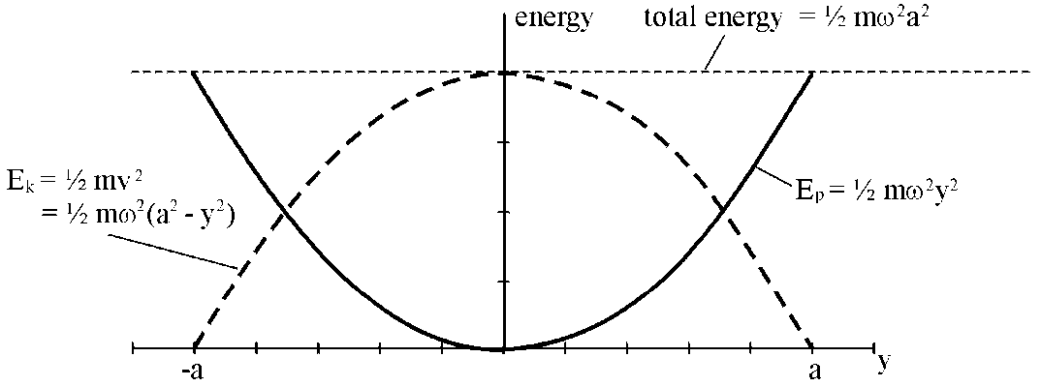

### Example on energy and SHM

*The graph below shows how the potential energy, Ep, of an object undergoing SHM, varies with its displacement, y. The object has mass 0.40 kg and a maximum amplitude of 0.05 m.*

*(a) (i) Find the potential energy of the object when it has a displacement of 0.02 m.*

*(ii) Calculate the force constant, k for the oscillating system. (k should have unit N m-1).*

*(b) Find the amplitude at which the potential energy equals the kinetic energy.*

### Solution

(a)(i) *From graph* Ep = 0.10 J

(ii) Ep = k y2

0.1 = k (0.02)2

k = = 500 N m-1

(b)  Ep = Ek

k y2 = m 2( a2 - y2 )

= k (a2 - y2) since 2 =

y2 = a2 - y2 or 2 y2 = a2

y = when Ep = Ek

y = = 0.035 m

## Damping of Oscillations

Oscillating systems, a mass on a spring, a simple pendulum, a bobbing mass in water, all come to rest eventually. We say that their motion is **damped**. This means that the amplitude of the motion decreases to zero because energy is transformed from the system. A simple pendulum takes a long time to come to rest because the frictional effect supplied by air resistance is small - we say that the pendulum is lightly damped. A tube oscillating in water comes to rest very quickly because the friction between the container and the water is much greater - we say that the tube is heavily damped.

If the damping of a system is increased there will be a value of the frictional resistance which is just sufficient to prevent any oscillation past the rest position - we say the system is **critically** damped. Systems which have a very large resistance, produce no oscillations and take a long time to come to rest are said to be **overdamped**. In some systems overdamping could mean that a system takes longer to come to rest than if underdamped and allowed to oscillate a few times.

An example of damped oscillations is a car shock absorber which has a very thick oil in the dampers. When the car goes over a bump, the car does not continue to bounce for long. Ideally the system should be critically damped. As the shock absorbers get worn out the bouncing may persist for longer.

The graphs below give a graphical representation of these different types of damping.

### Damped oscillations

|  |  |
| --- | --- |
| Critically damped | Overdamped |

# Waves

## Wave Motion

In a wave motion energy is transferred from one position to another with no net transport of mass.

Consider a water wave where the movement of each water particle is at right angles (transverse) to the direction of travel of the wave. During the wave motion each particle, labelled by its position on the x-axis, is displaced some distance y in the transverse direction. In this case, "no net transfer of mass" means that the water molecules themselves do not travel with the wave - the wave energy passes over the surface of the water, and in the absence of a wind/tide any object on the surface will simply bob up and down.

## The Travelling Wave Equation

The value of the displacement y depends on which particle of the wave is being considered. It is dependent on the x value, and also on the time t at which it is considered. Therefore y is a function of x and t giving y = f(x,t). If this function is known for a particular wave motion we can use it to predict the position of any particle at any time.

Below are 'snapshots' of a transverse wave taken at different times showing how the displacement of different particles varies with position x.

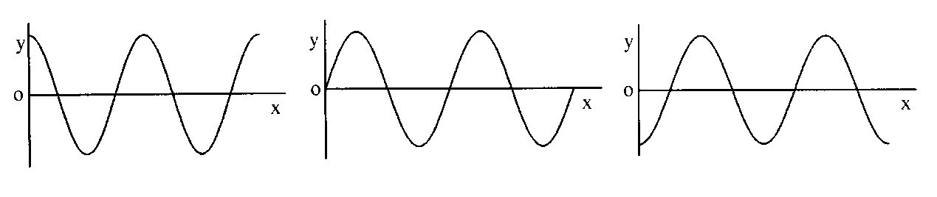

The following diagram shows the movement of **one** particle on the wave as a function of time.

|  |  |
| --- | --- |
| fig 2 | Initial condition at the origin: y = 0 when t = 0. |

For a wave travelling from **left to right** with speed v, the particle will be performing SHM in the y-direction.

The equation of motion of the particle will be:

y = a sin t where a is the amplitude of the motion.

The displacement of the particle is simple harmonic. The sine or cosine variation is the simplest description of a wave.

When y = 0 at t = 0 the relationship for the wave is y = a sin t, as shown above.

When y = a at t = 0 the relationship for the wave is y = a cos t.

### Deriving the travelling wave equation

Consider a snapshot of the wave as shown below.

|  |  |  |
| --- | --- | --- |
| fig 3  direction of wave |  | The time, t, for the wave disturbance to travel from A (x = 0) to B (x = x)  is  . |

Consider particle A at position x = 0.

The equation of motion of particle A is given by

y = a sin t

where t is the time at which the motion of particle A is observed.

Now consider particle B at position x = x and the time t = t.

Since wave motion is a repetitive motion:

motion of particle B (x = x, t = t) = motion of particle A (x = 0, t = ),

[i.e. the motion of particle B = motion of particle A at the **earlier** time of t = ].

General motion of particle A is given by y = a sin t, but in this case t = t − 

hence y = a sin t − ).

Motion of particle B (x = x, t = t) is also given by y = a sin t − ).

In general: y = a sin t - ) also   f and v = f 

y = a sin 2f(t - ) which gives

|  |  |
| --- | --- |
|  | for a wave travelling from left to right  in the **positive** x-direction. |

The equation of a wave travelling right to leftin the **negative** x-direction is

y = a sin 2( ft + ).

### The Intensity of a Wave

The intensity of a wave is directly proportional to the square of its amplitude.

intensity  a2

## Longitudinal and transverse waves

With transverse waves, as in water waves, each particle oscillates at right angles to the direction of travel of the wave. In longitudinal waves, such as sound waves, each particle vibrates along the direction of travel of the wave.

## Principle of Superposition of Waveforms

Travelling waves can pass through each other without being altered. If two stones are dropped in a calm pool, two sets of circular waves are produced. These waves pass through each other. However at any point at a particular time, the disturbance at that point is the algebraic sum of the individual disturbances. In the above example, when a ‘trough’ from one wave meets a ‘crest’ from the other wave the water will remain calm.

A **periodic** wave is a wave which repeats itself at regular intervals. All periodic waveforms can be described by a mathematical series of sine or cosine waves, known as a Fourier Series. For example a saw tooth wave can be expressed as a series of individual sine waves.

y(t) = - sin t - sin 2t - sin 3t - .............

The graph below shows the first four terms of this expression.

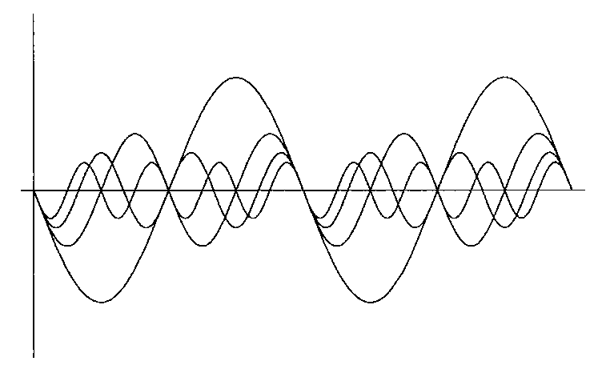

When all these terms are superimposed (added together) the graph below is obtained. Notice that this is tending to the sawtooth waveform. If more terms are included it will have a better saw tooth form.

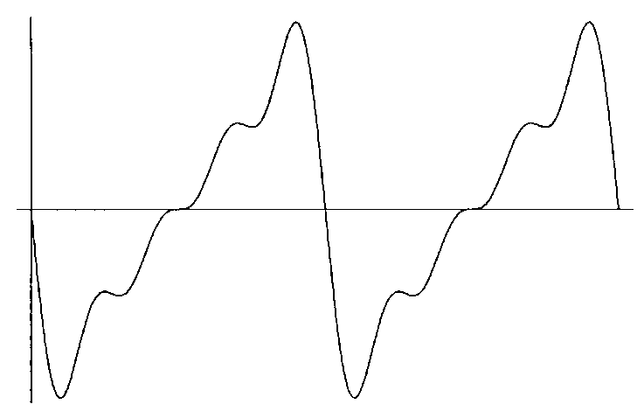

## Phase Difference

A phase difference exists between two points on the same wave.

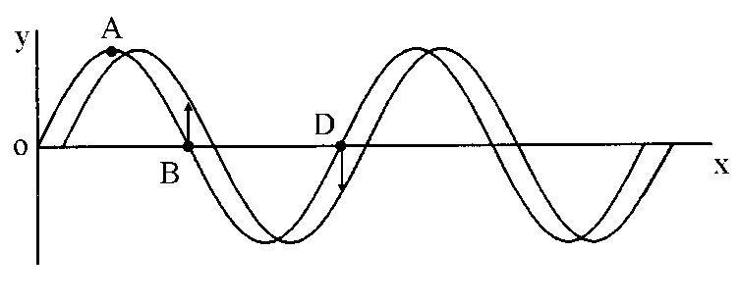Consider the snapshots below of a wave travelling to the right in the positive   
x-direction.

Points O and D have a phase difference of 2 radians.

They are both at zero displacement and will next be moving in the negative direction. They are separated by one wavelength ().

Points O and B have a phase difference of  radians.

They both have zero displacement but B will next be going positive and O will be going negative. They are separated by /2. Notice that points A and B have a phase difference of /2.

The table below summarises phase difference and separation of the points.

|  |  |
| --- | --- |
| Phase difference | Separation of points |
| 0 | 0 |
|  | /4 |
| ❐ | /2 |
|  | ● |

Notice that  =  = constant.

If the phase difference between two particles is  when the separation of the particles is x,

then  = .

In general, for two points on a wave separated by a distance x the phase difference is given by:

|  |  |
| --- | --- |
|  = 2  | where   is the phase angle in radians |

### Example

*A travelling wave has a wavelength of 60 mm. A point P is 75 mm from the origin and a point Q is 130 mm from the origin.*

*(a) What is the phase difference between P and Q?*

*(b) Which of the following statements best describes this phase difference:*

*‘almost completely out of phase’; ‘roughly ¼ cycle out of phase’;   
‘almost in phase’.*

### Solution

(a) separation of points = 130 - 75 = 55 mm = 0.055 m

phase difference = 2 = 5.76 radians

(b) P and Q are separated by 55 mm which is almost one wavelength, hence they are ‘almost in phase’. Notice that 5.76 radians is 330°, which is close to 360°.

## Stationary Waves

A stationary wave is formed by the interference between two waves, of the **same** frequency and amplitude, travelling in **opposite** directions. For example, this can happen when sound waves are reflected from a wall and interfere with the waves approaching the wall.

A stationary wave travels neither to the right nor the left, the wave ‘crests’ remain at fixed positions while the particle displacements increase and decrease in unison.

|  |  |
| --- | --- |
| fig 7 | A - antinodes  N - nodes |

There are certain positions which always have **zero amplitude** independent of the time we observe them; these are called **nodes**.

There are other points of **maximum amplitude** whichare called **antinodes**.

Note that the distance between each node and the next node is and, that the distance between each antinode and the next antinode is .

### Use of standing waves to measure wavelength

Standing waves can be used to measure the wavelength of waves. The distance across a number of minima is measured and the distance between consecutive nodes determined and the wavelength calculated. This method can be used for sound waves or microwaves.

### Formula for standing waves

Consider the two waves y1 and y2 travelling in the opposite direction, where

y1 = a sin 2( ft - ) and y2 = a sin 2( ft + )

When these two waves meet the resultant displacement y is given by

y = y1 + y2 = a sin 2( ft - ) + a sin 2( ft + )

y = 2 a sin 2ft cos (using a sin P + a sin Q = 2a sincos)

Giving y = 2 a sin t cos

Notice that the equation is a function of two trigonometric functions, one dependent on time *t* and the other on position  *x* . Consider the part which depends on position. We can see that there are certain fixed values of x for which cos is equal to zero. These are x = , , , etc.

This shows that there are certain positions where y = 0 which are independent of the time we observe them - the nodes.

The positions at which the amplitude of the oscillation is maximum are given by cos = 1, that is x = 0 , ,  , , etc. These are points of maximum amplitude - the antinodes.

# Interference - Division of Amplitude

## Producing interference

Interference of waves occurs when waves overlap. There are two ways to produce an interference pattern for light: division of amplitude and division of wavefront. Both of these involve splitting the light from a single source into two beams. We will consider division of amplitude first and division of wavefront in the next section.

### Division of amplitude

This involves splitting a single light beam into two beams, a reflected beam and a transmitted beam, at a surface between two media of different refractive index. In some cases multiple reflections can occur and more than two beams are produced. Before we consider specific examples we need to consider some general properties of interference.

## Coherent sources

Two coherent sources must have a **constant phase difference**. Hence they will havethe **same frequency**.

To produce an interference pattern for light waves the two, or more, overlapping beams always come from the **same single source**. When we try to produce an interference pattern from two separate light sources it does not work because light cannot be produced as a continuous wave. Light is produced when an electron transition takes place from a higher energy level to a lower energy level in an atom. The energy of the photon emitted is given by E = hf where E is the difference in the two energy levels, f is the frequency of the photon emitted and h is Planck’s constant. Thus a source of light has continual changes of phase, roughly every nanosecond, as these short pulses of light are produced. Two sources of light producing the same frequency will not have a constant phase relationship so will not produce clear interference effects.

This is not the case for sound waves. We can have two separate loudspeakers, connected to the same signal generator, emitting the same frequency which will produce an interference pattern.

## Path Difference and Optical Path Difference

Sources S1 and S2 are two coherent sources **in air**.

## 

The path difference is (S2Q - S1Q). For constructive interference to take place at Q, the waves must be in phase at Q. Hence the path difference must be a whole number of wavelengths.

(S2Q - S1Q) = m where m = 0, 1, 2, 3, ...

(**Note**: the letter m is used to denote an integer, not n, since we use n for refractive index.)

Similarly, for destructive interference to take place the waves must be out of phase at Q by /2 (that is a ‘crest’ from S1 must meet a ‘trough’ from S2).

(S2Q - S1Q) = (m + )

### Optical path difference

In some situations the path followed by one light beam is inside a transparent material of refractive index, n. Consider two coherent beams S1 and S2 where S1Pis in air and S2P is in perspex of refractive index n = 1.5. We will consider the point P itself to be in air.

|  |  |
| --- | --- |
| perspex  S2  S1  P | The geometrical path difference S1P - S2P is zero.  But will there be constructive interference at P? |

The wavelength inside the perspex is **less** than that in air perspex = . Hence the waves from S1 and S2 may **not** arrive at P in phase. For example, if there were exactly Z whole waves between S1P, there will be 1.5 x Z waves between S2P which may or may not be a whole number of wavelengths.

The **optical path length** must be considered not the geometrical path length.

Optical path length = refractive index × geometrical path length

Thus the relationships for constructive and destructive interference must be considered for **optical path lengths**,S2P and S1P.

|  |  |
| --- | --- |
| For constructive interference | (S2P - S1P) = m where m is an integer |
| For destructive interference | (S2P - S1P) = (m + )   where m is an integer |

### Phase difference and optical path difference

The optical path difference is the difference in the two optical path lengths, namely (S2P - S1P) in our general example.

The phase difference is related to the optical path difference:

phase difference =  × optical path difference

where  is the wavelength in vacuum.

Notice that when the optical path difference is a whole number of wavelengths, the phase difference is a multiple of 2, i.e. the waves are in phase.

## Phase Change on Reflection

To understand interference caused by multiple reflections it is necessary to consider what happens when a light wave moving in air hits a material such as glass.

On a large scale we can see what happens to the wave when a pulse on a rope or 'slinky' reflects off a dense material such as a wall.

|  |  |
| --- | --- |
|  | The reflected pulse is said to undergo a phase change of 180° or  radians. The reflected pulse is 180° out of phase with the incident pulse. If these two pulses were to meet they would momentarily cancel as they passed one another. |

There is a similar phase change when a light wave is reflected off a sheet of glass.

In general for **light** there is a **phase change of  on reflection** at an interface where there is an **increase** in optical density, e.g. a higher refractive index such as light going from air to glass. There is **no** phase change on reflection where there is a decrease in optical density, e.g. a lower refractive index such as light going from glass to air.

## Thin parallel sided film

Interference by division of amplitude can be produced by thin films as shown below.



Notice that an **extended** source can be used. The amplitude of the beam is divided by reflection and transmission at D1, and again by reflection and transmission at D2 at the back of the glass sheet.

An eye, at A, will focus the reflected beams and an eye at B will focus the transmitted beams. Thus interference patterns can be observed in both the reflected and transmitted beams.

### Condition for maxima and minima in the fringes formed in a thin film

The following explanations are for light incident normally on a thin film or sheet of glass. The diagrams only show light paths at an angle to distinguish clearly the different paths.

#### Reflected light

air

air

glass

incident ray

1

2

*t*

The ray following path 1 reflects off the glass which has a higher refractive index than air. It therefore experiences a  phase change.

The ray following path 2 reflects off air so experiences no phase change on reflection. However, it travels through the glass twice so has an optical path difference compared to ray 1 of 2*nt*, where *n* is the refractive index of the glass.

Therefore for constructive interference for the reflected light, i.e. for rays 1 and 2 to be in phase, then the optical path difference 2*nt* must give a  phase change. Therefore:

2*nt* = (m + ½) where m is an integer.

For constructive interference for the reflected light, i.e. for rays 1 and 2 to be exactly out of phase, then the optical path difference 2*nt* must give zero phase change. Therefore:

2*nt* = m where m is an integer.

#### Transmitted light

air

air

glass

incident ray

1

3

2

4

*t*

The ray following path 3 passes through the glass with zero phase change.

The ray following path 4 reflects off air twice so experiences no phase change on reflection. However, it travels through the glass twice more than path 3 so has an optical path difference compared to ray 3 of 2*nt*, where *n* is the refractive index of the glass.

Therefore for constructive interference for the transmitted light, i.e. for rays 3 and 4 to be in phase, then the optical path difference 2*nt* must give zero phase change. Therefore:

2*nt* = m where m is an integer.

For constructive interference for the transmitted light, i.e. for rays 3 and 4 to be exactly out of phase, then the optical path difference 2*nt* must give a  phase change. Therefore:

2*nt* = (m + ½) where m is an integer.

#### Note

For a certain thickness of thin film the conditions are such that the reflected light and transmitted light have opposite types of interference. Therefore energy is conserved at all times.

#### Example

*A sheet of mica is 4.80 m thick. Light of wavelength 512 nm is shone onto the mica. When viewed from above, will there be constructive, destructive, or partial destructive interference? The refractive index of mica is 1.60 for light of this wavelength.*

#### Solution

For destructive interference 2*nt* = m

2 × 1.60 × 4.80 × 10−6 = m × 512 × 10−9

m = 30

This is an integer. Hence destructive interference is observed.

## Wedge Fringes

Two glass slides are arranged as shown below.

Division of amplitude takes place at the *lower* surface of the top glass slide.

|  |  |
| --- | --- |
|  | Enlarged view showing the geometry |

When viewed from above the optical path difference = 2t

There is a phase difference of  on reflection at A. Hence the condition for a dark fringe is 2t = m assuming an air wedge.

For the next dark fringe t increases by (see right hand sketch above).

Thus the spacing of fringes, x, is such that tan  giving

x = 

|  |  |
| --- | --- |
| ❑  L  D  For a wedge of length L and spacing D  tan  = . |  |

|  |  |  |
| --- | --- | --- |
| The fringe spacing is given by | x = | where  is the wavelength of light in air. |

In practice the distance across a number of fringes is measured and x determined.

Notice that the fringes are formed inside the wedge, and that the two reflected rays are diverging. The eye, or a microscope, must be focussed between the plates for viewing the fringes.

A wedge can be formed by two microscope slides in contact at one end and separated by a human hair or ultra thin foil at the other end. In this way the diameter of a human hair can be measured.

Similarly, if a crystal is placed at the edge and heated, the thermal expansion can be measured by counting the fringes as the pattern changes.

## Non-reflecting Coating

Good quality lenses in a camera reflect very little light and appear dark or slightly purple. A thin coating of a fluoride salt such as magnesium fluoride on the surface of the lens allows the majority of the light falling on the lens to pass through.

The refractive index, n, of the coating is chosen such that 1 < n < nglass.

|  |  |
| --- | --- |
|  | Notice that there is a phase change of  at both the first and second surfaces.  For cancellation of reflected light: optical path difference = . Optical path in fluoride = 2nd  thus 2nd = and  d = |

Complete cancellation is for one particular wavelength only. Partial cancellation occurs for other wavelengths.   
The wavelength chosen for complete cancellation is in the yellow/green (i.e. middle) of the spectrum. This is why the lens may look purple because the reflected light has no yellow present. The red and blue light are partially reflected to produce the purple colour observed.

### Colours in thin films

When a soap film is held vertically in a ring and is illuminated with monochromatic light it initially appears coloured all over. However when the soap drains downwards a wedge shaped film is produced, with the top thinner than the bottom. Thus horizontal bright and dark fringes appear. When illuminated by white light, colours are formed at positions where the thickness of the film is such that constructive interference takes place for that particular colour. Just before the soap film breaks, the top appears black because the film is so thin there is virtually no path difference in the soap. Destructive interference occurs because of the phase change on reflection.

Similar colours are observed when a thin film of oil is formed on water.

# Interference - Division of Wavefront

## Division of Wavefront

When light from a single point source is incident on two small slits, two coherent beams of light can be produced. Each slit acts as a secondary source due to diffraction.

If an extended source is used, each part of the wavefront will be incident on the slit at a different angle. Each part of the source will then produce a fringe pattern, but slightly displaced. When the intensity of all the patterns is summed the overall interference pattern may be lost. However a line source parallel to the slits is an exception.

Compare this with the use of an **extended** source in ‘division of amplitude’.

## Young's Slits Experiment

The diagram below shows light from a single source of monochromatic light incident on a double slit. The light diffracts at each slit and the overlapping diffraction patterns produce interference.



A bright fringe is observed at P. Angle PMO is .

N is a point on BP such that NP = AP. Since P is the first bright fringe BN = 

For **small** values of  AN cuts MP at almost 900 giving angle MAQ =  and hence angle   .

Again providing  is **very** **small**, sin  = tan  =  in radians

From triangle BAN:  =  also from triangle PMO:  = 

Thus =  or x =  

Giving the fringe separation between adjacent fringes x

x = 

**Note**

This formula only applies if x<<D, which gives  small. This is likely to be true for light waves but not for microwaves.

The position of the fringes is dependent on the wavelength. Thus if white light is used we can expect overlapping colours either side of a central white maximum. The red, with the longer wavelength, will be the furthest from this white maximum (xred > xviolet since red > violet).

# Polarisation

## Polarised and unpolarised waves

Light is a wave motion, and is part of the electromagnetic spectrum. In all **electromagnetic waves** the electric field and magnetic field vary. The diagram below shows a 3-dimensional picture of such a wave.

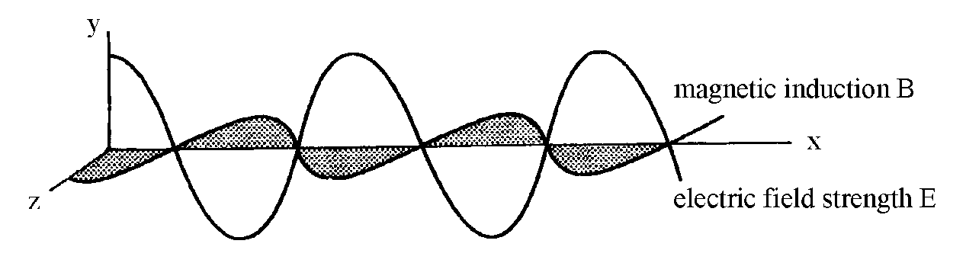

The above diagram shows the variation of the electric field strength, E, in the x-y plane and the variation of the magnetic induction, B, in the x-z plane. In this example the electric field strength is only in one plane. The wave is said to be plane polarised, or **linearly polarised**. For example, in Britain this is the way that T.V. waves are transmitted. Aerials are designed and oriented to pick up the vertical electric field strength vibrations. These vibrations contain the information decoded by the electronic systems in the television.

Notice that the electromagnetic wave is made up of two mutually perpendicular transverse waves. The oscillations of E and B.

Light from an ordinary filament lamp is made up of many separate electromagnetic waves produced by the random electron transitions in the atoms of the source. So unlike the directional T.V waves, light waves from a lamp consist of many random vibrations. This is called an **unpolarised** wave.

When looking at an **unpolarised** wave coming towards you the direction of the electric field strength vector would appear to be vibrating in all direction, as shown in the diagram (i) on the left below. The magnetic induction vector would be perpendicular to the electric field strength vector, hence this too would be vibrating in all directions However when discussing polarisation we refer to the electric field strength vector only.

All the individual electric field strength vectors could be resolved in two mutually perpendicular direction to give the other representation of a **unpolarised** wave, as shown below in the centre diagram (ii).

(iii) polarised wave

(i) unpolarised wave

(ii) unpolarised wave

The right hand diagram (iii) above represents a **polarised** wave.

### Longitudinal and transverse waves

Note that only transverse waves can be polarised. Longitudinal waves, e.g. sound waves, cannot be polarised.

## Polarisation using Filters

We can produce a **linearly polarised** wave if we can somehow absorb the vibrations in all the other directions except one.

In 1852 Herapath discovered that a crystal of iodo-quinine sulphate transmitted one plane of polarisation, other planes being absorbed. In 1938 Land produced the material ‘Polaroid’, which has a series of parallel long hydrocarbon chains. Iodine atoms impregnate the long chains providing conduction electrons. Light is only *transmitted* when the electric field strength vector is *perpendicular* to the chain.

The arrangement below shows a polaroid filter at X producing linearly polarised light. The polaroid at X is called a **polariser.** Vibrations of the electric field strength vector at right angles to the axis of transmission are absorbed.



A second polaroid at Y is placed perpendicular to the first one, as shown above. This is called an **analyser.** The analyser absorbs the remaining vibrations because its axis of transmission is at right angles to the polariser at X and no light is seen by the eye. The light between X and Y is called **linearly** or **plane polarisation**.

These effects also can be demonstrated using microwaves and a metal grid.



The microwaves emitted by the horn are plane polarised. In this example the electric field strength vector is in the *vertical plane*. The waves are **absorbed** by the rods and re-radiated in all directions. Hence there will be a very low reading on the receiver, R. When the metal grid is rotated through 90o the waves will be transmitted, and the reading on the receiver will rise. Notice that the microwaves are *transmitted* when the plane of oscillation of the electric field strength vector is *perpendicular* to the direction of the rods.

## Polarisation by Reflection

Plane polarised waves can be produced naturally by light reflecting from any electrical insulator, like glass. When refraction takes place at a boundary between two transparent materials the components of the electric field strength vector parallel to the boundary are largely reflected. Thus reflected light is partially plane polarised.

### Plane polarisation at the Brewster angle



Consider a beam of unpolarised light incident on a sheet of smooth glass. This beam is partially reflected and partially refracted. The angle of incidence is varied and the reflected ray viewed through an analyser, as shown above. It is observed that at a certain angle of incidence ip the reflected ray is plane polarised. No light emerges from the analyser at this angle.

The **polarising angle** ip or **Brewster’s angle** is the angle of incidence which causes the reflected light to be linearly polarised.

This effect was first noted by an experimenter called Malus in the early part of the nineteenth century. Later Brewster discovered that **at** the polarising angle ip the refracted and reflected rays **are separated by 90°.**

Consider the diagram above, which has this 90° angle marked:

n =

but r = (90 - ip) thus sin r = sin (90 - ip) = cos ip

thus n = = tan ip

### *Example*

Calculate the polarising angle for glycerol, n = 1.47.  
What is the angle of refraction inside the glycerol at the Brewster angle?

### Solution

Using the equation n = tan ip 1.47 = tan ip giving ip = 56o.

At the Brewster angle, which is the polarising angle,   
 angle of refraction + ip = 90o thus angle of refraction = 44o.

## Reduction of Glare by Polaroid sunglasses

When sunlight is reflected from a horizontal surface, e.g. a smooth lake of water, into the eye, eyestrain can occur due to the glare associated with the reflected light. The intensity of this reflected beam can be reduced by wearing polaroid sunglasses. These act as an analyser and will cut out a large part of the reflected polarised light.

# Data

**Common Physical Quantities**

|  |  |  |
| --- | --- | --- |
| Quantity | Symbol | Value |
| Gravitational acceleration | g | 9.8 m s-2 |
| Radius of Earth | RE | 6.4 x 106 m |
| Mass of Earth | ME | 6.0 x 1024 kg |
| Mass of Moon | MM | 7.3 x 1022 kg |
| Mean radius of Moon orbit |  | 3.84 x 108 m |
| Universal constant of gravitation | G | 6.67 x 10-11 m3 kg-1 s-2 |
| Speed of light in vacuum | c | 3.0 x 108 m s-1 |
| Speed of sound in air | v | 3.4 x 102 m s-1 |
| Mass of electron | me | 9.11 x 10-31 kg |
| Charge on electron | e | -1.60 x 10-19 C |
| Mass of neutron | mn | 1.675 x 10-27 kg |
| Mass of proton | mp | 1.673 x 10-27 kg |
| Planck’s constant | h | 6.63 x 10-34 J s |
| Permittivity of free space | 0 | 8.85 x 10-12 F m-1 |
| Permeability of free space | 0 | 4 x 10-7 H m-1 |

**Astronomical Data**

|  |  |  |  |  |  |  |  |
| --- | --- | --- | --- | --- | --- | --- | --- |
| Planet or  satellite | Mass/ kg | Density/  kg m-3 | Radius/ m | Grav. accel./ m s-2 | Escape velocity/ m s-1 | Mean dist from Sun/ m | Mean dist from Earth/ m |
| Sun | 1.99x 1030 | 1.41 x 103 | 7.0 x 108 | 274 | 6.2 x 105 | -- | 1.5 x 1011 |
| Earth | 6.0 x 1024 | 5.5 x 103 | 6.4 x 106 | 9.8 | 11.3 x 103 | 1.5 x 1011 | -- |
| Moon | 7.3 x 1022 | 3.3 x 103 | 1.7 x 106 | 1.6 | 2.4 x 103 | -- | 3.84 x 108 |
| Mars | 6.4 x 1023 | 3.9 x 103 | 3.4 x 106 | 3.7 | 5.0 x 103 | 2.3 x 1011 | -- |
| Venus | 4.9 x 1024 | 5.3 x 103 | 6.05 x 106 | 8.9 | 10.4 x 103 | 1.1 x 1011 | -- |

## Tutorial 1.0

### Simple Harmonic Motion

1. (a) On object undergoes simple harmonic motion. State the condition which must apply to the unbalanced force acting on the object.

(b) Give three examples of simple harmonic motion (SHM).

2. (a) State the equation which defines SHM.

(b) (i) Show by differentiation that *each* of the following is a solution of the equation for SHM: y = a cost and y = a sint.

(ii) State the condition under which the equation for SHM is given by *each* of the following: y = a cost and y = a sint

(c) Derive the equation for the velocity v = ±ω using:

(i) y = a cost

(ii) y = a sint.

3. An object moves with SHM with a frequency of 5 Hz and an amplitude of 40 mm.

(a) Find the acceleration at the centre and extremities of the motion.

(b) Determine the velocity at the centre and extremities of the motion.

(c) Calculate the acceleration and velocity at a point midway between the centre and extremity of the motion.

4. A horizontal platform oscillates vertically with SHM with a slowly increasing amplitude. The period of the oscillations is 0.10 s.  
What is the maximum amplitude which will allow a mass resting on the platform to remain in contact with the platform?

5. (a) Derive expressions for the kinetic energy and potential energy of a particle executing SHM.

(b) An object of mass 0.20 kg oscillates with SHM with an amplitude of 100 mm. The frequency of the oscillations is 0.50 Hz.

(i) Calculate the maximum value of the kinetic energy of the object. State where this occurs.

(ii) State the minimum value of the kinetic energy. State where this occurs.

(iii) Find the maximum value of the potential energy of the object. State where this occurs.

(iv) Calculate the potential energy and the kinetic energy at a point mid way between the centre and extremity of the motion.

(v) What can you state about the value of the sum of the potential energy and the kinetic energy at any point?

6. The displacement, y, in mm of a particle is given by y = 0.44sin28t.

(a) Find the amplitude of the motion.

(b) Find the frequency of the motion.

(c) Find the period of the motion.

(d) Find the time taken for the particle to move a distance of 0.20 mm from the equilibrium position.

7. (a) What effect does damping have on an oscillatory system?

(b) Briefly explain the terms critical damping and overdamping.

(c) Give two examples where damping is useful.

## Tutorial 1.1

### Simple Harmonic Motion

1 The displacement, in cm, of a particle is given by the equation: y = 4 cos 4 t.

(a) State the amplitude of the motion.

(b) Calculate the frequency, and hence the period, of the oscillation.

(c) Calculate the location of the particle, in relation to its rest position, when;

(i) t = 0

(ii) t = 1.5 s.

2 A body, which is moving with SHM, has an amplitude of 0.05 m and a frequency of 40 Hz.

(a) Find the period of the motion.

(b) State an appropriate equation describing the motion.

(c) (i) Calculate the acceleration at the mid-point of the motion **and** at the position of maximum amplitude.

(ii) Calculate the maximum speed of the body and state at which point in the motion this speed occurs.

3 An object of mass 0.50 kg moves with SHM. The amplitude and period of the motion are 0.12 m and 1.5 s respectively. Assume that the motion starts with a = + 0.12 m.

From this information, calculate:

(a) the position of the object when t = 0.40 s

(b) the force (magnitude and direction) acting on this object when t = 0.40 s

(c) the minimum time needed for the object to travel from its starting point to a point where the displacement is - 0.06 m.

4 A prong of a tuning fork, which can be assumed to be moving with simple harmonic motion, has the following equation governing its motion:

y = 2.0 sin (3.22 x 103 t) where y is in mm.

(a) Find the maximum amplitude and the frequency of the tuning fork’s motion.

(b) Calculate the maximum acceleration of the prong on the tuning fork.

(c) On graph paper, draw the variation of displacement against time for the first two cycles of the motion. Assume that the motion starts from the equilibrium position.

(d) As the sound of a tuning fork dies away, the frequency of the note produced does not change.  
What conclusion can we draw about the period of this, and indeed any object, moving with SHM?

5 A sheet of metal is clamped in the horizontal plane and made to vibrate with SHM in the vertical plane with a frequency of 40 Hz.

When some sand grains are sprinkled on to the plate, it is noted that the sand grains can lose contact with the sheet of metal. This occurs when the acceleration of the SHM is ≥ 10 m s-2. Calculate the maximum amplitude of the motion for which the sand will always be in contact with the metal sheet.

6 A vertical spring stretches 0.10 m when 1.2 kg mass is allowed to hang from the end of the spring.

(a) Calculate the spring constant, k, given by these figures.

(b) The mass is now pulled down a distance of 0.08 m below the equilibrium position and released from rest.

(i) State the amplitude of the motion.

(ii) Calculate the period **and** the frequency of the motion.

(iii) Find the maximum speed of the mass **and**  the total energy of the oscillating system.

7 A block of mass 5.0 kg is suspended from a spring which has a force constant of 450 N m-1.

A dart which has a mass of 0.060 kg is fired into the block from below with a speed of   
120 m s-1, along the vertical axis of the spring. The dart embeds in the block.

(a) Find the amplitude of the resulting simple harmonic motion of the spring/block system.

(b) What percentage of the original kinetic energy of the dart appears as energy in the oscillating system?

8. Explain what is meant by the terms ‘damping’ and ‘critical damping’ when applied to oscillating systems.

## Tutorial 2.0

### Waves

1. (a) State the relationship between the intensity and the amplitude of a wave.

(b) The amplitude of a wave increases ninefold.

What is the change in the intensity?

2. ‘All waveforms can be described by the superposition of sine or cosine waves’.

Explain what is meant by this statement using either a square wave or a sawtooth wave as an example.

3. (a) The relationship y = a sin2(ft – x/) represents a travelling wave.

State clearly the meaning of each symbol in this equation.

(b) A travelling wave is represented by the relationship y = 0.60 sin(150t – 0.40x) where standard SI units are used throughout.

(i) What is the amplitude of the wave?

(ii) Determine the frequency of the wave.

(iii) State the period of the wave.

(iv) Calculate the wavelength of the wave.

(v) What is the wave speed?

4. Two waves are represented by the relationships:

y1 = 4.0 sin2(8t – 5x) and y2 = 4.0 sin(16t – 21x) respectively.

(a) Which of the following quantities are the same for the two waves:

amplitude, frequency, wavelength, period.

(b) Are the two waves in phase? You must justify your answer.

5. (a) Explain what is meant by a ‘stationary wave’.

(b) Define the terms ‘nodes’ and ‘antinodes’.

## Tutorial 2.1

### Waves

1 A travelling wave is represented by the equation y = 3 sin 2(10t - 0.2x) where y is in cm. Calculate, for this wave:

(a) the amplitude;

(b) the frequency;

(c) the wavelength;

(d) the speed.

2 Write the equation for a plane sinusoidal wave travelling in the + x direction which has the following characteristics:

amplitude = 0.30 m, wavelength = 0.50 m and frequency = 20 Hz.

3 A travelling wave is represented by the following equation:

y1 = 0.20 sin (220 t - 30 x) (i)

where y1 and x are measured in m from the origin.

Write the equation for the displacement, y2, of a wave travelling in the opposite direction which has twice the frequency and double the amplitude of the wave represented by equation (i) above.

4 The equation of a transverse wave on a stretched string is represented by:

y = 0.04 sin[2(  - )] where y and x in metres and t in seconds.

(a) What is the amplitude of the wave?

(b) Calculate the wavelength of the wave.

(c) What is the frequency of the wave?

(d) Describe the movement of any particle of the string over one complete period, T, of the wave.

5 The equation of a transverse wave travelling in a rope is given by:

y = 0.01 sin  (2.0 t - 0.01 x) where y and x in metres and t in seconds.

(a) Calculate the velocity of the wave in the x-direction.

(b) Find the maximum **transverse** speed of a particle in the rope.

6 The following equation represents a wave travelling in the positive x-direction

y = a sin 2 (ft - )

Using the relationships f = 1/T, v = f , and k = 2/ show that the following are also possible equations for this wave.

(a) y = a sin 2(- ) (b) y = a sin (t - kx )

(c) y = a sin 2f (t - ) (d) y = a sin

7A wave of frequency 500 Hz has a velocity of 350 m s-1.

(a) How far apart are two points which are 60° i.e. out of phase?

(b) What is the phase difference between two displacements at the same point, at a time separation of 0.001 s?

8 A progressive wave and a stationary wave each have the same frequency of 250 Hz and the same velocity of 30 m s-1.

(a) Calculate the phase difference between two vibrating points on the progressive wave which are 10 cm apart.

(b) State the equation for the travelling wave if its amplitude is 0.03 m.

(c) Calculate the distance between the nodes of the stationary wave.

9 (a) Explain what is meant by a 'travelling wave' and a 'stationary wave'. State clearly the differences between the two.

(b) Describe a method involving the formation of standing waves which you could use to measure the wavelength of microwaves. In your answer you should include:

- a sketch of any apparatus you would use;

- details of measurements taken;

- details of how you would arrive at a final answer.

10 (a) The sketch below shows an experimental arrangement to measure the wavelength of sound waves coming from a loudspeaker.



The oscilloscope trace shows the level of sound picked up by the microphone which is moved between the loudspeaker and the reflector.

In one particular trial it was noted that the microphone travelled a distance of 0.24 m between adjacent maxima. The signal generator was set at   
700 Hz.

Calculate:

(i) the wavelength and

(ii) the velocity of the sound wave emitted from the loudspeaker.

(b) Another loudspeaker is connected in parallel with the first and the two sound waves allowed to overlap. The two speakers are facing in the same direction and the reflector is removed.  
  
Describe and explain what a listener would hear as he walks across in front of the two speakers.

## Tutorial 3.0

### Interference – division of amplitude

1. (a) State the condition for two light beams to be coherent.

(b) Explain why two light beams, of the same frequency, but from different sources are unlikely to be coherent.

(c) Can two loudspeakers connected to the same signal generator emit coherent beams of sound waves? Explain your answer.

2. (a) Define the term optical path difference.

(b) State the relationship between the optical path difference and phase difference.

(c) A hollow air filled perspex microfibre is shown below. Light of wavelength 700 nm passes through and around the microfibre.



(i) Determine the optical path length between AB.

(ii) A ray of light follows the path AB above. Another ray follows the path CD, just outside the block.

What is the phase difference between the two rays?

3. (a) Light in air is reflected from a glass surface. What is the change in phase of the light waves?

(b) What change in phase occurs when light in glass is reflected at a glass/water boundary back into the glass.

4. A thin parallel sided film is used to produce interference fringes.

(a) Using the thin film as an example, explain the term ‘interference produced by division of amplitude’. Include a sketch of the path of the light rays through the film

(b) (i) State the condition for a minimum to be produced in the fringes formed by reflection from the film of monochromatic light of wavelength .

(ii) What is the effect on the fringe pattern when the thickness of the film increases?

5. (a) Derive the expression for the distance between the fringes which are formed by reflection of light from a thin wedge.

(b) Two glass slides are 100 mm long. A wedge is formed with the slides by placing the slides in contact at one end. The other ends of the slide are separated by a piece of paper 30 m thick. Interference fringes are observed using light of wavelength 650 nm. Calculate the separation of the fringes.

(c) When looking at a slightly different part of the fringe pattern the fringes are observed to be slightly closer together. What does this imply about the paper.

You must justify your answer.

6. (a) Derive the expression d = /4n for the thickness of a non-reflecting coating.

(b) What thickness of coating is required to give non-reflection in green light of wavelength 540 nm for a lens of refractive index 1.53.

# (c) Explain why some lenses with a non-reflective coating appear coloured.

## Tutorial 3.1

### Interference – division of amplitude

1 To observe interference effects with light waves the sources must be coherent.

(a) Explain carefully what is meant by coherent waves.

(b) Explain why the conditions for coherence are usually more difficult to satisfy for light than for sound or microwaves.

2 (a) Explain what is meant by division of amplitude.

(b) Explain why an extended source can be used in experiments which involve division of amplitude.

3 An air wedge 0.10 m long is formed by two glass plates in contact at one end and separated by a thin piece of foil at the other end as shown below.



Interference fringes are observed in reflected light of wavelength 6.9 x 10-7 m. The average fringe separation is 1.2 x 10-3 m.

(a) Explain how the fringes are formed.

(b) Calculate the thickness of the foil.

(c) The foil is now heated and its thickness increases by 10%.

Calculate the new separation of the fringes.

4 (a) Derive the expression for the thickness of a non-reflecting coating on a lens. Your answer should be in terms of the incident wavelength and the refractive index of the coating.

(b) Calculate the thickness of the coating required to produce destructive interference at a wavelength of 4.80 x 10**-7** m, given that the refractive index of the coating is 1.25.

5 A lens is coated with a thin transparent film to reduce reflection of red light of wavelength   
6.7 x 10-7 m. The film has a refractive index of 1.30.   
Calculate the required thickness of the film.

6 A soap film of refractive index 1.3 is illuminated by light of wavelength 6.2 x 10-7 m. The light is incident normally on the soap film.

Calculate the minimum thickness of soap film which gives no reflection.

## Tutorial 4.0

### Interference – division of wavefront

1. (a) An interference pattern is obtained by division of wavefront. What is meant by ‘division of wavefront’.

(b) Why must the source be a point source to produce interference by division of wavefront?

(c) Explain why an extended source can be used to produce an interference pattern by division of amplitude.

2. The diagram below shows the set up for a Young’s double slit experiment.



(a) Derive the expression x =  for the fringe spacing.

(b) State any assumptions made in the above derivation.

3. Two parallel slits have a separation of (0.24 ± 0.01) mm. When illuminated by light an interference pattern is observed on a screen placed (3.8 ± 0.1) m from the double slits. The fringe separation is observed to be (9.5 ± 0.1) mm.

(a) Calculate the wavelength of the light used.

(b) Determine the uncertainty in this wavelength.

4. Two slits, of separation d, are made on a slide. The slide is illuminated by monochromatic light as shown below.



Fringes are observed on the screen.

(a) The fringe spacing is observed to be too small to make accurate measurements.

State one way of increasing the fringe spacing using this apparatus.

(b) The light beam is replaced by one of light of a higher wavelength.

What effect will this have on the fringe spacing?

(c) The slide is removed and replaced with another slide. The second slide has two slits with a smaller separation, d.

What effect does this have on the fringe pattern?

(d) What can be used to measure the slit separation?

(e) Describe how the fringe separation could be measured.

## Tutorial 4.1

### Interference – division of wavefront

1 There are two methods of producing interference with light, namely;  
division of amplitude and division of wavefront.

Give an example of each of the above and explain, with the aid of diagrams, the difference between the two methods.

2 White light illuminates two narrow closely spaced slits. An interference pattern is seen on a distant screen.

(a) Explain how the interference pattern occurs.

(b) The white fringes have coloured edges. Explain how this occurs.

3 A laser beam is directed towards a double slit and an interference pattern is produced on a screen which is 0.92 m from the double slit. The separation of the double slit is 2.0 x 10-4 m. The wavelength of the light used is 695 nm.

(a) Calculate the separation of the bright fringes on the screen.

(b) The double slit is now replaced with a different double slit of separation 1.0 x 10-4 m.

State and explain what effect this change will have on the interference pattern.

4 Two parallel slits have a separation of 5.0 x 10-4 m. When illuminated by light of unknown wavelength an interference pattern is observed on a screen placed 7.2 m from the double slit. The separation of the bright fringes on the screen is 8 mm.   
Calculate the wavelength of the light used.

5 A pupil holds a double slit in front of his eye and looks at a tungsten lamp with a scale immediately behind it.

scale

eye

d

D

double slit

tungsten filament lamp

filter

(a) A red filter is placed in front of the lamp. Describe what he sees and explain in terms of waves how this arises.

(b) The red filter is then replaced by a blue one. Explain any difference in fringe separation with blue and with red.

(c) Explain why the fringes have coloured edges when no filter is used.

(d) With the red filter in place, the student estimates the apparent separation of the bright fringes to be 5.0 mm when the distance D is 2.0 m. The slit separation is 0.25 mm. Calculate the wavelength of the light passing through the filter from these measurements.

6 In a Young’s slit experiment designed to demonstrate the interference of light, two parallel slits scratched on a blackened microscope slide are illuminated by an intense beam of monochromatic light.

d

screen

light beam

D

slide

Bright fringes with an average separation x are observed on a distant screen.

(a) State the effect of

(i) bringing the screen closer to the slits

(ii) reducing the separation of the slits.

(b) Explain the effect on the Young’s interference pattern of

(i) covering one of the slits

(ii) using light of a longer wavelength

(iii) using white light.

(c) Two parallel slits 0.5 mm apart are found to produce fringes with an average separation of 10 mm on a screen placed at a distance of 8 m from the double slit. What do these figures give for the wavelength of the incident light?

(d) In the practical determination of this wavelength three distances have to be measured. By considering each measurement in turn, explain which one would be the most critical in obtaining a reasonably accurate result.

7 A beam of yellow light from a single slit falls on a double slit, which is mounted on the end of a cardboard tube as shown below.

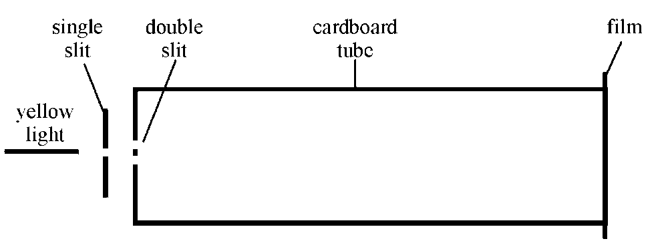

The interference pattern formed is recorded on a piece of photographic film placed over the end of the tube. When the film is developed a series of black lines can be seen. One such film is shown below.

(a) In one experiment a student obtains the following results:  
 distance between dark lines = 7 ± 1 mm  
 separation of double slit = 0.20 ± 0.01 mm  
 distance from double slit to film = 2.40 ± 0.01 m

From these measurements, calculate:

(i) the wavelength of yellow light;

(ii) the uncertainty in this value.

(b) (i) Describe one method of measuring the double slit separation to the stated degree of accuracy.

(ii) Give one way in which the uncertainty in the measurement of the separation of the black lines on the film could be reduced.

(c) In each case, state and explain the effect on the film pattern, when:

(i) the double slits are closer together;

(ii) blue light is used instead of yellow light;

(iii) one of the slits is covered.

## Tutorial 5.0

### Polarisation

1. (a) Explain the difference between linearly polarised and unpolarised waves.

(b) Describe how an unpolarised wave can be linearly polarised using a polaroid filter.

(c) Describe how a ‘polariser’ and ‘analyser’ can prevent the transmission of light.

2. Monochromatic light is incident at a boundary between air and another medium.

The reflected light is found to be polarised.

(a) What information does this provide about the nature of the medium?

(b) Derive the expression relating the polarising angle and the refractive index of the medium for this light.

(c) State the other common name for the polarising angle.

3. Light is incident on a rectangular block of perspex

(a) Draw a sketch to show the position of the polarising angle for perspex.

(b) Mark on your sketch for part (a) the value of the polarising angle.

4. Explain how sunglasses can remove glare.

5. The refractive index of a liquid is 1.45.

(a) Calculate the polarising angle for this liquid.

(b) Determine the value of the angle of refraction for this polarising angle.

6. The critical angle in a certain glass is 40.5°.

What is the polarising angle for this glass?

7. A spectrum can be produced by a prism because the refractive index changes with the frequency of light.

What effect will an increase in the frequency of light have on the polarising angle?

You must justify your answer.

8. Light is incident on a water surface as shown below.



The angle between the ray Q and R is 90°.

(a) The ray Q is observed through a sheet of polaroid. The polaroid is rotated.

Describe and explain what is observed.

(b) Calculate the polarising angle for water.

(c) Copy the diagram and label in the correct places the values of the angle of incidence and angle of refraction.

## Tutorial 5.1

### Polarisation

1 Light is reflected from a smooth glass surface at an angle which produces plane polarised light. The refractive index of the glass is 1.52.

(a) Calculate the angles of incidence and refraction.

(b) Describe how you would prove that the reflected light was plane polarised.

2 A student investigates the glare from a smooth water surface using a polaroid filter as an analyser. She finds that the angle of incidence required to produce plane polarised light is 52°.

(a) State the angle of refraction.

(b) Calculate the refractive index of water given by these figures.

3 A beam of white light is reflected from the flat surface of a sample of crown glass. The information below gives the variation of refractive index with wavelength for crown glass.

refractive index wavelength / nm

1.52 650 - red

1.53 510 - green

1.54 400 - violet

(a) Calculate the range of polarising angle for incident white light.

(b) Calculate the maximum angle of refraction.

4 A student sets up the following microwave apparatus.



The transmitter, T, sends out microwaves of wavelength 0.028 m.

As the metal grid is rotated through 360°, the reading on the receiver, R, becomes a maximum and then a minimum and then a maximum again.

(a) Calculate the frequency of the microwaves.

(b) Explain fully the behaviour of the reading on the receiver as the metal grid is rotated.

(c) Another student sets up a small portable television in front of the window in his new flat. He finds that unless he raises the metal venetian blind at the window the reception on the television is very poor.

Explain why the reception is so poor in this situation.

5. Monochromatic light is travelling into a medium and is reflected at the boundary with air. The critical angle for this light in the medium is 38o.   
Calculate the polarising angle?

6 (a) What is meant by the polarising angle ip?

(b) State another name for this angle ip

(c) Derive the relationship between the polarising angleand the refractive index.

(d) A beam of white light is incident on a flat glass surface at an angle of 56o. The reflected beam is plane polarised.

(i) Calculate the angle of refraction in the glass

(ii) Calculate the refractive index of the glass.

7 (a) Sunlight is reflected off the smooth water surface of an unoccupied swimming pool. The refractive index of water is 1.33.

(i) At what angle of reflection is the sunlight completely plane polarised?

(ii) What is the corresponding angle of refraction for the sunlight that is refracted into the water.

(b) At night an underwater floodlight is turned on the pool.

(i) At what angle of reflection is the floodlight completely plane polarised?

(ii) What is the corresponding angle of refraction for the light that is refracted into the air?