

WILLIAMWOOD HIGH SCHOOL

S4 National 5

PHYSICAL EDUCATION

Factors Impacting on Performance

**Question 1**

**Exam Preparation**

Name: ____________________________

Teacher: ___________________________

**Contents**

PHYSICAL (fitness) 3

Physical (fitness) Feature – Stamina 4

Physical (fitness) Feature – Stamina 5

Physical (fitness) Feature – Speed 6

Physical (fitness) Feature – Speed 7

Physical (fitness) Feature – Agility 8

Physical (fitness) Feature – Agility 9

Physical Factor (Fitness) - Plan 10

Physical Factor (Fitness) Task 11

EMOTIONAL 13

Emotional Feature - Anxiety 14

Emotional Feature - Anger 16

Emotional Feature - Anger 17

Emotional Feature - Confidence 18

Emotional Factor Task 21

MENTAL 23

Mental Feature – Decision Making 24

Mental Feature – Decision Making 25

Mental Feature - Concentration 26

Mental Feature - Concentration 27

Mental Feature – Motivation 28

Mental Feature – Motivation 29

Mental Factor - Plan 30

Mental Factor Task 31

SOCIAL 33

Social Feature – Roles & Responsibilities 34

Social Feature – Roles & Responsibilities 35

Social Feature – Roles & Responsibilities 36

Social Feature – Relationships 37

Social Feature – Relationships 38

Social Feature – Communication 39

Social Feature – Communication 40

Social Factor - Plan 41

Social Factor Task 42

# PHYSICAL (fitness)

**Factors Impacting on Performance**

There are four key factors that impact on performance. The table below shows the Physical Factor (Fitness) features that we will be focusing on during National 5 PE:

|  |  |  |  |  |
| --- | --- | --- | --- | --- |
| **FACTOR** | **AREA** | **FEATURES** | | |
| **PHYSICAL** | FITNESS | Stamina | Speed | Agility |

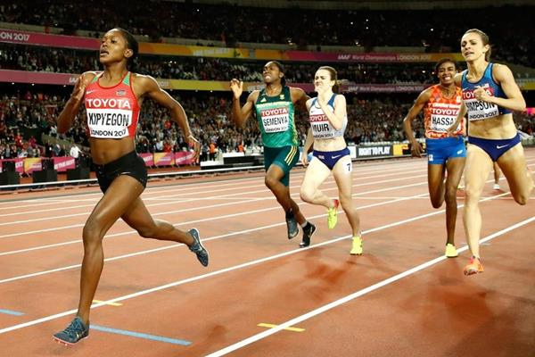

# Physical (fitness) Feature – Stamina

**STAMINA**

**Definition** (*for information only, not required for answer*)

Stamina is the ability of the heart and lungs to supply oxygen to the working muscles during sustained exercise.

**Point (Introduction)**

One feature that impacts my performance within the physical factor is stamina.

**Example (Context)**

For example, having good stamina in *(insert activity)* allows me to:

* run at a faster pace for longer during the race.
* maintain a steady pace for the duration of the race.
* work for an extended period of time without getting tired.
* run at a variety of speeds for the duration of the game to keep up with play.

**Explanation (Impact)**

This means that:

* I can achieve a faster time and better finishing position. When I completed my 1500m, my time was ……… and I finished in …… place.
* I have a strong finish at the end of the race, and can overtake other runners in the final 200m to gain a better finishing position.
* I am able to maintain a high level of skill throughout the game and not make mistakes.
* I can cover large areas of the pitch for the duration of the game allowing me to support my team in attack and defence.

# Physical (fitness) Feature – Stamina

***Example Answer***

*One feature that impacts my performance within the physical factor is Stamina. For example, having good stamina in a 1500m allows me to run at a faster pace for longer during the race. This means that I can achieve a faster time and better finishing position. When I completed my 1500m, my time was 6.05 mins and I finished in 3rd place.*

# Physical (fitness) Feature – Speed

**SPEED**

**Definition** (*for information only, not required for answer*)

Speed is the body’s ability to perform an action or cover a distance in a short period of time.

**Point (Introduction)**

One feature that impacts my performance in the physical factor is speed.

**Example (Context)**

For example, having good speed in *(insert activity*) allows me to:

* achieve a ‘sprint start’, to gain a lead position in the first 100m of the race.
* quickly overtake opponents throughout the race.
* quickly move away from my opponent and into a space.
* quickly move ahead of the ball to get into an attacking position.
* move quickly towards my opponent to close them down.

**Explanation (Impact)**

This means that:

* I can move away from the other athletes quickly, preventing me from getting boxed in and possibly falling.
* I can prevent other athletes from slowing me down, allowing me to keep running at my own pace.
* I can receive a pass from my team mate in a space which allows me to keep possession of the ball and start attacks.
* I can receive the ball close to the opposition goal which gives me a better chance of getting a shot on target.
* I can force my opponents into mistakes and regain possession of the ball to start counter attacks for my team.

# Physical (fitness) Feature – Speed

***Example Answer***

*One feature that impacts my performance within the physical factor is speed. For example, having good speed in a 1500m allows me to achieve a ‘sprint start’, to gain a lead position in the first 100m of the race. This means that I can move away from the other athletes quickly, preventing me from getting boxed in and possibly falling.*

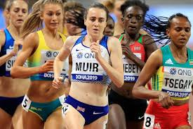

# Physical (fitness) Feature – Agility

**AGILITY**

**Definition** (*for information only, not required for answer*)

Agility is the ability to change the position of the body quickly, precisely and with control. This uses a combination of balance, speed, strength and co-ordination.

**Point (Introduction)**

One feature that impacts my performance in the physical factor is agility.

**Example (Context)**

For example, having good agility in *(insert activity*) allows me to:

* change my body position and direction efficiently throughout the game, allowing me to react quickly to changes in possession.
* dribble at speed whilst keeping control of the ball, changing direction quickly to get past opponents.
* keep up with my opponent when they have the ball, constantly moving to stay between them and the goal.

**Explanation (Impact)**

This means that:

* I can move quickly for missed passes and interceptions, allowing me to get the ball up the pitch quickly catching the opposition off-guard.
* I can help my team set up an attack because I have more time and space to make an accurate pass/shot at goal. This means we are more likely to keep possession/score.
* I can mark and pressurise them, making it more difficult to score.

# Physical (fitness) Feature – Agility

***Example Answer***

*One feature that impacts my performance within the physical factor is agility. For example, having good agility in football allows me to keep up with my opponent when they have the ball, constantly moving to stay between them and the goal.**This means that I can mark and pressurise them, making it more difficult for them to score.*

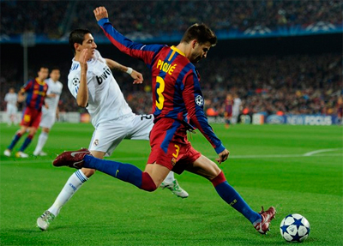

# Physical Factor (Fitness) - Plan

Use the boxes provided below to write a plan for the following question:

*For the physical (fitness) factor,* ***explain*** *its impact on performance. (2 marks)*

|  |  |  |  |
| --- | --- | --- | --- |
| **FEATURE 1:** | **Point**  **(Introduction)** | **Example**  **(Context)** | **Explanation**  **(Impact)** |
| **FEATURE 2:** |  |  |  |

# Physical Factor (Fitness) Task

Use the notes you have written on page 7 to answer the following question in the space provided:

*For the physical (fitness) factor, explain its impact on performance. (2 marks)*

|  |
| --- |
| **Physical (Fitness) Factor:**  ______________________________________________________________________________  ______________________________________________________________________________  ______________________________________________________________________________  ______________________________________________________________________________  ______________________________________________________________________________  ______________________________________________________________________________  ______________________________________________________________________________  ______________________________________________________________________________  ______________________________________________________________________________  ______________________________________________________________________________  ______________________________________________________________________________  ______________________________________________________________________________  ______________________________________________________________________________  ______________________________________________________________________________  ______________________________________________________________________________  ______________________________________________________________________________  ______________________________________________________________________________  ______________________________________________________________________________  ______________________________________________________________________________  ______________________________________________________________________________  ______________________________________________________________________________  ______________________________________________________________________________  ______________________________________________________________________________  ______________________________________________________________________________  ______________________________________________________________________________  ______________________________________________________________________________  ______________________________________________________________________________  ______________________________________________________________________________  ______________________________________________________________________________  ______________________________________________________________________________  ______________________________________________________________________________  ______________________________________________________________________________  ______________________________________________________________________________  ______________________________________________________________________________  ______________________________________________________________________________  ______________________________________________________________________________  ______________________________________________________________________________  ______________________________________________________________________________  ______________________________________________________________________________  ______________________________________________________________________________  ______________________________________________________________________________  ______________________________________________________________________________  ______________________________________________________________________________  ______________________________________________________________________________  ______________________________________________________________________________  ______________________________________________________________________________ |

# EMOTIONAL

**Factors Impacting on Performance**

There are four key factors that impact on performance. The table below shows the Emotional Factor along with some more specific features that we will be focusing on during National 5 PE:

|  |  |  |  |
| --- | --- | --- | --- |
| **FACTOR** | **FEATURES** | | |
| **EMOTIONAL** | Anxiety | Anger | Confidence |



# Emotional Feature - Anxiety

**ANXIETY**

**Definition** (*for information only, not required for answer*)

An emotional state which can cause feelings of nervousness or apprehension.

**Point (Introduction)**

One feature that impacts my performance in the emotional factor is anxiety.

**Example (Context)**

For example, having high levels of anxiety when playing *(insert activity*) can lead to me:

* having negative thoughts and feelings that stop me from trying my best.
* playing in my comfort zone and not trying difficult skills.
* not getting involved in the game and looking for space as I am too scared to make a mistake
* forgetting moves during my dance/gymnastics routine.

**Explanation (Impact)**

This means that:

* I do not track back my opponents when they are attacking making it easier for them to score.
* I become predictable to my opponent making it easier for them to regain possession from me or score points.
* My team has less attacking options when in possession of the ball making it easier for the other team to defend and create counter attacks.
* My routine does not link and I am unable to use the full working area which results in marks being lost from the judges.

**Emotional Feature - Anxiety**

***Example Answer***

*One feature that impacts my performance within the emotional factor is anxiety. For example, having high levels of anxiety when playing netball can lead to me having negative thoughts and feelings which stop me from trying my best. This means that I do not track back my opponents when they are attacking making it easier for them to score.*

# Emotional Feature - Anger

**ANGER**

**Definition** (*for information only, not required for answer*)

An emotional state which can cause displeasure, annoyance or aggression.

**Point (Introduction)**

One feature that impacts my performance in the emotional factor is anger.

**Example (Context)**

For example, feelings of anger in *(insert activity*) can cause me to:

* make silly mistakes like putting too much power into a shot.
* react aggressively to a poor refereeing decision in a game.
* become wound up by team mates who are performing better.
* become a target for the opposition team who are trying to put me off my game.
* make rash decisions and give away constant fouls.

**Explanation (Impact)**

This means that:

* I hit the shuttle too hard and it goes out of the back of the court. This gives my opponent an easy point and makes it more difficult for me to win the match.
* I will get booked by the referee and will be unable to make tackles during the rest of the game in case I get sent off. This makes it easier for my opponents to dribble it past me and create goal scoring opportunities.
* I won’t pass the ball to team mates who are in better positions, making it easier for the opposition to tackle me or make interceptions.

# Emotional Feature - Anger

* I will become distracted by the opposition and make silly mistakes which could result in more scoring opportunities for the opposition.
* I will put my team under pressure as we are constantly losing possession or having to defend set pieces.

***Example Answer***

*One feature that impacts my performance within the emotional factor is anger. For example, feelings of anger in football can cause me to react aggressively to a poor refereeing decision in a game. This means that I will get booked by the referee and will be unable to make tackles during the rest of the game in case I get sent off. This makes it easier for my opponents to dribble past me and create goal scoring opportunities.*

# Emotional Feature - Confidence

**CONFIDENCE**

**Definition** (*for information only, not required for answer*)

The ability to have a feeling or belief that you can rely on your own or others ability.

**Point (Introduction)**

One feature that impacts my performance in the emotional factor is confidence.

**Example (Context)**

For example, high levels of confidence in *(insert activity*) allows me to:

* play outside my comfort zone and attempt complex/more difficult skills, for example a lay-up.
* hold onto the ball longer and take my time to ensure I make the correct decision.
* take my time and not rush my gymnastics routine and hold each of my balances for at least 3 seconds.
* commit to 50/50 challenges and tackles because I have more self-belief.
* keep my opponents on their toes because I continually change up my play so they don’t know what to expect.
* be fully involved in the game and trust my team-mates to do the same.

**Emotional Feature - Confidence**

**Explanation (Impact)**

This means that:

* I am able to score more points for my team because the layup has a higher success rate than the other shots I use.
* I can wait to see if my team-mates are in good attacking positions before I pass the ball. This will give my team a better chance of keeping possession of the ball and/or scoring.
* I have time to think about my next move, making sure I am prepared. It also means that my routine will be more controlled and fluent, giving me a higher score from the judges.
* I have a greater chance of gaining possession of the ball for my team. It also may unnerve the opposition and, meaning they give the ball away more easily.
* my opponent will be less likely to predict my next shot/move, making it easier for me to score a point.
* we have good team dynamics because everyone plays their position and are there to support and cover each other. We will play more effectively as a team, and will have better chance of winning

***Example Answer***

*One feature that impacts my performance in the emotional factor is confidence. For example, high levels of confidence in basketball allows me to play outside my comfort zone and attempt complex/more difficult skills, for example a lay-up. This means that I am able to score more points for my team because the layup has a higher success rate than the other shots I use.*

**Emotional Factor – Plan**

Use the boxes provided below to write a plan for the following question:

*For the emotional factor,* ***explain*** *its impact on performance. (2 marks)*

|  |  |  |  |
| --- | --- | --- | --- |
| **FEATURE 1:** | **Point**  **(Introduction)** | **Example**  **(Context)** | **Explanation**  **(Impact)** |
| **FEATURE 2:** |  |  |  |

# Emotional Factor Task

Use the notes you have written on page 14 and answer the following question in the space provided:

*For the emotional factor, explain its impact on performance. (2 marks)*

|  |
| --- |
| **Emotional Factor:**  ______________________________________________________________________________  ______________________________________________________________________________  ______________________________________________________________________________  ______________________________________________________________________________  ______________________________________________________________________________  ______________________________________________________________________________  ______________________________________________________________________________  ______________________________________________________________________________  ______________________________________________________________________________  ______________________________________________________________________________  ______________________________________________________________________________  ______________________________________________________________________________  ______________________________________________________________________________  ______________________________________________________________________________  ______________________________________________________________________________  ______________________________________________________________________________  ______________________________________________________________________________  ______________________________________________________________________________  ______________________________________________________________________________  ______________________________________________________________________________  ______________________________________________________________________________  ______________________________________________________________________________  ______________________________________________________________________________  ______________________________________________________________________________  ______________________________________________________________________________  ______________________________________________________________________________  ______________________________________________________________________________  ______________________________________________________________________________  ______________________________________________________________________________  ______________________________________________________________________________  ______________________________________________________________________________  ______________________________________________________________________________  ______________________________________________________________________________  ______________________________________________________________________________  ______________________________________________________________________________  ______________________________________________________________________________  ______________________________________________________________________________  ______________________________________________________________________________  ______________________________________________________________________________  ______________________________________________________________________________  ______________________________________________________________________________  ______________________________________________________________________________  ______________________________________________________________________________  ______________________________________________________________________________  ______________________________________________________________________________  ______________________________________________________________________________ |

# MENTAL

**Factors Impacting on Performance**

There are four key factors that impact on performance. The table below shows the Mental Factor along with some more specific features that we will be focusing on during National 5 PE:

|  |  |  |  |
| --- | --- | --- | --- |
| **FACTOR** | **FEATURES** | | |
| **Mental** | Decision Making | Concentration | Motivation |

[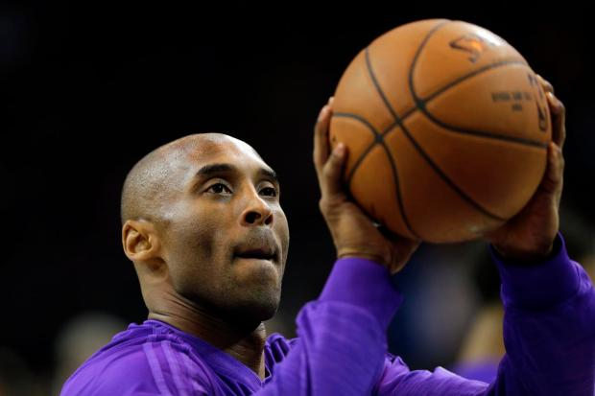](https://www.google.co.uk/url?sa=i&rct=j&q=&esrc=s&source=images&cd=&cad=rja&uact=8&ved=2ahUKEwjJ-YrCy8DiAhWGnxQKHVteAacQjRx6BAgBEAU&url=/url?sa%3Di%26rct%3Dj%26q%3D%26esrc%3Ds%26source%3Dimages%26cd%3D%26ved%3D%26url%3Dhttps://www.ocregister.com/2016/04/13/kobe-bryants-fiercely-competitive-drive-defined-him-from-day-one-of-his-20-year-lakers-career/%26psig%3DAOvVaw3Mp7uoQmKBXgg422h4L0PH%26ust%3D1559214051521309&psig=AOvVaw3Mp7uoQmKBXgg422h4L0PH&ust=1559214051521309)

# Mental Feature – Decision Making

**DECISION MAKING**

**Definition** (*for information only, not required for answer*)

The ability to apply the correct option or course of action to execute skills successfully.

**Point (Introduction)**

One feature that impacts my performance in the mental factor is decision making.

**Example (Context)**

For example, good decision making in *(insert activity*) allows me to:

* choose the best shot to play to put my opponent under pressure. If the shuttle is high in the middle of the court, I would play a smash because it is a fast, powerful shot and difficult to return.
* select what player in my team to pass to. If I am playing in defence, I would clear the ball away from goal by passing wide to a player who is in a space on the wings of the pitch.
* choose what type of pass to make. When I was being marked tightly by a tall player, I made the decision to play a bounce pass to my team-mate who was quite close to me.
* choose what skills I put in my routine and the order in which I perform them. I made the decision to perform a one-handed cartwheel followed by a handstand because they are both difficult moves that I could do well.
* select whether to pass, dribble or shoot. When my team got the ball up the court quickly and passed to me, I made the decision to shoot with a lay-up because I was closest to the basket and there was no one in the opposite team in front of me.

# Mental Feature – Decision Making

**Explanation (Impact)**

This means that:

* my opponent is more likely to make a mistake like missing the shuttle or hitting it into the net, allowing me to win the point.
* my team could set up an attack by dribbling the ball down the wings of the pitch and crossing the ball into the oppositions box. This would give us a good scoring opportunity.
* it was more difficult for my opponent to get her hands down quickly enough to intercept the pass, so my team were able to make short accurate passes down the court to our shooters.
* I could be awarded a higher mark because my routine had some difficult skills in it and it flowed well from one move to the next.
* I had a greater chance of scoring points for my team because the layup is a highly accurate shot when performed correctly.

***Example Answer***

*One feature that impacts my performance in the mental factor is decision making. For example, good decision making in badminton allows me choose the best shot to play to put my opponent under pressure. If the shuttle is high in the middle of the court, I would play a smash because it is a fast, powerful shot and difficult to return. This means that my opponent is more likely to make a mistake like missing the shuttle or hitting it into the net, allowing me to win the point.*

# **Mental Feature - Concentration**

**Concentration**

**Definition** (*for information only, not required for answer*)

The ability to completely focus your attention on something for a period of time.

**Point (Introduction)**

One feature that impacts my performance in the mental factor is concentration.

**Example (Context)**

For example, having good concentration in *(insert activity*) allows me to:

* perform with good technique so that my skills are more accurate. When I volley set the ball for my team-mate, I focus on playing it high at the net in front of them by moving quickly underneath it and pushing upwards with my legs.
* filter out distractions and focus on the important parts of my performance. During my gymnastics routine, I had to block out my classmates who were watching me and concentrate on stretching up after each move and keeping my legs straight and toes pointed.
* react and respond effectively to other players’ movements. My opponent was moving very fast and constantly changing direction with the ball and I had to really concentrate so that I could stay with them and pressurise them.
* remember specific tactics or strategies. I was playing Centre and when the opposition were attacking, I had to remember to block their Goal Attack from getting into the shooting circle.

Mental Feature - Concentration

**Explanation (Impact)**

This means that:

* my volley set is high and accurate so that my team-mate has more time to move into position and time their jump to spike the ball. This will give my team more chance of winning the rally.
* the quality of my routine was better and I finished each move in a controlled manner meaning I got a higher mark.
* I could stay between my opponent and the goal, making it more difficult for them to shoot and giving me the chance of an interception.
* they would only have one shooter in the circle against my teams two defenders, making it more it more difficult for them to feed the ball in and keep possession.

***Example Answer***

*One feature that impacts my performance in the mental factor is concentration. For example, good concentration in volleyball allows me to perform with good technique so that my skills are more accurate. When I volley set the ball for my team-mate, I focus on playing it high at the net in front of them by moving quickly underneath it and pushing upwards with my legs. This means that my volley set is high and accurate so that my team-mate has more time to move into position and time their jump to spike the ball. This will give my team more chance of winning the rally.*

[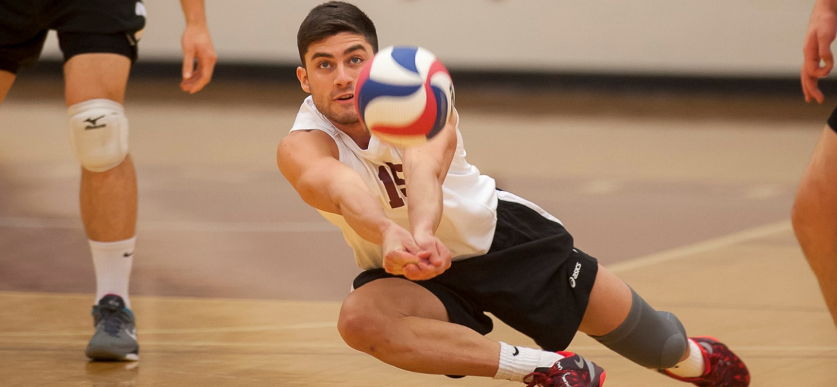](https://www.google.co.uk/url?sa=i&rct=j&q=&esrc=s&source=images&cd=&ved=2ahUKEwjyyu_gz8DiAhVDxIUKHa6wBl8QjRx6BAgBEAU&url=http://springfieldcollegepride.com/sports/mvball/2014-15/releases/201502075pe6xh&psig=AOvVaw1I4jxFPUtMoyW8XzpFamF2&ust=1559215228978514)

# Mental Feature – Motivation

**MOTIVATION**

**Definition** (*for information only, not required for answer*)

Motivation is your level of desire to succeed. In order to effectively improve your performance you must be well motivated.

**Point (Introduction)**

One feature that impacts my performance in the mental factor is motivation.

**Example (Context)**

For example, having good motivation in *(insert activity*) allows me to:

* keep trying hard and not give up, especially if I am not playing well.
* try my best, so that I get the best mark I can for my assessment.
* play my best, even against an opponent who I think is better than me.
* keep trying hard and not give up, even if my team are losing.

# Mental Feature – Motivation

**Explanation (Impact)**

This means that:

* I will be more likely to improve my performance and start winning points.
* If I have something to motivate me, like a competition or a trophy, it will encourage me to keep working hard throughout my performance.
* having a positive attitude will make it more likely that I will perform well and even win.
* I could motivate and encourage other players in my team to keep working hard, giving us a better chance of evening up the score.

***Example Answer***

*One feature that impacts my performance in the emotional factor is motivation. For example, high levels of motivation in badminton allows me to keep trying hard and not give up, especially if I am not playing well. This means that I will be more likely to improve my performance and start winning points.*

# Mental Factor - Plan

Use the boxes provided below to write a plan for the following question:

*For the mental factor,* ***explain*** *its impact on performance. (2 marks)*

|  |  |  |  |
| --- | --- | --- | --- |
| **FEATURE 1:** | **Point**  **(Introduction)** | **Example**  **(Context)** | **Explanation**  **(Impact)** |
| **FEATURE 2:** |  |  |  |

# Mental Factor Task

Use the notes you have written on page 21 and answer the following question in the space provided:

*For the mental factor, explain its impact on performance. (2 marks)*

|  |
| --- |
| **Mental Factor:**  ______________________________________________________________________________  ______________________________________________________________________________  ______________________________________________________________________________  ______________________________________________________________________________  ______________________________________________________________________________  ______________________________________________________________________________  ______________________________________________________________________________  ______________________________________________________________________________  ______________________________________________________________________________  ______________________________________________________________________________  ______________________________________________________________________________  ______________________________________________________________________________  ______________________________________________________________________________  ______________________________________________________________________________  ______________________________________________________________________________  ______________________________________________________________________________  ______________________________________________________________________________  ______________________________________________________________________________  ______________________________________________________________________________  ______________________________________________________________________________  ______________________________________________________________________________  ______________________________________________________________________________  ______________________________________________________________________________  ______________________________________________________________________________  ______________________________________________________________________________  ______________________________________________________________________________  ______________________________________________________________________________  ______________________________________________________________________________  ______________________________________________________________________________  ______________________________________________________________________________  ______________________________________________________________________________  ______________________________________________________________________________  ______________________________________________________________________________  ______________________________________________________________________________  ______________________________________________________________________________  ______________________________________________________________________________  ______________________________________________________________________________  ______________________________________________________________________________  ______________________________________________________________________________  ______________________________________________________________________________  ______________________________________________________________________________  ______________________________________________________________________________  ______________________________________________________________________________  ______________________________________________________________________________  ______________________________________________________________________________  ______________________________________________________________________________ |

# SOCIAL

**Factors Impacting on Performance**

There are four key factors that impact on performance. The table below shows the Social Factor along with some more specific features that we will be focusing on during National 5 PE:

|  |  |  |  |
| --- | --- | --- | --- |
| **FACTOR** | **FEATURES** | | |
| **SOCIAL** | Roles & Responsibilities | Relationships | Communication |

[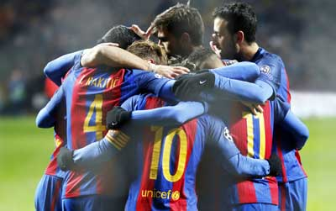](https://www.google.co.uk/url?sa=i&rct=j&q=&esrc=s&source=images&cd=&cad=rja&uact=8&ved=0ahUKEwjE8eDimL7XAhWLAcAKHQ2sCi0QjRwIBw&url=https://www.barcelona.com/barcelona_tickets/fc_barcelona_football_tickets/players&psig=AOvVaw2pLhfFDN-HEp2-b-x-xZW-&ust=1510752764167571)

Social Feature – Roles & Responsibilities

**ROLES & RESPONSIBILITIES**

**Definition** (*for information only, not required for answer*)

This is the interaction of performers within a team or group, to make the group or team more effective.

**Point (Introduction)**

One feature that impacts my performance in the social factor is roles and responsibilities.

**Example (Context)**

For example, having good roles and responsibilities in *(insert activity*) allows me to:

* know where I am positioned on the court and who I am marking when I play in a specific positon
* know my position (role) and understand what I have to do (responsibilities) within that position. I play guard and one of my responsibilities is to bring the ball up the court and feed it to the forwards.
* know exactly where I should be on the court at all times to ensure my team have an effective team formation. My team had four players, so we played in a diamond formation. We had one backcourt player, two spikers and a setter at the net.
* know my role during specific set pieces. When we are defending a corner my role is to protect the front post.

Social Feature – Roles & Responsibilities

**Explanation (Impact)**

This means that:

* I can tightly mark the opposition player, making it more difficult for them to get free for a pass and shoot.
* we can catch the opposition off-guard by getting the ball up the court quickly. When I have the ball, my team-mates will quickly move ahead of me to set up an attack. This means we have a greater chance of taking an unopposed shot and hopefully scoring.
* my team were able to cover the court more effectively, minimising space for the opposition to play the ball to and win a point.
* my team can get organised quickly and mark oppositions players so that they have less chance of getting a shot at goal.

***Example Answer***

*One feature that impacts my performance in the social factor is roles and responsibilities. For example, having good roles and responsibilities in netball allows me to know where I am positioned on the court and who I am marking when I play in a specific position. This means that I can tightly mark the opposition player, making it more difficult for them to get free for a pass and shoot.*

*.*

Social Feature – Roles & Responsibilities

**Formations**

In hockey/football, the formation describes how the players in a team are positioned on the pitch. Different formations can be used depending on whether a team wishes to play more attacking or defensive football. The formation selected will also be based upon the following;

* The strengths and weaknesses of individual/team.
* In recognition of opposition’s strengths and weaknesses ie. a specific formation may be chosen to try and exploit the oppositions weaknesses.

The formation is dependent on the size of the team. For example;

Small Sided Games (5v5) (6v6) Full Pitch Games

2-2-1, 2-3-1 4-4-2, 3-5-2, 4-5-1, 3-4-3

Generally there will be an overbalance of players in the midfield to allow the formation to have flexibility. For example, the central midfielder can push up to support the attack or drop back to support the defence.

**Set Pieces**

# Social Feature – Relationships

**RELATIONSHIPS**

**Definition** (*for information only, not required for answer*)

Relationships are the way in which two or more people or groups regard and behave towards each other.

**Point (Introduction)**

One feature that impacts my performance in the social factor is relationships.

**Example (Context)**

For example, having good relationships in *(insert activity*) allows me to:

* be aware of my own individual strengths and that of my team-mates, and use these to benefit the team as a whole. I know that one of the spikers is stronger with their left hand, so I always set the ball high to that side of them.
* have a relationship between the music during my performance. During my dance routine, I continually changed my moves to reflect the music. When the music was slow, I performed graceful balances and when it was fast I performed powerful jumps and tumbles.
* get on well with my coach and other players, and trust and respect each other’s decisions. During half time, my coach changed my position from Centre to Goal Attack because our usual GA had just come back from injury and needed to rest the second half.
* behave appropriately towards other members of my team, being positive towards one and other and displaying mutual respect.

# Social Feature – Relationships

**Explanation (Impact)**

This means that:

* they are able to perform a more powerful, accurate spike because they are using their strong hand. This makes it more difficult for the opposition to return the ball.
* I was able to stay in time with the music and show more expression and feeling in my moves. My performance looked much more fluent and interesting so I got a higher mark.
* although I didn’t normally play that position and didn’t feel very confident, I got on well with my coach and trusted their knowledge and experience to make good decisions for the team. I ended up shooting and scoring more goals than I thought I would and my team won the match.
* my team mates always work hard for one and other and make good decisions for the benefit of the team. This means we have a really good team morale which helps us perform better.

***Example Answer***

*One feature that impacts my performance in the social factor is relationships. For example, having good relationships in volleyball allows me to be aware of my own individual strengths and that of my team-mates, and use these to benefit the team as a whole. I know that one of the spikers in my team is stronger with their left hand, so I always set the ball high to that side of them. This means that they are able to perform a more powerful, accurate spike because they are using their strong hand. This makes it more difficult for the opposition to return the ball.*

# Social Feature – Communication

**COMMUNICATION**

**Definition** (*for information only, not required for answer*)

**Communication** is the successful sharing of meaningful information between people.

**Point (Introduction)**

One feature that impacts my performance in the social factor is communication.

**Example (Context)**

For example, having good communication in *(insert activity*) allows me to:

* let my teammates know if I am in space to receive a pass when they are in possession of the ball. When my team are receiving serve, I shout “mine” loudly to let my teammates know I am going for the ball.
* ensure my teammates are organised and in the correct position throughout the game. When my opponent was always getting free for a centre pass, I shouted to another player to help me double mark them.
* ensure everyone knows where they should be positioned during set pieces and knows who they are marking.

# Social Feature – Communication

**Explanation (Impact)**

This means that:

* the rest of my team can make the correct decision of where to move to on the court, so they are in the correct position to set up an attack at the net and win the point.
* my teammate and I were able to work together to put my opponent under greater pressure and prevent them from getting free for a pass. The opposition had fewer passing options and we eventually gained possession of the ball.
* all of the opposition players are marked prior to the set piece being taken and ensures that they don’t get a shot at goal.

***Example Answer***

*One feature that impacts my performance in the social factor is communication. For example, having good communication in volleyball allows me to let my teammates know if I am in space to receive a pass when they are in possession of the ball. When my team are receiving serve, I shout “mine” loudly to let my teammates know I am going for the ball. This means that the rest of my team can make the correct decision of where to move to on the court, so they are in the correct position to set up an attack at the net and win the point.*

[](https://www.google.co.uk/url?sa=i&rct=j&q=&esrc=s&source=images&cd=&cad=rja&uact=8&ved=2ahUKEwj3-t_BzcDiAhWDAmMBHc5lAgkQjRx6BAgBEAU&url=/url?sa%3Di%26rct%3Dj%26q%3D%26esrc%3Ds%26source%3Dimages%26cd%3D%26ved%3D%26url%3Dhttps://www.foxsports.com.au/netball/netball-world-cup-2015-aussie-diamonds-players-ratings-v-england/news-story/0c173ac597f26ad389ad4079a3d61868%26psig%3DAOvVaw1A98UIm5jQfQHtwyQBmuHO%26ust%3D1559214590053242&psig=AOvVaw1A98UIm5jQfQHtwyQBmuHO&ust=1559214590053242)

# Social Factor - Plan

Use the boxes provided below to write a plan for the following question:

*For the social factor,* ***explain*** *its impact on performance. (2 marks)*

|  |  |  |  |
| --- | --- | --- | --- |
| **FEATURE 1:** | **Point**  **(Introduction)** | **Example**  **(Context)** | **Explanation**  **(Impact)** |
| **FEATURE 2:** |  |  |  |

# Social Factor Task

Use the notes you have written on page 28 and answer the following question in the space provided:

*For the social factor, explain its impact on performance. (2 marks)*

|  |
| --- |
| **Social Factor:**  ______________________________________________________________________________  ______________________________________________________________________________  ______________________________________________________________________________  ______________________________________________________________________________  ______________________________________________________________________________  ______________________________________________________________________________  ______________________________________________________________________________  ______________________________________________________________________________  ______________________________________________________________________________  ______________________________________________________________________________  ______________________________________________________________________________  ______________________________________________________________________________  ______________________________________________________________________________  ______________________________________________________________________________  ______________________________________________________________________________  ______________________________________________________________________________  ______________________________________________________________________________  ______________________________________________________________________________  ______________________________________________________________________________  ______________________________________________________________________________  ______________________________________________________________________________  ______________________________________________________________________________  ______________________________________________________________________________  ______________________________________________________________________________  ______________________________________________________________________________  ______________________________________________________________________________  ______________________________________________________________________________  ______________________________________________________________________________  ______________________________________________________________________________  ______________________________________________________________________________  ______________________________________________________________________________  ______________________________________________________________________________  ______________________________________________________________________________  ______________________________________________________________________________  ______________________________________________________________________________  ______________________________________________________________________________  ______________________________________________________________________________  ______________________________________________________________________________  ______________________________________________________________________________  ______________________________________________________________________________  ______________________________________________________________________________  ______________________________________________________________________________  ______________________________________________________________________________  ______________________________________________________________________________  ______________________________________________________________________________ |