Williamwood High School

Physical Education

National 5

PHYSICAL FACTOR



Name: _____________________

Teacher: _____________________

Name:

# Contents

How to answer question types 2

Cycle of Analysis 3

Timeline 4

**Factors Impacting on Performance**

Speed 7

Stamina 8

Factors Impacting on Performance - Plan 9

Q1 Homework Task 10

**Gathering Information**

30m Sprint (Speed) 12

Cooper Test (Stamina) 13

Q2 Homework Task 14

Challenges 15

Challenges Plan 16

Q3 Homework Task 17

**Approaches to develop performance**

Interval Training 19

Fartlek Training 20

Q4 Homework Task 21

**Monitoring/Evaluating**

Repeating Method 1 23

Repeating Method 2 24  
 Q5 Homework Task 25  
 Importance of Monitoring 26

Importance of Monitoring Plan 27

Q6 Homework Task 28

Future Development Needs 29

4 week training Diary 30

**How to answer different questions**

[](https://www.google.co.uk/url?sa=i&url=https://webstockreview.net/explore/discussion-clipart-discussion-question/&psig=AOvVaw0MFCdzbsEmXnhTK7-gMi8Q&ust=1592041934419000&source=images&cd=vfe&ved=0CAIQjRxqFwoTCLDgicKA_OkCFQAAAAAdAAAAABAS)

**Step (1)** Look for command words:

* **Identify**
* **Describe**
* **Explain**

**Step (2)** Look for topic area

* **Factors Impacting on Performance**
* **Methods of Gathering Information**
* **Approaches to Develop Performance**
* **Methods of Monitoring/Evaluating Performance**

**Step (3)** Use the correct formula for answering the command work

* **Identify:** Simply name what is being asked.
* **Describe:** Step by step process of how to carry out what is being asked
* What resources/equipment is required?
* How did you set it up (equipment needed, helpers e.g. starter/timer etc.)?
* What does it look like?
* How did you complete the method?
* What does the method measure?
* What did you do with your results?
* **Explain:** Point 🡪 Example 🡪 Explanation

# Cycle of Analysis

1. I GATHER INFORMATION on my performance by assessing my level of performance and the demands of my performance.

2. I then ANALYSE the results to identify my strengths and weaknesses.

3. I then create a programme of work to DEVELOP my performance.

4. Finally, I MONITOR/EVALUATE, which means I find out if I have successfully improved my performance and what to do next.

|  |  |  |  |  |
| --- | --- | --- | --- | --- |
|  | **S3 National 5 Athletics Block ( 8th subject)** | | | |
|  | **Practical** | | **Classroom** | **Homework** |
| **Week 1** |  |  | Introduction to PE |  |
| ***Week 2*** | **Gathering Information**  *Fitness Test : 30m sprint* | **Gathering Information**  Fitness Test : Cooper Run  Fitness Test : 30m Sprint | Factors Impacting Performance (page 7, 8 & 9) | Formal homework task 1:  Factors impacting performance (page 10) |
| **Week 3** | **Approaches**  Fartlek / Interval | **Approaches**  Fartlek / Interval | Gathering information (page 12 & 13) and introduction to page 15 & 16. | Formal homework 2:  How to gather information (page 14) |
| **Week 4** | **Approaches**  Fartlek / Interval | **Approaches**  Fartlek / Interval | Gathering information challenges (page 15 & 16) | Formal homework 3:  Challenges when gathering information (page 17) |
| ***Week***  ***5*** | **Monitoring** | **Monitoring**  *Cooper Run* | Approaches (page 19 & 20) | Formal homework 4:  Approaches (page 21) |
| **Week 6** | **Approaches**  Fartlek / Interval | **Approaches**  Fartlek / Interval | Monitoring (page 23 & 24 | Formal homework 5:  How to monitor progress (page 25) |
| ***Week 7*** | **Approaches**  Fartlek / Interval |  | Monitoring (pages 26 &27) | **Formal homework 6:**  Importance of monitoring (page 28) |
| **Week 8** |  | **Evaluating**  Cooper Run | Future Development needs (page 29) |  |

## FACTORS IMPACTING ON PERFORMANCE

###### Factors Impacting on Performance

The PE course is all about 4 key ‘**factors**’ that impact on performance. The table below shows the **Physical Factor** along with some more specific ‘**features**’ that we will be focusing on during the first block of National 5 PE:

|  |  |  |
| --- | --- | --- |
| **FACTOR** | **FEATURES** | |
| **Physical** | Speed | Stamina |

[](https://www.google.co.uk/url?sa=i&url=https://www.platinumtraininginstitute.com/not-just-placebos-maca/endurance-and-stamina/&psig=AOvVaw12EB1xbLo6m2BwymKNBDhE&ust=1592397279339000&source=images&cd=vfe&ved=0CAIQjRxqFwoTCPCKmKSshuoCFQAAAAAdAAAAABAE)

**Later in S3 we will look at the other three factors (Emotional, Mental and Social.)**

# Physical Feature 1

**Speed**

**Definition of speed**

Speed is the ability of the body to move quickly.

**Point**One feature that impacts on my performance within the physical factor is **speed**.

**Example**



**How to use**

1. Open your camera app on your phone.
2. Hold the camera at the QR code.
3. Click the link and it will take you to the YouTube clip.
4. If this does not work, use the link below or download a GR code   
    app to your phone.

<https://youtu.be/yCBsoXVAEoo>

**Explanation**

*Referring to video think about the questions below*

* Why is speed important at the start of the 1500m?
* Why is speed important at the during of the 1500m?
* Why is speed important at the end 1500m?

**Example Answer- DO NOT COPY ANSWER**

(Point) One feature that impacts on my performance within the physical factor is **speed**. (Example) For example, if I have a good sprint start in the 1500m race I can take an early lead. (Explanation) As a result, I am able to set the pace for my other opponents and gain a lead position in the race.

# Physical Feature 2

# Stamina

**Definition of stamina**

Stamina is the ability to work for an extended period of time without fatigue setting in.

**Point**

One feature that impacts on my performance within the physical factor is stamina.

**Example**

**How to use**

1. Open your camera app on your phone.
2. Hold the camera at the QR code.
3. Click the link and it will take you to the YouTube clip.
4. If this does not work, use the link below or download a GR code   
   app to your phone.

<https://youtu.be/FRDJrjmVGvw>

**Explanation**

*Referring to video think about the questions below*

* Why is it important to have stamina during a long distance race?
* How can stamina impact your performance at the end of the race?

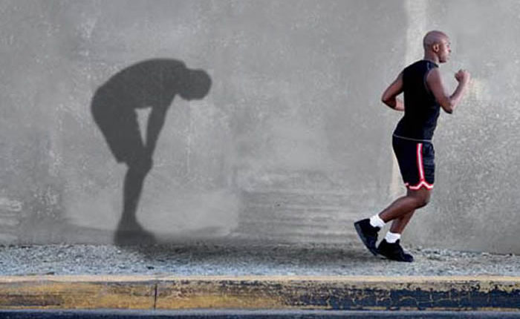

**Factors Impacting Performance - Plan**

Use the boxes provided below to write a plan for the following question:

*Question: For the physical factor,* ***explain*** *its impact on performance.* ***(2 marks)***

***FOR THIS QUESTION, YOU CAN CHOOSE TO WRITE ABOUT ANY SPORT.***

|  |  |  |  |
| --- | --- | --- | --- |
| **EXAMPLE – DO NOT COPY** | **Point**  **Introduction**  **Feature: Speed**  One feature that impacts my performance in the physical factor is speed. | **Example**  **Sport: 1500m**  - I have a good ‘sprint start’  - As a result, I am able to take an early lead…  --Set the pace of the race.  -- Can set a challenge for my opponents. | **Explanation**  **(Including Impact)**  - Speed has an impact on a 'sprint start' that helps gain a lead position in the 1500m. |
| **FEATURE 1** | **Feature 1:** | **Sport:** |  |
| **FEATURE 2** | **Feature 2:** | **Sport:** |  |

# 

# Formal Homework Task 1

Use the plans you have written on page 9 and **draft** the following question in the space provided. **Your final answer will be submitted on Google Classrooms.**

Q1) For the Physical factor **explain** its impact on performance. ***(2 marks)***

***FOR THIS QUESTION, YOU CAN CHOOSE TO WRITE ABOUT ANY SPORT.***

**Feature 1:**

**SPORT: ­­______________**

**POINT: ______________________________________________________________________________________________________________________________________________________________________________________________________________________________**

**EXAMPLE:** *For example* **…. _______________________________________________________________________________________________________________________________________________________________________________________________________________________________________________________________________________________________ EXPLANATION:** *This means that* **…. ____________________________________________________________________________________________________________________________________________________________________________________________________________________________________________________________________________________________________________________________________________________________________________________________________________________________________________________________**

**Feature 2:**

**SPORT: ­­______________**

**POINT: ______________________________________________________________________________________________________________________________________________________________________________________________________________________________**

**EXAMPLE:** *For example…* **________________________________________________________________________________________________________________________________________________________________________________________________________________________________________________________________________________________________________EXPLANATION:** *This means that…* **____________________________________________________________________________________________________________________________________________________________________________________________________________________________________________________________________________________________________________________________________________________________________________________________________________________________________________________________**

___________________________________________________________________________________

________________________________________________________________________________

## GATHERING INFORMATION

### 

**30 Metre Sprint Test (Speed)**

* This test aims to measure my ability to effectively and efficiently build up acceleration, from a standing start;
* The test comprises of 3 x 30 metre runs, from a flying start;
* There is a full recovery between each run;
* My classmate or teacher will record the time for me to complete each 30 metres sprint
* My score is the average of my three sprints.

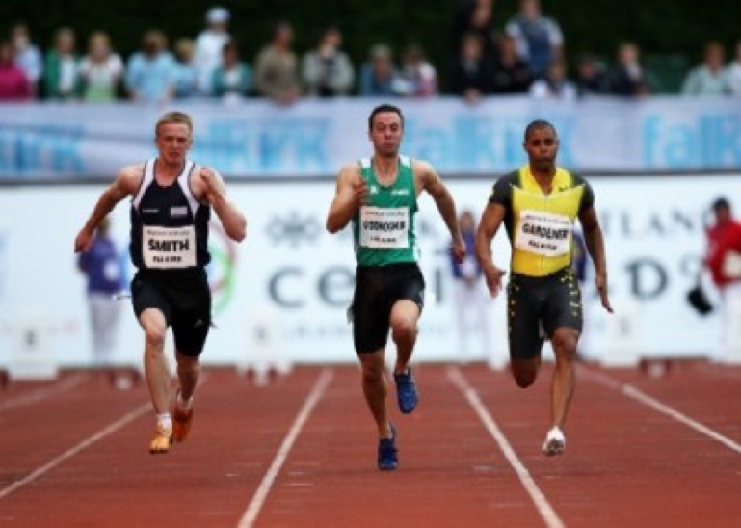

My time: _________ seconds

**Analysis**

Class Average: _________ seconds

Class Best: _________ seconds

|  |  |  |  |  |  |
| --- | --- | --- | --- | --- | --- |
| Gender | Excellent | Above Average | Average | Below Average | Poor |
| Male | <4.0 | 4.2 - 4.0 | 4.4 - 4.3 | 4.6 - 4.5 | >4.6 |
| Female | <4.5 | 4.6 - 4.5 | 4.8 - 4.7 | 5.0 - 4.9 | >5.0 |

**12 Minute Cooper Test (Stamina)**

* The Cooper Test is a 12-minute run that measures stamina;
* The object is to run as far as I can in 12 minutes;
* I will use the 400m running track to complete this test;
* The test should be ran at a steady, constant pace that I can maintain for the full duration;
* The further I run, the better my score;
* My score is the distance in metres covered in 12 minutes;
* I measure my distance to the nearest **fully completed** 100m.

**My score: _________ metres**

|  |  |  |  |  |  |
| --- | --- | --- | --- | --- | --- |
| Age | Excellent | Above Average | Average | Below Average | Poor |
| Male 13-14 | >2700m | 2400-2700m | 2200-2399m | 2100-2199m | <2100m |
| Females 13-14 | >2000m | 1900-2000m | 1600-1899m | 1500-1599m | <1500m |
| Males 15-16 | >2800m | 2500-2800m | 2300-2499m | 2200-2299m | <2200m |
| Females 15-16 | >2100m | 2000-2100m | 1700-1999m | 1600-1699m | <1600m |

**Formal Homework Task 2**

**How to Gather Information**

When describing each test:

* What resources/equipment is required?
* How did you set it up (equipment needed, helpers e.g. starter/timer etc.)?
* What does it look like?
* How did you complete the method?
* What does the method measure?
* What did you do with your results?

**Draft** the following question in the space provided.

**Your final answer will be submitted on Google Classrooms.**

Q2) **Identify** one appropriate method you used to gather data on your **PHYSICAL** performance in an activity of your choice. ***(1 mark)***

Method:

_______________________________________________________________________________________

**Describe** how you carried out this method to gather information. ***(2 marks)***

Description:

______________________________________________________________________________________

______________________________________________________________________________________

______________________________________________________________________________________

______________________________________________________________________________________

______________________________________________________________________________________

______________________________________________________________________________________

______________________________________________________________________________________

______________________________________________________________________________________

______________________________________________________________________________________

______________________________________________________________________________________

______________________________________________________________________________________

______________________________________________________________________________________

______________________________________________________________________________________

______________________________________________________________________________________

______________________________________________________________________________________

**Challenges when gathering information**

**Point 1:**

One challenge you may face gathering information about your performance is **human error**. Mistakes can easily be made when organising, measuring, counting or timing test.

**Example**

*For example*… timing and recording 30m sprint test. Partners delayed reaction to start the stopwatch.

**Explanation**

*This means that*…the information is unreliable as all date is inaccurate.

**Point 2:**One challenge you may face gathering information about your performance is the **weather conditions.** Test completed outdoors can be significantly affected by a variety of weather conditions.

**Example:**

*For example… (Write your own explanation)*

**Explanation:**

*This means that… (Write your own explanation)*

**Point 3:**

One challenge you may face gathering information about your performance is **peer/self- bias.**

**Example:**

*For example… (Write your own explanation)*

**Explanation**

*This means that... (Write your own explanation)*

**Challenges - Plan**

Use the boxes provided below to write a plan for the following question:

***Explain a challenge you may face when gathering information about your performance****.* ***(2 marks)***

**DO NOT COPY EXAMPLE.**

|  |  |  |
| --- | --- | --- |
| **Point** | **Example** | **Explain** |
| **Point 1:**  One challenge you may face gathering information about your performance is **human error**. Mistakes can easily be made when organising, measuring, counting or timing test. | ***- For example*,** Timing and recording 30m sprint test.  - Partners delayed reaction to start the stopwatch. | ***- This means that***the information is unreliable as all date is inaccurate. |
| **Point 2:** |  |  |
| **Point 3:** |  |  |

**Formal Homework Task 3**

**Challenges when Gathering Information**

**Draft** the following question in the space provided.

**Your final answer will be submitted on Google Classrooms.**

Q3) **Explain** a challenge you may face when gathering information about your performance.

***(1 Mark)***

*Point ________________________________________________________________________*

*_____________________________________________________________________________*

*Example ______________________________________________________________________*

*_____________________________________________________________________________*

*_____________________________________________________________________________*

*_____________________________________________________________________________*

*Explanation _____________________________________________________________________________*

*_____________________________________________________________________________*

*_____________________________________________________________________________*

*_____________________________________________________________________________*

*_____________________________________________________________________________*

## APPROACHES TO DEVELOP PERFORMANCE

**Approaches to Develop Performance**

**Interval Training**

**Description:**

* Interval training involves periods of work followed by a recover.
* I can use the 400m track for interval training and use cones to indicate each change of 100m
* Example of a simple 20-minute interval training session:
* Sprint 200m - Walk 200m

**When describing each approach:**

* Where did you carry out the approach?
* What resources/equipment did you need?
* How did you set it up (equipment needed, helpers e.g. starter/timer etc.)?
* 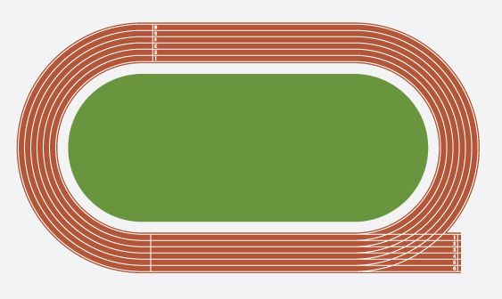What does it look like?
* How did you complete the approach?
* How could you make approach harder?

WALK 200m

SPRINT 200m

**Fartlek Training**

**Description:**

* It involves running at a variety of paces;
* I can use the 400m track for fartlek training and use cones to indicate each change of pace:
* Example of a simple 20-minute fartlek training session:

Walk 100m **-** ¾ Pace 100m **-** Jog 100m **-** Sprint 100m

**When describing each approach:**

* Where did you carry out the approach?
* What resources/equipment did you need?
* How did you set it up (equipment needed, helpers e.g. starter/timer etc.)?
* What does it look like?
* How did you complete the approach?
* How could you make approach harder?

### Image result for blank athletics track

WALK 100m

½ PACE 100m

JOG 100m

SPRINT 100m

# Formal Homework 4

# Approaches to Develop Performance

**Draft** the following question in the space provided.

**Your final answer will be submitted on Google Classrooms.**

Q4) **Describe** an approach that you used to develop your performance in the **PHYSICAL** factor. ***(2 marks)***

Approach: _________________________________________________________________________­

Description: _______________________________________________________________________

__________________________________________________________________________________

__________________________________________________________________________________

__________________________________________________________________________________

__________________________________________________________________________________

__________________________________________________________________________________

__________________________________________________________________________________

__________________________________________________________________________________

__________________________________________________________________________________

__________________________________________________________________________________

__________________________________________________________________________________

__________________________________________________________________________________

__________________________________________________________________________________

__________________________________________________________________________________

__________________________________________________________________________________

__________________________________________________________________________________

__________________________________________________________________________________

__________________________________________________________________________________

## MONITORING/EVALUATING

**How to Monitor Progress**

The effectiveness of your training is monitored by **repeating** and **comparing** each of the methods used to gather information every 2-3 weeks.

We will monitor our performance based on the **12-minute cooper test and training programme.**

**Method 1: Repeat 12-Minute Cooper Test**

* Repeat the 12-Minute Cooper test during your training.
* **Compare** and **analyse** the results of your 12-Minute Cooper test from before and during training.
* **Must be completed using the exact same conditions.**
* Same weather conditions
* Same time of day
* Same equipment

|  |  |
| --- | --- |
| Results before training | Results during training |
|  |  |

[](https://www.google.co.uk/url?sa=i&url=https://www.retentionscience.com/blog/automating-machine-learning-monitoring-rs-labs/&psig=AOvVaw0OS5vxOqwPYr5EysWiVTzF&ust=1592397476182000&source=images&cd=vfe&ved=0CAIQjRxqFwoTCPjA84GthuoCFQAAAAAdAAAAABAE)

**Method 2: Training Diary**

**Training Session No**.: **1                                    Date: ___________**

**My target for this session is:** ___________________________________________________

**Approach(es) used today:** _________________________________

|  |
| --- |
| Today's Session included: (Provide a short description for each)  **Warm up:**  **Approach:**  **Cool down:** |

|  |
| --- |
| **Comment on the success of your session**...  **Some things you may wish to consider:**  How difficult was the session?  Did you enjoy it?  Did you meet any targets set?  Is there a need to progress/make it easier next time? |

**Formal Homework Task 5**

**How to Monitor Progress**

**Draft** the following question in the space provided.

**Your final answer will be submitted on Google Classrooms.**

Q5) **Describe** a method that you used to monitor your performance. ***(2 marks)***

Method:

Description:

**Use the following questions as guide to answer question 5**

* What **method** did you use to monitor your performance?
* What did you do with your **previous and current** time/score?
* Did you make any changes to your training programme based on your time/score?
* Why is it important to repeat the method in the exact same conditions as before?

**The Importance of Monitoring**

**Point 1:**

One reason why it is important to monitor your performance is to **allow comparisons to previous data collections.**

**Example:**

*For example…*

12-Minute Cooper test before 2500m.

12-Minute Cooper test after 2800m.

**Explanation:**

*This means that*…monitoring gives you new data which you can then compare to your old data. This allows you to check progress and see if you have met your targets.

**Point 2:**

One reason why it is important to monitor your performance is to **motivate yourself to keep working or to work harder.**

**Example:**

*For example… (Write your own example)*

**Explanation:**

*This means that*…Monitoring your progress can motivate you to work even harder, as you realise you have met your targets and are capable of success.

**Point 3:**One reason why it is important to monitoring your performance is to **identify any new strengths/development needs/targets**

**Example:**

*For example… (Write your own example)*

**Explanation:**

*This means that… (Write your own explanation)*

**Importance of monitoring - Plan**

Use the boxes provided below to write a plan for the following question:

***Explain the importance of monitoring your performance? (2 marks)***

**DO NOT COPY EXAMPLE.**

|  |  |  |
| --- | --- | --- |
| **Point** | **Example** | **Explain** |
| **Point 1:**  One reason why it is important to monitor your performance is to **allow comparisons to previous data collections.** | ***For example…***  12-Minute Cooper test before 2500m.  12-Minute Cooper test after 2800m.  = Successful training | ***This means that…***  Monitoring gives you new data which you can then compare to your old data. This allows you to check progress and see if you have met your targets. |
| **Point 2:** |  |  |
| **Point 3:** |  |  |

**Formal Homework Task 6**

**Importance of Monitoring**

**Draft** the following question in the space provided.

**Your final answer will be submitted on Google Classrooms.**

Q6) **Explain** the importance of monitoring your performance. ***(2 marks)***

**Point 2:**

**Example:** *For example…*

**Explain:** *This means that…*

Example:

Explain:

**Point 1:**

**Example:** *For example…*

**Explain:** *This means that…*

Example:

Explain:

**Future Development Needs**

|  |  |  |
| --- | --- | --- |
| **Factor** | **Features** | **Approaches** |
| **PHYSICAL** | Stamina  Speed | Interval Training  Fartlek Training |
| **MENTAL** | Decision Making  Concentration | Visualisation  Positive Self-Talk |
| **SOCIAL** | Relationships  Roles/Responsibilities | Team Building  Team Briefing |
| **EMOTIONAL** | Anger  Anxiety | Visualisation  Positive Self-Talk |

Now that you have completed the physical factor, circle **one feature** that you would like to develop in the future.

**8 Week Training Diary**

**Training Session No**.: **1                                    Date: ___________**

**My target for this session is:**

___________________________________________________

**Approach(es) used today:** _________________________________

|  |
| --- |
| Today's Session included: (Provide a short description for each)  **Warm up:**  **Approach:**  **Cool down:** |

|  |
| --- |
| **Comment on the success of your session**...  **Some things you may wish to consider:**  How difficult was the session?  Did you enjoy it?  Did you meet any targets set?  Is there a need to progress/make it easier next time? |

**Training Session No**.: **2                                    Date: ___________**

**My target for this session is:**

___________________________________________________

**Approach(es) used today:** _________________________________

|  |
| --- |
| Today's Session included: (Provide a short description for each)  **Warm up:**  **Approach:**  **Cool down:** |

|  |
| --- |
| **Comment on the success of your session**...  **Some things you may wish to consider:**  How difficult was the session?  Did you enjoy it?  Did you meet any targets set?  Is there a need to progress/make it easier next time? |

**Training Session No**.: **3                                   Date: ___________**

**My target for this session is:**

___________________________________________________

**Approach(es) used today:** _________________________________

|  |
| --- |
| Today's Session included: (Provide a short description for each)  **Warm up:**  **Approach:**  **Cool down:** |

|  |
| --- |
| **Comment on the success of your session**...  **Some things you may wish to consider:**  How difficult was the session?  Did you enjoy it?  Did you meet any targets set?  Is there a need to progress/make it easier next time? |

**Training Session No**.: **4                                   Date: ___________**

**My target for this session is:**

___________________________________________________

**Approach(es) used today:** _________________________________

|  |
| --- |
| Today's Session included: (Provide a short description for each)  **Warm up:**  **Approach:**  **Cool down:** |

|  |
| --- |
| **Comment on the success of your session**...  **Some things you may wish to consider:**  How difficult was the session?  Did you enjoy it?  Did you meet any targets set?  Is there a need to progress/make it easier next time? |

**Training Session No**.: **5                                  Date: ___________**

**My target for this session is:**

___________________________________________________

**Approach(es) used today:** _________________________________

|  |
| --- |
| Today's Session included: (Provide a short description for each)  **Warm up:**  **Approach:**  **Cool down:** |

|  |
| --- |
| **Comment on the success of your session**...  **Some things you may wish to consider:**  How difficult was the session?  Did you enjoy it?  Did you meet any targets set?  Is there a need to progress/make it easier next time? |

**Training Session No**.: **6                                 Date: ___________**

**My target for this session is:**

___________________________________________________

**Approach(es) used today:** _________________________________

|  |
| --- |
| Today's Session included: (Provide a short description for each)  **Warm up:**  **Approach:**  **Cool down:** |

|  |
| --- |
| **Comment on the success of your session**...  **Some things you may wish to consider:**  How difficult was the session?  Did you enjoy it?  Did you meet any targets set?  Is there a need to progress/make it easier next time? |

**Training Session No**.: **7                                  Date: ___________**

**My target for this session is:**

___________________________________________________

**Approach(es) used today:** _________________________________

|  |
| --- |
| Today's Session included: (Provide a short description for each)  **Warm up:**  **Approach:**  **Cool down:** |

|  |
| --- |
| **Comment on the success of your session**...  **Some things you may wish to consider:**  How difficult was the session?  Did you enjoy it?  Did you meet any targets set?  Is there a need to progress/make it easier next time? |

**Training Session No**.: **8                                   Date: ___________**

**My target for this session is:**

___________________________________________________

**Approach(es) used today:** _________________________________

|  |
| --- |
| Today's Session included: (Provide a short description for each)  **Warm up:**  **Approach:**  **Cool down:** |

|  |
| --- |
| **Comment on the success of your session**...  **Some things you may wish to consider:**  How difficult was the session?  Did you enjoy it?  Did you meet any targets set?  Is there a need to progress/make it easier next time? |