##### 

##### Williamwood High School logo

May 2020

WILLIAMWOOD HIGH SCHOOL

HIGHER

PHYSICAL EDUCATION

Factors Impacting Performance

**Physical**

**Football / Hockey**

Name: ____________________________

Teacher: ____________________________

# Contents

Cycle of Analysis 1

Command Words 2

Timeline 3

**Impacting Performance: The Physical Factor** 4

Physical Factor 5

Physical Fitness 6

Physical Skills 10

Model Performer 11

**Gathering Information** 13

Qualitative/Quantitative Data 14

Gathering Information 16

Gathering Information – Advantages/Disadvantages 17

12 Min Cooper Run 19

30 Metre Sprint 20

Illinois Agility Test 21

Alternate Hand Throw 22

Performance Profile Wheel 23

Video Analysis 26

Feedback 27

Goal setting 28

**Approaches To Develop Physical Factor (PDP)** 27

Personal Development Programme (PDP) 31

Interval Training 33

Fartlek Training 34

Isolated Drills/Practices 35

Conditioned Games 38

Principles of Training 39

Principles of Effective Practices 42  
Goal Setting (SMART Targets) 41

Monitoring & Evaluating 46

Re-Test Sheet 47

Training Diary 48

Future Development Needs 51

**Homework Questions** 52

**Cycle of Analysis**

Every topic in Higher Physical Education relates to the ‘cycle of analysis’. It is used to analyse and develop your performance as part of a performance improvement programme. As we continually repeat the cycle, performance should show a gradual and continued improvement.

**Command Words**

|  |  |
| --- | --- |
| **Describe** | **Explain** |
| * **HOW** we did something * **WHAT** was involved * **WHAT** it looked like * **WHERE** it was done | For each mark…   * Point * Example * Explain (...this means that…) |
| **Analyse** | **Evaluate** |
| For each mark…   * Point * Example * Explain (...this means that…)   *You could consider advantages and disadvantages.* | For each mark…   * Point * Example * Explain (...this means that…)   *You could consider advantages and disadvantages.*  *You should link your answer to your performance/PDP.* |

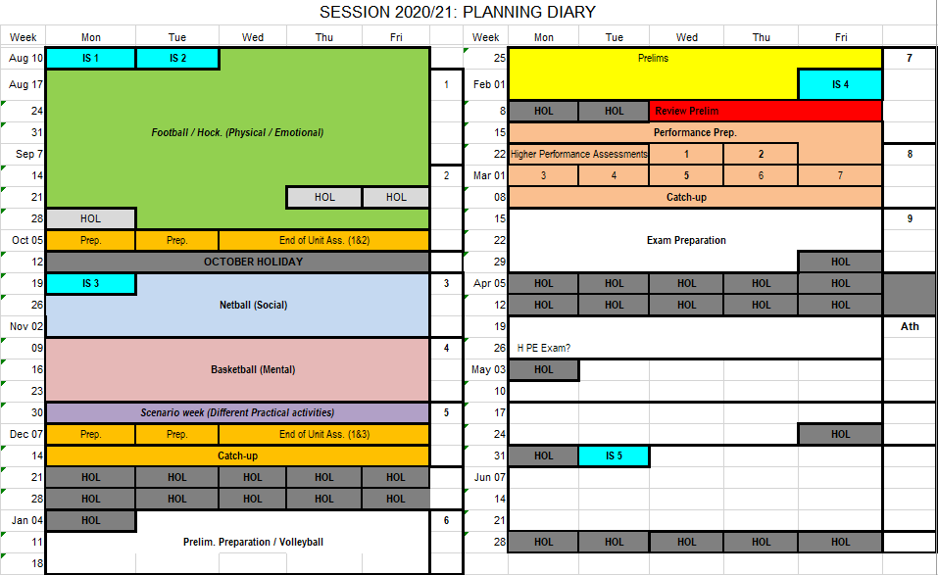

**FACTORS IMPACTING ON PERFORMANCE**

**(PHYSICAL)**

## Physical Factor

The physical factor can be divided in to two separate areas:

1. Physical Fitness
2. Physical Skills

|  |  |  |
| --- | --- | --- |
| *Factor* | **Physical** | |
| *Area* | **Physical Fitness** | **Physical Skills** |
| *Feature* | Aspects of Fitness   * **Stamina** * Speed * Coordination * Agility | Quality of Performance   * Fluency * Accuracy * Control * Effort |

For football/hockey, we are going to focus on the features from the table above.

Brief descriptions of these specific aspects are given on the following pages.

An example of how to structure a paragraph for factors impacting performance exam question is also provided for each feature.

**Structure: Point – Example - Explanation**

**1.Physical Fitness**

**Stamina**

Stamina is the ability of the heart and lungs to supply oxygen to the working muscles during sustained exercise.

**Stamina is needed in football to:**

* continue running at a variety of speeds for the duration of the game to keep up with play;
* provide support in attack and defence
* cover large areas of the pitch throughout the game;
* produce short bursts of speed to get back and cover in defence, even in the later stages of games;
* ensure a high level of skill is maintained.

**Stamina: Point – Example – Explanation**

**Point** - Stamina can negatively impact my performance in football.

**Example** - For example, I struggle to keep up with the pace of the game towards the end and cannot get close to the person I am marking.

**Explanation** - This means that my opponents have more time when they are in possession to set themselves and play an accurate pass to a team mate as I can’t get close enough to them to put them under pressure.

**Speed**

Speed is the ability to cover a distance in a short period of time.

**Speed is needed in football to:**

* Move into space quickly to receive a pass with more time and space.
* Beat my opponent to get free to create passing options.
* Drive past defenders towards the goal to create a goal scoring opportunity.
* Stay close to my opponent in defence to deny him space to receive a pass.

**Speed: Point – Example – Explanation**

**Point** - Speed can positively impact my performance in badminton.

**Example** - For example, my speed allows me to get back to the ‘base’ position before my opponent returns the shuttle.

**Explanation** - This means that I am in the best possible position to reach the shuttle when it is returned and increases my chance of playing an attacking stroke as I am rarely caught out of position.

###### **Coordination**

Coordination is the ability to control movements smoothly and fluently. To perform in a coordinated way, groups of muscles need to work in a certain order to create an effective action.

**Coordination is needed in football to**:

* Drive towards goal and perform a pass, shot or cross accurately while moving at pace.
* Dribble the ball past defenders, keeping control of the ball.
* Receive a pass and adjust my position to control the ball effectively.

**Coordination: Point – Example – Explanation**

**Point** – Coordination can negatively impact my performance.

**Example** – For example, when I receive a pass I often struggle to adjust my body to get in to the best position to control it.

**Explanation** – This means that I do not control the ball close to my body which often provides my opponent with an opportunity to steal the ball resulting in my team losing possession.

**Agility**

Agility is a combination of speed and flexibility.

**A high level of agility is needed in football to:**

* Change my body position and direction quickly and efficiently throughout the game.
* Changing direction quickly to get past defenders in order to create a goal scoring opportunity.
* Keep up with my opponent, marking pressurising and jockeying her, forcing errors.
* Stay between my opponent and the goal, moving at speed and changing direction.
* React quickly to changes in possession.

**Agility: Point – Example – Explanation**

**Point** – Agility can positively impact my performance.

**Example** – For example, when I am in possession of the ball I can quickly change direction to get past the defender.

**Explanation** - This means that I have more time and space to lift my head and look for an unmarked team mate to pass to.

**2. Physical Skills**

**Power**

Power is the ability to exert a maximal force in as short a time as possible.

**A high level of power is needed in football to:**

* Score from outside the box.
* Switch the play to the opposite side of the pitch when in possession.
* Successfully clear the ball when under pressure in defence.

**Accuracy**

Accuracy is the ability to direct a ball to a target area with precision. A performer can also demonstrate accuracy by performing movements with precision so that they look exactly like a model performance.

**Accuracy is needed in football to:**

* Pass and maintain possession in your team.
* Place an attempt at goal accurately to the corner of the goal away from the goalkeeper.

**Model Performer**

**Physical Fitness**

**A high level of aerobic endurance in football will allow the performer to;**

* Track from attack to defence quickly and continuously
* Maintain a high level of skill for longer (fatigue later in game)
* Defend and mark opposition effectively by applying pressure
* Have the energy to perform bursts of speed throughout game
* Cover all areas of the pitch effectively

**Physical Skill**

**A high level of skill in Badminton/football will allow the performer to;**

* Alert and ready
* Variety of strokes
* Effective Footwork/Court Movement Skills
* Accuracy/Shot Placement
* Moving back to base/ready position
* Quality of touch
* Ability to disguise shots
* Skills available to reach back of opponents court
* Fine touch and power shots
* Agile
* Sustain long rallies
* Tactical Play (play to your opponents weaknesses)
* Intimidation
* Know when to play appropriate shot
* Decision making
* Anticipation
* Quick reactions
* Maintain control under pressure
* Motivation
* Concentration

**Who are my skilled performers?**

* A Professional (Premier league match, internet, video)
* Classmate.
* Teacher.

**Benefits of Considering a Skilled/Model Performer**

* Gives a clear picture of what you are trying to do as skilled/model performers are consistent.
* It allows performance comparison against specific criteria
* Helps identify strengths and weaknesses and set targets.
* Provides various types of feedback - Visual (if videoed and watched on TV), Verbal (If another pupil in your class)
* Skilled/model performers can be observed at different levels e.g. other pupils in your class, your teacher or from a video performance e.g. Olympic footage
* Provides you with a challenge in practices.
* Makes it easier to break the skill down in to the preparation, action and recovery stages
* Help motivate you to copy their skills and techniques
* Shows a wide range of skills which can inspire you to try to improve.

## GATHERING INFORMATION / GOAL SETTING

**Types of Information**

Information gathered on performance can be characterised in terms of **Quantitative** and **Qualitative** Data.

**Quantitative Data**

**Quantitative** data is concerned with facts and figures and provides statistics and a measurement of performance in related areas. This allows for easy comparison to others. Methods include:

* Standardised Fitness tests,
* Sports Competition Anxiety Test (SCAT),
* Observation Sheets,
* Performance Profile Wheels (PPW).
* Training Diaries

Advantages (Benefits)

* Fast and easy to compare.
  + For example…
  + **This means that**… Saves time.
* Easier to understand data.
  + For example…
  + **This means that**… Less chance of mistakes.
* Data can be used to make class averages.
  + For example…
  + **This means that**…I can use the averages to compare/set targets.
* Data can be used to make graphs/tables to track progress.
  + For example…
  + **This means that**…it is easy and fast to track progress.

Disadvantages (Limitations)

* Does not provide you with any specific detail.
  + **This means that**…I do not know exactly where I need to improve.

**Qualitative Data**

**Qualitative** data involves methods which are ways of collecting data concerned with describing meaning, rather than with drawing statistical inferences.

Methods include:

* interview,
* receiving feedback from a coach or teacher,
* questionnaire,
* training diary,
* Performance Profile Wheel (PPW),
* Sports Competition Anxiety Test (SCAT).

Advantages (Benefits)

* More detail provided.
  + For example…
  + **This means that**…I know specifics / exactly where I need to improve
* Creates an opportunity to expand.
  + For example…
  + **This means that**…I can provide further information to make it very clear and easy to understand.

Disadvantages (Limitations)

* Harder to compare information.
  + For example…
  + **This means that**…takes more time / might not be possible.
* Success depends on the experience of whoever is providing the information.
  + For example…
  + **This means that**…information might not be accurate

**How to Gather Information**

We will gather information using a variety of different methods taken from the list below:

|  |  |  |  |
| --- | --- | --- | --- |
| **Factor** | **Area** | **Feature(s)** | **Method** |
| Physical | Fitness | Aerobic Endurance | 12 Min Cooper Test |
| Speed | 30m Sprint |
| Agility | Illinois Agility Test |
| Coordination | Alternative Hand Throw |
| Skills | * Fluency * Control * Accuracy * Effort | Performance Profile Wheel |

(‘Data collection’ is just another phrase that means ‘gathering information’.)

**Gathering Information – Advantages/Disadvantages**

**Performance Profile Wheel**

**Advantages (Benefits)**

* Easy to complete / fill out and interpret
  + For example…
  + **This means that…**more accurate/valid

* Permanent record.
  + For example…
  + **This means that…**track progress
* Can be completed from another person’s point of view
  + For example…
  + **This means that**…more accurate/valid.
* Can be completed live by another person
  + For example…
  + **This means that**…more accurate/valid.
* It can be made personal to you when deciding on what features to include.
  + For example…
  + **This means that**…it allows you to identify the exact information you require.

**Disadvantages (Limitations)**

* Success of the method depends on the knowledge/experience of the person completing the PPW.
  + For example…
  + **This means that…**information might not be accurate.
* Information is not very specific.
  + For example…
  + **This means that…**might not be relevant to performer.

**12 Min Cooper Test**

**Advantages (Benefits)**

* Easy to complete and easy to interpret.
  + For example…
  + **This means that…**more accurate/valid
* Permanent record.
  + For example…
  + **This means that…**track progress
* Set rules and procedures.
  + For example…
  + **This means that**…more accurate and easier to compare
* Provides Quantitative Data.
  + For example
  + **This means that…**See page 9

**Disadvantages (Limitations)**

* Results are not very detailed.
  + For Example
  + **This means that…information is not reliable**
* Subjective / Biased
  + For example…
  + **This means that…information might not be accurate**
* Not activity specific (questions are general)
  + For example…
  + **This means that…information is not reliable**

**Aerobic Endurance**

|  |  |  |  |
| --- | --- | --- | --- |
| **Factor** | **Area** | **Feature** | **Method** |
| Physical | Fitness | Aspects of Fitness  (Aerobic Endurance) | Standardised Fitness Test: 12-Minute Cooper |

The test comprises of measuring how far an athlete can run/walk in twelve minutes. The teacher starts the test and blows the whistle to stop after 12 minutes. This test should be run at a steady, constant pace that you can maintain for the full duration. A partner should record the total distance covered to the nearest 100 metres.

**Results**

BEFORE AFTER

Your score: _________ m Your score: _________ m

Class Ave. : _________ m Class Ave.: _________ m

Class Best: _________ m Class Best: _________ m

|  |  |  |  |  |  |
| --- | --- | --- | --- | --- | --- |
| Age | Excellent | Above Average | Average | Below Average | Poor |
| Male 13-14 | >2700m | 2400-2700m | 2200-2399m | 2100-2199m | <2100m |
| Females 13-14 | >2000m | 1900-2000m | 1600-1899m | 1500-1599m | <1500m |
| Males 15-16 | >2800m | 2500-2800m | 2300-2499m | 2200-2299m | <2200m |
| Females 15-16 | >2100m | 2000-2100m | 1700-1999m | 1600-1699m | <1600m |
| Males 17-19 | >3000m | 2700-3000m | 2500-2699m | 2300-2499m | <2300m |
| Females 17-20 | >2300m | 2100-2300m | 1800-2099m | 1700-1799m | <1700m |

|  |  |  |  |  |  |
| --- | --- | --- | --- | --- | --- |
| Experienced Athletes | | | | | |
| Gender | Excellent | Above Average | Average | Below Average | Poor |
| Male | >3700m | 3400-3700m | 3100-3399m | 2800-3099m | <2800m |
| Females | >3000m | 2700-3000m | 2400-2999m | 2100-2399m | >2100m |

**Speed**

|  |  |  |  |
| --- | --- | --- | --- |
| **Factor** | **Area** | **Feature** | **Method** |
| Physical | Fitness | Aspects of Fitness;  Speed | Standardised Test:  30m Sprint |

This test aims to measure an athlete's speed between two points 30m apart, from a flying start.

The test comprises of 3x30 metre runs, from a flying start, with a full recovery between each run. Your classmate or teacher should record the time for you to complete the 30 metres. Your score is the average of your three sprints.

##### ANALYSIS j0405936

BEFORE AFTER

Your time: _________ secs Your time: _________ secs

Class Ave. : _________ secs Class Ave.: _________ secs

Class Best: _________ secs Class Best: _________ secs

|  |  |  |  |  |  |
| --- | --- | --- | --- | --- | --- |
| Gender | Excellent | Above Average | Average | Below Average | Poor |
| Male | <4.0 | 4.2 - 4.0 | 4.4 - 4.3 | 4.6 - 4.5 | >4.6 |
| Female | <4.5 | 4.6 - 4.5 | 4.8 - 4.7 | 5.0 - 4.9 | >5.0 |

**Agility**

|  |  |  |  |
| --- | --- | --- | --- |
| **Factor** | **Area** | **Feature** | **Method** |
| Physical | Fitness | Aspects of Fitness;  Agility | Standardised Test:  Illinois Agility Test |

The length of the course is 10 metres and the width (distance between the start and finish points) is 5 metres. 4 cones can be used to mark the start, the finish and the two turning points. Each cone in the centre is spaced 3.3 metres apart.

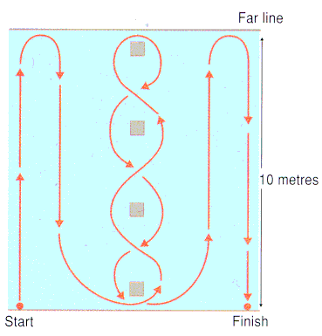

* The athlete lies face down on the floor hands outstretched at the start point.
* On command, the athlete jumps to his/her feet and negotiates the course around the cones as fast as possible to the finish.
* A classmate records the time taken to complete the course.

Your time (before): _________ seconds

Your time (after): _________ seconds

##### ANALYSIS j0405936

Class Average: _________ seconds

Class Best: _________ seconds

|  |  |  |  |  |  |
| --- | --- | --- | --- | --- | --- |
| Gender | Excellent | Above Average | Average | Below Average | Poor |
| Males 16-19 | <15.2 secs | 15.2 - 16.1 secs | 16.2 - 18.1 secs | 18.2 - 18.3 secs | >18.3 secs |
| Females 16-19 | <17.0 secs | 17.0 - 17.9 secs | 18.0 - 21.7 secs | 21.8 - 23.0 secs | >23.0 secs |

**Coordination**

|  |  |  |  |
| --- | --- | --- | --- |
| **Factor** | **Area** | **Feature** | **Method** |
| Physical | Fitness | Aspects of Fitness;  Coordination | Standardised Test:  Alternate Hand Throw |

Alternate Hand Throw

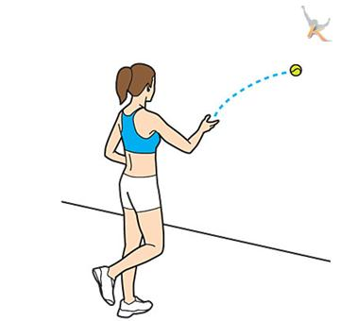

* Stand with your feet exactly two metres from a wall;
* Your teacher or classmate will start the stopwatch and say GO.
* Throw a tennis ball with your right hand against the wall then catch it with your left hand;
* Throw the ball with your left hand against the wall then catch it with your right;
* Repeat steps 3 and 4 as many times as possible for 30 seconds;
* Perform the test up to three times then calculate your average score.

|  |  |  |  |  |  |
| --- | --- | --- | --- | --- | --- |
| Age | High Score | Above Average | Average | Below Average | Low score |
| 15-16 years | >35 | 30 – 35 | 25 - 29 | 20 - 24 | <20 |

Your score (after): _________

Class Average: _________

Class Best: _________

Your score (before): _________

Class Average: _________

Class Best: _________

**Method 1 – Performance Profile Wheel (PPW) Quantitative & Qualitative**

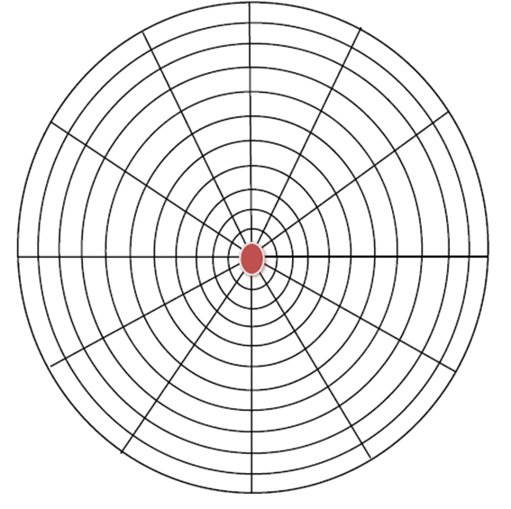

**Analysis**

* **_____________________________________________________________________**

____________________________________________________________________

* **_____________________________________________________________________**

_________________________________________________________________

* **___________________________________________________________________________**

____________________________________________________________________

**Before**

**Method 1 – Performance Profile Wheel (PPW) Quantitative & Qualitative**



**Analysis**

* **_____________________________________________________________________**

____________________________________________________________________

* **_____________________________________________________________________**

_________________________________________________________________

* **___________________________________________________________________________**

____________________________________________________________________

**DURING**

**Method 1 – Performance Profile Wheel (PPW) Quantitative & Qualitative**



**Analysis**

* **_____________________________________________________________________**

____________________________________________________________________

* **_____________________________________________________________________**

_________________________________________________________________

* **___________________________________________________________________________**

____________________________________________________________________

**AFTER**

**Video Analysis**

A video recording of a performance is very useful tool for compiling evidence because it allows you to view a performance **repeatedly**.  The **pause/stop/rewind** function allows you to accurately analyse each sub-routine of a performance.

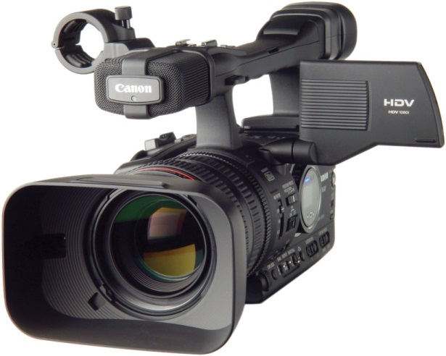It allows you to **record** movements and decisions undertaken in a performance and can provide an **insight into the emotional and mental state of a performer**.

It is a **permanent** record of your ability at that time and can be used later to **compare & monitor** improvements in your performance and against those of a model performer.

You should use a video recording of your performance in **conjunction with** an observation schedule.  Video recording of your own or another’s performance enables you to observe movements more accurately.

**Feedback**

Feedback describes information you collect about your performance. The two types of feedback are also known as internal and external.

**Internal Feedback** relates to my own **thoughts** and **feelings** about my own performance.

**External Feedback** can be obtained through **verbal**, **written** or **visual** information.

Verbal Feedback: Spoken feedback from classmate / teacher

Written Feedback: Analysis Sheet

Visual Feedback Watching my own performance

Recorded Video / Ipad

**Importance of Feedback**

* Important in the development of my weak skill as it allows me to make **comparisons** between my performance and a skilled performance
* Helps me to **identify the strengths and weaknesses and plan improvements** within my performance
* Can also **motivate** me to continue to develop my high clear
  + for example, if the feedback I receive is positive but indicates that I am not making good progress this will help raise my level of motivation as I will know that I need to **concentrate more** and work even harder
* If the feedback I receive is positive and indicates that I am making good progress this can **inspire me** to keep working as I will want to improve even more.

**Considerations when giving/receiving feedback:**

* Receiving:
  + Listening, respect
* Accepting:
  + Trust, interpreting the information, tool for motivation, implementation of recommended changes as a result of feedback
* Giving:
  + Appropriateness and types of feedback, quantity and depth
* Timing of feedback
  + Immediate, delayed, continuous (before, during and after PDP/performance)

**Goal Setting (SMARTER Targets)**

An effective performer requires a range of technical, physical and mental skills to cope with the demands of competition. Developing these skills requires careful planning and this can be achieved by setting short/immediate targets and long-term targets.

Always set **SMARTER** targets:

**S** pecific

**M** easurable

**A** chievable

**R** ealistic

**T** ime-phased

**E** xciting

**R** ecorded

**Short-term goal - example**

An example of a realistic short-term target could be to develop your aerobic endurance by increasing your training zone from 70% to 75% of your maximum after 2 weeks training.

**Long-term goal - example**

An example of a realistic long-term target could be to develop your aerobic endurance to a level that will improve your overall performance and win a certain event.

**Advantages (Benefits) of Goal Setting:**

* It increases motivation and determination (i.e. if you reach your first short term target this will motivate you to continue.)
* It reinforces the desire to keep working and builds self-confidence
* It provides valuable feedback which will help identify development needs, training requirements and provide a starting point to monitor progress

j0293844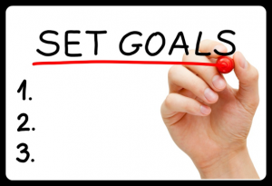

|  |  |  |
| --- | --- | --- |
| **Target Table** | | |
| **Method of Gathering**  **Info.** | **Current**  **Score** | **Target Score** |
| Cooper Test |  |  |
| 30m Sprint |  |  |
| PPW (Choose one skill) |  |  |

## APPROACHES TO DEVELOP THE PHYSICAL FACTOR

## (Personal Development Programme - PDP)

Personal Development Programme (PDP)

Football/Hockey – Physical & Emotional Factors

|  |  |  |  |  |
| --- | --- | --- | --- | --- |
|  | **SESSION 1** | **SESSION 2** | **SESSION 3** | **SESSION 4** |
| **WEEK 1** | WU - jogging, stretching, 8-10 mins  Approach 1  Fartlek, 15 mins  Sprint 50m  ½ pace, 100m  Walk 50m  Approach 2  Deep Breathing  Cond. Game – | WU - jogging, stretching, 8-10 mins  Approach 1  200m Intervals  3:1 work:rest  6 reps  Approach 2  Positive Self-talk  Cond. Game – | WU - jogging, stretching, 8-10 mins  Approach 1  Isolated drills  (stage 1)  Approach 2  Visualisation  (during isolated drills)  Cond. Game – |  |
| **WEEK 2** |  |  |  |  |
| **WEEK 3** |  |  |  |  |

**Approaches to Develop Performance**

We will use a variety of different approaches to develop our performance taken from the list below:

|  |  |  |  |
| --- | --- | --- | --- |
| **Factor** | **Area** | **Feature** | **Approach** |
| Physical | Fitness | Aspects of Fitness   * *Aerobic Endurance* | Interval Training |
| Fartlek |
| Skills | Quality of Performance   * *Fluency* * *Accuracy* * *Control* * *Effort* | Isolated Drills |
| Conditioned Games |

**Interval Training**

|  |  |  |  |
| --- | --- | --- | --- |
| **Factor** | **Area** | **Feature** | **Approach** |
| Physical | Fitness | Aspects of Fitness  (Aerobic Endurance) | Interval training |

**Interval Training**

**Interval training** is a type of physical training that involves a series of low- to high-intensity exercise workouts interspersed with rest or relief periods. The high-intensity periods are typically at or close to anaerobic exercise, while the recovery periods involve activity of lower intensity. Varying the intensity of effort exercises the heart muscle, providing a cardio workout, improving aerobic capacity and permitting you to exercise for longer and/or more intense levels.

**Interval training** can be made harder by increasing the intensity or period of work, or by decreasing the rest period. It can improve speed, muscular endurance or power with a large work to ratio (1:4), or it can improve CRE with a shorter work to rest ratio (1:1) but over a longer period of time.

**\*\* You can monitor your HR using a Fitbit ☺**

PDP Interval Work to Rest Ratio:

**Week Ratio Distance**

Week 1 & 2 = 1:3 200m

Week 3 & 4 = 1:2 200m

Week 5 & 6 = 1:1.5 200m

**Fartlek Training**

|  |  |  |  |
| --- | --- | --- | --- |
| **Factor** | **Area** | **Feature** | **Approach** |
| Physical | Fitness | Aspects of Fitness  (Aerobic Endurance) | Fartlek Training |

**Fartlek Training**

The term fartlek is Swedish for - ‘speed play.’ Fartlek training involves continuously working for a period of time. Within this time the intensity at which you work varies.

This training should replicate the pace of running required in a particular activity. There could also be a change in terrain to increase/decrease intensity (flat/incline/decline).

* This method of training improves stamina;
* It involves training at a variety of paces;
* I will use the 400m track for fartlek training and use cones to indicate each change of pace:

Example of a simple 20-minute fartlek training session:

Walk 100m **-** ¾ Pace 100m **-** Jog 100m **-** Sprint 100m

**Isolated Drills/Practices**

|  |  |  |  |
| --- | --- | --- | --- |
| **Factor** | **Area** | **Feature** | **Approach** |
| Physical | Skills | Quality of Performance  (Fluency, Accuracy,Control &Effort) | Isolated Drills/Practices |

**Isolated Drills/Practices**

* Repetition drills, as the name suggests, involves **performing a skill repeatedly.**
* The full skill can be repeated over and over again to develop muscle memory making the skill more natural and automatic.
* Repetition drills can also be used to focus on and practice certain parts (subroutines) of a skill that require development.
* Focussing on the skill or part of the skill through repetition drills also eliminates the distraction of the game and other skills, and helps to ‘groove’ the correct technique.
* Varying the practice conditions and including appropriate rest periods are required when completing repetition drills to avoid boredom and fatigue.
* An example of this could be performing a push pass twenty times.

**Football Training Examples:**

**Passing**

Player passes to opposite line then runs round cone and joins opposite line. Repeat. Weak foot / one touch / etc. can be added.

**Passing & Shooting**

Player passes to team-mate then drives forward towards goal. Team-mate lays ball off for player to shoot at goal.Player then jogs around the cones to perform the drill again.

**Shooting**

Player starts at cone facing the goal. Player then selects a ball to shoot and sprints back to cone. Player repeats.

**Crossing & Passing**

W

M

S

Midfielder passes to striker. Striker controls and passes back to midfielder. Midfielder passes ball wide into space. Winger drives forward, control ball and crosses ball. Striker attacks the cross and attempts to score. Midfielder joins the attack to provide support.

**Tackling**

1v1 to line. Attacking player dribbles the ball towards the defender but does not try to pass defender (passive attacker). Defender must win possession of ball. Players then switch roles. Progression: Attacking player attempts to pass defender.

3v1 possession game. Three attacking players try to keep possession of the ball using only two-touches each. Defender must win possession of the ball. Progression: Attacking players can use up to three touches / as many touches as they like.

**Conditioned Games**

|  |  |  |  |
| --- | --- | --- | --- |
| **Factor** | **Area** | **Feature** | **Approach** |
| Physical | Skills | Quality of Performance  (Fluency, Accuracy, Control &Effort) | Conditioned Games |

**Conditioned Games**

* This method involves playing a competitive game but with conditions in place that encourages you to focus on and use your weak skill.
* Conditioned games usually involve certain **adaptations** to the **formal rules** of the game. This is designed to emphasise, through the game, the particular skill you have been developing.

**Football Examples**

* One team can make 5 passes without the ball intercepting they score a point for their team.
* 5 passes must be made for an attempt can be made on goal
* Another example, for tackling, is shown below:

|  |  |  |
| --- | --- | --- |
|  |  |  |

3-zone tackling game. One player from each team in each zone (defence / midfield / attack). The ball must be moved from the defender to midfielder to attacker, who will attempt to score. Opposition in each zone should try to win possession of the ball. Progression: add more players.

**Principles of Training**

Before devising your training programme, or considering what methods of training to use, you must be aware of the *principles of training*. These give structure and progression to a training programme and also ensure that improvements are made over time.

**1. Specificity**

Your training must be specific and relevant to the activity, the aspect of fitness to be improved and your own level of fitness:

* **Specific to the game of football/hockey**. Football/hockey related movements are included in the programme, e.g. side stepping, moving backwards, etc. as well as skills required within the game e.g. dribbling, passing, shooting, crossing.
* **Specific to the demands of the activity**. CRE is an important aspect of fitness within football/hockey. To ensure CRE is being improved, a variety of different movement patterns are included in the programme, e.g. running up and down the while dribbling.
* **Specific to your current level of fitness**. Regularly monitoring your heart rate (using HR monitor) ensures you are working at the correct intensity and within your training zone.

**2. Progressive Overload**

Your body needs to be subjected to a certain level of stress for any improvement to be made in your fitness levels. This is called overload. Overload must be progressive so you are gradually increasing the stress we place on our body. As our fitness levels improve and our body’s adapt, we must gradually increase the frequency, intensity and/or durationof our training in order for further improvements to be made. This is known as **progressive overload**.

**Frequency:** How often you train.

For example, 3 times per week.

*Progressive Overload: I increased my training to 4 times per week.*

**Intensity:** How hard you train/ pace of training

For example, work:rest ratio 2:1

*Progressive Overload: I increased my work:rest ratio to 3:1*

**Duration / Time:** How long you train for.

For example, Skills/CRE Circuit for 18 mins (6 stations x 3 mins).

*Progressive Overload: I increased my session to 24 mins*

*(6 stations x 4 mins).*

**3. Overtraining**

It is important when training that you take adequate rest and recovery to avoid the dangers of overtraining. Working too hard in a session can lead to extreme fatigue and lead to injury. Long term over training can lead to permanent injury or damage. Rest and recovery is often underestimated. This can be properly addressed by adapting the levels of frequency, intensity and duration in your training programme. You must also review and monitor your programme and keep a training diary so that you can record your thoughts on how your fitness is developing and know when it is time to progress.

**4. Reversibility**

If you stop training, or train irregularly, then your body will start to return to the condition it was in before you began training. The time this takes to occur is dependent on how long you trained for. For example if you were only training for a few weeks then reversibility would occur very quickly. For those performers who train over long periods of time the drop off in fitness levels takes considerably longer. This is because it takes a long time for the body to adapt to ever increasing fitness levels. Once a high level of fitness has been established then the time taken to loose fitness is considerably longer. This is known as reversibility.

**Importance of Progressive Overload**

* Your body needs to be subjected to a certain level of stress for an improvement to be made in your fitness levels. This is called **overload**.
* Overload must be **progressive** so you are gradually increasing the stress you place on your body.
* As you train, your body **adjusts** to your current fitness programme.
* In order for you to improve your fitness, you must **adapt** your programme.
* I need to **progressively overload** my training so that I am exercising at an increasingly higher level i.e. I need to make my training **harder/more difficult**.
* When you progressively overload the body it adapts and gets used to the new stress and can cope with the new overload.
* This results in you becoming **fitter**.
* If you want to continue to improve your performance then you must again increase the overload.
* This can be done by increasing the **Frequency, Intensity or Duration**.

**Principles of Effective Practice**

The *principles of effective practice* give structure and progression to a programme of work and also ensure that improvements are made over time. There are 7 principles of effective practice you must consider when planning a training programme:

**I**ntensity of Practice

**W**ork-to-Rest Ratio

**A**chievable Progressive Stages

**S**trengths and Weaknesses

**A**wareness of Skilled Performer

**C**lear Objectives

**E**ffect of Boredom and Fatigue

**Intensity of Practice**

The method of practice chosen must be appropriate to the stage of learning, for example…

* Practices at the **cognitive** stage should be more basic and focused on individual subroutines of the weak stroke. They should involve little or no pressure and movement, for example…
  + shadow and basic feed practices
* Practices at the **practice** stage should be more game-like but still focused mainly on weak stroke. They should involve slightly more pressure and some movement, for example…
  + whole/part/whole and simple continuous rally practices
* Practices at the **automatic** stage should be as game-like as possible, while still focusing on the weak stroke. They should involve decision making, increased pressure, movement and combinations of strokes, for examples…
  + combination and pressure practices

Also

* As the performer’s skill level and experience increases, the intensity of the practices should be **increased** to be more challenging
* The intensity of the practices refers to both the **complexity** of the practice itself and the **work-to-rest ratio**

**Work-to-Rest Ratio**

Practices must be planned to have appropriate periods of work and rest…

* if **work periods are too long**, fatigue and / or boredom could set in which will reduce the quality of practices and encourage bad habits in performance
* if **work periods are too short** then the subroutines would not be properly acquired by the performer
* if **rest periods are too long** then the body can begin to ‘cool down’ increasing the risk of injury and reducing the performer’s ability to perform to the best of their ability
* if **rest periods are too short** then the performer will not recover fully, which would also cause a reduction in the quality of practice

For example

* A **3 hour training session**, without breaks, will **tire out** the individual and **concentration**, as well as the **quality of the skills** performed, will **drop**.
* A **5 minute skill session** will have **little or no effect** on the individual’s acquisition or improvement of a new /weak skill.

**Achievable Progressive Stages**

As the performer’s skill level increases, it is vital that the intensity of practices is also increased…

* If practices are progressed **too slowly** then **boredom can develop** as the level of intensity will be too low for the performer
* If practices are progressed **too quickly** then the **quality will decrease** as the level of intensity will be too high for the performer

For example

* Once a performer demonstrates control, fluency and consistency during a **shadow practice** they should progress to a slightly more complex shadow practice or change to a **simple feed practice**, before boredom develops
* However, if the performer progressed directly from shadow practices to continuous rally practices then the intensity would be too high, there would be no control, fluency or consistency and the quality would decrease

**Strengths and Weaknesses**

Practices should be focused on improving your weak stroke…

* At the cognitive stage of learning practices should focus on individual subroutines with the strokes that are particularly weak
* At the practice stage of learning the subroutines performed together but practices are still focused on execution of the weak stroke
* At the automatic stage practices relate to the weak stroke, but focus more on applying the stroke in game-like situations
* During some practices it is also useful to be aware of strengths in order to allow the performer to remain focused on the weak stroke, for example…
  + During combination rally practices it would be appropriate to design a pattern of strokes that includes the performer’s stronger strokes combined with their weak stroke. This means that they can still focus on the weak stroke, not worrying about how to perform the other strokes.
  + Eg, HS=>HC=>Drop Shot=>Net shot=>Underarm lift=> repeat from HC.

**Awareness of Skilled Performer**

During all practices it is vital to ensure that the stroke and each individual subroutine are error free and being performed with control, fluency and consistency…

* Comparisons to the skilled performer allow this
* Feedback is essential to enable you to make comparisons
* The focus must be on the quality of practice, rather than quantity

For example

* During a shadow practice it is important that some sort of external feedback is received in order to correct any errors in performance. This could be verbal feedback from a classmate / teacher or visual feedback using video delay. The feedback would be based in comparisons between the performer and the skilled performer – a P.A.R. sheet could also be used.

**Clear Objectives**

Setting clear objectives can help with motivation and also allows accurate monitoring / evaluating.

For example

* Short term objectives could be…
  + ‘by the end of week two of my programme of work, I aim to have improved my positioning and have turned side in preparation for the high clear’
  + ‘by week three of my programme of work, my aim is to improve my Poole Test score by 4 points’
* Long term objectives could be…
  + ‘by the end of my programme of work, to improve my high clear, specifically the four weakest subroutines on my PAR sheet’
  + ‘to get as high a grade as possible in Higher PE’

**Smart Targets**

* Specific… to the activity
* Measurable… success in achieving the target can be measured
* Achievable… targets can be achieved
* Realistic… targets are realistic
* Time based… targets can be achieved within a time-limit

**Effect of Boredom and Fatigue**

* If the method of practice is…
  + **too high an intensity** then **fatigue** can develop
  + **too low an intensity** then **boredom** can develop
* In both cases, the performer is likely to have many errors in their subroutines, develop bad habits and skill development will affected

For example

1. If a performer carried out a combination practice for ten minutes without a break, the quality of the skill and subroutines would drop. Appropriate work-to-rest ratios would have to be introduced to ensure that the intensity was high enough to challenge the performer, but low enough to allow the performer to carry out the practice with equality.

* If a performer who was at the practice stage of learning was carrying out a simple feed practice that was more suitable to the cognitive stage they would become bored and lose interest. A more suitable practice for that stage of learning would need to be used, such as a continuous rally practice.

**Monitoring and Evaluating**

**Monitoring**

The effectiveness of your programme of work is **monitored** by:

* Repeating and comparing each of the methods used to gather information **DURING** training (every 3-4 weeks).

1. Keeping a Training Diary
2. Knowledge of results

**Evaluating**

**Evaluating** is carried out at the **END** of your training programme.

* Making informed decisions based on the evidence you have recorded from the monitoring process to judge the effectiveness of the PDP.

**Importance of Monitoring / Evaluating your Performance**

* To allow **comparisons** to previous information gathered
  + For example…
  + **This means that…**
* To check if **targets** have been met;
  + For example…
  + **This means that…**
* To **motivate** me to keep working or to work harder.
  + For example…
  + **This means that…**
* To see if my programme has been **appropriate** (principles);
  + For example…
  + **This means that…**
* To see if I need to make any **changes / adaptations** to my programme (progression);
  + For example…
  + **This means that…**

**Re-test Sheet**

This will allow you to record your new results. Transfer your results from the ‘gathering information’ section to complete the ‘BEFORE TRAINING’ column.

|  |  |  |  |  |
| --- | --- | --- | --- | --- |
|  |  | **Gathering Information** | **Monitoring Programme** | **Evaluating Programme** |
| **Aspect of Fitness** | **TEST** | **BEFORE TRAINING** | **DURING TRAINING** | **AFTER TRAINING** |
| **Cardio-Respiratory Endurance** | 12-Minute Cooper Test |  |  |  |
| Multistage Fitness Test |  |  |  |
| **Speed** | 30m Sprint |  |  |  |
| **Agility** | Illinois Agility Test |  |  |  |
| **Coordination** | Alternate Hand Throw |  |  |  |

**Performance Development Plan - Training Diary**

Training Session No. _________________ Date: ____________

My Target for this session is: ­­­­­­­­­­­­­­­­­_____________________________________________

Approach(es)/Method(s) used today: ______________________________

1. Today’s session included:

(b) Comment on success of today’s session. (How did you feel/get on? Did you achieve success? Did you make changes? Should there be any changes to your next session? )

**Performance Development Plan - Training Diary**

Training Session No. _________________ Date: ____________

My Target for this session is: ­­­­­­­­­­­­­­­­­_____________________________________________

Approach(es)/Method(s) used today: ______________________________

1. Today’s session included:

(b) Comment on success of today’s session. (How did you feel/get on? Did you achieve success? Did you make changes? Should there be any changes to your next session? )

**Performance Development Plan - Training Diary**

Training Session No. _________________ Date: ____________

My Target for this session is: ­­­­­­­­­­­­­­­­­_____________________________________________

Approach(es)/Method(s) used today: ______________________________

1. Today’s session included:

(b) Comment on success of today’s session. (How did you feel/get on? Did you achieve success? Did you make changes? Should there be any changes to your next session? )

**Future Development Needs**

These will come from other development needs you have identified when gathering information / monitoring your performance. This can be achieved using any of the methods listed below:

|  |  |  |
| --- | --- | --- |
| **Factor** | **Area** | **Feature(s)** |
| Physical | Fitness | * Stamina * Speed * Agility * Coordination * Power * Strength |
|
| Skills | * Passing * Shooting * Dribbling * Crossing   **Focus on improving:**  Accuracy  Control  power |
|
| Tactics | Principles of Play   * Width * Depth * Mobility * Tempo |
|

Your development needs are personal to you and can come from any of the four factors (Physical, Emotional, Social and Mental).

**You must be able to explain why this is a future development need.**

**E.g. what can’t you do and how does this impact your performance or how would your performance benefit from improving a specific feature?**

|  |  |  |
| --- | --- | --- |
|  |  |  |