Social Factor
Williamwood High School
Physical Education
National 5



Name: _____________________

Teacher: _____________________

Name:

Contents

Introduction

Cycle of Analysis 2
Timeline 3

Factors Impacting on Performance
Relationships 6
Roles/Responsibilities 7
Factors Impacting on Performance - Plan 8
Q1 Homework Task 9

Gathering Information
Self-Evaluation Sheet 11
Q2 Homework Task 12
Q3 Homework Task 13

Approaches to Develop Performance
Team Briefing 15
Team Building 16
Q4 Homework Task 16
Monitoring
Self-Evaluation Sheet 18
Q5a Homework Task 19
Q5b Homework Task 20

Cycle of Analysis

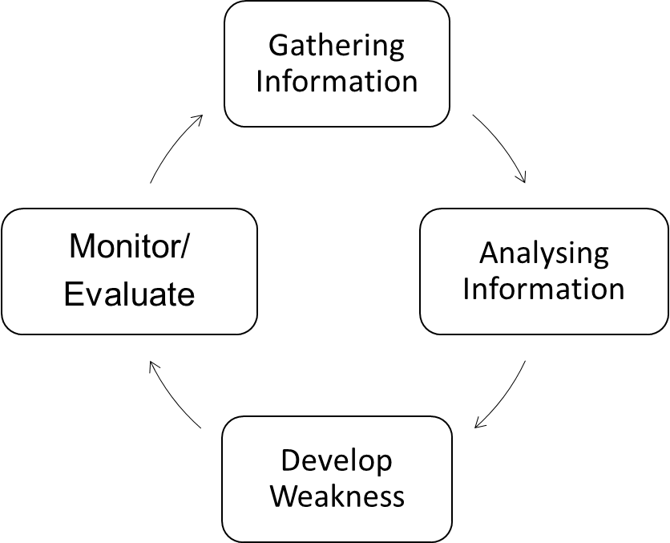

1. I GATHER INFORMATION on my performance by assessing my level of performance and the demands of my performance.

2. I then ANALYSE the results to identify my strengths and weaknesses.

3. I then create a programme of work to DEVELOP my performance.

4. Finally, I MONITOR/EVALUATE, which means I find out if I have successfully improved my performance and what to do next.

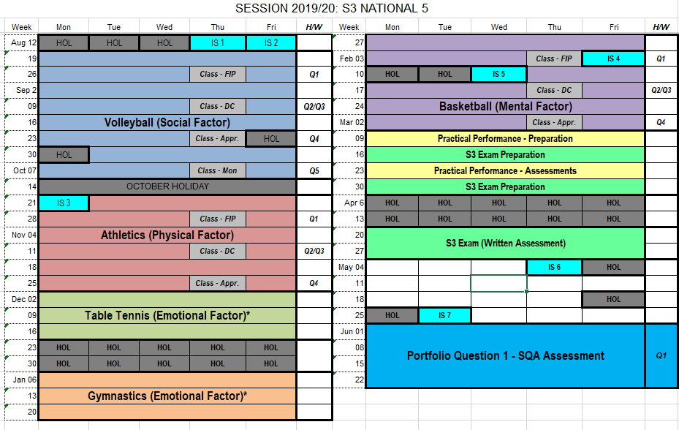
SESSION 2018/19: PLANNING DIARY – S3 NATIONAL 5

FACTORS IMPACTING ON PERFORMANCE

Factors Impacting on Performance

There are four key factors that impact on performance. The table below shows the Social Factor along with some more specific features that we will be focusing on during National 5 PE:

FACTOR | FEATURES
SOCIAL | Relationships | Roles/Responsibilities



Social Feature – Relationships

RELATIONSHIPS

Point (Definition)
A relationship is the way in which two or more people, or groups, behave towards each other.

Explanation
- Has an impact on the potential success of a team performance.

- A poor relationship in a team will produce a weaker performance.

- Individual sports like tennis require a strong relationship between the coach and player.

- In dance, there is a relationship between the performer and the music.

.

Social Feature – Roles/Responsibilities

ROLES/RESPONSIBILITIES

Point (Definition)
Each player within a group or team will have a specific role and within each role there are specific responsibilities.

Explanation
- The team work together and support each other.

- Team mates keep the team morale high during a performance.

- Everyone has a common goal.

- Teams can communicate effectively together to carry out their roles.

- A team can clearly identify each individuals role within the team

- A poor relationship in a team will produce a weaker performance.

- Individuals not completing their own role and responsibilities successfully can contribute to how effective the team is.

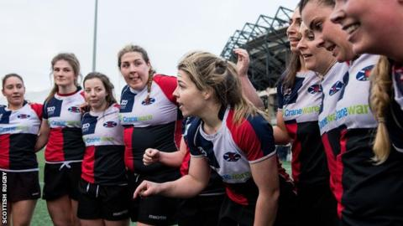

Factors Impacting Performance - Plan

Use the boxes provided below to write a plan for the following question:

For the social factor, explain its impact on performance. (2 marks)

EXAMPLE – DO NOT COPY | Point  (Definition)  RELATIONSHIPS:  - Two or more people  - Behave towards each other | Explanation  If there are poor relationships between members a team can produce a weaker performance. | Example  (Including Impact)  NETBALL  - Goal shooter and goal attack do not always agree on tactics  - As a result, they often don’t pass to each other when should  - = less goals scored
FEATURE 1
FEATURE 2

Factors Impacting Performance Homework Task

Use the plans you have written on page 7 and answer the following question in the space provided:

Q1) For the social factor explain its impact on performance. (2 marks)
Feature 1:
Introduction________________________________________________________________________

___________________________________________________________________________________

Point (Definition) ___________________________________________________________________

___________________________________________________________________________________

Explanation________________________________________________________________________

___________________________________________________________________________________

Example___________________________________________________________________________

___________________________________________________________________________________

___________________________________________________________________________________

___________________________________________________________________________________

________________________________________________________________________________

________________________________________________________________________________

Feature 2:
Introduction________________________________________________________________________

___________________________________________________________________________________

Point (Definition) ____________________________________________________________________

___________________________________________________________________________________

Explanation________________________________________________________________________

___________________________________________________________________________________

Example___________________________________________________________________________

___________________________________________________________________________________

___________________________________________________________________________________

___________________________________________________________________________________

___________________________________________________________________________________

________________________________________________________________________________

GATHERING INFORMATION

Self-Evaluation Sheet

You will play 3 games of volleyball. At the end of each game, write a comment in relation to each of the 3 features, reflecting on how you felt during play.

Social Feature | Game
Social Feature | 1 | 2 | 3
Relationships  A relationship is the way in which two or more people, or groups, behave towards each other. | My teammates and I were unmotivated as we were losing the game. We started to make comments to each other which made us even more unmotivated | I missed a dig shot but my teammates helped me to pick my head up and try again by telling me I will get the next one.
Roles/Responsibilities  Each player within a group or team will have a specific role and within each role there are specific responsibilities. | I set the ball to the wings to play the ball over the net. The wings knew who was going for the ball as they each had a side of the court they were responsible for. | When I was the server I knew my responsibility was to serve the ball and cover the back of the court.

Gathering Information Homework Task

When describing each test:
- What resources/equipment is required?
- How did you set it up (equipment needed, helpers e.g. starter/timer etc.)?
- What does it look like?
- How did you complete the method?
- What does the method measure?
- What did you do with your results?

Q2) Identify one appropriate method you used to gather data on your SOCIAL performance in an activity of your choice. (1 mark)
Method:
_______________________________________________________________________________________

Describe how you carried out this method to gather information. (2 marks)

Description:
______________________________________________________________________________________

______________________________________________________________________________________

______________________________________________________________________________________

______________________________________________________________________________________

______________________________________________________________________________________

______________________________________________________________________________________

______________________________________________________________________________________

______________________________________________________________________________________

______________________________________________________________________________________

______________________________________________________________________________________

______________________________________________________________________________________

______________________________________________________________________________________

______________________________________________________________________________________

______________________________________________________________________________________

______________________________________________________________________________________

Challenges Homework Task

- Completed in different conditions/ circumstances.
- Poor performer subject knowledge.
- Inaccurate reflection of performance.

Q3) Explain a challenge you may face when gathering information about your performance.
(1 Mark)

Point ________________________________________________________________________

_____________________________________________________________________________

Explanation ___________________________________________________________________

_____________________________________________________________________________

_____________________________________________________________________________

_____________________________________________________________________________

Example _____________________________________________________________________

_____________________________________________________________________________

_____________________________________________________________________________

_____________________________________________________________________________

_____________________________________________________________________________

APPROACHES TO DEVELOP PERFORMANCE

Approaches to Develop Performance

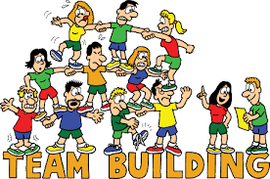
Team Building Exercises
All team building exercises help to develop the
relationships within a team. However, some may also
help to develop other features within the social factor.
You will be asked to complete some of the exercises
below with your team.
The Paper Tower
Materials: A3 paper, scissors
Instructions: Each team is given a single sheet of A3 paper and must construct the tallest free-standing structure in just five minutes using no other materials. Once the time is up each team reviews all the other team’s towers, discusses each one and decides how many marks it should receive out of 10. All scores are tallied up and the results announced.
Drop the Ball
Materials: Golf / table tennis balls, straws, tape

Instructions: Each small group receives 12 straws and 18 inches of masking tape. They get ten minutes to build a container that will catch a ball dropped from about ten feet. One team member stands on a chair, holds a golf ball at eye level. The other team members place their container on the floor under where it thinks the ball will land.

Each group gets three attempts. The group that gets a ball to go in and stay in using the least amount of attempts wins.

Human Knot
Materials: None
Instructions: Ten people stand in a circle, facing inward. Everyone reaches their right arm towards the centre of the circle and grabs someone’s hand. Make sure no one grabs the hand of the person right next to them. Everyone then reaches their left arm in and grab someone else's hand. Again, make sure it's not the person right next to them.
The group needs to work together to untangle the human knot without letting go of any hands. The goal is to end up in a perfect circle again. You can go over or under each other's arms, or through legs if needed!

Approaches to Develop Performance

Team Briefing

Team briefing is regular communication between coach/teacher and players that provides information or feedback to the team. The objective is to make sure that every player knows and understands what they and others are doing in the strategy/game plan.

Examples

Before Game - to confirm players position, team strategies, general game plan (e.g. Verbal)

Half-Time - analysis of play, change of strategy, refer to video evidence (e.g. Visual)

After Game - analysis of performance, team analysis sheets, evaluation (e.g. Written)

Approaches to Develop Performance Homework Task

Q4) Describe an approach that you used to develop your performance in the SOCIAL factor. (2 marks)

Approach: _________________________________________________________________________

Description: _______________________________________________________________________

__________________________________________________________________________________

__________________________________________________________________________________

__________________________________________________________________________________

__________________________________________________________________________________

__________________________________________________________________________________

__________________________________________________________________________________

__________________________________________________________________________________

__________________________________________________________________________________

________________________________________________________________________________

MONITORING

Self-Evaluation Sheet

You will play 3 games of Volleyball. At the end of each game, comment

in relation to each of the 3 features, reflecting on how you felt during play.

Social Feature | Game
Social Feature | 1 | 2 | 3

Relationships

A relationship is the way in which two or more people, or groups, behave towards each other.

Roles/Responsibilities

Each player within a group or team will have a specific role and within each role there are specific responsibilities.

Monitoring

The effectiveness of your training is monitored by repeating and comparing each of the methods used to gather information every 2-3 weeks.

We will monitor our performance based on the Self-Evaluation sheet.

Process: Repeat Self-Evaluation sheet

- Repeat the Self-Evaluation sheet immediately after your training session.

- Compare and analyse the results of your Self-Evaluation sheet from before and during training.

Monitoring Homework Task 1

Q5a) Describe a method that you used to monitor your performance. (2 marks)

Method:

Description:

Importance of Monitoring

Evaluating is carried out at the end of your training programme.

- To allow comparisons to previous information gathered;
- To check what progress has been made;
- To check if targets have been met;
- To see if my programme has been appropriate (principles);
- To see if I need to make any changes / adaptations to my programme (progression);
- To identify any new strengths / development needs
- To motivate me to keep working or to work harder.

Monitoring Homework Task 2

Q5b) Explain the importance of monitoring your performance. (2 marks)

Reason 1:

Reason 2:

