

WILLIAMWOOD HIGH SCHOOL

S4 National 5

PHYSICAL EDUCATION

Factors Impacting on Performance

**Question 1**

**Exam Preparation**

Name: ____________________________

Teacher: ___________________________

**Contents**

PHYSICAL (fitness) 3

Physical (fitness) Feature – Stamina 4

Physical (fitness) Feature – Speed 5

Physical (fitness) Feature – Agility 6

Physical Factor (fitness) - Notes 7

Physical Factor (Fitness) Task 8

EMOTIONAL 10

Emotional Feature - Anxiety 11

Emotional Feature - Anger 12

Emotional Feature - Fear 13

Emotional Factor - Notes 14

Emotional Factor Task 15

MENTAL 17

Mental Feature – Level of Arousal 18

Mental Feature - Concentration 19

Mental Feature – Decision Making 20

Mental Factor - Notes 21

Mental Factor Task 22

SOCIAL 24

Social Feature - Motivation 25

Social Feature – Relationships 26

Social Feature – Team Dynamics 27

Social Factor - Notes 28

Social Factor Task 29

# PHYSICAL (fitness)

**Factors Impacting on Performance**

There are four key factors that impact on performance. The table below shows the Physical Factor (Fitness) features that we will be focusing on during National 5 PE:

|  |  |  |  |  |
| --- | --- | --- | --- | --- |
| **FACTOR** | **AREA** | **FEATURES** | | |
| **PHYSICAL** | FITNESS | Stamina | Speed | Agility |

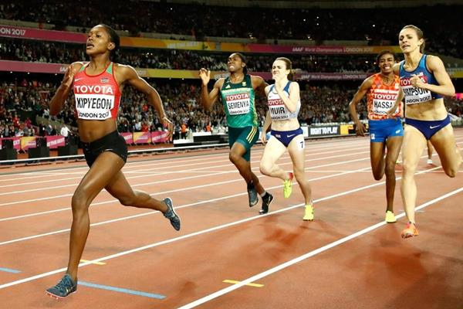

# Physical (fitness) Feature – Stamina

**STAMINA**

**Point (Definition)**

Stamina is the ability of the heart and lungs to supply oxygen to the working muscles during sustained exercise.

**Explanation**

* Allows a performer to work for an extended period of time without fatigue setting in.
* Run at a faster pace for longer.
* Maintain a steady pace for the duration of the race.
* Ensures a strong finish (sprint finish) at the end of the race.
* Cover large areas of the pitch.
* Ensure a high level of skill is maintained throughout the game.
* Continue running at a variety of speeds for the duration of the game to keep up with play.

[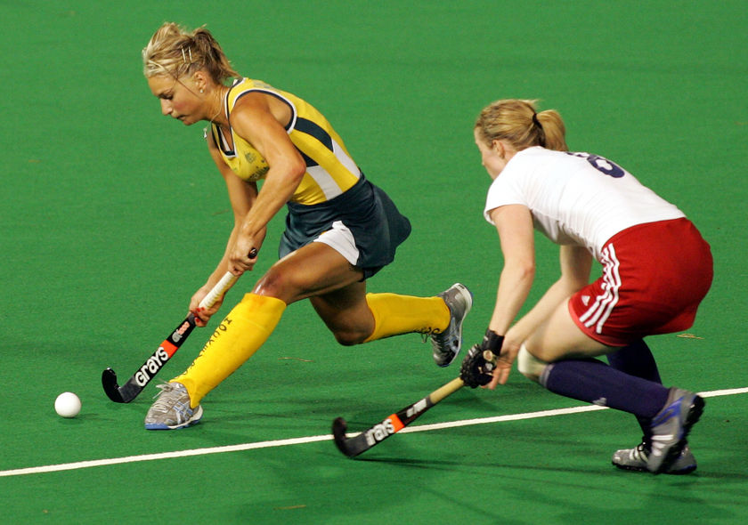](http://www.google.co.uk/url?sa=i&rct=j&q=&esrc=s&source=images&cd=&cad=rja&uact=8&ved=0ahUKEwjF4q3uxMDNAhWHuRQKHQmTAZ8QjRwIBw&url=http://www.greenfields.eu/sports-news/hockey-australia-selects-greenfieldsa-tx/&psig=AFQjCNFtjGZ-LvfdX7o2grPgYnyiDvEjCg&ust=1466853157789741)

# Physical (fitness) Feature – Speed

**SPEED**

**Point (Definition)**

Speed is the body’s ability to perform an action or cover a distance in a short period of time.

**Explanation**

* Achieve a ‘sprint start’, to gain a lead position in the first 100m.
* Overtake opponents throughout the race.
* Achieve a ‘sprint finish’ to overtake competitors in the final 100m.
* Move into space quickly to receive a pass.
* Quickly move ahead of the ball to get into an attacking position.
* Beat my opponent to get free.
* Dribble the ball quickly down the wing to get past the opposition.
* Drive past defenders towards the goal.
* Keep up with my opponent to prevent them moving into space.
* Move quickly towards my opponent to close them down.

# Physical (fitness) Feature – Agility

**AGILITY**

**Point (Definition)**

Agility is the ability to change the position of the body quickly, precisely and with control. This uses a combination of balance, speed, strength and co-ordination.

**Explanation**

* Change my body position and direction quickly and efficiently throughout the game.
* Dribble at speed whilst keeping control of the ball.
* Changing direction quickly to get past defenders.
* Keep up with my opponent, marking pressurising and jockeying them.
* Stay between my opponent and the goal, moving at speed and changing direction.
* React quickly to changes in possession.
* Move quickly for missed passes, tackles and interceptions.

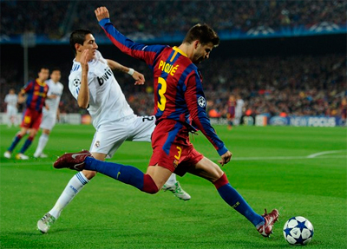

# Physical Factor (fitness) - Plan

Use the boxes provided below to write a plan for the following question:

*For the physical (fitness) factor,* ***explain*** *its impact on performance. (2 marks)*

|  |  |  |  |
| --- | --- | --- | --- |
| **EXAMPLE – DO NOT COPY** | **Point**  **(Definition)** | **Explanation** | **Example**  **(Including Impact)** |
| **FEATURE 1:** |  |  |  |
| **FEATURE 2:** |  |  |  |

# Physical Factor (Fitness) Task

Use the notes you have written on page 7 to answer the following question in the space provided:

*For the physical (fitness) factor, explain its impact on performance. (2 marks)*

|  |
| --- |
| **Physical (Fitness) Factor:**  ______________________________________________________________________________  ______________________________________________________________________________  ______________________________________________________________________________  ______________________________________________________________________________  ______________________________________________________________________________  ______________________________________________________________________________  ______________________________________________________________________________  ______________________________________________________________________________  ______________________________________________________________________________  ______________________________________________________________________________  ______________________________________________________________________________  ______________________________________________________________________________  ______________________________________________________________________________  ______________________________________________________________________________  ______________________________________________________________________________  ______________________________________________________________________________  ______________________________________________________________________________  ______________________________________________________________________________  ______________________________________________________________________________  ______________________________________________________________________________  ______________________________________________________________________________  ______________________________________________________________________________  ______________________________________________________________________________  ______________________________________________________________________________  ______________________________________________________________________________  ______________________________________________________________________________  ______________________________________________________________________________  ______________________________________________________________________________  ______________________________________________________________________________  ______________________________________________________________________________  ______________________________________________________________________________  ______________________________________________________________________________  ______________________________________________________________________________  ______________________________________________________________________________  ______________________________________________________________________________  ______________________________________________________________________________  ______________________________________________________________________________  ______________________________________________________________________________  ______________________________________________________________________________  ______________________________________________________________________________  ______________________________________________________________________________  ______________________________________________________________________________  ______________________________________________________________________________  ______________________________________________________________________________  ______________________________________________________________________________  ______________________________________________________________________________ |

# EMOTIONAL

**Factors Impacting on Performance**

There are four key factors that impact on performance. The table below shows the Emotional Factor along with some more specific features that we will be focusing on during National 5 PE:

|  |  |  |  |
| --- | --- | --- | --- |
| **FACTOR** | **FEATURES** | | |
| **EMOTIONAL** | Anxiety | Anger | Fear |



# Emotional Feature - Anxiety

**ANXIETY**

**Point (Definition)**

An emotional state which can cause feelings of nervousness or apprehension.

**Explanation**

* It is important that you remain composed and control your anxiety levels in order to prevent it from having a negative effect on your performance.
* Being constantly worried and nervous about your performance will affect how well you can perform.
* You may struggle to focus and have a negative outlook on the activity.
* Can lead to mistakes in difficult techniques within your performance as your focus is on your nerves and not your performance.
* Negative thoughts and feelings can stop you from trying your best.
* Can affect your decision making and cause you to make the wrong or safe decision.
* Can affect your concentration and cause you to make mistakes with your control or accuracy of a movement or skill.
* Can make you forget moves in your gymnastic or dance routine.

# Emotional Feature - Anger

**ANGER**

**Point (Definition)**

An emotional state which can cause displeasure, annoyance or aggression.

**Explanation**

* Anger is experienced by a performer when they feel they have been mistreated, offended or if they are displeased by their own performance.
* Anger in sport can be very useful in the right situation and a player who controls their anger is much more effective:
* Controlled anger could result in a greater determination to play better and not give up.
* Controlled anger could also be channelled into a shot or stroke to create more power.
* Anger that is not controlled will probably have a negative effect on performance:
* An inability to control your anger can lead to reacting aggressively to a situation in a game.
* Becoming wound up by opponents who are performing better or experiencing greater success.
* Negative self-talk could demotivate the performer.
* Poor decision making as a result of reacting in the heat of the moment.
* Opponents look to ways of irritating each other in the hope it puts them off a game plan or affects their performance.

# Emotional Feature - Fear

**FEAR**

**Point (Definition)**

Fear is an emotion caused by something which appears to be a threat, which then causes you to hold back, pull away, hide away, etc.

**Explanation**

* Fear produces negative thoughts, which directly impacts confidence.
* It can cause you to back off, hide or avoid something completely.
* If you fear an opponent or opposition then it is likely that your own performance level will drop significantly, which will make it easier for the opposition to compete and possibly give them an advantage.
* Fear of failure or not performing well can prevent you from getting involved in a team performance or pushing yourself to perform at your best in a competition.
* Fear of failure prevents performers from going outside their comfort zone resulting in an athlete not taking risks.
* Fear of injury can prevent a performer going in for a tackle or performing a particular skill in a routine.



# 

# Emotional Factor - Plan

Use the boxes provided below to write a plan for the following question:

*For the emotional factor,* ***explain*** *its impact on performance. (2 marks)*

|  |  |  |
| --- | --- | --- |
| **Point**  **(Definition)** | **Explanation** | **Example**  **(Including Impact)** |
|  |  |  |
|  |  |  |

# Emotional Factor Task

Use the notes you have written on page 14 and answer the following question in the space provided:

*For the emotional factor, explain its impact on performance. (2 marks)*

|  |
| --- |
| **Emotional Factor:**  ______________________________________________________________________________  ______________________________________________________________________________  ______________________________________________________________________________  ______________________________________________________________________________  ______________________________________________________________________________  ______________________________________________________________________________  ______________________________________________________________________________  ______________________________________________________________________________  ______________________________________________________________________________  ______________________________________________________________________________  ______________________________________________________________________________  ______________________________________________________________________________  ______________________________________________________________________________  ______________________________________________________________________________  ______________________________________________________________________________  ______________________________________________________________________________  ______________________________________________________________________________  ______________________________________________________________________________  ______________________________________________________________________________  ______________________________________________________________________________  ______________________________________________________________________________  ______________________________________________________________________________  ______________________________________________________________________________  ______________________________________________________________________________  ______________________________________________________________________________  ______________________________________________________________________________  ______________________________________________________________________________  ______________________________________________________________________________  ______________________________________________________________________________  ______________________________________________________________________________  ______________________________________________________________________________  ______________________________________________________________________________  ______________________________________________________________________________  ______________________________________________________________________________  ______________________________________________________________________________  ______________________________________________________________________________  ______________________________________________________________________________  ______________________________________________________________________________  ______________________________________________________________________________  ______________________________________________________________________________  ______________________________________________________________________________  ______________________________________________________________________________  ______________________________________________________________________________  ______________________________________________________________________________  ______________________________________________________________________________  ______________________________________________________________________________ |

# MENTAL

**Factors Impacting on Performance**

There are four key factors that impact on performance. The table below shows the Mental Factor along with some more specific features that we will be focusing on during National 5 PE:

|  |  |  |  |
| --- | --- | --- | --- |
| **FACTOR** | **FEATURES** | | |
| **Mental** | Level of Arousal | Decision Making | Concentration |

[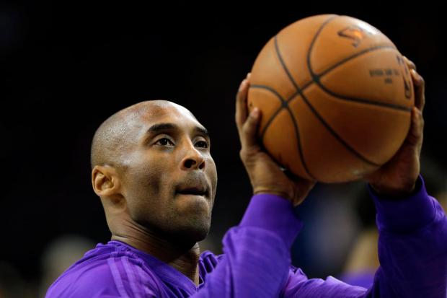](https://www.google.co.uk/url?sa=i&rct=j&q=&esrc=s&source=images&cd=&cad=rja&uact=8&ved=2ahUKEwjJ-YrCy8DiAhWGnxQKHVteAacQjRx6BAgBEAU&url=/url?sa%3Di%26rct%3Dj%26q%3D%26esrc%3Ds%26source%3Dimages%26cd%3D%26ved%3D%26url%3Dhttps://www.ocregister.com/2016/04/13/kobe-bryants-fiercely-competitive-drive-defined-him-from-day-one-of-his-20-year-lakers-career/%26psig%3DAOvVaw3Mp7uoQmKBXgg422h4L0PH%26ust%3D1559214051521309&psig=AOvVaw3Mp7uoQmKBXgg422h4L0PH&ust=1559214051521309)

# Mental Feature – Level of Arousal

**LEVEL OF AROUSAL**

**Point (Definition)**

The ability to control your mental level of excitement to ensure peak performance. It refers to the state of mental preparedness for participation in an activity.

**Explanation**

* Level of mental arousal is key to success in all activities. Having too low or too high a level of arousal may result in a loss of performance.
* If our mental arousal is too low then we may not perform at our highest level. We may appear to be tired, disinterested or distracted.

* If it is too high, we may become stressed or overly excitable due to expectations, the importance of the occasion or the number of people watching.
* It is import to find the correct level of mental arousal to perform at your best, excited enough, yet calm enough to perform.

# **Mental Feature - Concentration**

**Concentration**

**Point (Definition)**

The ability to completely focus your attention on something for a period of time.

**Explanation**

* Good concentration requires the ability to filter out distractions and focus on the important parts of a performance.
* When performers concentrate well they can take in all the information they need to make good decisions.

* They react and respond effectively to other players’ movements.
* They will have good technique therefore their performance will be more precise and accurate.
* They can remember specific tactics or strategies.

[](https://www.google.co.uk/url?sa=i&rct=j&q=&esrc=s&source=images&cd=&ved=2ahUKEwjyyu_gz8DiAhVDxIUKHa6wBl8QjRx6BAgBEAU&url=http://springfieldcollegepride.com/sports/mvball/2014-15/releases/201502075pe6xh&psig=AOvVaw1I4jxFPUtMoyW8XzpFamF2&ust=1559215228978514)

# Mental Feature – Decision Making

**DECISION MAKING**

**Point (Definition)**

The ability to apply the correct option or course of action to execute skills successfully.

**Explanation**

* Can have a positive or negative impact on your performance and your ability to work well under pressure.
* Poor decisions can lead to the loss of possession.
* If you make the right decision on a regular basis, you are likely to experience a positive outcome.
* Decisions can be made about what formation, tactics or position you play.
* Decisions can be made about what skill to perform depending on where you, your team-mates and the opposition are on the pitch/court.
* Decisions can be made about what skills you link together in a routine or what space you use.

# Mental Factor - Plan

Use the boxes provided below to write a plan for the following question:

*For the mental factor,* ***explain*** *its impact on performance. (2 marks)*

|  |  |  |
| --- | --- | --- |
| **Point**  **(Definition)** | **Explanation** | **Example**  **(Including Impact)** |
|  |  |  |
|  |  |  |

# Mental Factor Task

Use the notes you have written on page 21 and answer the following question in the space provided:

*For the mental factor, explain its impact on performance. (2 marks)*

|  |
| --- |
| **Mental Factor:**  ______________________________________________________________________________  ______________________________________________________________________________  ______________________________________________________________________________  ______________________________________________________________________________  ______________________________________________________________________________  ______________________________________________________________________________  ______________________________________________________________________________  ______________________________________________________________________________  ______________________________________________________________________________  ______________________________________________________________________________  ______________________________________________________________________________  ______________________________________________________________________________  ______________________________________________________________________________  ______________________________________________________________________________  ______________________________________________________________________________  ______________________________________________________________________________  ______________________________________________________________________________  ______________________________________________________________________________  ______________________________________________________________________________  ______________________________________________________________________________  ______________________________________________________________________________  ______________________________________________________________________________  ______________________________________________________________________________  ______________________________________________________________________________  ______________________________________________________________________________  ______________________________________________________________________________  ______________________________________________________________________________  ______________________________________________________________________________  ______________________________________________________________________________  ______________________________________________________________________________  ______________________________________________________________________________  ______________________________________________________________________________  ______________________________________________________________________________  ______________________________________________________________________________  ______________________________________________________________________________  ______________________________________________________________________________  ______________________________________________________________________________  ______________________________________________________________________________  ______________________________________________________________________________  ______________________________________________________________________________  ______________________________________________________________________________  ______________________________________________________________________________  ______________________________________________________________________________  ______________________________________________________________________________  ______________________________________________________________________________  ______________________________________________________________________________ |

# SOCIAL

**Factors Impacting on Performance**

There are four key factors that impact on performance. The table below shows the Social Factor along with some more specific features that we will be focusing on during National 5 PE:

|  |  |  |  |
| --- | --- | --- | --- |
| **FACTOR** | **FEATURES** | | |
| **SOCIAL** | Motivation | Relationships | Team Dynamics |

[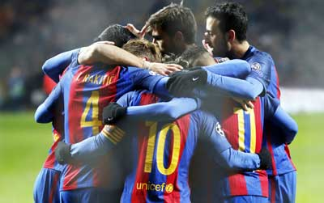](https://www.google.co.uk/url?sa=i&rct=j&q=&esrc=s&source=images&cd=&cad=rja&uact=8&ved=0ahUKEwjE8eDimL7XAhWLAcAKHQ2sCi0QjRwIBw&url=https://www.barcelona.com/barcelona_tickets/fc_barcelona_football_tickets/players&psig=AOvVaw2pLhfFDN-HEp2-b-x-xZW-&ust=1510752764167571)

# **Social Feature - Motivation**

**MOTIVATION**

**Point (Definition)**

Motivation is your level of desire to succeed. In order to effectively improve your performance you must be motivated.

**Explanation**

* A performer needs to be motivated to do well and succeed.
* Internal motivation is how much a performer wants to succeed for themselves.
* External motivation means you are driven to succeed for reasons other than simply participation, for example for a prize, reward or grade.
* How well you are performing, whether you or your team are winning or losing, will affect your motivation. It is much more difficult to motivate yourself to keep trying hard and not give up, if you are not playing well or you or your team are losing.
* How well your team-mates are performing can affect your levels of motivation, even if you yourself are playing well.
* Performers who are well motivated can also motivate others in their team to keep working hard.

# Social Feature – Relationships

**RELATIONSHIPS**

**Point (Definition)**

Relationships are the way in which two or more people or groups regard and behave towards each other.

**Explanation**

* Has a significant impact on the potential success of a team performance.A poor relationship in a team will produce a weaker performance.
* Players should behave appropriately towards other members of their team, being positive towards one and other and displaying mutual respect.
* Strong relationships will mean team members trust one and other.
* Good relationships will keep the team morale high during a performance.
* Individual sports like tennis require a strong relationship between the coach and player.
* In dance or gymnastics, there is a relationship between the performer and the music.

# Social Feature – Team Dynamics

**TEAM DYNAMICS**

**Point (Definition)**

The interaction of performers within a team or group. It is mainly to do with making the group or team more effective than the sum of its parts.

**Explanation**

* Individuals carrying out their own role and responsibilities successfully will contribute to the effectiveness of the team.
* Players work together effectively and support each to utilise the strengths of its members.
* Players co-operate and communicate effectively with their teammates.
* Everyone has a common goal and players work hard and play for each other for the benefit of the team.

[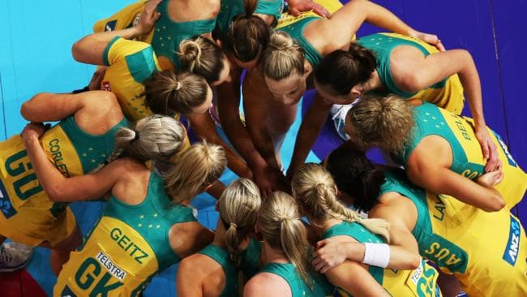](https://www.google.co.uk/url?sa=i&rct=j&q=&esrc=s&source=images&cd=&cad=rja&uact=8&ved=2ahUKEwj3-t_BzcDiAhWDAmMBHc5lAgkQjRx6BAgBEAU&url=/url?sa%3Di%26rct%3Dj%26q%3D%26esrc%3Ds%26source%3Dimages%26cd%3D%26ved%3D%26url%3Dhttps://www.foxsports.com.au/netball/netball-world-cup-2015-aussie-diamonds-players-ratings-v-england/news-story/0c173ac597f26ad389ad4079a3d61868%26psig%3DAOvVaw1A98UIm5jQfQHtwyQBmuHO%26ust%3D1559214590053242&psig=AOvVaw1A98UIm5jQfQHtwyQBmuHO&ust=1559214590053242)

# Social Factor - Plan

Use the boxes provided below to write a plan for the following question:

*For the social factor,* ***explain*** *its impact on performance. (2 marks)*

|  |  |  |
| --- | --- | --- |
| **Point**  **(Definition)** | **Explanation** | **Example**  **(Including Impact)** |
|  |  |  |
|  |  |  |

# Social Factor Task

Use the notes you have written on page 28 and answer the following question in the space provided:

*For the social factor, explain its impact on performance. (2 marks)*

|  |
| --- |
| **Social Factor:**  ______________________________________________________________________________  ______________________________________________________________________________  ______________________________________________________________________________  ______________________________________________________________________________  ______________________________________________________________________________  ______________________________________________________________________________  ______________________________________________________________________________  ______________________________________________________________________________  ______________________________________________________________________________  ______________________________________________________________________________  ______________________________________________________________________________  ______________________________________________________________________________  ______________________________________________________________________________  ______________________________________________________________________________  ______________________________________________________________________________  ______________________________________________________________________________  ______________________________________________________________________________  ______________________________________________________________________________  ______________________________________________________________________________  ______________________________________________________________________________  ______________________________________________________________________________  ______________________________________________________________________________  ______________________________________________________________________________  ______________________________________________________________________________  ______________________________________________________________________________  ______________________________________________________________________________  ______________________________________________________________________________  ______________________________________________________________________________  ______________________________________________________________________________  ______________________________________________________________________________  ______________________________________________________________________________  ______________________________________________________________________________  ______________________________________________________________________________  ______________________________________________________________________________  ______________________________________________________________________________  ______________________________________________________________________________  ______________________________________________________________________________  ______________________________________________________________________________  ______________________________________________________________________________  ______________________________________________________________________________  ______________________________________________________________________________  ______________________________________________________________________________  ______________________________________________________________________________  ______________________________________________________________________________  ______________________________________________________________________________ |