WILLIAMWOOD HIGH SCHOOL
S4 National 5
PHYSICAL EDUCATION
Factors Impacting on Performance

Badminton
Pupil Workbook

Name: ____________________________

Teacher: ____________________________

Contents

Cycle of Analysis 4

Command Words 5

Badminton Strokes 6
General Observation Schedule 7
Question 2a – Portfolio notes 9
Question 2a – Portfolio written task 10

Importance of Target Setting 12
Question 2g – Portfolio notes 13
Question 2g – Portfolio written task 14

Training Approaches 16
Training Approaches 17
Question 2h – Portfolio notes 19
Question 2h – Portfolio written task 20

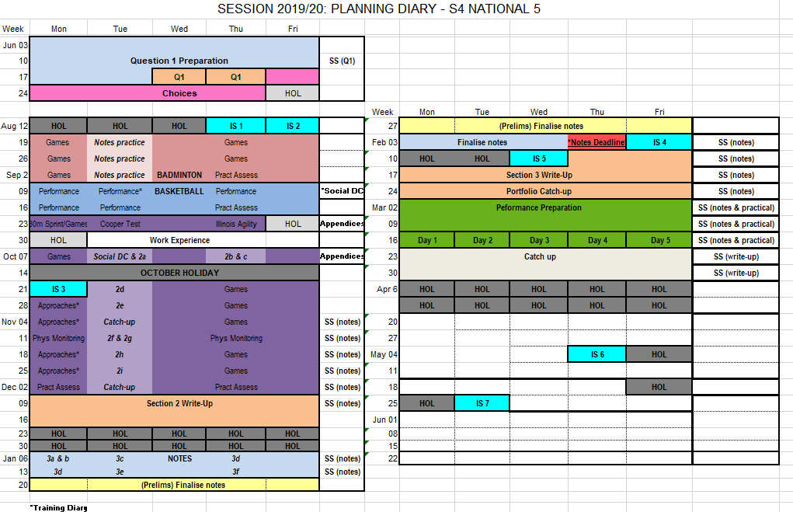

Cycle of Analysis

1. I GATHER INFORMATION on my performance by assessing my level of performance and the demands of my performance.

2. I then ANALYSE the results to identify my strengths and weaknesses.

3. I then create a programme of work to DEVELOP my performance.

4. Finally, I MONITOR/EVALUATE, which means I find out if I have successfully improved my performance and what to do next.

Command Words

Identify | Identify means saying things like:
- Recall key points of knowledge  - Give examples | - Name it!  - Select  - Give an example
Describe | Describe means saying things like:
- What?  - When?  - Who?  - Where?  - How? | - Paint a picture with words  - What process did you go through?  - “This required...”  - “I needed...”
Explain | Explain means saying things like:
- Point  - Explanation  - Example | - “Because …”  - “This means that…”  - “This allows…”  - “To make sure that …”  - “To provide me with the opportunity to …”  - “When I needed to …”  - “This gives me…”
Justify | Justify means saying things like:
- Personal reasons  - Benefits | - “I felt that…”  - “I chose to…”
Evaluate | Evaluate means saying things like:
- Valued judgement  - Benefits/limitations  - Comparisons | - “...was successful”  - “My performance improved because…”  - “This allowed me to…”  - “This helped me…”  - “As a result…”

Badminton Strokes

Short Serve - Played low to the front of your opponent’s court.
- Reduces your opponent’s ability to attack.
- Can encourage your opponent to lift the shuttle & enable
you to gain the attack.

High Serve - Played high to the back of the court.
- Forces your opponent to the back of the court.
- Gives you more time to respond to the shot that your
opponent will play.

Overhead clear - Played high and to the back of your opponent’s court.
- Can increase your own organisation time.
- When performed correctly it can put your opponent under
a lot of pressure.

Drop Shot - Played low and to the front of your opponent’s court.
- Played with disguise to suggest to your opponent that an
overhead clear or smash is being played.
- Most effective when placed close to the net.
- Reduces your opponent’s time to react.
- Encourages your opponent to lift the shuttle and enable
you to gain the attack.

Smash - Is a fast powerful attacking shot played downwards.
- Stroke is performed with power and speed.
- Intended to finish a rally.
- Makes it extremely difficult for your opponent to return.

Net shot - Played low and to the front of your opponents court.
- Most effective when placed close to the net.
- Reduces your opponent’s time to react.
- Can force your opponent to the front of the court.
- Encourages your opponent to lift the shuttle and enable
you to gain the attack.

Lift - Played high and to the back of your opponent’s court.
- Allows you more time to return to base.
- Forces your opponent to the back of the court.

General Observation Schedule

Skill Observed | Successful | Total | Unsuccessful | Total | Overall  success
Short Serve
High Serve
Overhead Clear
Drop Shot
Smash
Net Shot
Lift

Challenges of General Observation Schedule (Q2a)

Human Error

When you have someone else recording information on performance the validity of the results are dependent on the observers focus and attention during the match and the importance they place on the process.

Lack of Knowledge

If they are lacking activity knowledge their perception of what equals an effective shot might be different from the reality.

Speed of game

Badminton is a very fast paced sport and there is likely to be a number of shots in every rally. This can make it impossible for one observer to record all shots played. When they take their eye of the match to complete the schedule shots are missed questioning the reliability of the findings.

Reliability

If the opposition is not of a similar ability this will provide false results and a performer might not be forced to play their full range of shots if insufficient pressure is applied.

Validity

The mental and emotional state of the performer is crucial if accurate results are to be collected. Lack of motivation, resilience, and anxiety will impact the quality of shots, decisions, concentration and technique. If a performer is over tired, hungry etc. this will impact their play and ultimately the results.

Question 2a – Portfolio notes

2a. Explain the challenges you may face when gathering reliable data.
(3marks)
Point | Explanation | Example

Question 2a – Portfolio written task

2a. Explain the challenges you may face when gathering reliable data.
(3marks)
______________________________________________________________________________

______________________________________________________________________________

______________________________________________________________________________

______________________________________________________________________________

______________________________________________________________________________

______________________________________________________________________________

______________________________________________________________________________

______________________________________________________________________________

______________________________________________________________________________

______________________________________________________________________________

______________________________________________________________________________

______________________________________________________________________________

______________________________________________________________________________

______________________________________________________________________________

______________________________________________________________________________

______________________________________________________________________________

______________________________________________________________________________

______________________________________________________________________________

______________________________________________________________________________

______________________________________________________________________________

______________________________________________________________________________

______________________________________________________________________________

______________________________________________________________________________

______________________________________________________________________________

______________________________________________________________________________

______________________________________________________________________________

______________________________________________________________________________

______________________________________________________________________________

______________________________________________________________________________

______________________________________________________________________________

______________________________________________________________________________

______________________________________________________________________________

______________________________________________________________________________

______________________________________________________________________________

______________________________________________________________________________

______________________________________________________________________________

______________________________________________________________________________

______________________________________________________________________________

______________________________________________________________________________

______________________________________________________________________________

______________________________________________________________________________

______________________________________________________________________________

______________________________________________________________________________

______________________________________________________________________________

Importance of Target Setting (Q2g)

Goal setting can help a performer learn new skills or develop the skills they currently have. Small training goals can give a performer a little push on the way to achieving their ultimate long-term goal. Benefits of setting targets are:

- Allows you to plan a personal development programme that is focused on the target area.
- Gives you a clear idea of what you are working towards. This will help provide quality and focus during training sessions.
- It increases motivation and determination as you have something to work towards.
- It gives you something to compare yourself to so you know if your training has been successful and you have achieved your goals.
- Allows you to progress your training further so that you continue to improve.
- If you reach your first short-term target, you can make a new target to ensure you continually develop your performance and hopefully achieve your long-term target.
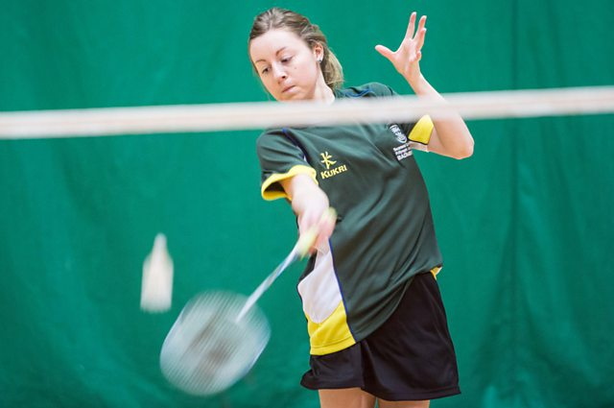

Question 2g – Portfolio notes

2g. Explain why it is important to set targets.
(3 marks)

Point | Explanation | Example

Question 2g – Portfolio written task

2g. Explain why it is important to set targets. (3 marks)
______________________________________________________________________________

______________________________________________________________________________

______________________________________________________________________________

______________________________________________________________________________

______________________________________________________________________________

______________________________________________________________________________

______________________________________________________________________________

______________________________________________________________________________

______________________________________________________________________________

______________________________________________________________________________

______________________________________________________________________________

______________________________________________________________________________

______________________________________________________________________________

______________________________________________________________________________

______________________________________________________________________________

______________________________________________________________________________

______________________________________________________________________________

______________________________________________________________________________

______________________________________________________________________________

______________________________________________________________________________

______________________________________________________________________________

______________________________________________________________________________

______________________________________________________________________________

______________________________________________________________________________

______________________________________________________________________________

______________________________________________________________________________

______________________________________________________________________________

______________________________________________________________________________

______________________________________________________________________________

______________________________________________________________________________

______________________________________________________________________________

______________________________________________________________________________

______________________________________________________________________________

______________________________________________________________________________

______________________________________________________________________________

______________________________________________________________________________

______________________________________________________________________________

______________________________________________________________________________

______________________________________________________________________________

______________________________________________________________________________

______________________________________________________________________________

______________________________________________________________________________

______________________________________________________________________________

______________________________________________________________________________

Training Approaches (Q2hi)

Your Personal Development Programme will include a variety of training approaches from the table below:

Factor | Area | Approach
PHYSICAL | Skills | Shadow Practices
 |  | Repetition Practices
 |  | Conditioned Games

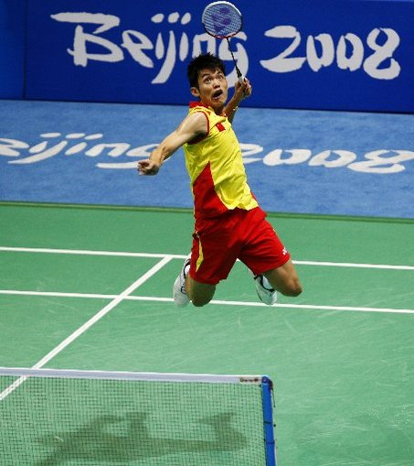

Training Approaches (Q2h)

Approach 1: Shadow Practices

Description
Shadow practice involves rehearsing the movement required for the action/skill. This involves performing a skill repeatedly with no shuttle, focusing on specific subroutines. The movement is usually performed in slow motion to 'groove' the technique and helps the performer get used to it. Once the movement has been mastered correctly, it can then be performed at normal/ greater speed.

There are two types of shadow practice that can be used to refine a skill:

- No court movement
  - Perform stroke on spot (3 sets of 10 repetitions)

- With court movement
  - Return to middle of court after each stroke (3 sets of 10 repetitions)

Approach 2: Repetition Practices

Description

This method involves performing a skill repeatedly on the spot or with movement. You can practice very small parts of the skill or the entire skill repeatedly.

There are a variety of different repetition practices that can be used to refine a skill:
- Racquet Feed
  - Involves a racquet feed which means that the feed will be more game-like;
  - Can be performed with or without court movement.

- Continuous Rally
  - Playing your weak stroke continuously while classmate tries to maintain the rally;

- Combination Rally
  - Involves a rally which follows a continuous, predetermined stroke pattern;
  - Combinations of straight and diagonal strokes can be very useful with this practice.

- Pressure Drill
  - A practice which involves increased level of pressure;
    - E.g. A more game-like feed such as a multi-feed or varied feed

Approach 3: Conditioned Games

Description
This method involves playing a competitive game but with conditions in place that encourages you to focus on and use your weak stroke.

Conditioned games usually involve certain adaptations to the formal rules of the game. This is designed to emphasise, through the game, the particular skill you have been developing.

Examples

- Double points
  - Players get 2 points for winning rally with weak stroke

- Weak Stroke Return
  - Service must be returned by weak stroke

- No smashes
  - to encourage more use of the high clear

- Tramlines
  - 2 points for winning clear that lands in the tramlines

- Diagonal games
  - play diagonal to work on power and angle of the Overhead Clear

- Middle of the court is out of bounds
  - forces to play accurate high clears and tight drop shots

Question 2h – Portfolio notes

2h. (i) Select and describe an approach that you used to develop your performance in badminton. (2 marks)

- _____________________________________________________________________________________

  - __________________________________________________________________________________

  - __________________________________________________________________________________

  - __________________________________________________________________________________

  - __________________________________________________________________________________

  - __________________________________________________________________________________

  - __________________________________________________________________________________

  - __________________________________________________________________________________

2h. (ii) Select and describe an approach that you used to develop your performance in badminton. (2 marks)

- ________________________________________________________________

  - ______________________________________________________________

  - ______________________________________________________________

  - ______________________________________________________________

  - ______________________________________________________________

  - ______________________________________________________________

  - ______________________________________________________________

  - ______________________________________________________________

  - ______________________________________________________________

Question 2h – Portfolio written task

2h. (i) Select and describe an approach that you used to develop your
performance in badminton. (2 marks)

_________________________________________________________________

_________________________________________________________________

_________________________________________________________________

_________________________________________________________________

_________________________________________________________________

_________________________________________________________________

_________________________________________________________________

_________________________________________________________________

_________________________________________________________________

_________________________________________________________________

_________________________________________________________________

______________________________________________________________________________

______________________________________________________________________________

______________________________________________________________________________

______________________________________________________________________________

______________________________________________________________________________

______________________________________________________________________________

______________________________________________________________________________

______________________________________________________________________________

______________________________________________________________________________

2h. (ii) Select and describe an approach that you used to develop your
performance in badminton. (2 marks)

_________________________________________________________________

_________________________________________________________________

_________________________________________________________________

_________________________________________________________________

_________________________________________________________________

_________________________________________________________________

_________________________________________________________________

_________________________________________________________________

_________________________________________________________________

_________________________________________________________________

_________________________________________________________________

______________________________________________________________________________

______________________________________________________________________________

______________________________________________________________________________

______________________________________________________________________________

______________________________________________________________________________

______________________________________________________________________________

______________________________________________________________________________

______________________________________________________________________________

______________________________________________________________________________

______________________________________________________________________________

______________________________________________________________________________
______________________________________________________________________________

