Context – Society & Culture Topic – Clothes & aspects
of other countries

Learning Outcomes
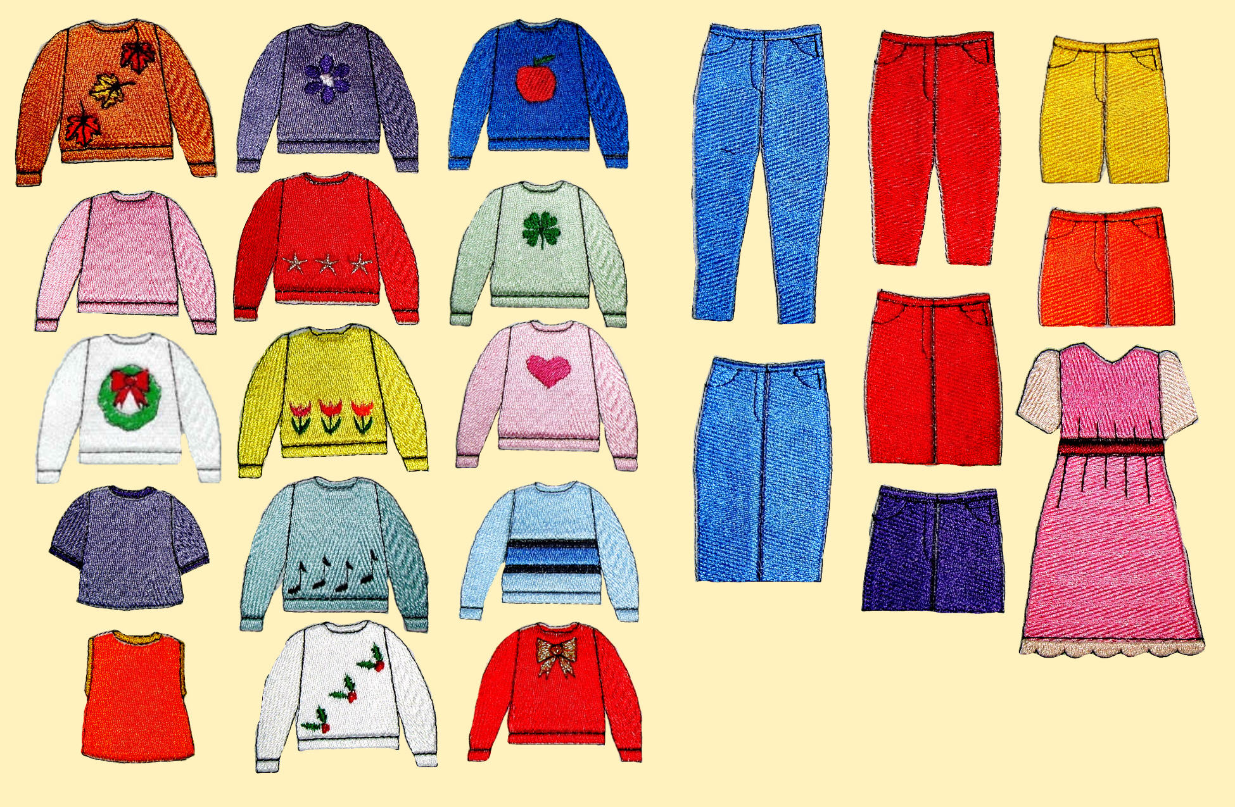
By the end of this unit I will be able to do the following:
- Know the vocabulary for clothes
- Say what I wear on school days and at the weekend
- Give opinions on school uniform
- Take part in shopping role-play
- Be able to describe what other people wear in detail
- Find out the same information about others by asking appropriate questions
- Be familiar with typical clothes from other countries
- Listen for information and show understanding, responding appropriately
- Using a dictionary, read and show understanding of Spanish texts
- Organise and use information to create, amend and produce information and opinions in writing.

- Design a poster about Spain or another Spanish speaking country (include typical clothes + other cultural aspects)

Language Knowledge and Understanding
- Clothes and activities
- Agreement of adjectives
- Ponerse
- Further use of adjectives, time phrases and opinions


Skills Assessment Programme
- Talkiing: 2 shopping Role-Plays
- Writing: A blog on school uniform

- Reading & Listening: Level 4



