

**Canadian Science Scholarship**

**Toronto, June 2019**

*CALL FOR APPLICATIONS*

*FROM S6 LEAVERS*

[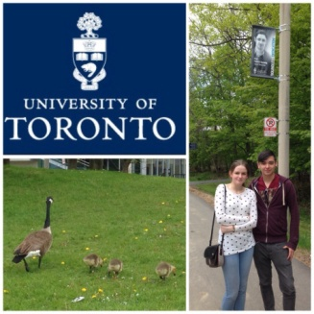](https://bairdofbute2014.files.wordpress.com/2014/05/20140523-203111-73871791.jpg)[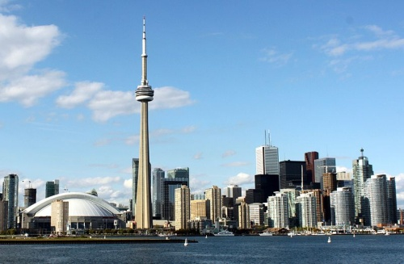](https://upload.wikimedia.org/wikipedia/commons/3/3a/Toronto_skyline_(2012).jpg)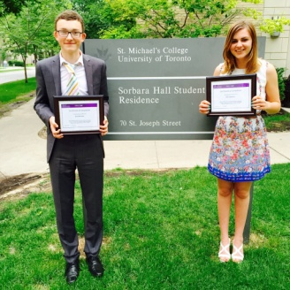

[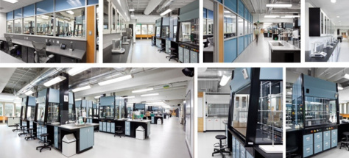](https://bairdofbute2014.files.wordpress.com/2014/05/20140523-194043-70843504.jpg)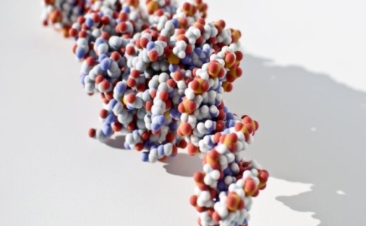

*ASK YOUR SCHOOL FOR INFORMATION AND APPLICATION*

Contact: ______________________________________________________________________________________