

**Canadian Science Scholarship**

**2019**

*Programme Description*

*and*

*Procedures*

[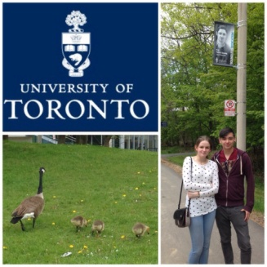](https://bairdofbute2014.files.wordpress.com/2014/05/20140523-203111-73871791.jpg)[](https://upload.wikimedia.org/wikipedia/commons/3/3a/Toronto_skyline_(2012).jpg)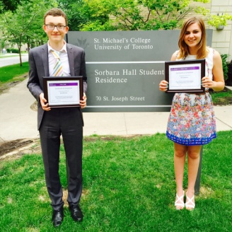

[](https://bairdofbute2014.files.wordpress.com/2014/05/20140523-194043-70843504.jpg)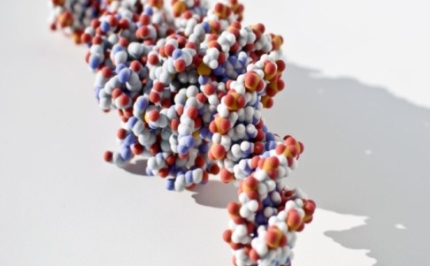

*For video introduction to the programme visit* ***youtube*** *and search on*

***“Aspire new edit Dec 2018”***

**BAIRD OF BUTE SOCIETY CANADIAN SCIENCE SCHOLARSHIP – 2019**

1. **General**

The Baird of Bute Society has, since 2014, offered a Canadian Science Scholarship and invites applications from across Scotland for each of the two places in the 2019 Programme.

The Scholarship is offered in June 2019 – ideally commencing as close to June 1st as possible dictated by participant school requirements.

1. **Background**

**The Society**

The Scholarship has been developed by the Baird of Bute Society which offers programmes to young people across Scotland. The Society was established to honour Andrew Blain Baird a humble Bute blacksmith who in 1910 achieved the First Attempted All-Scottish Heavier than Air Powered Flight in an aircraft of his own design and manufacture.

The Society employs Baird’s example to **Inspire** the youth of Scotland **to Aspire** to greatness in their lives.

**Purpose**

The purpose of the Canadian Science Scholarship is to provide two young people the opportunity to acquire experiences and skills to allow each to better succeed in their upcoming university studies.

The Scholarship Participant spends approximately two weeks in the Baird of Bute Society’s “Bench to Bedside” programme in a number of southern Ontario based participating institutions and organizations. Dr Patrick Gunning’s University of Toronto research facilities provides the bench while with Dr Markwell they will be immersed in healthcare related issues and facilities.

Through these opportunities, the Participant will enhance his/her science knowledge and skill and will have numerous opportunities for multi-disciplinary networking, continuing education, and access to a wide range of life science expertise in a variety of related settings. The Baird of Bute Society Canadian Science Scholarship provides a unique opportunity for the Participant to broaden and deepen his/her interest in and understanding of Science.

1. **The Scholarship Programme**

The Scholarship Programme is entitled *“From Bench to Bedside”* and follows Life Science from the genesis of an idea, to research, development, testing, clinical and human trials and ethical issues all the way to its introduction at the bedside.

**Faculty and Facilities** *(Timing and locations subject to possible modification)*

As an introduction to the breadth and depth of Science the Programme begins at the Ontario Science Centre.

*[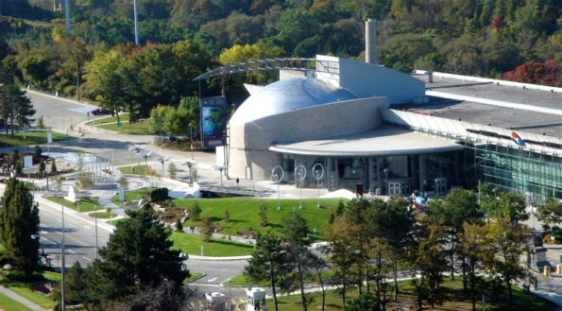](https://upload.wikimedia.org/wikipedia/commons/8/8a/Ontario_Science_Centre_(249019835).jpg)*

1. **Ontario Science Centre – Toronto** *(2.0 days)*

The Ontario Science Centre delights, informs and challenges, enriching people’s lives and understanding through engagement with science of local, national and global relevance. Since 1969, the Ontario Science Centre has welcomed more than 50 million visitors, with an interactive approach that was the model for Science Centres around the world. It is the public centre for innovative thinking and provocative dialogue in science and technology, aiming to inspire a lifelong journey of curiosity, discovery and action to create a better future for the planet.

__________________

**Prof. Dr Patrick Gunning** hosts the participants for the **“Bench”** portion of the programme at the University of Toronto Mississauga Campus.

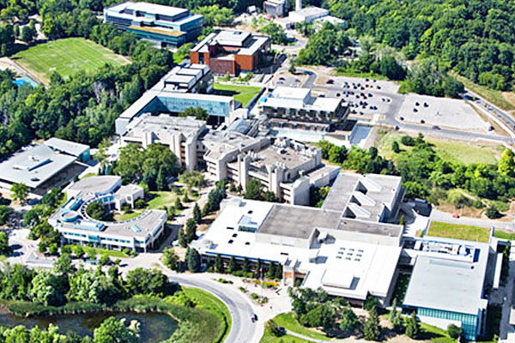

1. **University of Toronto – Mississauga** *(4.0 - 5.0 days)*

The UofT Mississauga is the home of the Gunning Group, one of the world’s most celebrated bio- Chemistry research teams currently working on a drug which is aimed at treating three forms of Cancer. Here the Participants experience hands on experience at all stages of this research.

_____________________________

**Prof. Dr Hazel Markwell,** hosts the Participants for their trip through the steps to move Science from the Bench to the **Bedside** at a variety of locations and leads them through a qualification process in the issues involved in the ethical conduct of research involving human participants. The programme is modified to best support the academic interests of the specific participants.

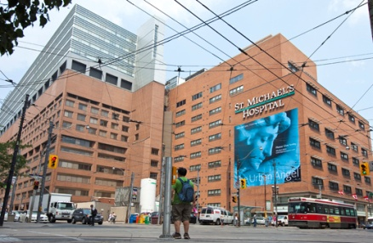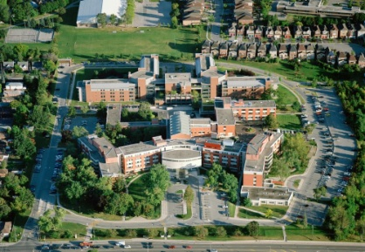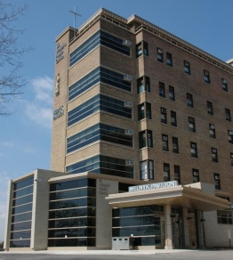

1. **The Mentors in Canada**

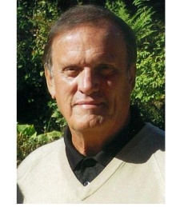

**Mr. Christopher Markwell** - *Scholarship Host and* *Chair of the Baird of Bute Society*

**

**Dr. Patrick Gunning** PhD – *University of Toronto Professor and Head of the Gunning Group*

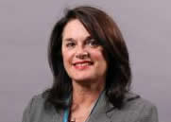

**Dr. Hazel Markwell** PhD - *Associate Professor and Chair of Bioethics, St Paul (Ottawa) University and President Markwell Ethics Inc.*

1. **Eligibility Requirements**

The Baird of Bute Society welcomes high-quality applications from young people who meet the essential criteria:

**Personal**

* Proposed, endorsed and supported by their school
* High academic achievement
* Good character
* Can use the experience to have positive impact on others
* Citizen or permanent resident of Scotland
* Possess a passport valid until at least December of 2018
* Meets Canadian Government Visitor admission requirements
* 18 years of age by July 1st of 2018
* Progressing towards a Scottish University in a Life Science or related programme
* No criminal record
* Record of community involvement
* Prepared to complete the on-line TCPS2 Ethics training programme
* Team player
* Prepared to maintain daily blog with other participants
* Prepared to complete weekly blog during 1st year of University
* Able to be insured for Visitors to Canada health insurance coverage
* Submit a personal Letter of Application
* Agree to be interviewed, as required, for selection (in person or on-line)
* Possess immunization as may be required by participating institutions

**Local**

* Proposed, endorsed and supported by their school
* Fundraising as might be required to cover personal incidentals and travel to/from Glasgow airport

1. **How to apply**

**The School**

Participating Scottish schools present the opportunity to potential participant(s).

The School may propose only one selected and supported candidate for review and consideration by the Baird of Bute Society.

**The Student**

Students who have been informed of and wish to pursue the opportunity must approach their Head of Year, Guidance Teacher or Head Teacher and request an application. *(In granting the application the school has indicated it would consider the student’ for their supported nomination).*

The Student must return the completed Application (see download instructions at Appendices and Exhibits) to the specified individual at the school.

**The School**

One nomination will be accepted from each school. The nomination with the completed application, the applicant’s letter of interest and the school’s letter for support must be e-mailed [bairdcdnscience@bairdofbute.co.uk](mailto:bairdcdnscience@bairdofbute.co.uk) no later than February 28, 2019.

**The Baird of Bute Society**

By March 1, 2019 selected candidates will be contacted for an interview to be conducted in person, by phone and or internet connection.

By March 15, 2019 the two successful participants will be advised of their selection and the dates and agenda of the 2019 Scholarship programme.

**Note:** The Scholarship programme will commence and terminate at Glasgow Airport, it being the responsibility of the participant (perhaps locally assisted) to provide required transportation. However, the selected candidate may, if required, request assistance with these expenses from the Baird of Bute Society.

**Appendices and Exhibits**

**CONTACT**

bairdcdnscience@bairdofbute.co.uk

**ADDITIONAL INFORMATION**

[www.bairdofbute.co.uk](http://www.bairdofbute.co.uk) - *click menu for Canadian Science Scholarship*

*youtube and search on - “Aspire New Edit Dec 2018”*

**SAMPLE PARTICIPANT BLOGS** *(annual programme locations subject to change)*

[www.baird](http://www.baird) ofbute2014.wordpress.com

www,bairdofbute2016.wordpress.com

**APPLICATION FORM Download**

Go to [www.bairdofbute.co.uk](http://www.bairdofbute.c.uk)

Click on Baird of Bute Society button

See Society Pages Menu

Click on Canadian Science Scholarship

Scroll to bottom of page

Click on Download Application Form

