Introduction to the Torah Judaism

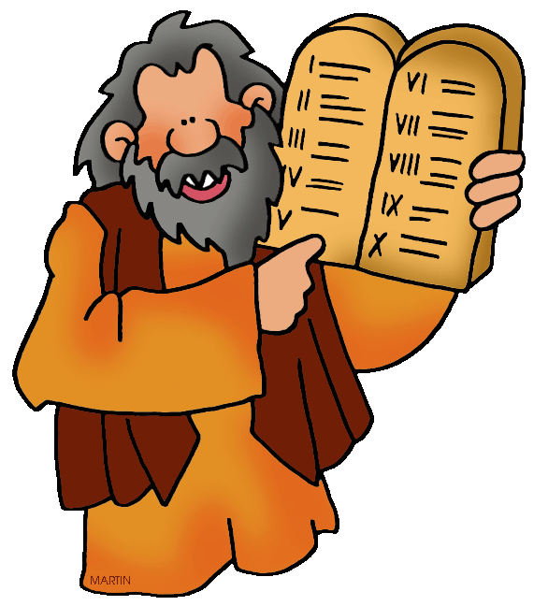
From Abraham to Moses
- 400 years after Abraham, Abraham’s descendants were slaves in Egypt.
- God chose Moses to lead them out of Egypt to freedom. This escape is known as the Exodus.
- In the Sinai Desert the most important event in Jewish history took place.
- God spoke to Moses and gave him the Ten Commandments written on tablets of stone.

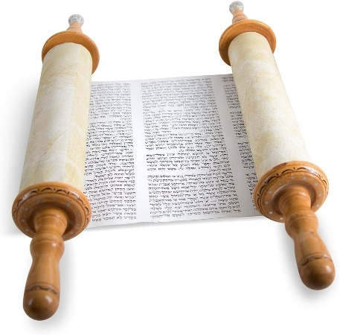
The Torah
- The Torah is the centre of the Jewish religion. It is the Word of God.
- Torah means ‘law’ or ‘teaching’.
- Jewish people believe the five books of the Torah contain the words that God spoke to Moses
- The Jewish people see the Torah as a way of life.

- The Torah is written in the Hebrew Language.
- It is read from right to left.
- As a holy book, it is treated with the utmost respect.
- The Torah is always written by hand which can take up to a year.

The making of a Torah
- The Torah is written on skin from a kosher animal (one which Jews regard as clean, acceptable).
- The scribe also has to use a quill pen made with five feathers of a kosher bird. A chicken would be acceptable, but not an ostrich or a seagull.
- The scribe uses black ink. Mistakes are not allowed.
- Watch the making of a Torah
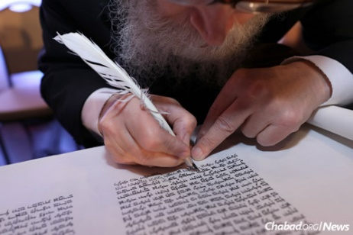
Why write the Torah by hand?
- It is a reward from God
- Gains respect from community
- It is time well spent in the service of God.

Written Task

- Who did God call to lead Abraham’s descendants out of Egypt?

- What was this escape known as?

- What was Moses given by God that was written on tablets of stone?

- What does the word ‘Torah’ mean?

- How many books make up the Torah?

- Research the Torah on Google and find out the name of the five books. Do you notice any similarities to the Bible?

- What language is the Torah written in and how is it read?

- What is the Torah written on? What is it written with?

- Give two reasons why the Torah is written by hand and not printed like a book.

