Pilgrimage To Makkah.

In all religions a pilgrim makes a pilgrimage to a place of religious significance as a form of prayer and in order to deepen their faith.

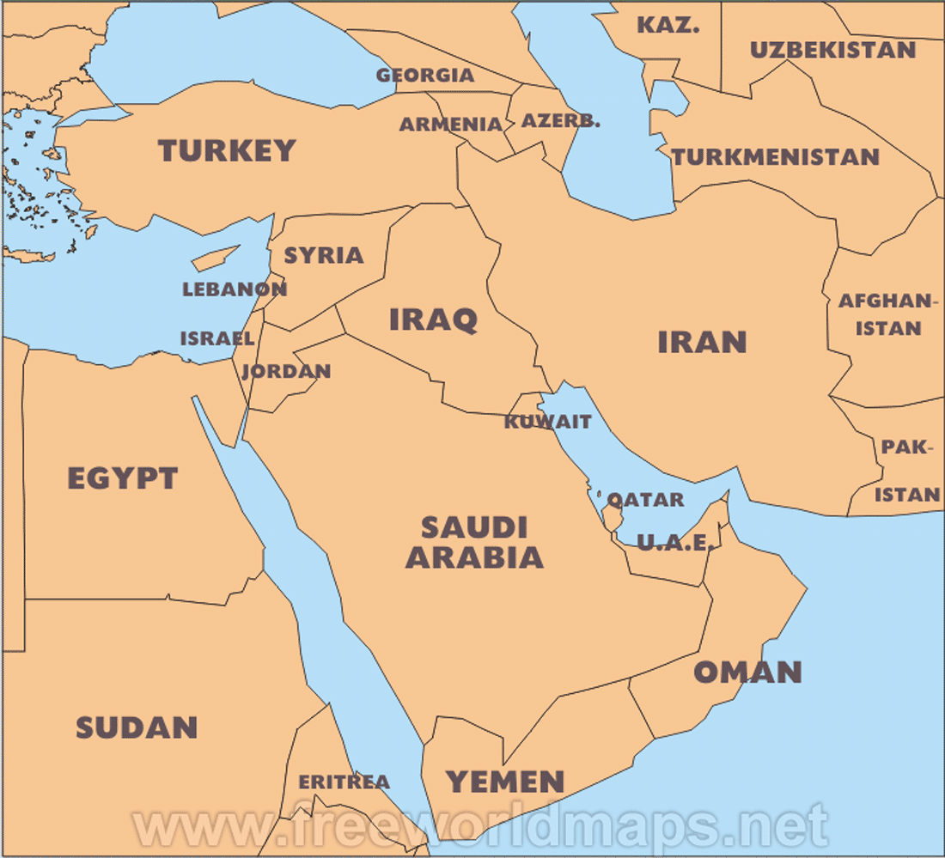
The City of Mecca in Saudi Arabia is the most important place on Earth for the World’s 900 million Muslims. Makkah has such significance in the Islamic Faith that when a Muslim prays – they are required to pray five times a day – they face Makkah.

You may know that Muslims will use a Prayer Mat which very often will have a set in compass to direct them to Makkah.

In the prayer hall those praying face a niche in a wall called the mihrab. The ensures that they are facing Makkah.

There are four reasons for Makkah being so important :

- Muslims believe that it was in Makkah that Ibrahim (Abraham in Christian Tradition) built the first temple of Allah – a mosque called the Ka’aba
- Muslims believe that the Ka’aba contains the Black Stone which Allah gave to Adam.
- Muhammad, the Prophet, was born in Makkah
- The Qu’ran commands Muslims to make the pilgrimage to Makkah.

God told the Prophet Ibrahim to take his wife (Hajira) and his son (Ishmael) on a journey to Arabia. He then told Ibrahim to leave his wife and son with some food and water. Having run out of water, Hajira ran up and down two hills, Safa and Marwah, in search of water. Unable to find any water she prayed to God and water then sprang miraculously from the ground. This source of water is called the Zamzam well which is still in the Ka’aba.
When Ibrahim returned, he was commanded to build the Ka’ba as a shrine dedicated to Allah where worship would take place. However, over time, people began to worship idols there instead of the one true God, Allah. Worshipping or considering anything or anyone to be equal to or above Allah is the greatest sin in Islam (this is called shirk). Much later, Muhammad restored the Ka’ba to its original purpose as a place for worshipping only Allah.
For Muslims it is a duty to go on pilgrimage to Makkah (Mecca) at least once in their lifetime, as long as they are physically able and can afford it. The pilgrimage to Makkah is called Hajj and is the fifth Pillar of Islam. Muslims try to go to Makkah during Dhu al-Hijjah, the twelfth month of the Islamic calendar. This reflects a Muslim's devotion, loyalty and belief and therefore helps him or her to grow spiritually.
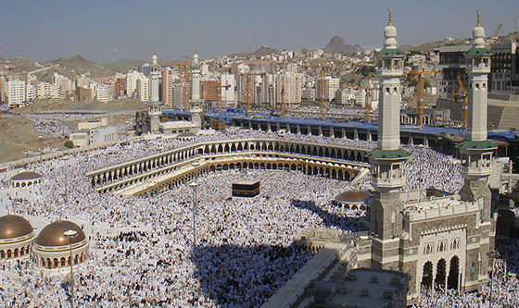
Following in the footsteps of the Prophet Muhammad - in the Qur'an the Prophet Muhammad is called the Seal of the Prophets, meaning he is the last and greatest of God's prophets. Even though Muhammad is not believed to be divine, he is a role model for all Muslims. Therefore, to go on pilgrimage to Makkah (Mecca) and follow in his footsteps is very important to Muslims.
Key belief – the pilgrimage to Makkah reminds Muslims of their key belief in the equality of all humankind before Allah, because each person takes part on exactly the same basis. This is reflected in a number of practices during the Hajj.
Spirituality - the Hajj prompts Muslims to reflect and think on their own lives. Modern lifestyles are hectic, but the Hajj gives Muslims the opportunity to switch off from work and trivial issues. It also allows Muslims to reconnect with what is really important and focus on spiritual matters.
Muslims must follow a number of important rituals whilst on Hajj:
Ihram relates to the state of purity and equality before God (Allah) which Muslims enter before going on Hajj. To symbolise this state, male pilgrims wear two lengths of white cloth whilst on Hajj; female pilgrims wear ordinary clothes, but must keep their faces uncovered. These clothes may be kept by the pilgrim and at their death used to wrap their body for burial. To enter into and maintain this state of purity, the pilgrim must put away distractions of life such as jewellery and perfume.
Ka'aba. On the first day of the Hajj, pilgrims walk around the Ka'aba seven times in an anti-clockwise direction while repeating prayers. This is called Tawaf. All people do this at the same time and only a few are able to touch or kiss the Black Stone, embedded in one corner of the Ka'aba. If a pilgrim isn't able to touch the Black Stone, they hold up their hand to it as they pass. The Black Stone is considered to be have been given by God to Adam, Abraham or Noah discovered it. The earliest mention of it predates Muhammad.
Walking around the Ka'aba with thousands of others represents the Muslim belief in the equality of all Muslims. Muslims are recommended to complete a second Tawaf at the end of their pilgrimage.
Safa and Marwah. Pilgrims next run between the hills of Safa and Marwah seven times. This is to represent the search of Hagar, Ibrahim's wife, for water for her son Ismail. Muslims believe that Ismail struck his foot on the ground and this caused a spring of water to gush out of the ground. This spring is called Zamzam, and pilgrims today frequently take its water with them when they return home.
Mina. Pilgrims travel from Makkah to Mina to spend the first night of the Hajj. The next morning they travel on to the plain of Arafat, where they stand on or near the Mount of Mercy from noon until dusk, praising Allah. This is the climax of the Hajj, and Muslims believe that this rite represents what it will be like on the Day of Judgement when all of humanity will be judged by Allah according to their actions.
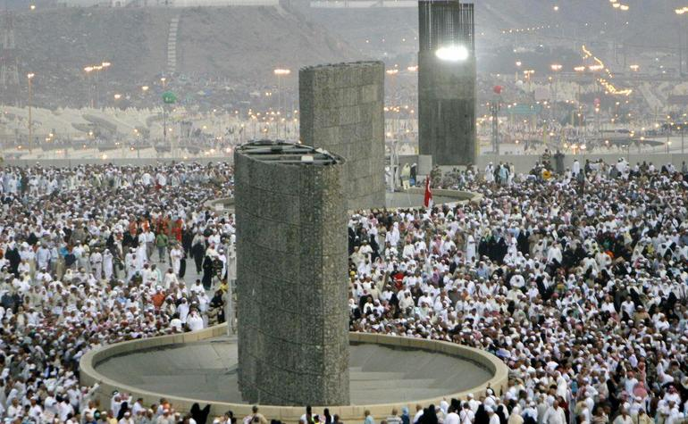
Muzdalifah. Pilgrims spend the second night at Muzdalifah, where they collect small stones to use on the third day when they return to Mina. They throw these stones at three pillars called Jamarat, which represent the Devil.
Muslims believe that the Devil tried three times to persuade Ibrahim to disobey Allah when he ordered Ibrahim to sacrifice his son Ismail. Muslims also make promises to fight the devil themselves and to strive against temptation.
Eid ul-Adha. At the end of the pilgrimage, Muslims celebrate the festival of Eid ul-Adha. This festival reminds them of Ibrahim's obedience when he was told by Allah to sacrifice his son, Ismail. Muslims may sacrifice a sheep or a goat to symbolise the lamb provided by Allah for Ibrahim to sacrifice in place of Ismail.

Assignments.

1. View this six minute video ‘What is Hajj?’ from Youtube

https://youtu.be/Ok7-mB62xeE

2. There is much which could be written about Hajj but this Assignment ask you to focus on four main themes of Hajj.

Read this sheet again and highlight sections which relate to obedience to the will of God; sacrifice; equality of all humanity, repentance for sin and a determination to do better.

Write a few paragraphs (300 words) on these four themes,

