Let Glasgow Flourish………

‘Let Glasgow flourish by the preaching of his Word and the praising of His name’ is the original motto for the City of Glasgow. It is also the inspiration for our School Motto – ‘Let Youth Flourish’.

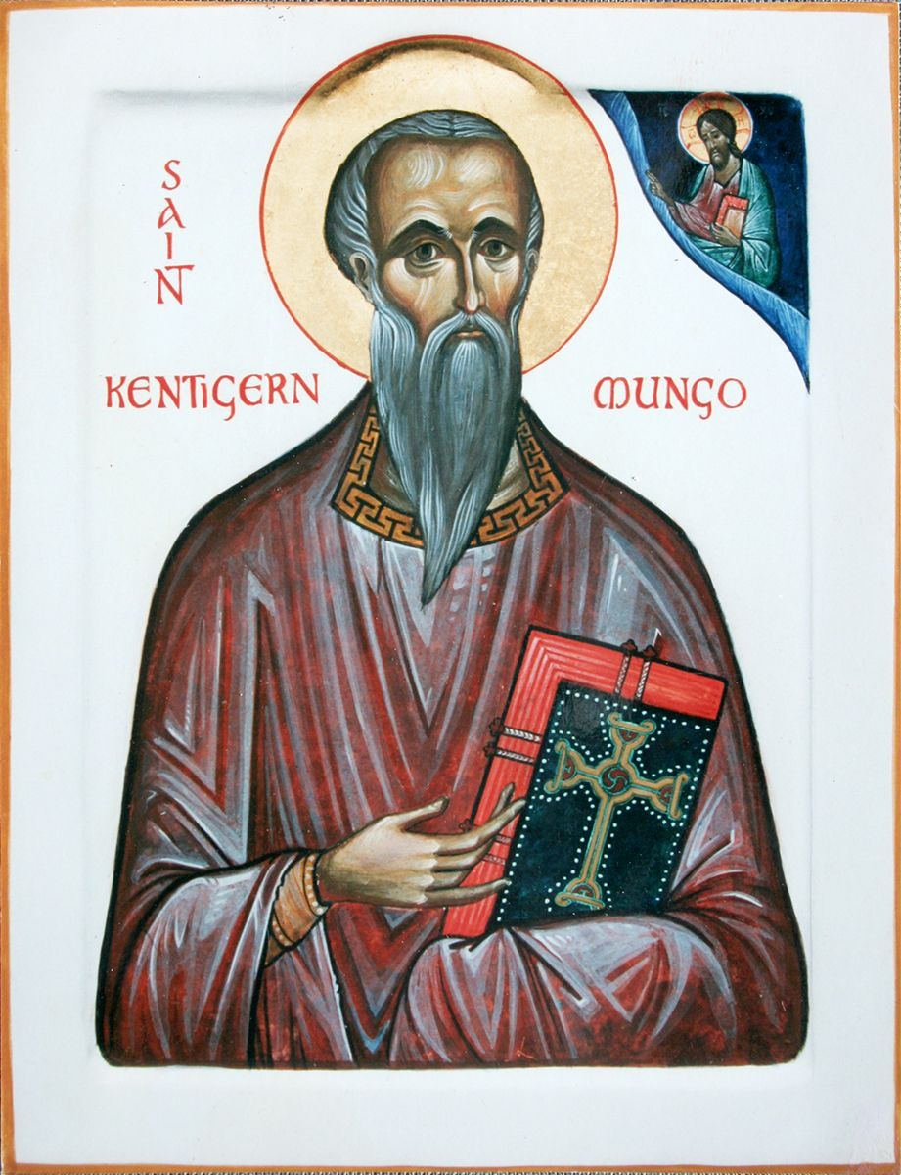
The Glasgow Motto was taken from a sermon of the City’s Patron Saint Mungo or as he is sometimes called, St Kentigern. St Mungo was born in 528 and died on 13 January 614 and the 13th of January is celebrated as his Feast Day. Mungo is also considered to be the founder of Glasgow and he is also responsible for its name.

There are many legends associated with St Mungo including his life being in danger while in his mother’s womb. We know that he was born in Culross in Fife and his mother was St Enoch – a name well known in Glasgow but not really with many details. There are often many legends associated with early saints and it is important that we try to understand what message they have for us today.

At an early age, Mungo was taught at Culross by St Serf who had a great influence on him. He seems to have followed around St Serf so much that St Serf gave him the nickname Mungo meaning ‘little one’ or ‘little puppy’.

At the age of 25, Mungo began his missionary work on the banks of the River Clyde. Here he was welcomed by the people previously converted to Christianity by St Ninian. Mungo built his church close to where the River Clyde met the Molendinar Burn. Since the 1200’s the site of this early church has formed part of Glasgow Cathedral at Townhead. The Cathedral is now part of the Church of Scotland.

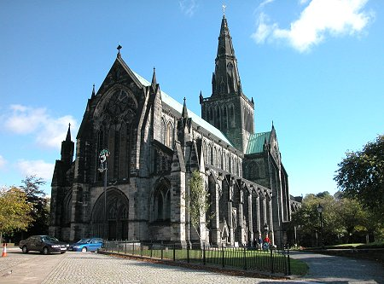
The name Glasgow comes from St Mungo’s description of it as ‘dear green place’ in a local language of the time as ‘glas cau’.
Glasgow Church of Scotland Cathedral at Townhead.

Mungo worked on the banks of the Clyde for 13 years until he had to flee the threats of a local king. He went to Wales and worked with St David until it was safe to return to Glasgow.

After many years of preaching the Gospel, Mungo died on 13th January 614. He was buried close by his church and today his tomb les in the centre of the Lower Choir of Glasgow Cathedral probably on the actual site of his grave.

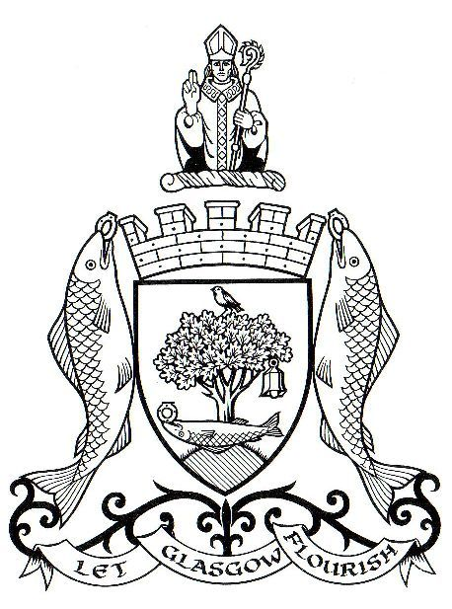
There are four miracles associated with St Mungo which are mentioned in a short poem. These four miracles are represented in the Glasgow Coat of Arms.

‘Here is the bird that never flew.
Here is the tree that never grew.
Here is the bell that never rang.
Here is the fish that never swam’.

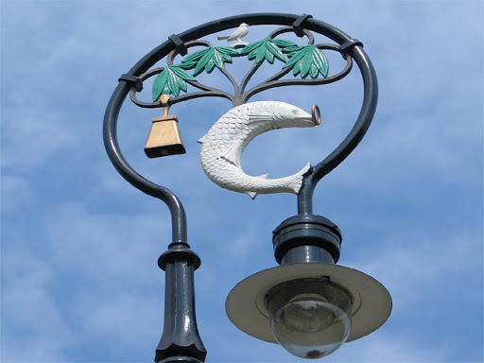
A lamppost near Glasgow Cathedral.
In the first legend, he is said to have restored life to the pet robin of St Serf which had been killed by some of his classmates in Culross, hoping to blame his for its death.

In the second, he used branches of a tree to restart a fire at St Serf’s monastery that had gone out because Mungo had fallen asleep while he was meant to be watching it. The third relates to a miraculous bell which he brought back with him from Rome.

The fourth legend is the best known. Queen Languoreth of Strathclyde was accused of infidelity by her husband, King Riderich, who alleged she had given her wedding ring to her lover. In reality, the King had thrown the ring into the river. Facing execution, the Queen appealed to Mungo who ordered a servant to catch a fish from the river. When the fish was cut open, the ring was found inside, demonstrating the Queen’s innocence.

It is Mungo’s courage and determination to preach the Gospel, even putting himself in danger, which makes St Mungo important to us.
A modern interpretation mural of St Mungo on a gable end on High Street, Glasgow.

St Mungo should inspire us to make a real effort to live our lives following the teaching of Jesus and through our example encourage others to have faith.

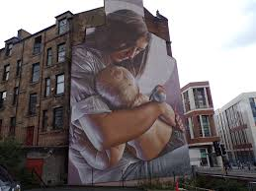

Two murals in Glasgow of St Mungo’s mother St Enoch also known as St Thenew.

View this ten minute video on St Mungo.

https://www.facebook.com/sanctafamiliamedia/videos/2172334726428963/

Assignments.

1. Using what we know to be fact, write a summary of life of St Mungo.

Year of birth Date of his death Mother’s name

Place of birth His teacher Meaning of his name

His church His work in Glasgow Name of Glasgow

Wales Return to Glasgow Where he is buried.

2. a. Write out the full motto of the City of Glasgow.

b. What do you think this means for us today ?

3. What are the four miracles associated with St Mungo ?

4. a. In what way is St Mungo and inspiration to us ?

b. Describe how in in your life, you follow the teaching of Jesus and encourage others to have faith.

5. Complete the St Mungo Word Search.

