Pilgrimage.

While there many different religions which different belief, practices, moral standards and teaching, it is true to say that there is more which is common to different religions than separates them.
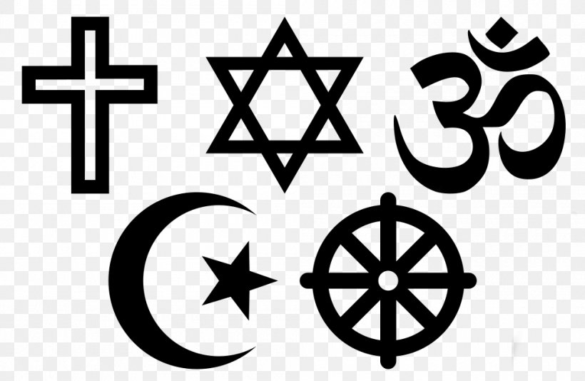
One such practice which is common to all religions is that of pilgrimage. Yet the meaning behind pilgrimages is not only restricted to have a religious significance. Many people, including atheists, will talk of the feelings and emotions of visiting places which are significant to their individual life or to have a wider, national or even global significance.

Many people will often visit the country in which their ancestors lived, even seeking out small villages and maybe even the house in which their grandparents or more distant ancestors lived. Even football fans will visit famous stadiums where great games took place especially those where ‘great victories’ were won. The idea of religious pilgrimage satisfies what appears to be a human yearning.
Often, people go on pilgrimage when they are at a crossroads in their lives, when undergoing a change in their life’s direction or relationships. Others may be in search of a deeper spirituality, healing and forgiveness. Or it may be that pilgrimage marks a special birthday, retirement or other hoccasion for giving thanks. It’s also a great adventure with the chance to meet new people and see new places.
For people of faith the reasons for going on pilgrimage might be:
- To set aside time for God and feel closer to him
- To discern his will and guidance at times of transition or difficulty
- To be strengthened in faith by the lives of people of faith who have gone before.
Pilgrimage can be a life-changing, transformational experience. A time of letting go of the old to let the new come in. Pilgrims don’t merely visit a place as tourists, they come away inspired and changed by it in some way. Going on pilgrimage may give us a new sense of awareness and wonder. Or result in a greater sense of our life’s purpose. Pilgrimage helps to illuminate the journey of life by helping us to focus on ‘what really matters’ and to rediscover the joy of giving and generosity. And to have a greater appreciation for life’s gift.

Assignments.

1. It is true to say that there is more which is common to different religions than separates them.

List six beliefs, practices or teachings which are common to most religions.

2. Places often have special significance to individuals, nations and to the world.

a. Name one place which has a special significance to you and or your family and explain its significance.

b. Name one place which has special significance to a particular country
and explain its significance.

3. With reference to religion, explain why pilgrimage is of importance to people of faith.

4. Which places are places of pilgrimage for the following faiths ?
Write a sentence or two about each.

- Catholicism.

- Islam.

- Judaism.

- Hinduism.

- Sikhism.

- Any other faith.

5. View this five minute powerpoint on the role of pilgrimage in the Catholic Tradition.

https://youtu.be/vB4qeDfZxYw

