Saint Ninian’s High School.

Religious Education.
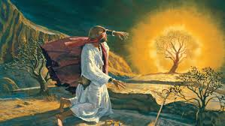

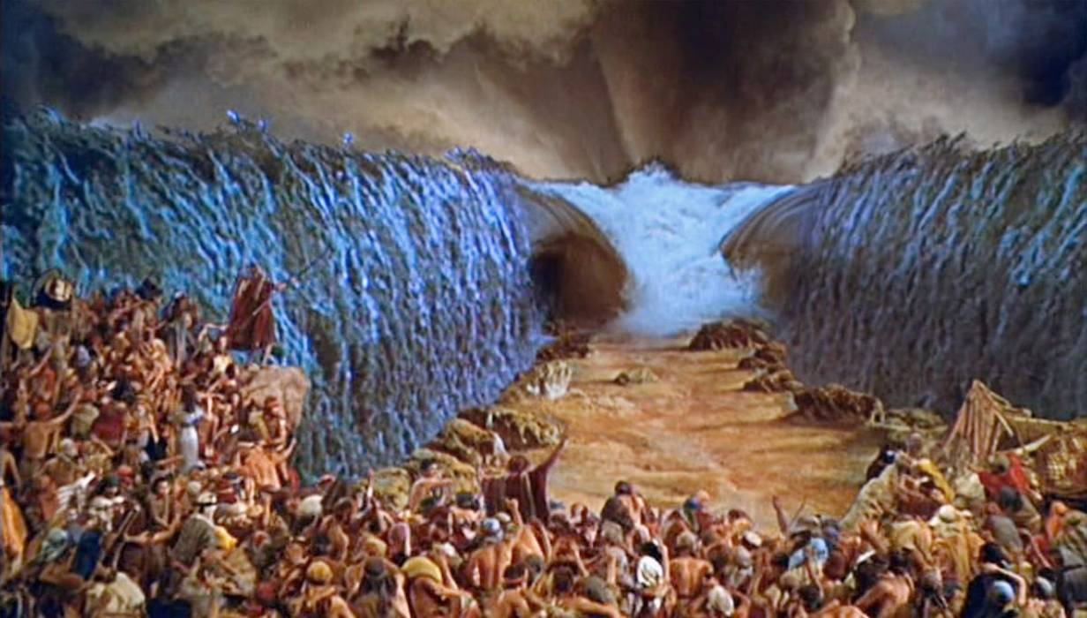
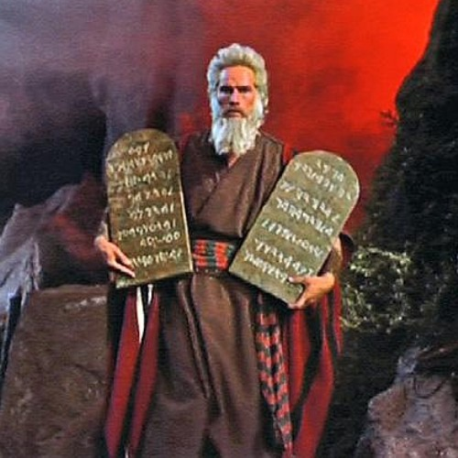
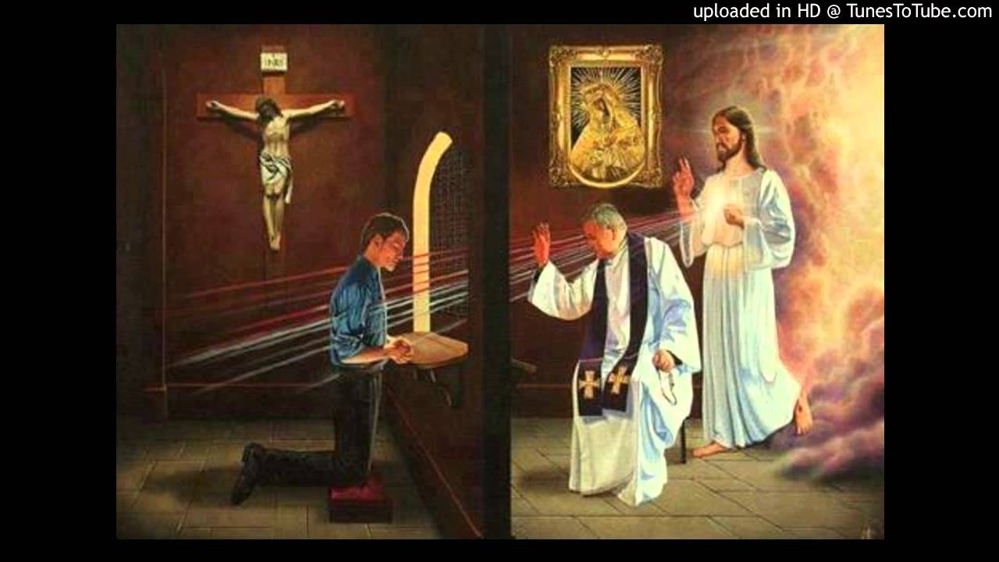

S2 : The People of God. (Part 2)
S2 Unit 2 Page 17.
Moses Returns To Egypt.

Moses grew up in the Pharaoh’s household and earned great respect. However, seeing an Egyptian overseer beating a Hebrew, Moses killed the Egyptian. This meant death for him. He fled Egypt to nearby Midian where her married and settled…………

Moses and the Burning Bush from Exodus Chapter 3.
3 Now Moses was tending the flock of Jethro his father-in-law, the priest of Midian and he led the flock to the far side of the wilderness and came to Horeb, the mountain of God. ² There the angel of the Lord appeared to him in flames of fire from within a bush. Moses saw that though the bush was on fire it did not burn up. ³ So Moses thought, “I will go over and see this strange sight—why the bush does not burn up.”
⁴ When the Lord saw that he had gone over to look, God called⁾ to him from within the bush, “Moses! Moses!”And Moses said, “Here I am.”
⁵ “Do not come any closer,” God said. “Take off your sandals, for the place where you are standing is holy ground.” ⁶ Then he said, “I am the God of your father, the God of Abraham, the God of Isaac and the God of Jacob.” At this, Moses hid his face, because he was afraid to look at God.
¹³ Moses said to God, “Suppose I go to the Israelites and say to them, ‘The God of your fathers has sent me to you,’ and they ask me, ‘What is his name?’^{(AF)} Then what shall I tell them?”
¹⁴ God said to Moses, “I am who I am. This is what you are to say to the Israelites: ‘I am has sent me to you.’
God called Moses to return to Egypt and to tell Pharaoh that God want his people set free. He told Moses that he was the God of Abraham, Isaac and Jacob. This was important as God had made the Covenant with Abraham.

S2 Unit 2 Page 18.

Despite his doubts and fears, Moses returned to Egypt. This began a series of interactions between Moses and Pharaoh. Moses told Pharaoh God’s demand. Pharaoh would refuse - a plague would be sent on Egypt and Pharaoh would panic and order the freedom of the Jews. He would then change his mind. This continued for nine occasions.
“You Are Right In Saying I Am”.

You may hear people saying that Jesus never claimed to be God. This is not the case. In many different ways and times Jesus clearly said he was God.

One such time is his trial before the Jewish Council – the Sanhedrin. The High Priest asks Jesus :

“Are you the Son of God?”

To which Jesus replies :

“It is you who say I am”.

At this the whole Council erupts and Jesus’ fate is sealed. Jesus is referring back to the Call of Moses when God called himself ‘I am who am’.

This became the personal name for God for the Jews. Indeed, it is so personal that it would never be said nor written fully.

Moses warned Pharaoh of a tenth and final plague – the death of the first born in each house.

Assignments.

1. Why did Moses flee Egypt ?

2. When and in what form did
God appear to Moses ?

3. What fears and doubts might Moses have had ?

4. When Moses asked, who did God say he was?
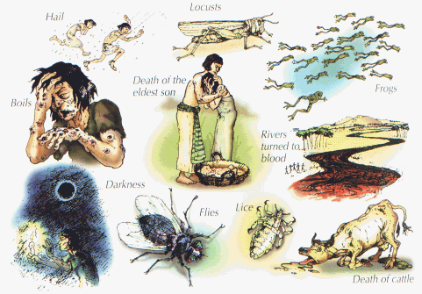
Why was this of importance ?

S2 Unit 2 Page 19.
Exodus.

God called Moses to go to Pharaoh and demand that the Israelites be set free. Through Moses God would keep his covenant with his people. This was the same covenant which had started with Abraham.

Through Abraham God has promised his people would be a great nation, would have a land of their own and would have his love and protection. At this time, circa 1250BC, the great nation was facing extinction, they were in a foreign land and if didn’t seem that anyone was protecting them. In their despair they remembered the Covenant and turned back to God.

God would save his people and Moses would lead his people from Egypt back to the Promised Land of Canaan.

View ‘Testament : The Bible in Animation – Moses.

https://clickv.ie/w/_bBo https://youtu.be/GRT6WPn2vnQ
This story of the escape from Egypt can be read in the book of Exodus in chapters 5-14. Chapter Fourteen of the story tells of the crossing of the Red Sea. The Bible gives a very exciting account of this. The people of Israel knew they were saved after this event.
The sea opened up and formed a great wall leaving a dry path for the Israelites to walk through. The water then fell down on the Egyptians.
In this case God promised to save his people and against all the odds they were saved. The Israelites had no doubts – God had saved them. God had kept his Covenant.

S2 Unit 2 Page 20.

1. a. In what ways were the terms of the Covenant not being met?
b. Why do you think this was the case ?

2. The sentences below summarise the story of Exodus.
They are not in the correct order.
Using Bible Gateway online, find Exodus Chapters 7-14
Using the headings in chapters 7-14 arrange these sentences into correct order.

The sea opens up and the Israelites cross over.
The first Passover – lambs are killed.
God commands Moses.
The Israelites prepare unleavened bread.
The first nine plagues.
The sea closes on the Egyptians.
The Israelites leave Egypt.
The last plague – death of the first-born.
Aaron’s magic does not impress pharaoh.

3. What is the name of the Jewish festival which celebrates the escape from Egypt?

4. The Jews still celebrate Exodus today as the great day in their history.
Name a similar day in our country or in another country.

5. Name some countries, people, groups or individuals who are not free today.
Write a sentence about one of these.
S2 Unit 2 Page 21.

The Covenant
After God had saved the Israelites, he asked Moses to lead them to Mount Sinai. At this place God would renew his covenant with his people. In return for their faith in him, God would be able to give his love and protect his people. Just as God made the Covenant through Abraham he would now use Moses.
This worksheet will examine the making of this covenant.
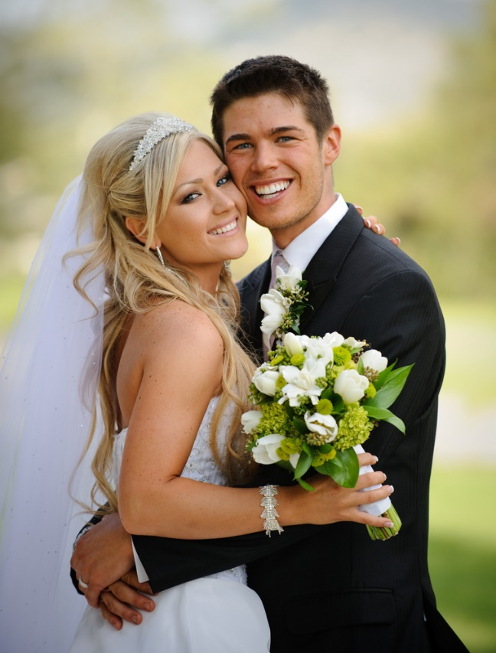
What is a covenant?
George and Lizanne are celebrating their marriage:
“I George take you, Lizanne for my
lawful wife, to have and to hold from
this day forward, for better, for worse, for richer, for poorer, in sickness and in health, till death do us part.”

The most important part of the marriage ceremony is when the man and woman promise to love each other and be loyal and faithful.
A marriage is a legal contract but that is not what keeps a couple together. What keeps them together his love. Marriage is often referred to as a covenant because it is a sacred relationship built on faith and love. This is the basis of the Covenant between God and his people.
After God had saved the Israelites from Egypt he asked them to go to Mount Sinai where he would renew the covenant he made with Abraham. To help them keep their covenant, God gave the Jews the Ten Commandments. To celebrate this covenant the blood of an animal was sprinkled over the people. This was a sign of new life and unity between God and his people.

S2 Unit 2 Page 22.
Assignments.

1. George and Lizanne promised to be loyal to each other.
What will keep them together?

A legal contract Love and faith in each other Money.

2. Which words best describe a covenant?

Agreement Pact Legal contract

Deal Friendship Relationship

4. From the word square find 13 words which are important for your recent work. Chose five words of the words from the word square and write a sentence about each word and its meaning for your work. Your recent work will help.
B L O O D R S A B C T D Z T N A N E V O C B N D L Z O C L K M O B A A E E S E S O M M O L F D S A R B C L A Q D E A E C R L A W H B E F H I X E S K L A M S N U O T O N I T R J I D L R M H D D C B N M O P R S T C U A A U O V W X Y A B G S T P T C A A S I G C L V S

S2 Unit 2 Page 23.
The Ten Commandments.
After freeing the Israelites from Egypt, God led them to Mount Sinai. On this mountain God would remind his people of the Covenant. He would tell them to have faith in him and he would be able to love and protect them. God gave the people the commandments to help them be faithful to him.

Assignments.
1. In pairs, write out the Ten Commandments. If you need help, complete the exercise on the next page.

2. a. Which of the commandments have to do with the friendship
between God and humanity?

b. Which of the commandments have to do with the relationship between people?

3. Which commandment do you think is the most important?

4. Learn the Ten Commandments.

The commandments were given to Moses around 3300 years ago but are still relevant today. The next assignments encourages you to think about the relevance of the Commandments for today.

S2 Unit 2 Page 24.

5. Copy these statements into your jotter.
Which Commandment is relevant to each statement ?

a. Following the teaching of the church Catholics should go to Mass on Sunday.
b. Do not dodge train fares.
c. Be obedient in the house.
d. Abortion is wrong.
e. Sex outside marriage is wrong.
f. Don’t gossip about other people especially spreading lies.
g. Be happy with what you have.
h. Don’t let money or goods rule your life.

6. a. If you were asked to make up Ten Commandments for today what would they be?
b. Are your commandments different from those given to Moses ?

7. Some people tried to trick Jesus by asking him which was the most important of the commandments?
The Ten Commandments

You shall have no other ------ before me.
Do not use God’s -------- without respect.
Keep the ------- Day holy.
Honour your -------and -------.
Do not commit m--------.
Do not commit a--------.
Do not s------
Do not accuse anyone w------.
Do not covet another man’s w------.
Do not ------another man’s --------.

What was his answer?
Read Mt 22 : 34 – 40

S2 Unit 2 Page 25.

God Forgives.
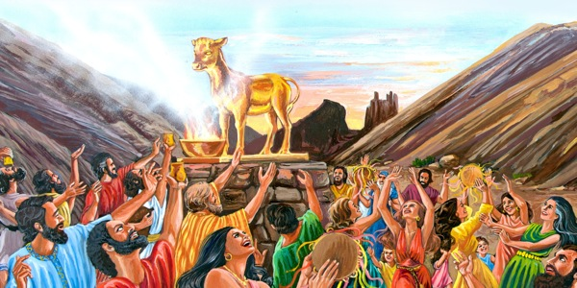
At Mount Sinai God renewed his covenant with his people. However, this was not the first time that God had to remind his people to be faithful to him. Even as Moses was receiving the commandments the people were getting up to all sorts of things as they worshipped a golden calf.
The history of the relationship between God and the Israelites was very stormy at times. While God remained faithful to the Israelites, they were not always faithful to him.
This sheet examines some of the occasions when the People of Israel turned away from God and broke the Covenant.
Assignments.
1. What does the name Israel mean and why is it important for the topic
being discussed on this page ?

2. The Bible Passages will help you to complete the sentences below.
Read each passage then complete the sentences.
Exodus 32 : 7 – 10 Numbers 20 : 2 – 5
Amos 2 : 6 – 11 Numbers 14 : 1 - 4

a. God said to Moses, “Go back down to the people. They have left the
_______. They have made a calf made out of ______ and ________ it”.

b. The people had no _______ and they _______ to Moses and _____. They complained, “Why have you brought us here to die in the wilderness?”

S2 Unit 2 Page 26.

c. The Lord says: “The people of _______ have sinned again and again, and for this I will ______ them. They make slaves of men who cannot pay their ______. They _______ down the ________ and push the ______ out of the way”.

d. The people _______ against _______ and Aaron, and said, “It would have been better to ____ in Egypt or even here in the ______. Let’s choose another leader and go back to _______”.

2. The Book of Judges gives another story of the people turning away from God. This story follows a pattern of many Bible stories:-

      - The people sin.
      - The people ask for forgiveness.
      - God forgives the people.

This passage is based on Judges Chapter 10 but the order has been mixed up. Using the pattern above rewrite this passage in the correct order.

Then the people realised what was wrong and called out to the lord,
“We have sinned against you, for we left you and worshipped the god of the Baals”.

In time God forgave the people for leaving him and gave them victory over their enemies’.

‘Once again the Israelites sinned against God by worshipping false gods. So God became angry with them and cold not protect them against their enemies. For eighteen years the Philistines and the Ammonites ruled over the people of Israel.

But God replied, “Did I not save you from the Egyptians and other people who ruled over you ? But still you left me and worshipped other gods. Let them help you”.

The people cried out, “We have sinned. Do what you want with us but save us today”. So they got rid of the false gods and worshipped the lord.
S2 Unit 2 Page 27.

God Forgives.
The Sacrament of Reconciliation.
The People of Israel would often break their Covenant with God and turn away from him. God was always faithful to them and ready to accept their sorrow and pleas for forgiveness. In our lives we are like the People of Israel – we struggle with God.

In our lives today we often turn away from God. However, we know that just as he forgave the people of Israel, God will forgive us. To help us, God has given us the Sacraments. The Sacrament of Reconciliation is very important for our lives. Even when we try out best, we might sin. Sadly, there are times when we might not try our best.

What is Sin ?
Sin is a failure to love God and others. It is deliberately dong what we know to be wrong. However, we need to understand that sin is not just breaking a rule.
Sin affects our relationship with God, it hurts ourselves and hurts other people.

Even though we have turned away from God, he has not turned away from us. The Sacrament of Reconciliation is available to us and God is waiting to help us when we open our hearts to him. He will give us the strength and courage to say ‘sorry’ to anyone we have hurt. He will forgive us and gives us the strength to do better.
S2 Unit 2 Page 28.
When we take part in the Sacrament of Reconciliation

- we are given the opportunity to think about what we do which keeps us from being the best people we can be.

- we think about our relationship with God.

- we think about how we treat other people.

- we think about anything we do which takes away from our safety or our dignity.

- we are truly sorry for our sins, ask for forgiveness from God and those whom we have hurt and commit to being better people.

- we have the time to ask the priest for advice on being a better person.

- we have the chance to rid ourselves of any guilt we might have for what we have done.

- we are given a guarantee that our sins are forgiven and we can move forward. This guarantee of forgiveness is from God through the priest.

- we make a small act of penance or sacrifice to try to make up for any harm which we have done.

- we are filled with strength from God to be better.
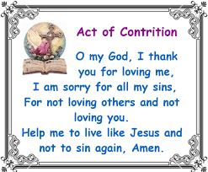

S2 Unit 2 Page 29.
Assignments.

1. In what ways are our lives like the history of the People of Israel ?

2. ‘Sin is not just breaking a rule’.
Explain what this means.

3. a. Using the Bullet Points on Page 28 prepare a Mind Map of the
advantages of the Sacrament of Reconciliation.

b. During the Sacrament of Reconciliation, from whom do we
ask forgiveness ?

4. Study the painting on Page 27.
Explain what this painting tells us about the Sacrament of Reconciliation.

5. a. How should we prepare for the Sacrament of Reconciliation ?

b. What should we do after the Sacrament of Reconciliation ?

6. The Sacrament of Reconciliation has been known as a number of names.

a. Write down other names used for this Sacrament.

b. Using a dictionary, find out the meaning of ‘reconciliation’.

c. Explain this is an appropriate name for the Sacrament.

7. Prepare a short prayer following this pattern:-

- we realise that we can do wrong –offend God, hurt ourselves and others.

- we ask God to forgive us.

- we know God loves and forgives us.

