The Solemnity of The Epiphany

The Solemnity of the Epiphany is a very important celebration for Christians and concludes our celebrations of the Christmas Season. The word Epiphany is an old Latin and Greek word which means “to show”.
The Christmas stories of Jesus’ birth are told in the Gospels of Luke and Matthew. These stories tell us the truth about Jesus.
The first visitors to the stable at Bethlehem were shepherds who had come to worship the saviour of the Jews. Shepherds were a sign of the Jewish people as many of their people were shepherds. One of the greatest Kings of Israel, David, was a shepherd.
Shepherds were very much on the fringe of the society. Their work meant that they spent much of their time away from other people on the hills with their sheep.
However, Jesus was not the saviour of the Jews but was the saviour of all of humanity.
The three wise men or Kings were to represent all of humanity. In the feast of the Epiphany Jesus is being shown to all of us as our saviour.

The three visitors are described as bringing gifts which have a special meaning.

Gold: This gift was a sign that Jesus was king but not a king as we might expect.

Frankincense: this is a sweet smelling mixture which was used in honouring gods. This gift showed that Jesus was believed to be God.

Myrrh: is another sweet smelling mixture which was used to anoint bodies before they were buried. The writers of the Gospels meant this to be a sign that Jesus would suffer.

The feast of the Epiphany used to be celebrated on 6 January but is now celebrated on the Sunday nearest this date. In many countries of Europe it is on this day that presents are given.

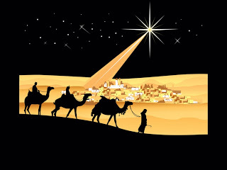
Assignments.

- Read Matthew 2 : 1-12

- Who was the king of Judea at the time of the birth of Jesus?

- What question did the three men ask?

- Why was Herod upset when he heard this question?

- What did Herod ask the three men to do and why do you think he did this?

- After visiting the stable what happened to the visitors?

- In some countries presents are given on this feast day, what presents would you give to Jesus?

Have your work corrected

- Who do the three men represent?

- Each of the gifts of the three men had a special meaning, explain these meanings in your own words.

- Why do you think the custom of giving presents began?

- Why did the Gospel writers add some extra details to the stories of Christmas?

- (a) Read Matthew 2: 13-18.

(b) Re-tell the events of these passages in your own words.

