Saint Ninian’s High School.

Friday Rosary : 15 May 2020.

Please join as a family to recite the Rosary at 12.20pm each Friday with members of the School Community.

In the Name of the Father.......

The Novena To The Sacred Heart.
O most holy Heart of Jesus, fountain of every blessing, I adore Thee, I love Thee and with a lively sorrow for my sins, I offer Thee this poor heart of mine. Make me humble, patient, pure and wholly obedient to Thy will. Grant, good Jesus, that I may live in Thee and for Thee. Protect me in the midst of danger; comfort me in my afflictions; give me health of body, assistance in my temporal needs, Thy blessing on all that I do, and the grace of a holy death. Within Thy heart I place my every care. In every need let me come to Thee with humble trust saying, Heart of Jesus help me.

Invocations to the Sacred Heart.
Merciful Jesus, I consecrate myself today and always to Thy Most Sacred Heart.
Most Sacred Heart of Jesus, I implore that I may ever love Thee more and more.
Most Sacred Heart of Jesus, I trust in Thee.
Most Sacred Heart of Jesus, have mercy on us.
Sacred Heart of Jesus, I believe in Thy love for me.
Jesus, meek and mild and humble of heart, make my heart like unto Thine.
Sacred Heart of Jesus, Thy Kingdom Come.
Most Sacred Heart of Jesus, convert sinners, save the dying, deliver the Holy Souls from Purgatory.

Mary Undoer of Knots.
Mother of fair love, I look to you.
Take into your hands the ribbon of my life and see the snarl of knots that keeps me bound to sin, anxiety, and hopelessness.

I beg you, Mother by your powerful intercession and long fingers of love and grace, undo the knots in my heart and in my life. Free me to love God as Christ loves.

The Holy Rosary.

Leader : Come, O Holy Spirit, fill the hearts of Your faithful,
Response : and enkindle in them the fire of Your love.

Leader : Send forth Your Spirit, O Lord, and they shall be created.
Response. And You shall renew the face of the earth.

Let us pray.

God our Father, pour out the gifts of Your Holy Spirit on the world. You sent the Spirit on Your Church to begin the teaching of the gospel: now let the Spirit continue to work in the world through the hearts of all who believe. Through Christ our Lord. Amen.

Leader : You, O Lord, will open my lips.
Response : And my tongue shall announce Your praise.

Leader : Incline unto my aid, O God.
Response : O Lord, make haste to help me.

Leader : Glory be to the Father………
Response : As it was in the beginning………

The Mysteries of Light.
As a family state for what intentions you will offer this recitation of the Rosary. Please includes all members of our School Community.

The First Mystery of Light : The Baptism of Jesus.

Read this reflection.

We pray for all those who are baptised. We pray that they will know the vocation of Baptism to love God and to serve him through love of our neighbour.

Consider those who need our prayers and our help in other practical ways. We pray that we will be good witnesses to the call of the Baptised.

Recite the Decade.

O my Jesus, forgive us our sins, save us from the fires of hell, lead all souls to Heaven, especially those most in need of Thy mercy. Amen.

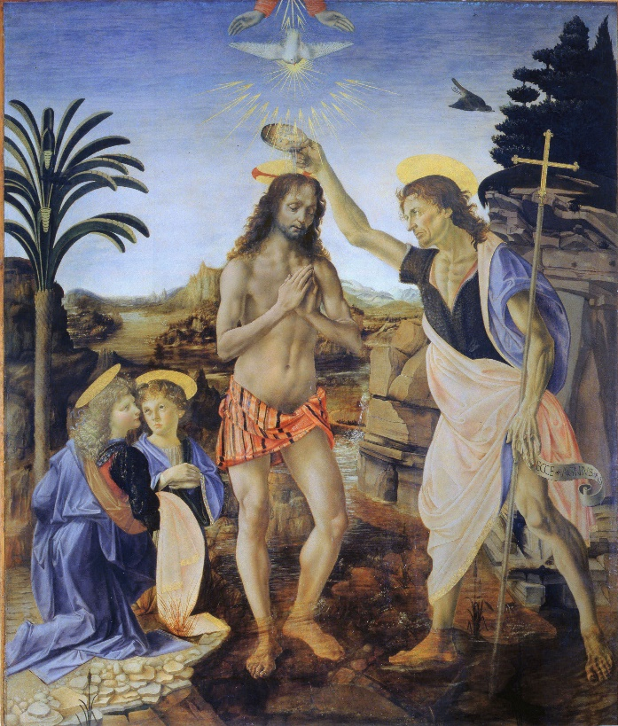

The Second Mystery of Light : The Marriage Feast of Cana,

Read this reflection.

We pray for all those who are married and for our families and all families. We pray that parents will be fine examples to their children and children will have the wisdom to see the good in their family.

We pray for couples who are enduring difficulties in their relationship that the Sacramental Love of Jesus will be with them.

Recite the Decade.

O my Jesus, forgive us our sins, save us from the fires of hell, lead all souls to Heaven, especially those most in need of Thy mercy. Amen.

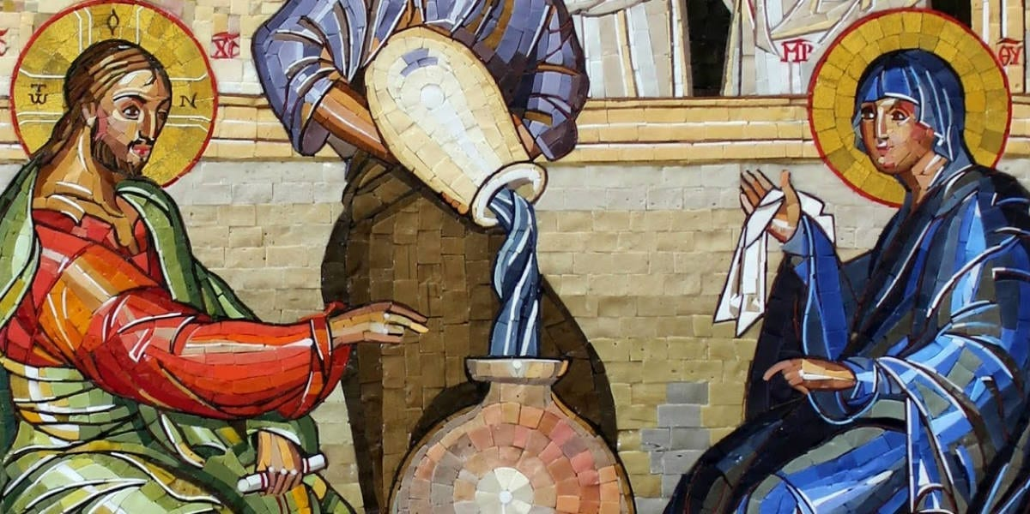

The Third Mystery of Light : The Proclamation of the Kingdom.

Read this reflection.

The preaching in which Jesus proclaims the Kingdom of God calls us to turn away from sin and be confident that our sins are forgiven when we are sorry for our wrongful actions. Though we cannot access the Sacrament of Reconciliation at this time we should ensure that we ask God for forgiveness and look forward to being better people.

Recite the Decade.

O my Jesus, forgive us our sins, save us from the fires of hell, lead all souls to Heaven, especially those most in need of Thy mercy. Amen.
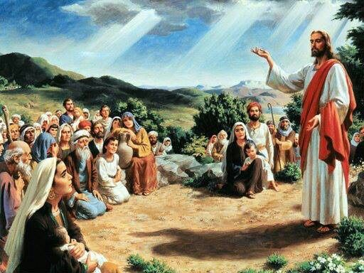

The Fourth Mystery of Light : The Transfiguration.

Read this reflection.

The faith of the Apostles is strengthened when they witness the Transfiguration of Jesus. We pray that our faith in the One, True God will always be strengthened throughout our lives.

Recite the Decade.

O my Jesus, forgive us our sins, save us from the fires of hell, lead all souls to Heaven, especially those most in need of Thy mercy. Amen.

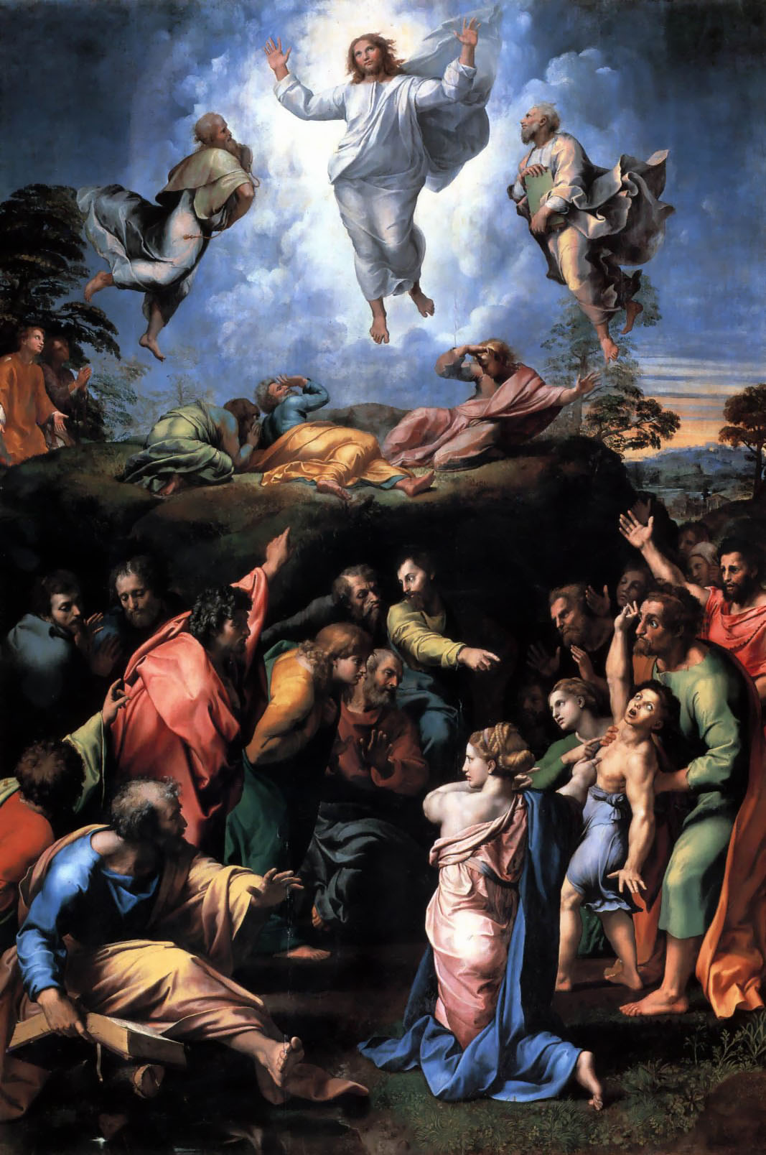

The Fifth Mystery of Light : The Institution of the Eucharist.

Read this reflection.

The Eucharist is ‘the source and summit’ of our faith. At this time we are not able to join with Jesus in the physical reality of the Eucharist. However, we should bring him to us with the prayer of Spiritual Communion.

My Jesus,
I believe that You are present in the Most Holy Sacrament.
I love You above all things,
and I desire to receive You into my soul.
Since I cannot at this moment receive You sacramentally,
come at least spiritually into my heart.
I embrace You as if You were already there
and unite myself wholly to You.
Never permit me to be separated from You.
Amen.

Recite the Decade.

O my Jesus, forgive us our sins, save us from the fires of hell, lead all souls to Heaven, especially those most in need of Thy mercy. Amen.

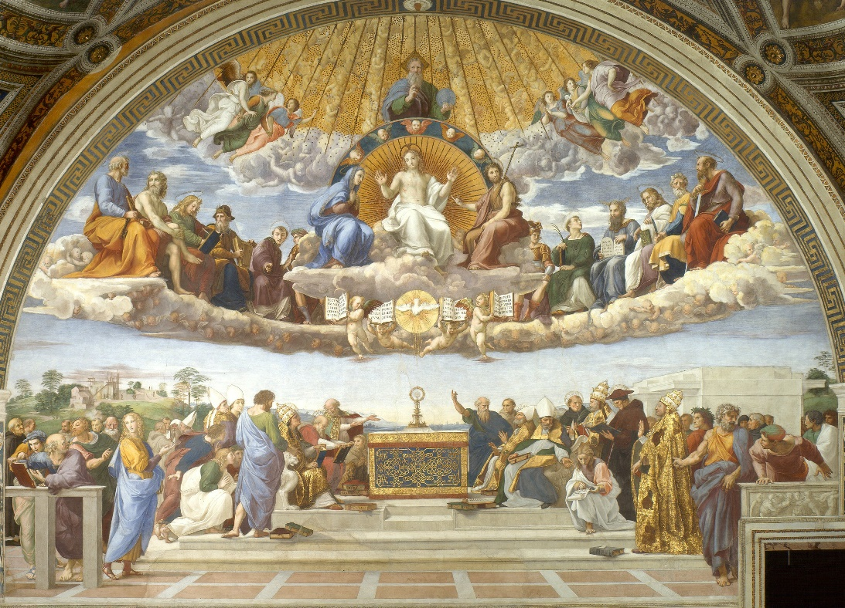

HAIL, HOLY QUEEN, Mother of Mercy, our life, our sweetness and our hope! To thee do we cry, poor banished children of Eve; to thee do we send up our sighs, mourning and weeping in this vale of tears. Turn then, most gracious advocate, thine eyes of mercy toward us, and after this our exile, show unto us the blessed fruit of thy womb, Jesus. O clement, O loving, O sweet Virgin Mary!
Leader : Pray for us, O holy Mother of God.
Response : That we may be made worthy of the promises of Christ.

Let us pray.
O God, Whose only-begotten Son, by His life, death and resurrection, has purchased for us the rewards of eternal life; grant, we beseech Thee, that meditating upon these mysteries in the most holy Rosary of the Blessed Virgin Mary, we may imitate what they contain, and obtain what they promise. Through the same Christ our Lord. Amen.

Most Sacred Heart of Jesus. Have mercy on us.
Immaculate Heart of Mary. Pray for us.
St. Ninian. Pray for us.

In the name of the Father……..

