The Feast of St Matthias, the Apostle.

Today, 14th May, is the Feast of St Matthias who replaced Judas as one of the Twelve Apostles. The Apostle were specially chosen by Jesus to work with him during his time preaching. They were also to be the leaders of the Early Church after Jesus had ascended into Heaven after his Resurrection.
The Teaching Tradition of the Church tells us that Pope Francis is a direct successor of Saint Peter and that our Bishop are in Apostolic Succession to the Twelve Apostles and speak with the authority given to them by Jesus.

We know more about some of the Apostles than we do about others. Your task today is to use the Bible References given below to name all the Apostles and from the References write down what we know about them.

Mark 1 : 16 Mark 1:19-20 John Mark 1:20)

John 1: 40 Matthew 10:3; Luke 6:19)

Luke 6:16 Luke 5:27-28. John 6:5

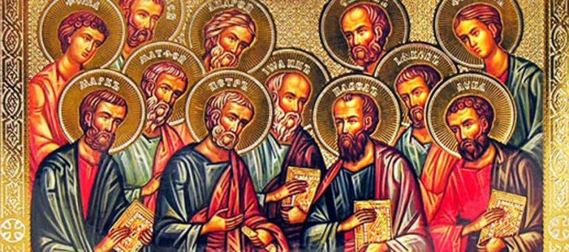
Acts 1 :13 John 20 : 25 Acts 1: 24-26

