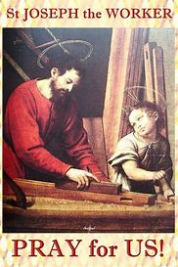
Saint Ninian’s High School.

Friday Rosary : 1st May 2020 : The Feast of St Joseph the Worker.

Please join as a family to recite the Rosary at 12.20pm each Friday with members of the School Community.

In the Name of the Father.......

The Novena To The Sacred Heart.
O most holy Heart of Jesus, fountain of every blessing, I adore Thee, I love Thee and with a lively sorrow for my sins, I offer Thee this poor heart of mine. Make me humble, patient, pure and wholly obedient to Thy will. Grant, good Jesus, that I may live in Thee and for Thee. Protect me in the midst of danger; comfort me in my afflictions; give me health of body, assistance in my temporal needs, Thy blessing on all that I do, and the grace of a holy death. Within Thy heart I place my every care. In every need let me come to Thee with humble trust saying, Heart of Jesus help me.

Invocations to the Sacred Heart.
Merciful Jesus, I consecrate myself today and always to Thy Most Sacred Heart.
Most Sacred Heart of Jesus, I implore that I may ever love Thee more and more.
Most Sacred Heart of Jesus, I trust in Thee.
Most Sacred Heart of Jesus, have mercy on us.
Sacred Heart of Jesus, I believe in Thy love for me.
Jesus, meek and mild and humble of heart, make my heart like unto Thine.
Sacred Heart of Jesus, Thy Kingdom Come.
Most Sacred Heart of Jesus, convert sinners, save the dying, deliver the Holy Souls from Purgatory.
Mary Undoer of Knots.
Mother of fair love, I look to you.
Take into your hands the ribbon of my life and see the snarl of knots that keeps me bound to sin, anxiety, and hopelessness.

I beg you, Mother by your powerful intercession and long fingers of love and grace, undo the knots in my heart and in my life. Free me to love God as Christ loves.

The Holy Rosary.

Leader : Come, O Holy Spirit, fill the hearts of Your faithful,
Response : and enkindle in them the fire of Your love.

Leader : Send forth Your Spirit, O Lord, and they shall be created.
Response. And You shall renew the face of the earth.

Let us pray.

God our Father, pour out the gifts of Your Holy Spirit on the world. You sent the Spirit on Your Church to begin the teaching of the gospel: now let the Spirit continue to work in the world through the hearts of all who believe. Through Christ our Lord. Amen.

Leader : You, O Lord, will open my lips.
Response : And my tongue shall announce Your praise.

Leader : Incline unto my aid, O God.
Response : O Lord, make haste to help me.

Leader : Glory be to the Father………
Response : As it was in the beginning………

The Joyful Mysteries.
As a family state for what intentions you will offer this recitation of the Rosary. Please includes all members of our School Community.

As today is the first day of the Month of Mary and the Feast of Saint Joseph the Worker we will recite the Joyful Mysteries.

The First Joyful Mystery : The Annunciation of the Lord.

Read this reflection.

In the quiet of a garden, God asks through an angel and a woman accepts. Mary is accepting to walk into a mystery. She does not know what lies ahead on this new path, but she knows who is asking and she trusts in him. There are many annunciation moments in our life, and sometimes we hesitate to say yes because we cannot foresee the future or control what will happen. In this mystery, ask Mary to give you a deep trust in the one who invites you to follow. Ask her to help you trust that even if the path ahead is full of crosses, God will be walking with you. If you hold his hand in the darkness, he will give you strength, peace, and an intimate joy that nothing can take away.

Recite the Decade.

O my Jesus, forgive us our sins, save us from the fires of hell, lead all souls to Heaven, especially those most in need of Thy mercy. Amen.
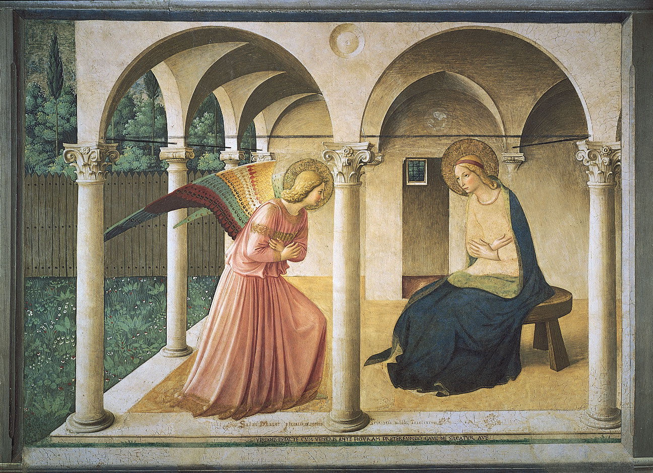

The Second Joyful Mystery : Mary Visits Her Cousin Elizabeth.

Read this reflection.

One of the wonders of God’s plan is that he chooses to associate souls, one to another, so that they help each other on their journey. As cousins, Mary and Elizabeth share a bond of kinship. But they also share a spiritual kinship because of how the Holy Spirit is acting in their lives, fashioning the Messiah and his prophet deep inside their wombs. During those months, Mary and Elizabeth don’t just sit around waiting. They are working, preparing for Elizabeth’s baby, quietly conversing, and praying. Together, they are like a little monastic community. In our lives too, God gives us spiritual friendships and soul-mates who help us grow closer to him. Sometimes he links our lives together for a larger purpose that will reveal itself with time. In this mystery, ask Mary to help you and your spiritual friends listen carefully for God’s voice in your lives, so that you can walk with him and with each other.

Recite the Decade.

O my Jesus, forgive us our sins, save us from the fires of hell, lead all souls to Heaven, especially those most in need of Thy mercy. Amen.

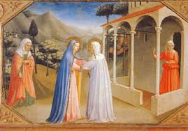

The Third Joyful Mystery : The Birth of Our Lord.

Read this reflection.

All of Bethlehem was dark and quiet when the Saviour made his entrance into the world, and his first home was in the protective circle of Mary’s arms. Imagine how Mary’s heart shone with a love spanning the tender, protective love of a mother holding her baby in her arms and the profound adoration of a soul adoring her Creator and Lord in the flesh. This was a day of fulfillment and joy—one of many along a path also rich in crosses. Nine months ago, she had given that first “yes” in the garden. Now it had become a life, a beautiful baby. It was so clear now that everything—even the future crosses that would be her “birth pains”—were worth it. In our lives too, there are times when God asks us to make a choice that we do not fully understand, and the blessing reveals itself only later in time. Once the blessing comes, we understand that the only way to understand God’s plan was to live it. In this mystery, ask Mary for the grace to believe in the blessings that were promised in your own life, even if they seem slow in coming. The most exquisite flowers sometimes take the longest to develop.

Recite the Decade.

O my Jesus, forgive us our sins, save us from the fires of hell, lead all souls to Heaven, especially those most in need of Thy mercy. Amen.
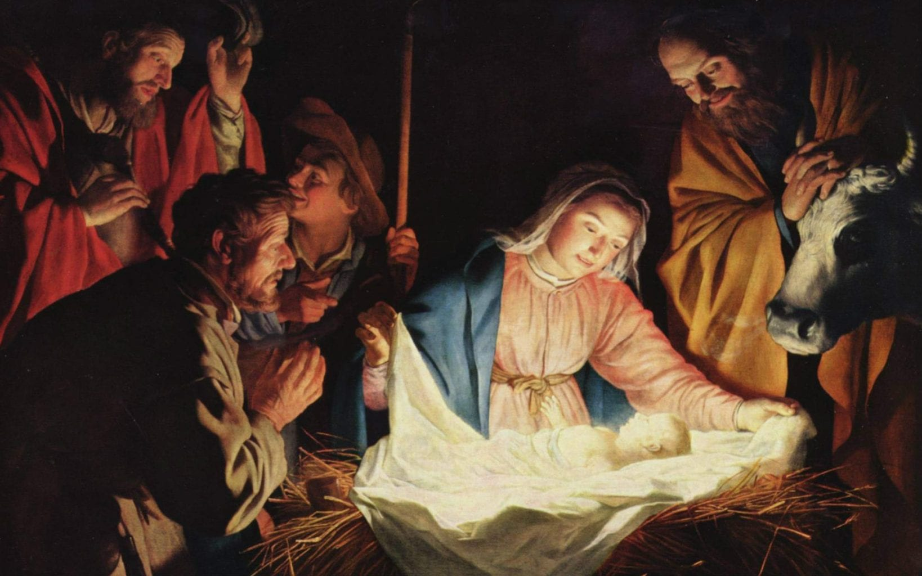

The Fourth Joyful Mystery : The Presentation in the Temple.

Read this reflection.

There had never been a presentation like the one that took place in the Temple that day, and there never would be again. Mary and Joseph were presenting the Only Begotten Son to the Eternal Father, in a temple that was merely the shadow and copy of the real temple in heaven. They were also acknowledging that this child was not their own, and that his first bond of kinship was to his Heavenly Father. Mary was not one to cling to her child with overprotective love, as some mothers do. Yet even she, the selfless and obedient one, was promised that a sword of sorrow would pierce her heart on the day of separation. Why does God give us such beautiful gifts and then ask us to give them up? Why does he allow a loving heart to be pierced with loss? These questions must be brought to Mary, who suffered this sword in a terrible way, more than any mother, any father. Through this mystery, she can help your heart accept what your mind cannot understand.

Recite the Decade.

O my Jesus, forgive us our sins, save us from the fires of hell, lead all souls to Heaven, especially those most in need of Thy mercy. Amen.
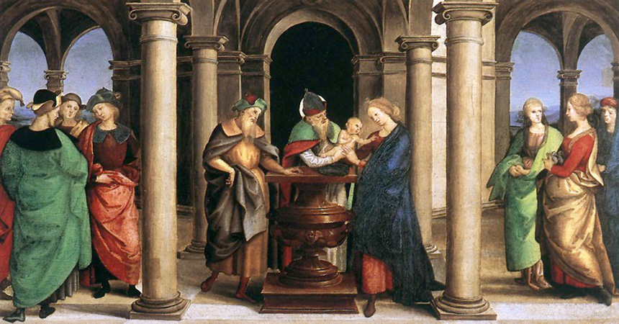

The Fifth Joyful Mystery : Jesus is Found In The Temple.

Read this reflection.

All of the joyful mysteries are somehow tinged with sorrow, but they are also touched with light and glory. In the precocious wisdom of a 12-year-old boy, Jesus gives his parents and the teachers a glimpse of his true stature. He knows who he is and what he came for, even as a boy. But he did not begin by teaching, just as he did not begin by commanding. He began in the humble position of one who listens and asks questions. He also began in the humility of a boy who obeys his parents. Why does Jesus listen and ask questions when he already knows all of the answers with perfect certainty? And why did he obey his mother and father when he himself had called them into existence? Perhaps Mary also reflected on these questions, wondering at the sweetness and respect with which God introduces himself into our lives, as a fellow pilgrim who lives our lives with us, whose questions make us reflect and grow, who listens to us with kindness and interest, and who perhaps has obeyed us—answering our prayers, forgiving our sins in confession, coming into our hearts in holy Communion— far more than we have obeyed him. In this mystery, ask Mary to help you see and touch this goodness of Jesus in your own life.

Recite the Decade.

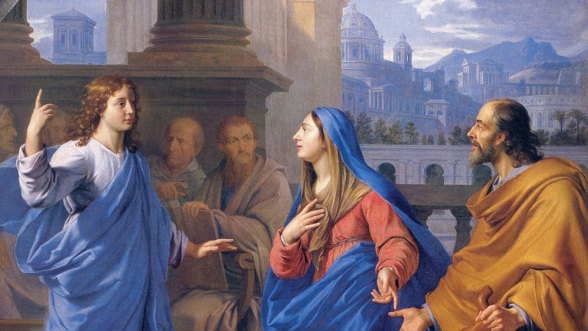
O my Jesus, forgive us our sins, save us from the fires of hell, lead all souls to Heaven, especially those most in need of Thy mercy. Amen.
HAIL, HOLY QUEEN, Mother of Mercy, our life, our sweetness and our hope! To thee do we cry, poor banished children of Eve; to thee do we send up our sighs, mourning and weeping in this vale of tears. Turn then, most gracious advocate, thine eyes of mercy toward us, and after this our exile, show unto us the blessed fruit of thy womb, Jesus. O clement, O loving, O sweet Virgin Mary!
Leader : Pray for us, O holy Mother of God.
Response : That we may be made worthy of the promises of Christ.

Let us pray.
O God, Whose only-begotten Son, by His life, death and resurrection, has purchased for us the rewards of eternal life; grant, we beseech Thee, that meditating upon these mysteries in the most holy Rosary of the Blessed Virgin Mary, we may imitate what they contain, and obtain what they promise. Through the same Christ our Lord. Amen.

Most Sacred Heart of Jesus. Have mercy on us.
Immaculate Heart of Mary. Pray for us.
St Joseph the Worker Pray for us.
St. Ninian. Pray for us.

In the name of the Father……..

