Saint Ninian’s High School.

Friday Rosary : 24 April 2020.

Please join as a family to recite the Rosary at 12.20pm each Friday with members of the School Community.

In the Name of the Father.......

The Novena To The Sacred Heart.
O most holy Heart of Jesus, fountain of every blessing, I adore Thee, I love Thee and with a lively sorrow for my sins, I offer Thee this poor heart of mine. Make me humble, patient, pure and wholly obedient to Thy will. Grant, good Jesus, that I may live in Thee and for Thee. Protect me in the midst of danger; comfort me in my afflictions; give me health of body, assistance in my temporal needs, Thy blessing on all that I do, and the grace of a holy death. Within Thy heart I place my every care. In every need let me come to Thee with humble trust saying, Heart of Jesus help me.

Invocations to the Sacred Heart.
Merciful Jesus, I consecrate myself today and always to Thy Most Sacred Heart.
Most Sacred Heart of Jesus, I implore that I may ever love Thee more and more.
Most Sacred Heart of Jesus, I trust in Thee.
Most Sacred Heart of Jesus, have mercy on us.
Sacred Heart of Jesus, I believe in Thy love for me.
Jesus, meek and mild and humble of heart, make my heart like unto Thine.
Sacred Heart of Jesus, Thy Kingdom Come.
Most Sacred Heart of Jesus, convert sinners, save the dying, deliver the Holy Souls from Purgatory.

Mary Undoer of Knots.
Mother of fair love, I look to you.
Take into your hands the ribbon of my life and see the snarl of knots that keeps me bound to sin, anxiety, and hopelessness.

I beg you, Mother by your powerful intercession and long fingers of love and grace, undo the knots in my heart and in my life. Free me to love God as Christ loves.

The Holy Rosary.

Leader : Come, O Holy Spirit, fill the hearts of Your faithful,
Response : and enkindle in them the fire of Your love.

Leader : Send forth Your Spirit, O Lord, and they shall be created.
Response. And You shall renew the face of the earth.

Let us pray.

God our Father, pour out the gifts of Your Holy Spirit on the world. You sent the Spirit on Your Church to begin the teaching of the gospel: now let the Spirit continue to work in the world through the hearts of all who believe. Through Christ our Lord. Amen.

Leader : You, O Lord, will open my lips.
Response : And my tongue shall announce Your praise.

Leader : Incline unto my aid, O God.
Response : O Lord, make haste to help me.

Leader : Glory be to the Father………
Response : As it was in the beginning………

The Glorious Mysteries.
As a family state for what intentions you will offer this recitation of the Rosary. Please includes all members of our School Community.

The First Glorious Mystery : The Resurrection.

Read this reflection.

Walk with the women as they walked to the tomb and feel how they felt when they saw the stone had been rolled back outside of the tomb. Jesus told them many things, but they did not understand. Mary Magdalene was crying. She saw a man that she thought was the gardener. It was Jesus. She was so overjoyed to see her beloved Jesus. Jesus is alive this day and He is with us. He is truly present in the Holy Eucharist. He dwells within our hearts in a special way when we are in the state of grace.

Recite the Decade.

O my Jesus, forgive us our sins, save us from the fires of hell, lead all souls to Heaven, especially those most in need of Thy mercy. Amen.

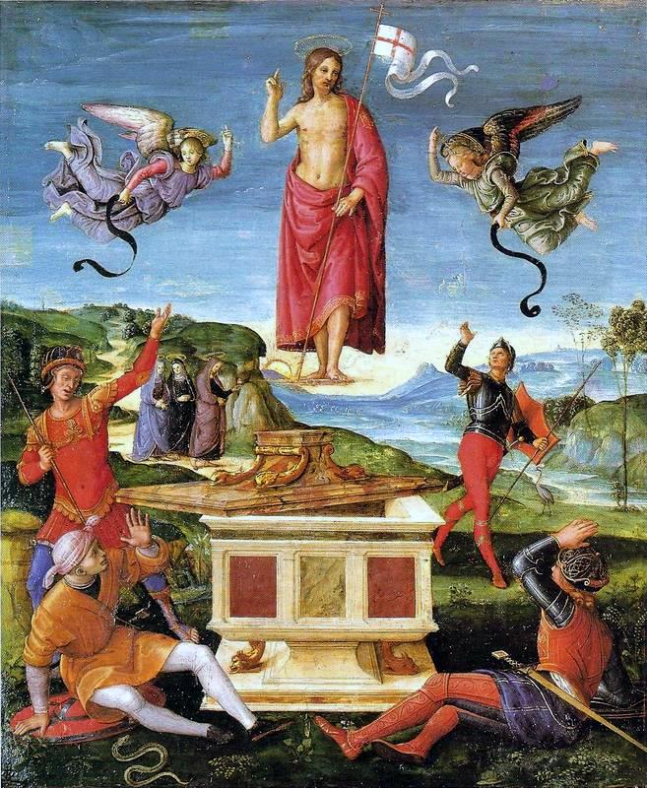

The Second Glorious Mystery : The Ascension.

Read this reflection.

He no longer walks the earth, but this day He lives in this world in the Holy Eucharist and He is truly present. He lives in our hearts. He tells us not to fear for He is here in our every breath and our every heartbeat. He is guarding us, for He loves us so much that He gave us His life that we would share in His divine life. We are His apostles today. We must spread His love to this world. We are doing His work. He wants us to be one in Him. He wants to act in us. We must put aside our selfish ways and be like Him. He wants us to give love to all.

Recite the Decade.

O my Jesus, forgive us our sins, save us from the fires of hell, lead all souls to Heaven, especially those most in need of Thy mercy. Amen.

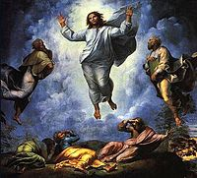

The Third Glorious Mystery :The Descent of the Holy Spirit.

Read this reflection.

When we are in the state of grace, the Father, Son, and Holy Spirit dwell within our hearts in a very, very special way. It is the Holy Spirit that transforms us more and more into the image and likeness of Jesus. It is the Holy Spirit alive within us that is constantly leading us on our way to be closer and closer to God. He is in our hearts when we are in the state of grace. He wants us to tell Him of our love for Him. The more that we tell the Holy Spirit how much we love Him, the more our hearts will burn within us for love of the Son and the Father.

Holy Spirit, alive in our hearts at this moment, how we love You. We want to be close to You. Fill us with the burning fire of God’s love in our hearts.

Recite the Decade.

O my Jesus, forgive us our sins, save us from the fires of hell, lead all souls to Heaven, especially those most in need of Thy mercy. Amen.

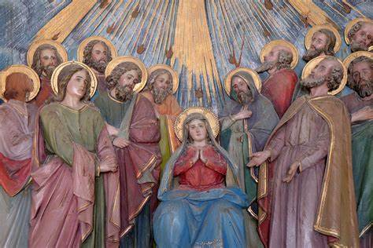

The Fourth Glorious Mystery : The Assumption of Mary.

Read this reflection.

How close Mary is to the Heart of her Son. She lived with Him. She cared for Him. She carried Him in her womb. She gave Him His life. She watched Him as He walked His way to Calvary. She stood under the cross. She watched Him as He ascended into heaven. It is through her heart that we will know the Heart of Jesus more and more.

Recite the Decade.

O my Jesus, forgive us our sins, save us from the fires of hell, lead all souls to Heaven, especially those most in need of Thy mercy. Amen.

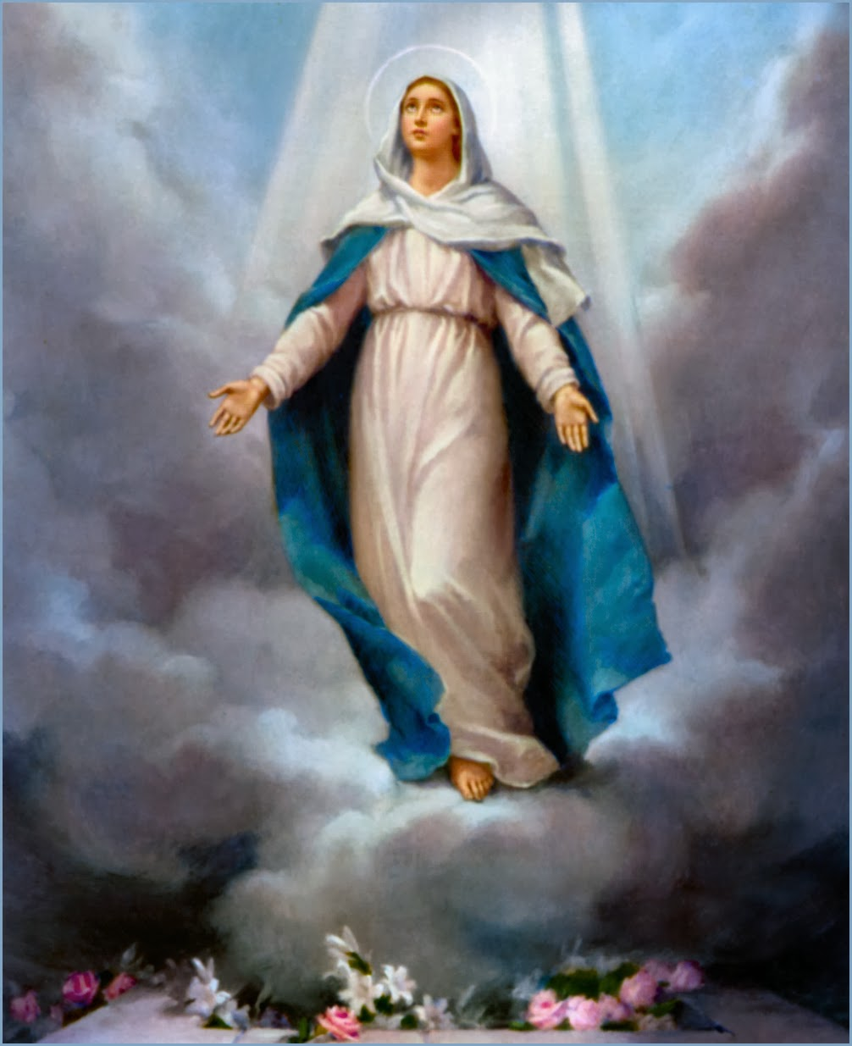

The Fifth Glorious Mystery : The Coronation of the Virgin.

Read this reflection.

We are called to purify our hearts. We must give our hearts to Jesus and Mary. Jesus loves us with the most tender love. He wants to be so close to us. We must give ourselves to Mary. Her heart is pure. We are sinners. We can get closer to God through Mary’s pure heart. Jesus gave us His Mother to mother us.

Recite the Decade.

O my Jesus, forgive us our sins, save us from the fires of hell, lead all souls to Heaven, especially those most in need of Thy mercy. Amen.

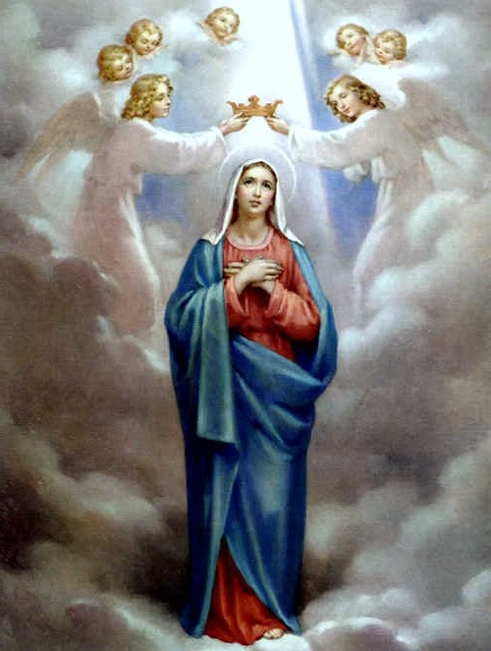

HAIL, HOLY QUEEN, Mother of Mercy, our life, our sweetness and our hope! To thee do we cry, poor banished children of Eve; to thee do we send up our sighs, mourning and weeping in this vale of tears. Turn then, most gracious advocate, thine eyes of mercy toward us, and after this our exile, show unto us the blessed fruit of thy womb, Jesus. O clement, O loving, O sweet Virgin Mary!
Leader : Pray for us, O holy Mother of God.
Response : That we may be made worthy of the promises of Christ.

Let us pray.
O God, Whose only-begotten Son, by His life, death and resurrection, has purchased for us the rewards of eternal life; grant, we beseech Thee, that meditating upon these mysteries in the most holy Rosary of the Blessed Virgin Mary, we may imitate what they contain, and obtain what they promise. Through the same Christ our Lord. Amen.

Most Sacred Heart of Jesus. Have mercy on us.
Immaculate Heart of Mary. Pray for us.
St. Ninian. Pray for us.

In the name of the Father……..

