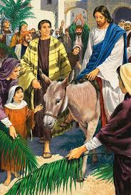

***Tuesday.***

On this day Jesus went into Jerusalem on a donkey.

The people welcome him as a great hero who would save them.

***Monday.***