The Angelus.
Introduction.
In these times without Public Masses, it is important that we keep our prayer life active. With so many people not at work or school, we may find it easier to make time for family prayer. This sheet gives information on a traditional prayer called the Angelus. The Angelus seems to have originated in the 14th Century in monasteries in Italy and even now is said three times a day at 6.00am; 12.00 Noon and 6.00pm. As the prayer became more used, bells would ring in local churches and the faithful would stop what they were doing to recite the Angelus. Many people continue this custom daily at 12.00 Noon.
You may like to gather as a family to read this sheet. Read over and reflect on the story of the Annunciation from Luke’s Gospel and then recite the Angelus.

The Annunciation of The Lord.
On 25 March we celebrate the Solemnity of the Annunciation of the Lord when the Angel Gabriel visited Mary to ask her to be the Mother of Jesus. This event is crucial in God’s Plan for our Salvation. This was not an easy choice for Mary who would at this stage be a young girl betrothed to Joseph.
At first we have a moment of hesitation from Mary who wonders how this could happen but then her faith in God moves her to accept what is God’s Will. Mary’s faith is an example to us all and encourages us to have faith in God.

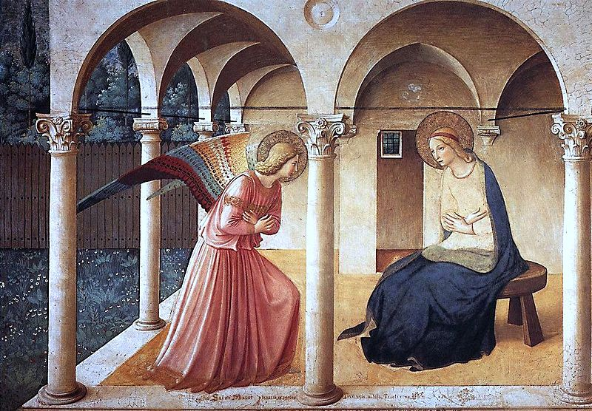

The story of the visit of the Angel Gabriel is told in Chapter 1 of the Gospel of St Luke.
In the sixth month of Elizabeth's pregnancy God sent the angel Gabriel to a town in Galilee named Nazareth. ²⁷ He had a message for a young woman promised in marriage to a man named Joseph, who was a descendant of King David. Her name was Mary. ²⁸ The angel came to her and said, “Peace be with you! The Lord is with you and has greatly blessed you!”
²⁹ Mary was deeply troubled by the angel's message, and she wondered what his words meant. ³⁰ The angel said to her, “Don't be afraid, Mary; God has been gracious to you. ³¹ You will become pregnant and give birth to a son, and you will name him Jesus. ³² He will be great and will be called the Son of the Most High God. The Lord God will make him a king, as his ancestor David was, ³³ and he will be the king of the descendants of Jacob forever; his kingdom will never end!”
³⁴ Mary said to the angel, “I am a virgin. How, then, can this be?”
³⁵ The angel answered, “The Holy Spirit will come on you, and God's power will rest upon you. For this reason the holy child will be called the Son of God. ³⁶ Remember your relative Elizabeth. It is said that she cannot have children, but she herself is now six months pregnant, even though she is very old. ³⁷ For there is nothing that God cannot do.”
³⁸ “I am the Lord's servant,” said Mary; “may it happen to me as you have said.” And the angel left her.

This momentous event is recounted in the traditional Angelus Prayer. In usual times, the Pope will come to his window overlooking St Peter’s Square in Rome each Sunday and lead the faithful gathered in the Square through the Angelus.
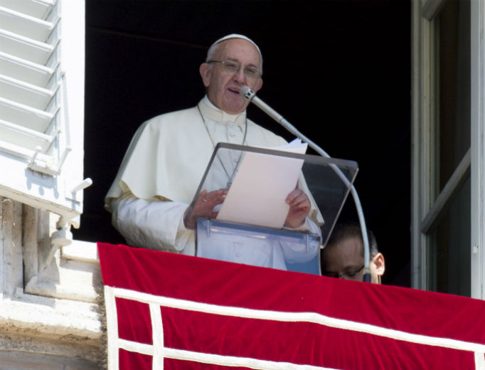

The Angelus Prayer.

Leader. The Angel of the Lord declared unto Mary,
Response. And she conceived of the Holy Spirit.
All. Hail Mary, full of Grace…………..

Leader. Behold the handmaid of the Lord.
Response. Be it done unto me according to Your Word.
All. Hail Mary, full of Grace…………..

Leader. And the Word was made flesh,
Response. And dwelt among us.
All. Hail Mary, full of Grace…………..

Leader. Pray for us, O holy Mother of God.
Response. That we may be made worthy of the promises of Christ.
Leader. Let us pray:
All. Pour forth, we beseech You, O Lord,
Your Grace into our hearts;
that as we have known the incarnation of Christ,
your Son by the message of an angel,
so by His passion and cross
we may be brought to the glory of His Resurrection.
Through the same Christ, our Lord. Amen.

