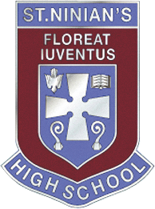
Art of the Month: February
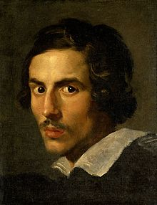

This painting is a seventeenth century selfie! That is, it is a self-portrait of Gian Lorenzo Bernini, an Italian sculptor, painter, architect, actor and theatre director. However, it is as a sculptor that he excels. It is said that he did for sculpture what Shakespeare did for literature. He was over eighty when he died and painted many self-portraits that suggest he had a keen awareness of himself. We see the fire in his eyes with his thick eyebrows and a lofty forehead, perhaps the beginning of balding, Later portraits depict him with signs of aging…slightly sunken cheeks, the remaining hair white and frizzy. So there is an honesty in his portrayal of his features, particularly as he approached death. He had a great devotion for most of his life to a Bona Mors (Good Death) and often visited the Church of the Gesù, which to this day you can visit in Rome. He prepared spiritually for his own death, sculpting a bust of Christ, which was his final opus.
So, why this particular painting in this particular month? On 22nd February, we celebrate the Feast of the Chair of Saint Peter the Apostle that reminds us of the teaching authority of the Pope…..and may serve us to ponder our teaching authority in St Ninian’s High School. A chair or ‘cathedra’ from which is derived the word cathedral, is the place where each bishop teaches his people. The Chair of the Bishop of Rome is that place from which the Pope presides over the whole Church and teaches us the Faith, which unites us with one another. Have you ever seen the Chair of St Peter when you have visited the Vatican Basilica? Well, no, you would not have been able to see it unless you were particularly fortunate to be there in when it was last uncovered for examination. This is where Gian Lorenzo enters into our story. Maestro Bernini it was who designed the baldachino or canopy directly under the dome of the basilica and above the tomb of the Blessed Apostle Peter, a work that took twelve years to complete. He was also the architect and designer of the gilt-bronze throne that encloses and conserves the relic of Peter’s wooden Chair, which was obviously ravaged by the elements and the years. This project took almost a decade to complete…..but…what a throne, what a project! At the time it was built, there was no other chair like it in the world. The throne is supported by bronze figures of Saint Ambrose, Saint John Chrysostom and Saint Athanasius, all Doctors of the Church. Above is the Latin inscription: "O Pastor Ecclesiae, tu omnes Christi pascis agnos et oves" (O pastor of the Church, you feed all Christ's lambs and sheep). The same writing is shown also in Greek. Doctor of the Church is a title given to saints recognized as having made a significant contribution to theology or doctrine through their research, study, or writing. We who have the joy and privilege of teaching the young students entrusted to our care will be successful in our efforts and cherished by our pupils when we, too, have given time and talent to research, study and writing.

Monsignor Monaghan

