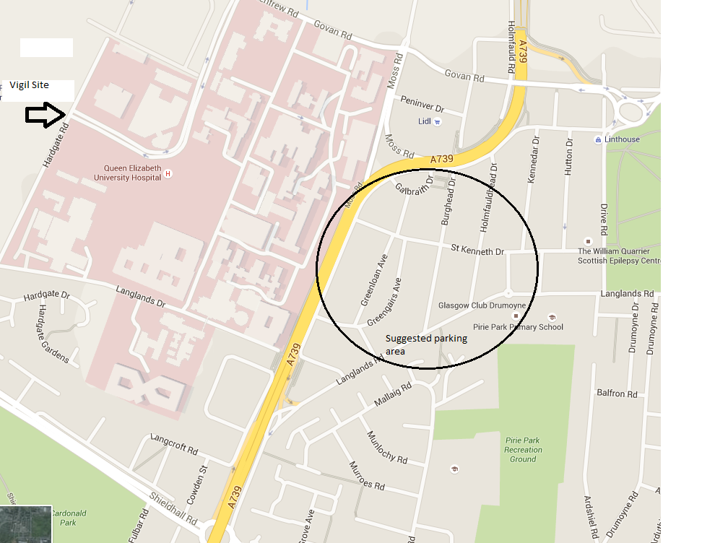

NB: Other side of hospital from the Govan Road

