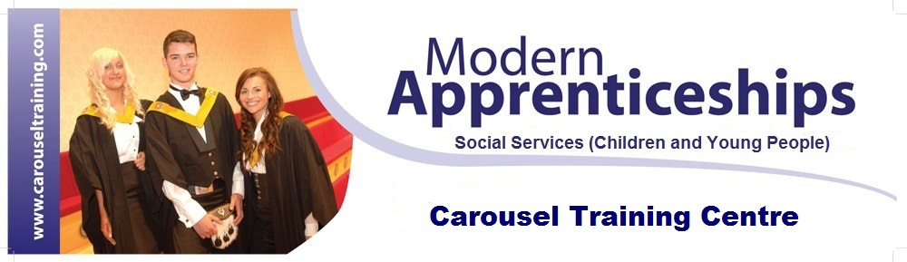

ARE YOU INTERESTED IN A CAREER IN EARLY YEARS?

- Are you aged between 16–19 years old?
- Do you want to work towards an industry recognised accredited qualification?
- Would you like to work full time as an Early Years Modern Apprentice in a nursery working with babies to children aged 5 years old?

The process is simple:

- We interview you for the training position.
- We assist you to secure employment while undergoing your training.

You will be trained over 12-15 months to be a fully qualified Childcare Practitioner, undertaking an SVQ Social Services (Children and Young People) SCQF Level 7.

You graduate upon completion.
- No experience is necessary.
- Work & Earn while you Learn!

APPLY ONLINE AT: www.carouseltraining.com
Carousel Training centre is an equal opportunities training provider

