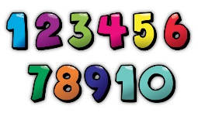
Real Life Maths Treasure Hunt
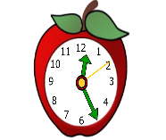
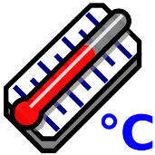
How many can you find? Where did you find them? Draw some of your own.
hot/cold | fast | slow  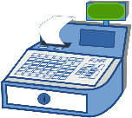 | money/ price
measure | pattern | date | shapes
long | short | a pair | heavy  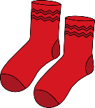
time | numbers | empty/full | light
Take a photo of yourself using maths in real life and upload it to your class blog.

