Bullying
Bullying is bad,
If you do it you are silly.
And if you think about the bullying you’ve done,
it will make you feel quite chilly!
The people who are bullied,
they don’t feel nice inside.
They should be warm and cosy,
and bursting with lots of pride.
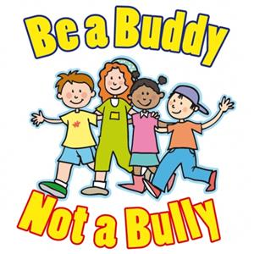
If you do a lot of bullying,
you are not helping at all.
Think about being nice,
so that you can stand tall!
By Penny Moran & Elsa Gray – Primary 3b

