All of the classes in St Mark’s Primary have a Class Blog to showcase their learning. Please click on the link below to access your child’s Class Blog.
https://blogs.glowscotland.org.uk/er/StMarks/curriculum/pupils/class-blogs/
The ABCS of Listening and Talking
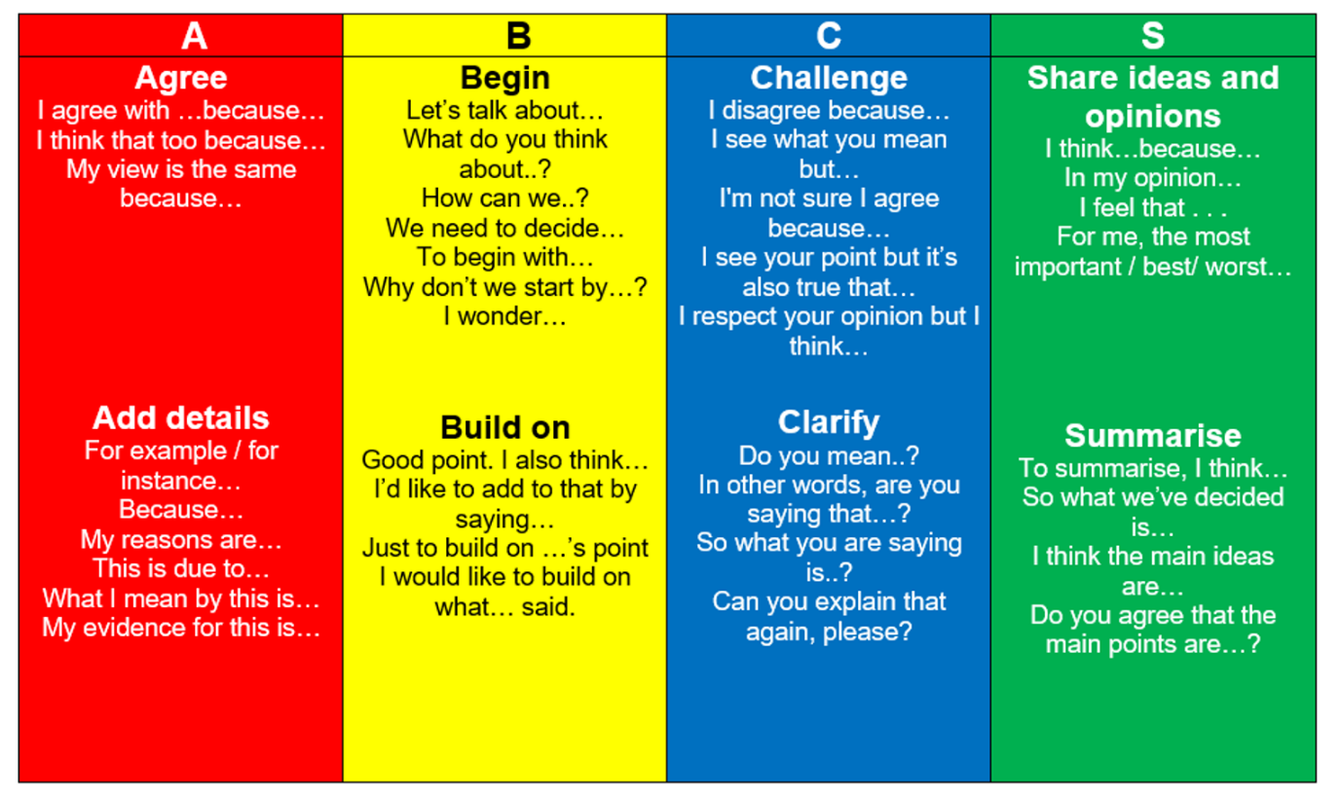

Please use the ABCS of Listening and Talking to discuss your child’s blog.
Please complete the Form below to provide us with feedback.
https://forms.office.com/Pages/ResponsePage.aspx?id=oyzTzM4Wj0KVQTctawUZKZRDdVqBog5Llqr6N49qsu5UNkFJRjg5REJOSUNZVlhNQjVXVEs0RFlaTS4u

