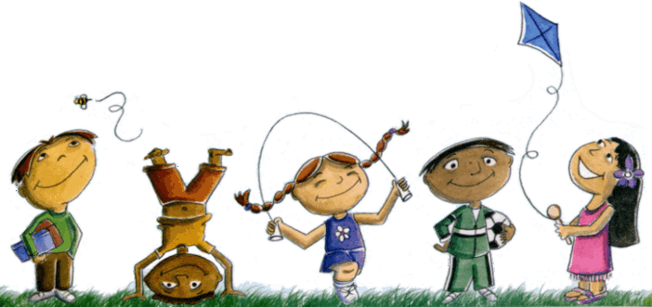
Name: Class:
Over the course of the week, you have been asked to participate in as many outdoor activities as you can. Below are a list of activities you can take part in. Colour in the boxes to show which activities you have completed. If you complete any other outdoor activities, please add them to the boxes below.
Paint some pebbles and turn them into colourful creatures. | Take some paper outside and do a landscape drawing. | Sketch some flowers or plants. | Draw a map of your route to school. | Chalk some patterns, pictures and words on the ground.
Make shadow shapes on a wall and, if possible, ask an adult to take some photographs. | Complete a traffic survey outside of your home-what vehicles go past? Or what colour cars? Make a graph to show your findings. | Make a collage of some of the living things you can see when outside. | Use feathers, beads and other objects to make an eye-catching wind chime. | Lie back and see what shapes you can see in the clouds draw or describe what you see.
Fill an empty washing-up liquid bottle up with water and write words on the ground. | Hunt for bugs in the garden park or woods with an adult. | Plant a seed. | Make a den outdoors. | Go outside at night with an adult and see if you can see the stars. Can you name any of the constellations?

