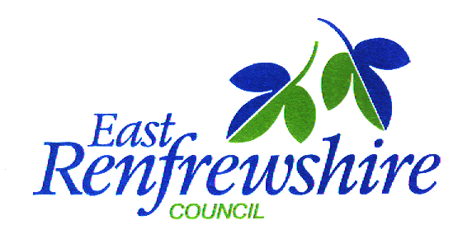

School Improvement Partnership Programme (SIPP) Guidance

Contents

- Introduction and Aims

- Core Principles

- Key features of effective school improvement partnerships

- Professional Enquiry and Collaborative Enquiry

- Research

- School Improvement Partnership Methodology

- Roles and Responsibilities

- Further Reading

Appendices

Appendix 1 – School Improvement Partnership Methodology

- Introduction and Aims

The Education (Scotland) Act 2016 places a duty on education departments to deliver services aimed at narrowing the attainment gap through improving outcomes for the most vulnerable children and young people. The related National Improvement Framework 2016, with the vision of delivering excellence and equity in equal measures within the education system builds on the strong foundations provided by the Getting it Right for Every Child approach, Early Years Collaborative, Curriculum for Excellence, Scotland’s School for the Future; National Youth Work Strategy; Youth Employment Strategy and Teaching Scotland’s Future to target and focus efforts to improve further. This framework has the priorities of improving attainment, closing the attainment gap, improving children and young people’s mental health and improving the employability skills and sustained, positive school leaver destinations. The synergies and interconnections across the key drivers of school leadership, teacher professionalism, parental engagement, assessment of children’s progress, school improvement and performance information, are essential to enable continuous improvement.

The School Improvement Partnership Programme (SIPP) is a collaborative school improvement strategy that promotes new ways of working across classrooms, schools and local authorities to tackle educational inequality. Data and collaborative enquiry are used to innovate, test and refine new approaches to tackle the attainment gap, which should be viewed within the broader context of attendance, attainment, exclusion/inclusion, engagement and participation. The programme is a natural extension of Curriculum for Excellence and, importantly, aligns with and reinforces a number of key educational policies and programmes including Curriculum for Excellence, Teaching Scotland’s Future, the SCEL Fellowship Programme and Raising Attainment for All. All of these are underpinned by the same key concepts of co-production, professional learning and enquiry.

The School Improvement Partnership Programme (SIPP) is a solution-focused approach to raising attainment with a focus on innovating to tackle educational inequality. It draws on the wealth of international educational research and practice demonstrating that the most effective school improvements are locally owned and led by teachers and school leaders working in partnership and collaboration with like-minded professionals. The partnerships aim to develop a shared commitment to improving outcomes for vulnerable children and young people. Research evidence indicates that well supported partnerships can lead to significant and sustained improvement, including raised attainment.

In the spirit of action research, the programme aims to encourage staff to learn from each other, experiment with their practice and monitor and evaluate change. School Improvement Partnerships are an action research programme involving a process of collaborative enquiry which creates leadership opportunities and professional learning.

- Core Principles

The core principles that underpin this programme are:

- Partnership working across schools and local authorities with a focus on exploring specific issues relating to educational inequity.
- The use of action research and evidence to identify key challenges, experiment with innovative practices and monitor developments.
- The creation of leadership opportunities and professional learning of staff at all levels.
- A commitment to reciprocity and mutual benefit to all involved.
- The development of arrangements to support long-term collaboration and new approaches to capacity building.
- Explicit links to strategic improvement planning in schools and local authorities.
- The involvement of a diverse range of partners.

- Key features of effective school improvement partnerships

- Targeting achievement (attendance, attainment, exclusion/inclusion, engagement, participation) of a small key group of learners.
- Understanding the importance of context and local ownership.
- Using evidence to inform practice.
- Teachers leading change through professional enquiry research.
- Learning from similarity and diversity.
- Moving practice and expertise around the partnership.
- Building relationships and networks across the cluster and authority.

- What is professional enquiry?

Professional enquiry is a 'finding out' or an investigation with an approach that can be explained or defended. The findings can then be shared so it becomes more than reflection or personal enquiry. It is usually undertaken within the practitioner’s own practice/ context or in collaboration with others.

Effective professional enquiry requires practitioners to:
- Be confident and open to challenge
- Have risk taking attitudes
- Question their own understandings, assumptions, beliefs and practices
- Engage with theory, literature and research

Enquiry tends to be least successful when they simply seek to prove/test ‘best practices’, make claims about ‘what works’ and/or test or implement latest initiatives. Enquiries without probing the deeper questions about the nature and purpose of the enquiry run the risk of being superficial and may become a 'tick box' exercise

When carried out effectively, practitioner enquiry can: lead to professional development and changes in pedagogy and curriculum; enable teachers collaboratively to develop the curriculum; improve the use of research findings and drive educational change.

What is collaborative enquiry?

Collaborative enquiry is where a group of practitioners share a common research question which can be 'investigated' through different lenses to enhance knowledge creation.

- What is research?

Research is the systematic and objective analysis and recording of controlled observations that may lead to the development of generalisations, principles, or theories, resulting in prediction and possible control of events.

Or simply, a scientific way of answering questions and testing hypothesis, in order to:

- Investigate existing problems and situation
- Provide solutions to problems
- Construct or create new procedures or systems
- Review existing knowledge
- Generate new knowledge

- School Improvement Partnership Methodology

Within the School Improvement Partnership Programme, a range of improvement methodologies can be used, with the single aim of addressing educational inequity through collaborative approaches to system improvement. Key findings across the partnerships highlight the positive impact such methodologies can have in promoting collaborative approaches and improving educational outcomes.
Lesson study is a collaborative professional development process that allows for an in depth exploration of an individual lesson in ways that enable participants to enhance their own and their pupils’ learning.
As well as the lesson study approach, collaborative action research and instructional rounds have been utilised within the national school improvement partnership programme. The plan, do, study, act model for improvement has been commonly used within the early years collaborative.

East Renfrewshire Educational Psychology Service, in partnership with the Quality Improvement Team, have developed guidance that aims to support the work of the school improvement groups in order to assist the planning, delivery and evaluation of interventions to improve outcomes for vulnerable learners (Appendix 1). This eclectic model for improvement is summarised below:

- Phase One - Performance information analysis and outcome focused planning
- Phase Two - Exploring and understanding the target group’s performance
- Phase Three - Intervention and Evaluation Planning
- Phase Four - Implement Intervention
- Phase Five - Evaluation and Reflection

- Roles and responsibilities

Role of Practitioner

- Collaborate with head teachers to analyse data and identify a small group of vulnerable learners to target intervention.
- Work in partnership with SIP practitioners to design, implement and evaluate interventions.
- Complete methodology/written paperwork.
- Engage learners and parents in gathering data to understand the importance of context and family context.
- Explore research to inform practice based intervention.
- Participate in learning rounds with practitioners observing and analysing impact of different teaching practices on pupils.
- Share outcomes/findings with learners, parents, staff and authority.
- Contribute to authority quality assurance processes as required.
- Apply your skills in enquiry to professional dialogue in your school and across your cluster.

Role of Head Teacher

- Collaborate with practitioners to analyse data and identify a group of individuals to focus intervention.
- Negotiate time to allow practitioner opportunity to fully engage with School Improvement Process.
- Encourage and support practitioners to be creative and innovative through engagement with research and collaborative enquiry.
- Provide opportunity for practitioners to share their findings.

Role of Education Development Officer, Quality Improvement Team and Educational Psychology Service

- Actively contribute to the work of each partnership encouraging creativity and innovation.
- Contribute to professional discussion regarding child development and effective learning and teaching.
- Support schools to identify vulnerable groups of learners through data analysis.
- Support the implementation of action research methodology.
- Facilitate the identification of effective evaluation measures.
- Signpost and where required access relevant research.
- Contribute to meeting the professional learning needs of teachers.
- Develop links with Universities.
- Facilitate the sharing of best practice across partnerships.
- Develop and implement quality assurance processes.

- Further Reading (please click on hyperlinks below)

Legislation/Policy

Education Scotland Act 2016

The National Improvement Framework 2016

Quality and improvement in Scottish education 2012-2016

Education Scotland: School Improvement Partnerships

Research

Education Scotland Improvement Hub

Education Endowment Foundation (school age);

Education Endowment Foundation (early learning);

Scottish version of the Education Endowment Foundation’s Learning and Teaching Toolkit

LGiU Scotland

The Sutton Trust

Interventions for Equity

Interventions for Literacy

Review of Family Learning

Improvement Methodology

Lesson Study

Collaborative Action Research

Instructional Rounds

Plan, Do, Study, Act

Appendix 1
East Renfrewshire School Improvement Partnerships Methodology

The following guidance aims to support the work of school improvement partnerships in order to assist the planning, delivery and evaluation of interventions to improve outcomes for vulnerable learners.
Diagram 1: Methodology Overview

Phase One: Performance Information Analysis and Outcome Focussed Planning

Step One: Analyse pupil performance information
Through analysis of pupil performance information identify a small group (4-6) of vulnerable learners to target in order to improve outcomes (attendance, attainment, exclusion/inclusion, engagement, participation).

Target Group:
Children with a diagnosis of Autism

Number of Pupils:
2 pupils from Isobel Mair School
2 pupils from Langlands Primary School

Staff:
Kirsteen MacKay, Isobel Mair School, East Renfrewshire
Joni Coleman, Langlands Primary School, Glasgow

Detail the rationale for selection (SIMD, gender, LAC, ethnicity, lowest performing 20%):
Pupils have a diagnosis of autism and socialising these pupils through a targeted approach of thoughtful pedagogy should raise attainment.

Step Two: Identify SMART outcomes for the target group
Following intervention, what improvements would you expect to see? It might be helpful to review these outcomes following completion of phase 2.

Expected SMART outcomes (attendance, attainment, exclusion/inclusion, engagement, participation):
- To develop their turn taking and attending skills
- To raise interaction skills
- To increase functional communication

Phase Two: Exploring and Understanding the Target Group’s Performance

Step One: Explore the strengths of and pressures on your target group
What are the factors that impact (positively/negatively) on this identified group of learners? You may want to consider the following (please note these are examples and not an exhaustive list).

- School learning environment – e.g. expectations of pupils, staff/pupil relationships, peer relations, quality and deployment of teaching and support staff, pedagogy, parental engagement
- Parental factors – e.g. engagement with pupils learning, relationships with school staff, value for education, parental educational experiences, parental physical, mental and cognitive health, parenting skills
- Pupil factors – e.g. SHANARRI, Aspirations for future, motivation for learning, pupils physical, emotional/mental and cognitive health, pupil involvement in their learning
Strengths/positive factors:
- Pedagogy
- Developing learning through motivating contexts and pupil interests
- Strong staff/ pupil relationships; school ethos

Pressures/negative factors:
- Nature of pupils’ additional support needs
- Challenge in supporting pupils to develop some pre-requisite skills
- To support staff to develop professional knowledge and understanding

Step Two: Evaluating the significance of the factors identified
Consider ways in which you can test (confirm/disprove) the significance of the factors outlined (e.g. existing school information, research evidence, assessment, professional enquiry, questionnaires, focus groups).

Confirmed strengths/positive factors:
- Observations
- Potential increase in positive interactions between pupils
- Record verbal utterances- increase in functional nature
- Unknown benefits that are unanticipated

Confirmed pressures/negative factors:

- Unknown

Phase Three: Intervention and Evaluation Planning

Step One: Identifying evidenced based interventions through research/professional enquiry
Through professional enquiry and reviewing the research literature, explore relevant evidence based interventions?
LEGO therapy is based on Attwood’s (1998) “constructive application” to use natural interests to motivate learning and use natural interests to change behaviour. Those with a diagnosis of autism find it challenging to socially interact with parents, teachers and peers. According to LeGoff (2004), those with autism often disregard the signals to interact with their peers and the methods used to develop social interaction skills are often commented as being “robotic attempts of imitation”. As interests, for many with autism, can be narrow Attwood (1998) and Greenspan and Wieder (1998) suggest that these interests should be utilised to develop social, communication and play skills.
What evidence based interventions could you implement to address the identified pressures of the target group?

As LEGO is a highly structured, predictable and repetitive construction toy, it is therefore likely that children with ASD will be motivated by tasks involving this toy, due to the fact that individuals with the condition are particularly attracted to systems. The approach uses a number of important elements; children develop LEGO brick building skills, including collaborative building, in individual therapy. They are then introduced to a group of peers, including some group members who do not have social skills deficits. The group met on a regular basis (and during that time engages in collaborative LEGO brick building activities and other projects, which are tailored to the skill level of the participants. Group members are assigned different responsibilities such as director, engineer, supplier, and builder. The team works together to assemble the project with and an emphasis on verbal and non-verbal communication, joint attention and task focus, collaborative problem-solving, sharing and turn-taking. During the LEGO system therapy sessions, social conventions can be directly instructed or prompted, based on the needs of the peers. For example, if two peers are physically fighting over a LEGO piece this can be redirect by the use of language, negotiation, and compromise to settle their dispute.

What actions could you take to build on the identified strengths of the target group?

Are there areas where the evidence base for improvement is weak?

Helpful tips:
- multifaceted interventions tend to be the most successful (i.e. they target child, family and school/class factors)
- consider other groups that are performing well despite similar ‘risk factors’ and how can you learn from their success
Step Two: Action Planning
Research question/s (no more than 2 or 3):

Does Lego Therapy develop social interaction and communication skills in Autistic children?

What are you going to do?

For 2 weeks observe pupils during free play (Lego) focussing on social play and communication. Recording information from both sessions.

Week 3 – introduce Lego Therapy as an intervention.

As session move forward reduce the amount of adult support

Supporting with visuals and objects to identify roles. Supply range of visuals of items that can be created/built.

What are the timescales - When are you going to do it? How long are you going to do it for?

21/3/18 – 23/5/18
8 weeks for 1 hour a week.

Who is going to be involved?

Isobel Mair School and Langlands Primary School
2 pupils from each school (1 P1 pupil and 1 P6 pupil)

How will the intervention be evaluated in the short and long term?

Social Skills Pupil Assessment (Appendix 1) to be carried out before and after the intervention focussing on social play and communication.
Observation sheets (Aappendix 2) completed during each session using The Leuven Scale of Active Engagement in Learning.

Do you intend to have a control/comparison group (i.e. a group of pupils who have similar needs who do not receive the intervention but take part in the pre and post evaluation for comparison purposes)?

No

Helpful tips/reflective questions:
- A research question is a clear, focused, concise and arguable question around which to centre your research.
- What are the resource implications?
- Do you need to plan CLPL?
- What might get in the way of the intervention being successful? If possible, how are you going to avoid this?
- Do you need to plan time for pre and post information/data gathering and analysis?
- Appendix 2 may be helpful to plan the actions required to implement your intervention

Phase Four: Action (Implement intervention)

Phase Five: Evaluation and Reflection

Step One: Measuring impact and outcomes
Following evaluation of the intervention (as planned in phase 3):

What impact has the intervention had?
This intervention has made an impact on the boys social and communication skills, which we have been able to track through using the play observation schedules. We broke down the intervention sessions and gradually added more structure through using Lego Therapy roles. When more external structure was put in place we noticed, particularly with one boy, that he was becoming disengaged and withdrew himself from the Lego play. This also had an impact on the rest of the group as communication structures broke down. We decided to use less structure and adult support for the last three interventions and found a vast improvement in communication with all boys. They were initiating conversations between themselves, using sentences, recalling each other by name, playing with each other creatively and their confidence had grown. They became great friends and we noticed the boys asking about Lego Therapy and were excited to meet up with each other each week. We found that Lego was a great resource to use as a basis for play as it’s intrinsically motivating and can be used as a sole resource. It was also a keen interest for all of our boys which created a strong basis for communication and interaction. At the start of the intervention all boys were playing independently and seeking adult interaction and by the end of the intervention the boys were independently creating conversation between themselves as they were playing.

Through collaborating with another school, both teachers have been given the opportunity to learn from each other and ask questions. Through this Lego Therapy intervention we have gathered evidence and used this in our routine everyday practice.

Have the SMART outcomes been achieved? Please describe.

Data Results
Participant | Social skills score at beginning of intervention | Social skills score at end of intervention | Difference
A | 24/60 | 24/60 | 0
M | 42/60 | 42/60 | 0
R | 33/60 | 33/60 | 0
L | 44/60 | 44/60 | 0

The Lego Therapy intervention has enhanced inclusion by providing an inclusive environment between two schools, where the boys felt safe and welcome. The Lego has engaged the boys and held their interest in order to provide an interactive communication environment. They boys participated throughout and through evaluation we feel that it had a positive impact on their social and functional communication skills. Turn taking and attending skills were enhanced through introducing job roles. Through the context of Lego Therapy the SMART outcomes were achieved. However, more time would be required to transfer these skills to our play settings.

Step Two: Critical Reflection
What have you learned?
We have learnt that Lego is a means of facilitating social development through a skill-building approach. The boys worked upon sorting Lego, finding Lego, and following visual instructions to build Lego.
We have learnt that a Lego session with too much structure took away from the boy’s independent communication and in turn demotivated one boy completely. When tight structures were removed the boys all communicated freely and positively. Free play with Lego worked well and allowed good observation of the boy’s communication.

What went well?
Socially the boys became a lot more confident in comparison to the beginning and were displaying lovely friendships. They enjoyed meeting up with each other each week and particularly looked forward to when they were visiting the other school. They enjoyed exploring the other schools resources. It also provided the boys some independence away from the class and ownership over something that their friends weren’t involved in.
Appendix 4

What didn’t work so well?
When too much structure was put in place, such as the roles. Structure would have been better added in later during intervention if we had more time.

Is there anything that could have been done better?
More time to progress the intervention and develop the Lego Therapy roles further.

Step Three: Planning for Improvement
What are you going to do now?

- Apply these principles to play sessions and observations.
- Keep communication links between two schools.
- Use Lego and Lego Therapy principles in everyday teaching practice.

Appendix 1

 | Social Skills Pupil Assessment
 | Name
 | Completed by: |  |  | Date:
 |  |  | Can do this independently, in a range of context 0= Never 1 = rarely 2 = sometimes 3 = mostly 4 all occasions

Conceptual Skill | General Skill | Specific Skill
Social Interaction | Social Conversation | Can look towards/in the direction of the person who is talking
 |  | Can express my personal thoughts/experiences/events
 |  | Can take a listening turn - no interruptions
 |  | Can take a talking turn e.g. asking a relevant question to someone or responding to a question
 |  | Can maintain an appropriate conversation by remaining on topic
 | Social Play | Can take a turn in a game
 |  | Can follow the rules
 |  | Can play co-operatively / share resources with others
 |  | Can be a good team player (e.g. participate, try my best, encourage and congratulate others)
 |  | Can accept losing / not being first
 | Learning | Can give my attention to a task for a set period of time
 |  | Can work co-operatively with others
 |  | Can follow familiar routines, including managing my belongings
 |  | Can accept making mistakes can provide opportunities for learning
 |  | Can identify when I need help and seek support appropriately

Appendix 2 - Playful Pedagogy – Observation Sheet
Pupil Name: Staff member: Time: Date:
Location: Other Pupils/ Staff Present
What is the pupil playing with? | The pupil is playing; |  | Are they: |  | Are they: |  | During the observation did the pupil:
 | On their own |  | Using the resource appropriately |  | Verbalising to themselves |  | Play with the same resource throughout
 | With an adult |  |  |  | Verbalising to an adult |  | Play with different resources
 | Near a child |  | Using the resource out of context |  | Verbalising to another pupil |  | Engage with any other pupil
 | With a child |  |  |  | Not Verbalising |  | Seek adult attention
- Disengaged | - Passive | - Intermittent | - Engaged | - Intense
Shows no interest in the play or the resources. May not interact with adults, peers or resources at all (or very minimal). May move away from the activity. | Shows some interest in play and/ or resources. May or may not interact with adults or peers. Will show some interest in the resources. May appear unfocussed on the play. May only be engaged in the task for 30 seconds – 1 minute. | Shows some interest in play and/ or resources. May interact with adults or peers. Will show interest in resources. May appear focused on the play. Will engage in task consistently for at least 1 minute. | Shows interest in play and/ or resources. May interact with adults or peers. Will show interest in resources. Appears focused on play. Will engage in task consistently for at least half the time (2-3 minutes). | Consistently engaged in the play for most of the activity time (4-5 minutes). Will show interest in resources. May interact with adults or peers. Focused on the play.
Observation Comments (Observation of child’s actions/ language) | Level of engagement | Learning pathway for next play session

Appendix 3

Lego task cards
Can be found at:
https://www.twinkl.co.uk/resource/t-t-11551-lego-building-challenge-cards
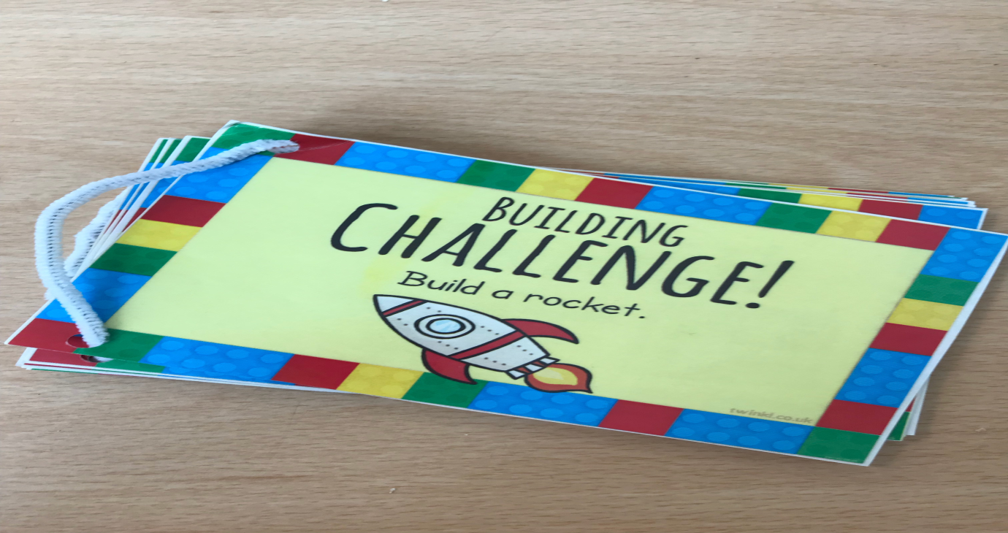
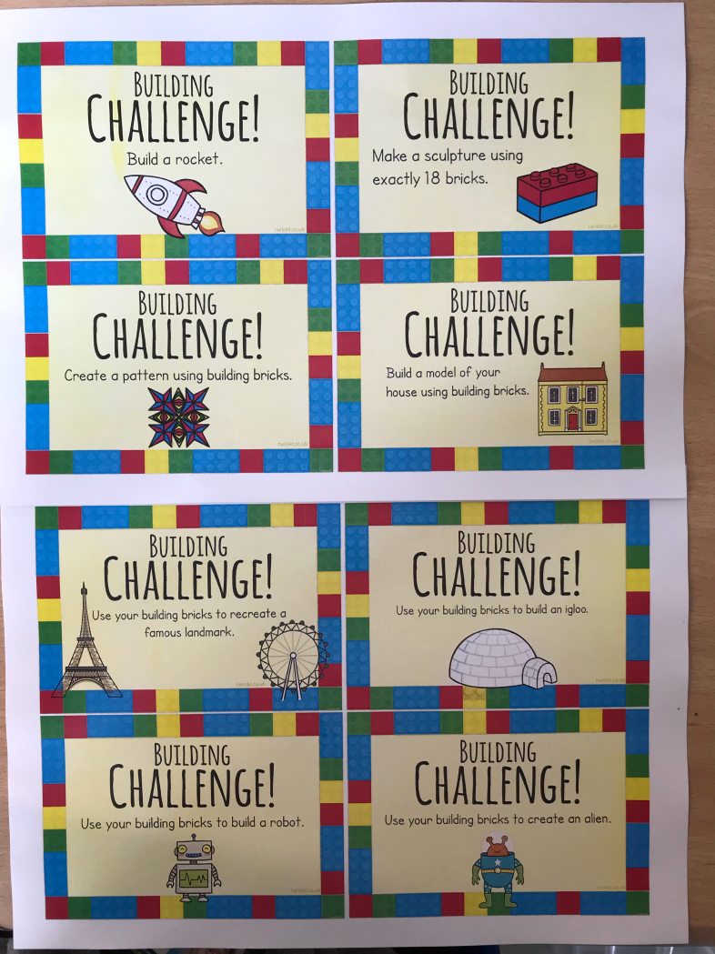
Appendix 4

21/03/18 First session
Participants used Lego appropriately. There was no communication or interaction between the participants. Each worked individually on their project.

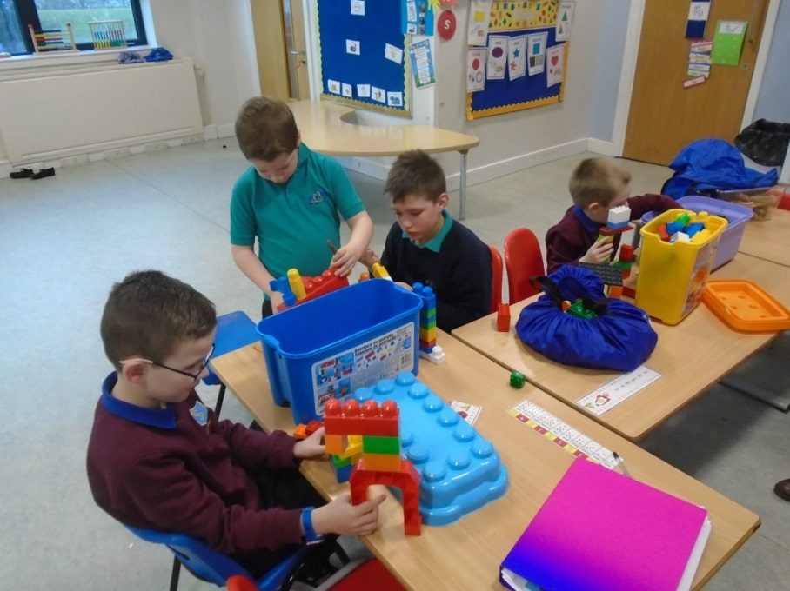

23/05/18 Last session
Participants were independently interacting and creating conversation between themselves as they were playing.

